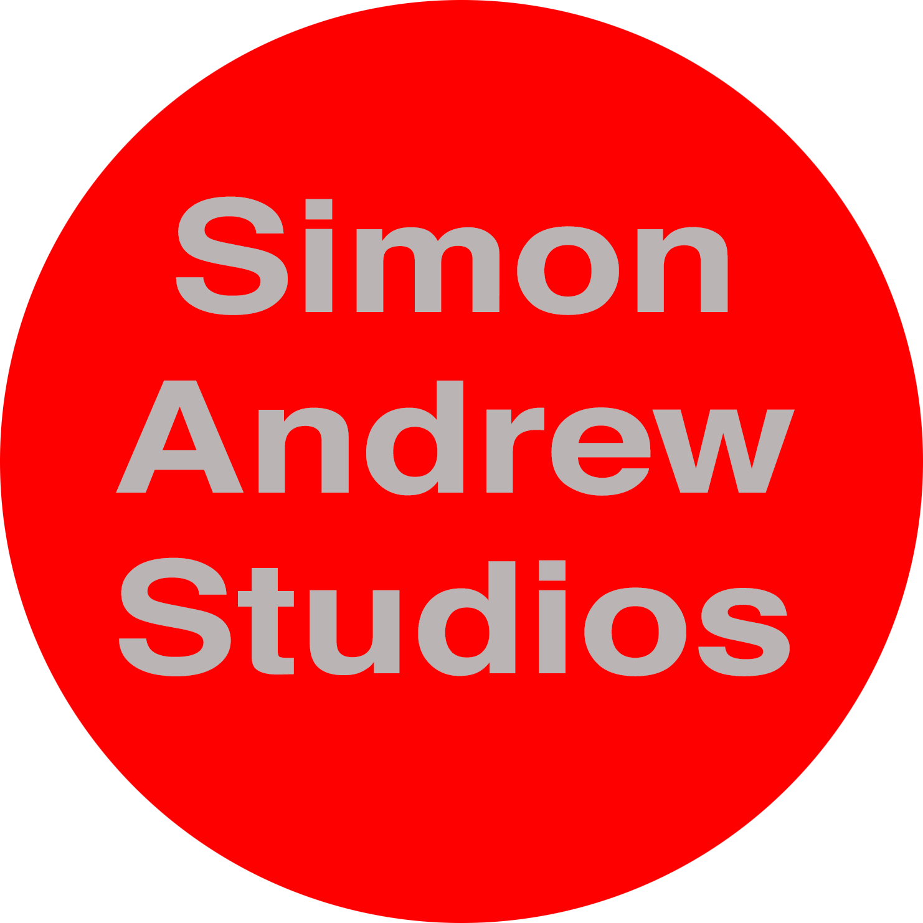

P.O. Box 2121 Kingston Ontario Canada K7L 5J8

Email: studio@simonandrew.com Web: http://www.simonandrew.com/

STATEMENT

When painting, I concern myself with colour relationships, compositional structures and the physicality of the paint. I consider ‘subject’ the framework on which I hang the paint. My work is as much about the medium as the message. Colour is applied in an almost casual manner, other times slabbed on or carefully blended creating a diverse range of marks. Paint is treated as a physical material in its own right. It is a substance of meaning, not merely a vehicle to a desired end.

I try to make my paintings work not just on the macro level but also on the micro. I would like them to contain testing and varied passages of colour in addition to unanticipated compositions. I hope my work does not reveal all it has to say straight away but works on the observer at different levels over time, so that at one moment they might be aware of a colour relationships, the next a compositional quirk, the mood of the work and so on. Ideally it should grow with the observer in an unpredictable way. My paintings are a distilling process. They are often primed with an emotional charge, triggered by an event or a place. The intention is that they should conclude as authentic reconstructed experience.

