KELLEY’S THOUGHTS ON THE WRITING PROCESS . . .
How do you come up with your stories, characters, character names, POV, etc.?
I people-watch and eavesdrop. A lot.
In Death by Diploma, Emma was my college roommate and current friend, and Leslie is one of my closest friends and colleagues from Colorado. The other names are just random ones I pulled out of my…hat.
The storylines can come from anywhere, I guess—news, television, myths. I taught high school English and drama for twenty years, including mythology—one of my favorite classes to teach. You can get a lot of ideas from mythologies and fairy tales, plus it’s SO fun to tell those stories in the classroom.
POV is tough to decide. I experiment with it all the time—the Chalkboard Outlines series is third person attached, but the Foundation series (YA Paranormal) alters between first and third person. And the YA standalone Down in the Belly of the Whale is first person, present tense. I’ve never done second person—maybe that’ll be next!

What do you think makes a good story?
Interesting characters with difficult decisions to make. I like it when I’m constantly asking “why did THAT happen?”; “who the heck is THAT?”; “why did that guy choose THAT path?”; etc. The questions are what keep me reading, and the people in the story make me care what’s going to happen as a result of those questions.

What does it take for you to love a character?
I need to believe their actions are true to their belief system and history.

How do you utilize that when creating your characters?
I ask that question of myself whenever the character decides to do something.

What is your writing routine? Are there things you absolutely need to start writing?
I have a small “office”— AKA a chair—in the corner of my bedroom, complete with laptop and picture of my late father, bookseller extraordinaire. There is a schedule taped to the side of my dresser, laying out chunks of time for each writing project and each social media outlet. Seven days a week!

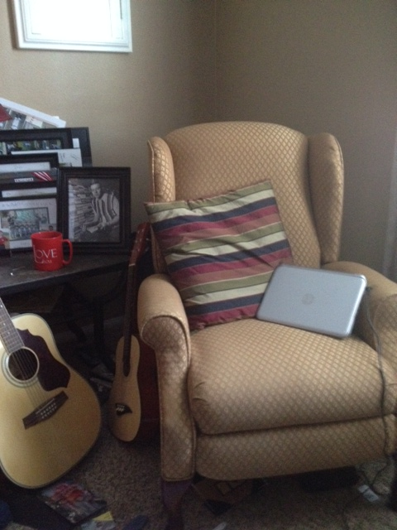

Do you work from an outline?
Ha. I WISH I were organized like that. No, I take whatever my basic story premise is, combine it with whichever characters I pick, and then we’re off to the races. It goes where it wants to. I bought this pretty pink three-ring binder. With pockets. My intention was (is) to have a section and a pocket for each of my characters, with journal entries, magazine pictures, objects, anything that would contribute to my knowledge of the story. Isn’t that a great idea? A mystery writer, Michele Scott, gave me that idea.

It’s still sitting on the shelf next to the computer—pretty, pink, and empty. I’m lucky if I can find pockets of time to do both marketing and writing, much less organizing my life that way.

Can you tell us a little about your writing philosophy?
I don’t know that I have a philosophy, per se. I have a compulsion to write stories or observations which expand upon people and situations. I hope to find an audience who likes the stories, but I will continue writing them no matter what, because if I don’t my head will explode.
What is your writing style? Outliner/planner or seat of the pantser?
My writing style has most definitely been pantser, but I’m in the middle of a book which is neither—instead it’s about tapping in to the brain’s evolutionary REQUIREMENT for story. It’s called Story Genius by Lisa Cron and so far it’s super interesting—I’m excited about implementing elements of this “blueprint” which is neither outlining nor pantsing, and I hope it helps me get better and better, which is always what I’m trying to do…

Can you tell us about your editing process?
I don’t edit anything until the entire first draft is finished. Then I give the manuscript to several beta readers, compile all their comments and ideas, and then dive in to the editing.

Do you listen to music as you write?
I have this recording I picked up at a “Write Your Book in a Weekend” conference. It’s sort of a beach-y, meditative type track with music and ocean sounds—also coyotes howling in the background. I know, right? Coyotes? But it puts me in a mind space that helps the words come out, for sure.

What do you find most challenging about the writing process, and how do you deal with it
I am most challenged by the number of ideas I have in my head and on my plate, and the inability to find enough time to spend on them all. I don’t deal very well with it, I think. I’m trying to just attack one thing at a time, because that’s all anyone can really do, isn’t it? I just wish I did it better.
I feel lucky that dealing with this constant challenge means I don’t really suffer from writer’s block. I have so many projects happening at any given time—right now I’m trying to finish a humorous self-help memoir (you’re right. Not an actual genre. Yet.), I have to change the POV on one YA Paranormal, COMPLETELY overhaul a YA Paranormal that is first in a series, and I need to contine on Chalkboard Outlines® Book Three, which I am
very excited about even though Book Two-Poison by Punctuation, has only been out for a while. So you see? If I get blocked on whatever I’m working on, then BAM, I shift to a different project. It’s nice that I have constant assignments for my magazine job also, because it’s a completely different type of writing, as are my fiction and non-fiction projects. Allows for whatever state my brain is in!
One more challenge—I have MS, have had it since 1994. Two symptoms I have are crushing fatigue, and the pesky problem of my right hand not working so well after a certain amount of activity on the computer or on the paper. Same problem with my left leg (on the street, not on the computer). I deal with those by living my life as a champion napper (I have a scooter, too). At least once a day I have to stop everything and lie down for a while. I did this when I was teaching, too. It’s awesome. I think everyone should do it.

When and where do you do your writing?
This is my office, AKA a chair and a laptop in the corner of my bedroom:

When I first started writing full time, I put a schedule on the wall, AKA the dresser sitting next to this chair, dividing my day between articles for the magazine (I write for nine community magazines here in San Diego), sending queries or proposals for unpublished writing projects, Facebook, Twitter, GoodReads, LinkedIn, blogs, and oh, yes, WRITING. Every day holds a combination of all those things, which are bookmarked by taking my two young sons to and from school and their myriad activities. And trying to have a date with my husband, who
is currently coaching three baseball teams. Someday.
It is an insane schedule, and I remember teaching full time being bonkers too (I taught English and drama for twenty years), but not like this. I love it, though! I’m living the dream.

What have you learned about promoting your books?
I am learning I can’t do it all. I’m trying to find a way to put them and myself out there in a way that is still conducive to me having a writing schedule and a family. I haven’t figured it out yet. I’m just going to do the best I can, in the hopes that my stories also speak for themselves and will make people want to read them.

What are you most proud of as a writer?
I feel like my writing isn’t pretentious. And what I mean by that is that it reflects me, really. I am impulsive and honest and that means not very tactful. If I use big words, it’s because I know them and they are the ones I chose to most accurately reflect what I’m trying to say, not because I want you to be impressed. Of course, it’s fine if you want to be impressed, but that’s not why I chose those words. I am idealistic and optimistic, and while this might never make me a creator of “literary” fiction, what you see is what you get. It comes from my heart and my self, and I am proud of that.

If someone wanted to become a writer, what tips would you give to them?
I would just tell them never to give up, and never stop learning and trying new things. Also, and I cannot emphasize this enough: YOU HAVE TO READ. A LOT. People who tell me they want to write but don’t want to read are delusional and will never succeed. This is true, I believe, in any profession: the more you study and practice, the better you will get. The best musicians listen to all kinds of music and learn about the history of music, the best politicians study all types of governments and policies, and et cetera, et cetera.

Hmph.

I could rant about this for days. You also have to write, a lot, although I don’t subscribe to the theory that says all of the people who say you have to write every day or this many words a day or X number of hours or whatever. You should figure out your own schedule and make sure it includes study and practice.
Oh, and you absolutely have to work on a thick skin. Like, tortoise shell thick. There are always people who have nothing better to do than knock you down, and it takes a long time and many rejections to find your success, but if you take the ones who offer constructive ideas and help and use them, and throw the non-helpful douchebag ideas away, it’ll all help you get better.

