KleenFry Equipment Rental Agreement

THIS RENTAL AGREEMENT (this “Agreement”) dated this ____ day of _______, 20___
BETWEEN:
KleenFry of 127 Estes Parkway Suite 8 Temple, TX 76501
(the “Owner”)
AND
Company Name, Address City, State Zip Code
(the “Renter”)

The Owner hereby rents to Renter all Equipment named and identified in Sections 1 to 3 of this Agreement, for use at such location and at such rental rate for approximately such time as is therein stated. The Owner shall furnish such Equipment, in operative condition. All rentals are subject to the following terms and conditions and Equipment will only be rented to persons over the age of 18.

- RENTAL PERIOD. The Rental Period shall cover all time consumed in transporting the Equipment, including the date of delivery and the date of return. This Rental shall begin on the pick-up date and shall terminate on return in fully working condition to the Owner. If the Equipment has to be repaired to return it to a fully working state, it will continue to be rented until it is repaired. The Rental period will end only when the Equipment has been returned to a fully working state.
- START DATE. The desired starting date submitted with your rental order should be the date of pickup. For equipment delivery, there is a non-refundable $25 delivery fee. Pick-ups can be scheduled Monday – Saturday 6am to 5pm and the office is located at 127 Estes Boulevard Suite 8, Temple, TX 76501.
- RETURN DATE. The Return Date is the date the equipment must be cleaned and returned to KleenFry. If you need KleenFry to pick up the equipment from your location, there is a non-refundable $25 pick-up fee. Returns can be scheduled Monday – Saturday 6am to 5pm and must be made to the KleenFry office located at 127 Estes Boulevard, Suite 8, Temple, TX 76501.
Start Date: ___________________ Return Date: ___________________ Number of Days: ______

- EQUIPMENT/RENTAL RATE. Choose the option best suited for your business needs. (Check one)
☐ - ARM-120 ☐ - Daily: $52.68 ☐ - Weekly: $167.70 ☐ - Monthly: $339.96
☐ - ARM-90 ☐ - Daily: $52.21 ☐ - Weekly: $165.34 ☐ - Monthly: $337.61
☐ - ARM-60 ☐ - Daily: $50.34 ☐ - Weekly: $156.01 ☐ - Monthly: $328.26

ARM-120 RC ($4,952.06), ARM-90 RC ($4,873.23), ARM-60 RC ($4,562.45)

- EQUIPMENT ID. Affixed to the Armadillo Filtration Machine is a unique number that identifies and tracks the location of each piece of Equipment. ________________________

- RENT CHARGES. Renter shall pay rent for the entire Rental Period on Equipment named in Section 2, at the rate set forth herein and the full payment is due upon pick-up or delivery of the Equipment.
- LATE CHARGES. If you do not return the Equipment to KleenFry by the Return Date, you will be charged at the Daily Rate for each day late until returned - up to the cost of replacement.
- NON-SUFFICIENT FUNDS. The Renter shall be charged $35 for each check that is returned to the Owner for lack of sufficient funds.

- RENT PAYMENT. The Renter shall send payments made payable to KleenFry and mailed to 127 Estes Parkway Suite 8 Temple, TX 76501. The following forms of payment are accepted. (Check one)

☐ - Check (Business, Cashier’s, Certified, or Personal) ☐ - Money Order ☐ - (Zelle, ACH) ☐ - Cash

- RESERVATION/DEPOSITS. Please reserve your Equipment as far in advance as possible to ensure availability. We require a deposit equal to 20% of the total rental cost or $25 whichever is greater to hold your reservation. The deposit will be applied to your total charge at the time of pick-up or delivery.
- CANCELLATIONS. If you cancel your order in writing within 7 days before the scheduled Start Date, no fees will be charged, otherwise, your deposit will be forfeited.

- LOSS OR DAMAGE. The Renter assumes all risk of loss or damage to the Equipment from any cause, with the exception of normal wear and tear. The Owner shall have the option of requiring the Renter to either repair the Equipment to a state of good working order or to replace the Equipment with like equipment and in equal condition.

- CLEANING. All Equipment must be returned dry and free of oil and debris. The presence of oil or debris will result in a cleaning charge of no less than $25 per item.

- ASSIGNMENT. The Renter shall not assign or sublet any interest in this Rental or the Equipment or permit the Equipment to be used by anyone other than the Renter or Renter’s employees that are Authorized Operators as provided in Section 16 of this Agreement.

- INDEMNITY. Renter shall indemnify the Owner, its agents, and employees against and hold harmless from, any claims, actions, suits, proceedings, costs, expenses, damages, and liabilities, including attorney’s fees, arising out of, connected with, or resulting from the Equipment or the Agreement, including without limitation, the manufacture, selection, delivery, leasing, renting, control, possession, use, operation, maintenance or return of the Equipment. Renter shall further indemnify Owner and hold harmless from all loss and damage to the Equipment during the Rental Period. Renter recognizes and agrees that included in this indemnity clause, but not by way of limitation, is Renter’s assumption of any liability for injury: disability and death of workmen and other persons caused by the operation, use, control, handling, or transportation of the Equipment during the Rental Period.

- GOVERNING LAW. This Agreement shall be construed and governed in accordance with the laws in the State of TEXAS.

- ENTIRE AGREEMENT AND MODIFICATION. This Agreement, including any exhibits attached hereto and made a part hereof, constitutes the entire Agreement between Lessor and Lessee concerning the subject matter hereof. This Agreement supersedes any prior agreements, representations, or dealings between the Parties. No modification or amendment of this Agreement shall be effective unless in writing and signed by both Parties.

- DELIVERY/PICKUP OF EQUIPMENT. The Renter’s delivery address for the Equipment at the start of the Rental Term: __________________________________________________. The Equipment shall be located at this location and remain during the term of this Agreement, and shall not be removed from that location without the Owner’s prior written consent.

- ACCEPTANCE OF EQUIPMENT. The Renter shall use the attached Exhibit “B” to inspect each item and part of the Equipment upon delivery and under this Agreement. The Renter shall have twenty-four (24) hours from the delivery date to inform the Owner of any discrepancies. If the Renter places the rented Equipment in service, the Renter acknowledges, by that act, that the Equipment complies with the Renter’s specifications.

- OPERATION AND MAINTENANCE. The Renter promises to operate the Equipment only in the normal and ordinary course of business, and not in violation of any law, rule, regulation, statute, or ordinance. The Owner shall be solely responsible for providing maintenance and repairs, except as otherwise provided in Section 16 below, including all labor and parts that may be required to keep the Equipment in good operating condition continuously.

- AUTHORIZED OPERATOR: Before installation of the Equipment, the Renter agrees to identify to the Owner at least two employees or agents that will be available for training and instruction on the proper operation of the Equipment by the Owner at the time of installation of the Equipment (following completion of such training, each such employee or agent shall be an “Authorized Operator”). The Renter shall notify the Owner as soon as reasonably practicable if an Authorized Operator leaves the employ or agency of the Renter. In such event, Renter and Owner shall make arrangements for an additional training session to replace such Authorized Operators. Renter shall not allow any other employees or agents of Lessee, other than the Authorized Operators, to operate or handle the Equipment at any time. Renter shall reimburse Owner for any required repairs to the Equipment due to damages caused by improper or negligent operation of the Equipment by Renter’s employees or agents and promises to indemnify and hold Owner harmless from and against any other damages or injuries caused by such improper or negligent operation of the Equipment by employees or agents.

Employee 1: _____________________________________________________

Employee 2: _____________________________________________________

- TITLE TO EQUIPMENT. The Equipment is, and shall at all times be and remain, the sole and exclusive property of KleenFry; and the Renter shall have no right, title or interest therein or thereto except as expressly set forth in this Agreement.

- DEFAULT. Any of the following shall constitute a default under this Agreement: (1) Failure of Payment. The failure of the Renter to make a required payment; (2) Violation of Agreement. The violation of any provision of this Agreement that is not corrected within five (5) business days after written notice has been received; (3) Bankruptcy. The insolvency or bankruptcy of the Renter; and (4) Seizure. The subjection of any of the Renter’s property to any levy, seizure, assignment, application, or sale for or by any creditor or government agency.

- RIGHTS UNDER DEFAULT. If the Renter defaults on any of the obligations of this Agreement, the Owner may immediately, without notice or demand, take possession of the Equipment. To repossess the Equipment, the Owner is entitled to enter any premises where the Equipment is located.

- RETURN OF PROPERTY ON TERMINATION. The Renter will promptly return the Equipment to the Owner in the condition received at the end of the term as specified in this Agreement. The Equipment must be returned to the Owner at the location designated by the Owner. Additional charges shall be added in the event the Equipment is damaged, missing any parts, or returned later than Date: ______________ and Time: _________. All charges shall commence from the Effective Date of this Agreement. The Renter shall pay the Owner an additional service charge of $25 per day for each day the Equipment has not been returned. The Owner shall invoice the client on a timely basis and all invoices are due upon receipt. If the Equipment is not returned for any reason, the Renter shall pay the Owner the Replacement Cost of the Equipment.

- ENTIRE AGREEMENT. This Agreement, including any exhibits attached hereto and made a part hereof, constitutes the entire Agreement between Owner and Renter concerning the subject matter hereof. This Agreement supersedes any prior agreements, representations, or dealings between the Parties. No modification or amendment of this Agreement shall be effective unless in writing and signed by both Parties.

- NOTICES: All notices, consents, waivers, or other communications, except invoices, required under this Agreement shall be in writing and mailed certified return receipt requested, postage prepaid, or delivered by overnight delivery service to:

Owner: KleenFry c/o Glen E. Williamson Jr.
Address: 127 Estes Parkway Suite 8 Temple, TX 76501
Renter: ____________________________
Address: ___________________________________

IN WITNESS WHEREOF, the Parties hereto have executed this Equipment Lease Agreement by a duly authorized representative effective as of the date set forth at the top of this Agreement.

Owner:
Company Name: Osgood Investments LLC, DBA KleenFry
Title: _________________________________________
Print Name: ___________________________________
Signature: ____________________________________
Date: ________________________________________

Renter:
Company Name: ________________________________
Title: _________________________________________
Print Name: ___________________________________
Signature: ____________________________________
Date: ________________________________________

Exhibit B Equipment Checklist
Note: This checklist is intended to help you inspect each part of the Equipment upon delivery. It is to be filled out immediately to ensure you have all parts accounted for. You shall have twenty-four (24) hours from the delivery date to inform the Lessor of any discrepancies.
Section 1 – Client Information
Company: ____________________________________ Location: ____________________________________

Contact Name: ________________________________ Contact Phone: _______________________________

Section 2 - Check the Type of Equipment Inspecting
☐ 120lb Armadillo Filter Machine ☐ 90lb Armadillo Filter Machine ☐ 60lb Armadillo Filter Machine
Model #: _________________________ Serial #: _________________________

Section 3 - Mark as Directed Below
• Place a check (√) mark in the Outcome box to indicate inspection is complete and satisfactory.
• Mark “M” in the Outcome box where an item is missing.
• Mark “D” in the Outcome box where an item is damaged.
• Report all items in need of repair to the Supervisor at the time of inspection.
Photo |  |  | Inspection Item | Quantity | Outcome
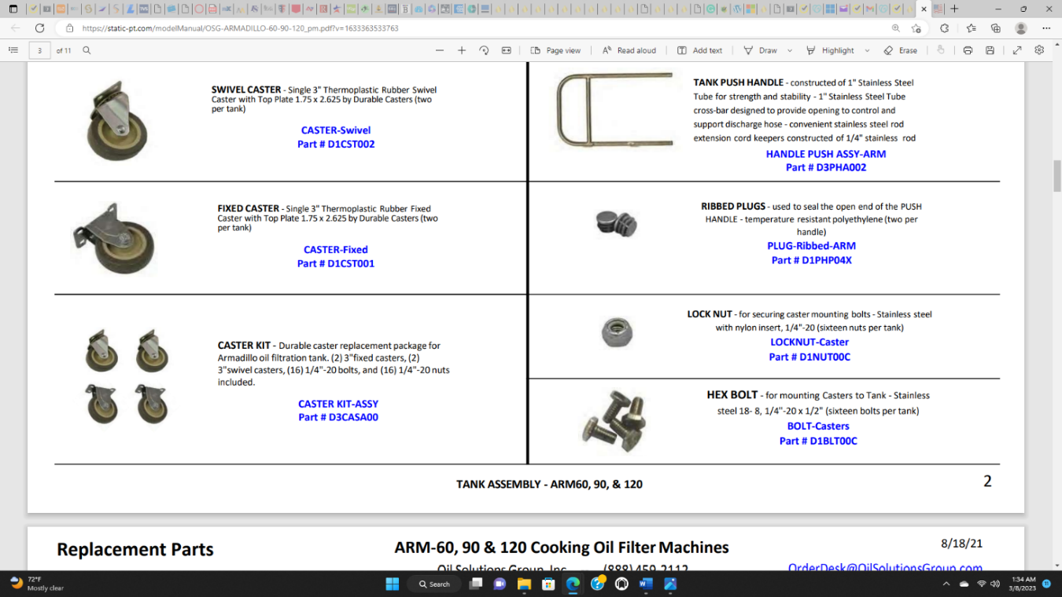 |  |  | Caster Fixed | 2
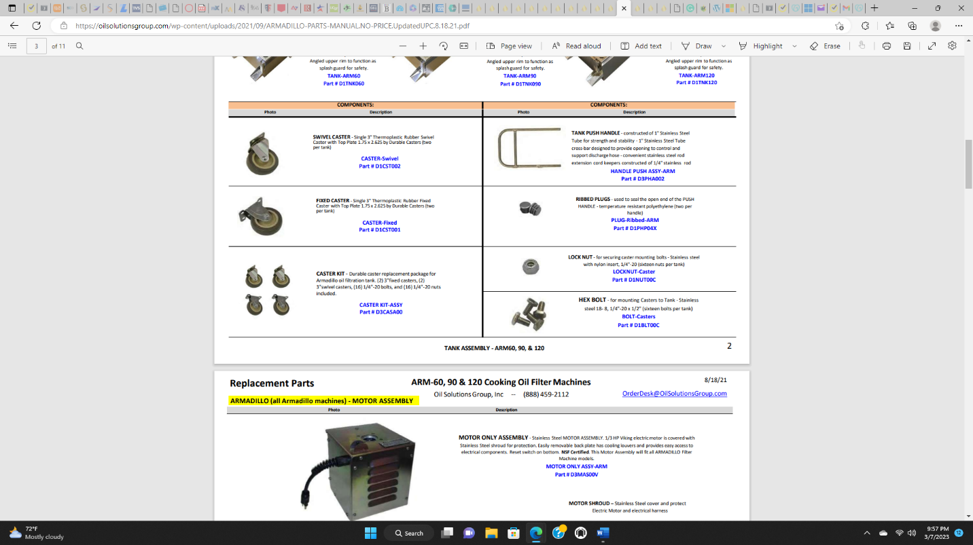 |  |  | Caster Swivel | 2
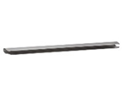 |  |  | CLIP 14” | 1
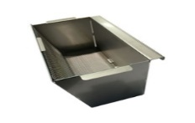 |  |  | CRUMB BASKET | 1
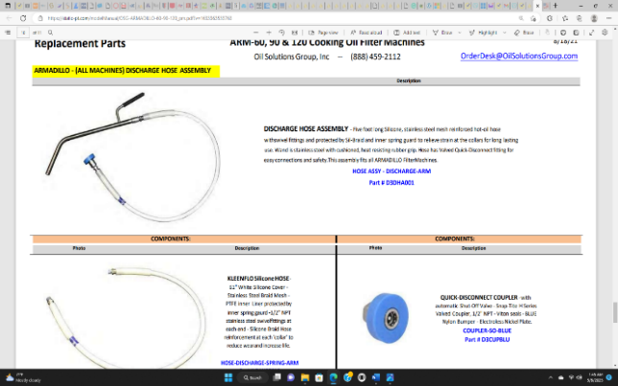 |  |  | DISCHARGE HOSE ASSEMBLY | 1
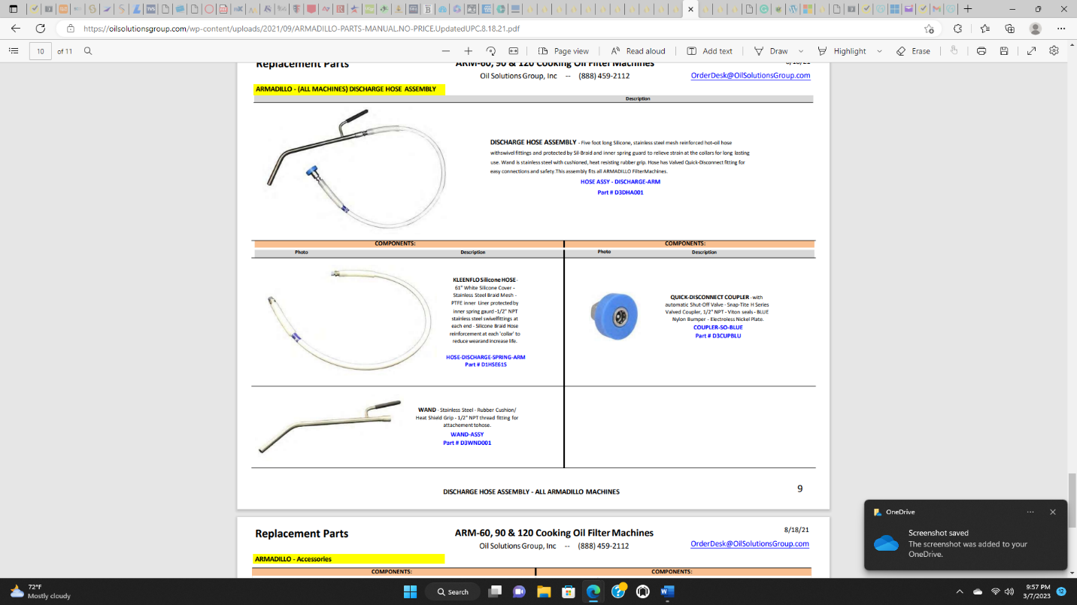 | COMPONENT |  | WAND with GRIP | 1
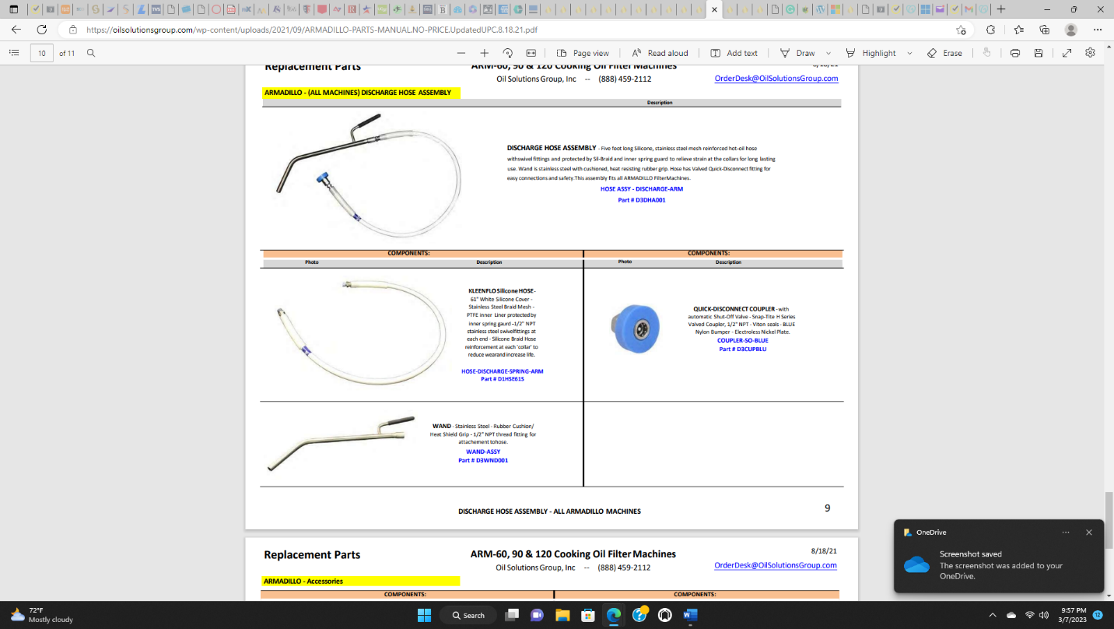 | COMPONENT |  | QUICK-DISCONNECT COUPLER-BLUE | 1
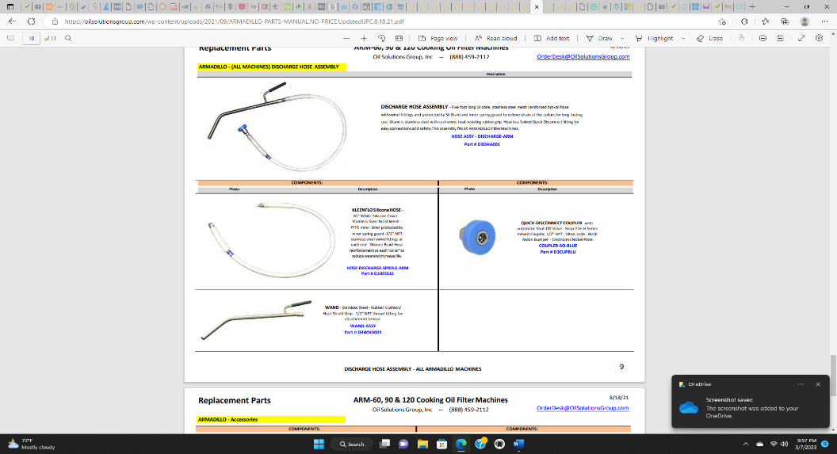 | COMPONENT |  | KLEENFLO SILICONE HOSE | 1
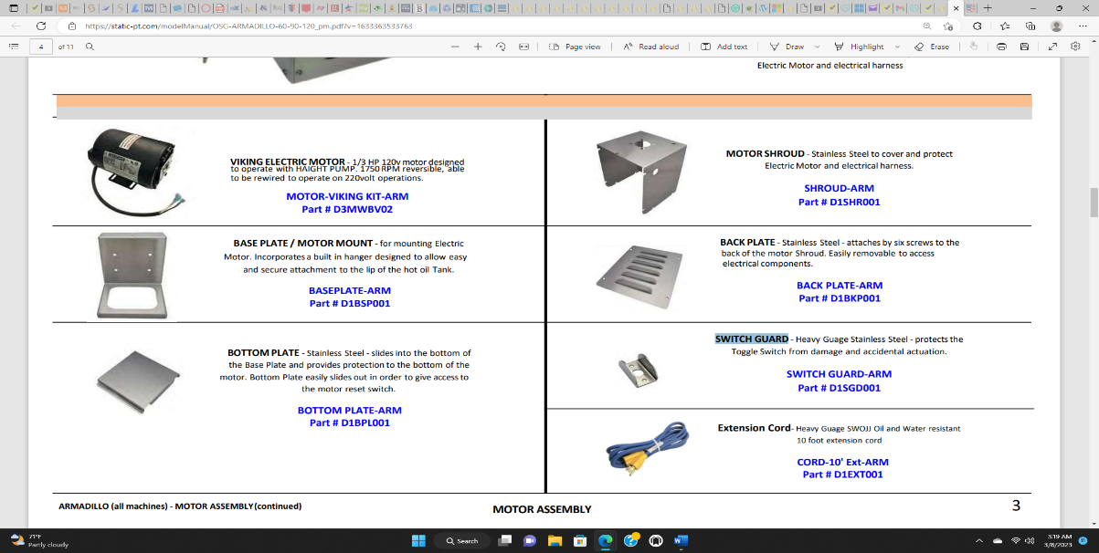 | COMPONENT |  | BACKPLATE | 1
Photo |  |  | Inspection Item | Quantity | Outcome
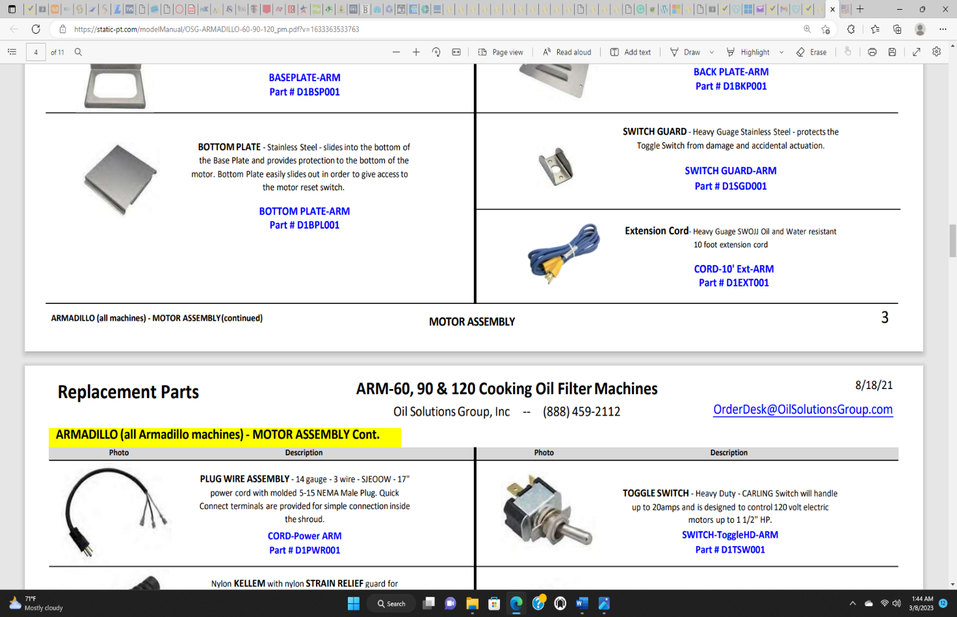 |  |  | EXTENSION CORD | 1 |  |  | Quantity | Outcome
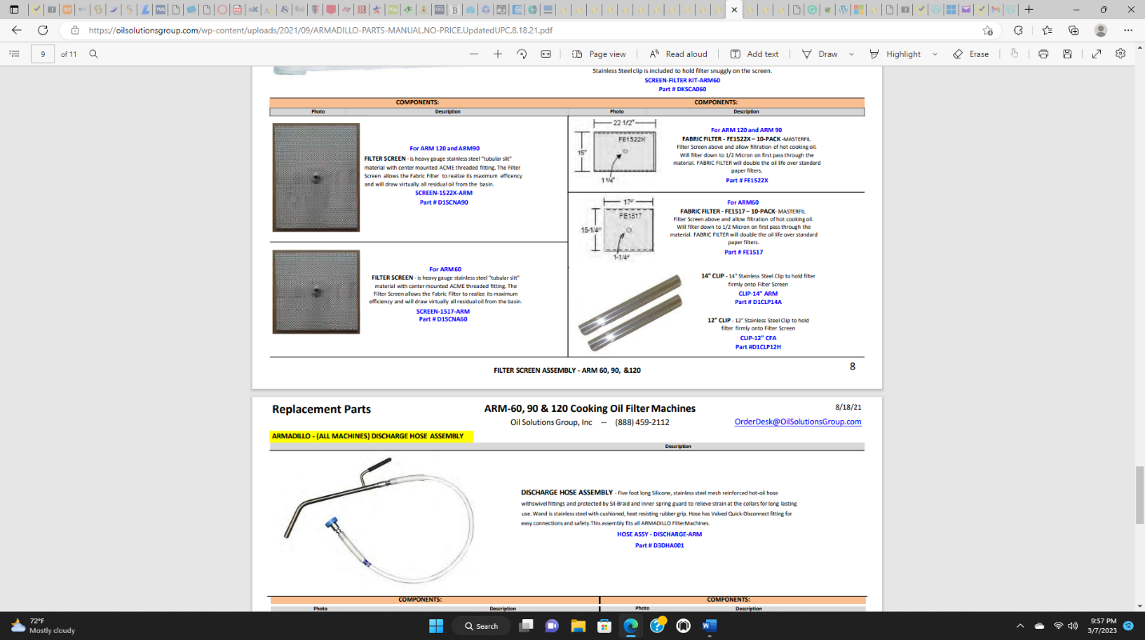 |  |  | FILTER SCREEN FOR ARM-60 | 1
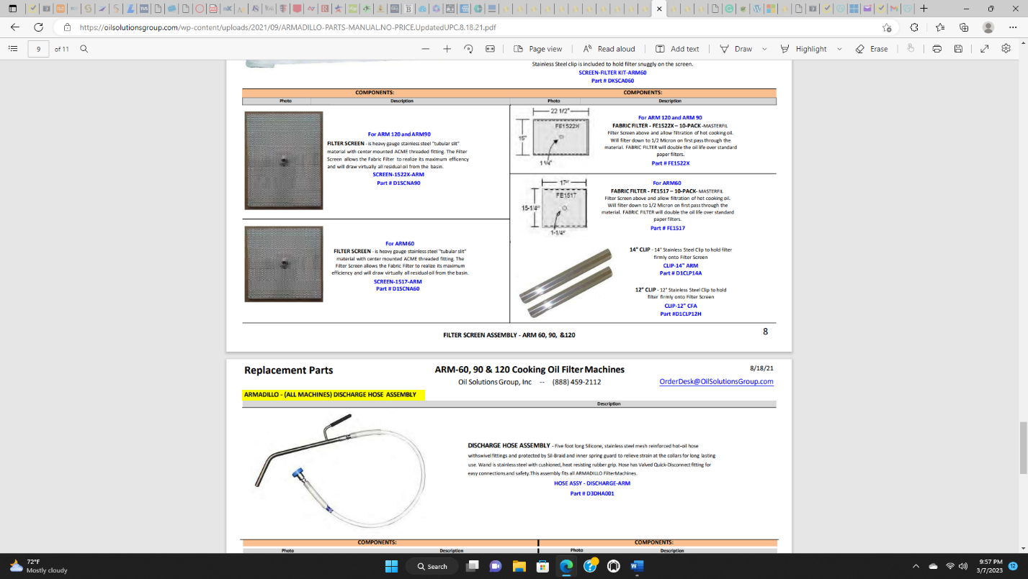 |  |  | FILTER SCREEN FOR ARM-120 AND ARM-90 | 1
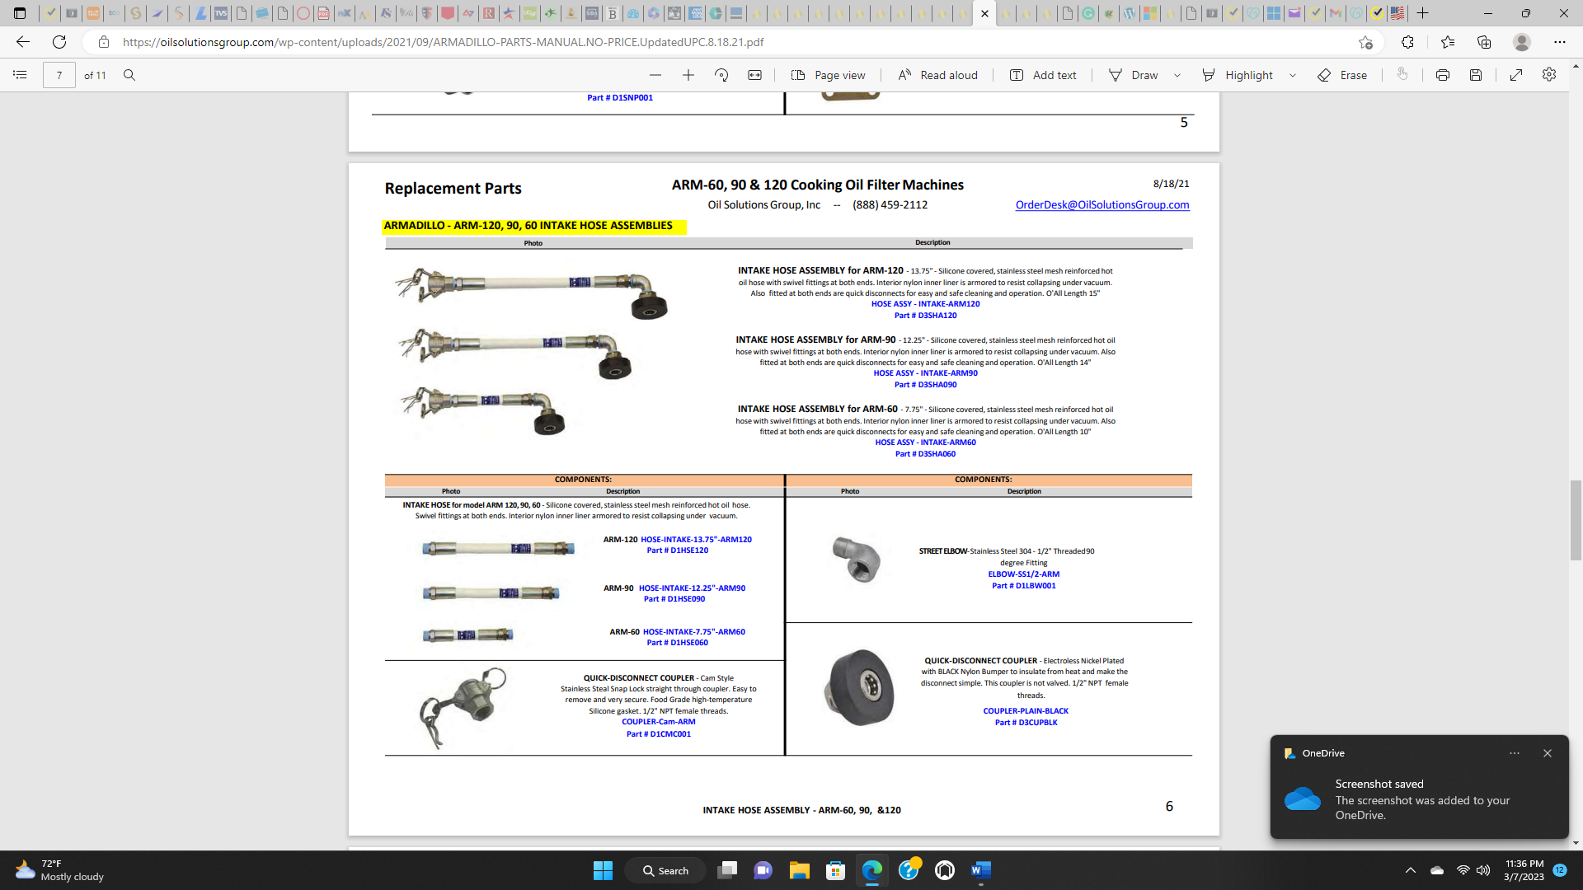 |  |  | INTAKE HOSE ASSEMBLY | 1
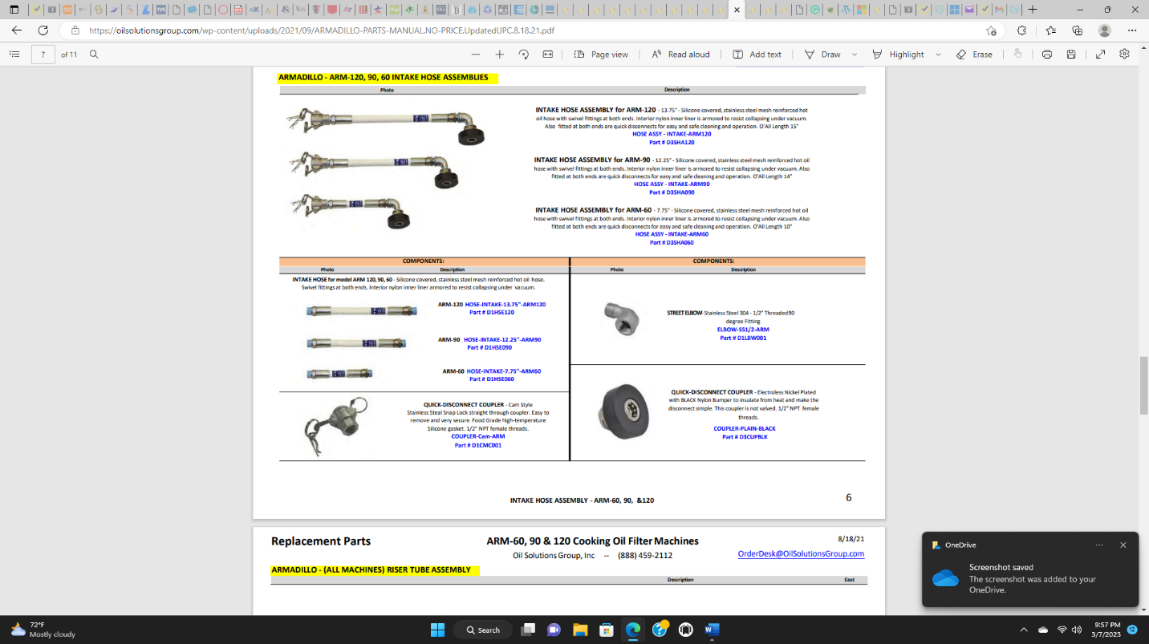 |  | COMPONENT | QUICK-DISCONNECT COUPLER-CAM | 1
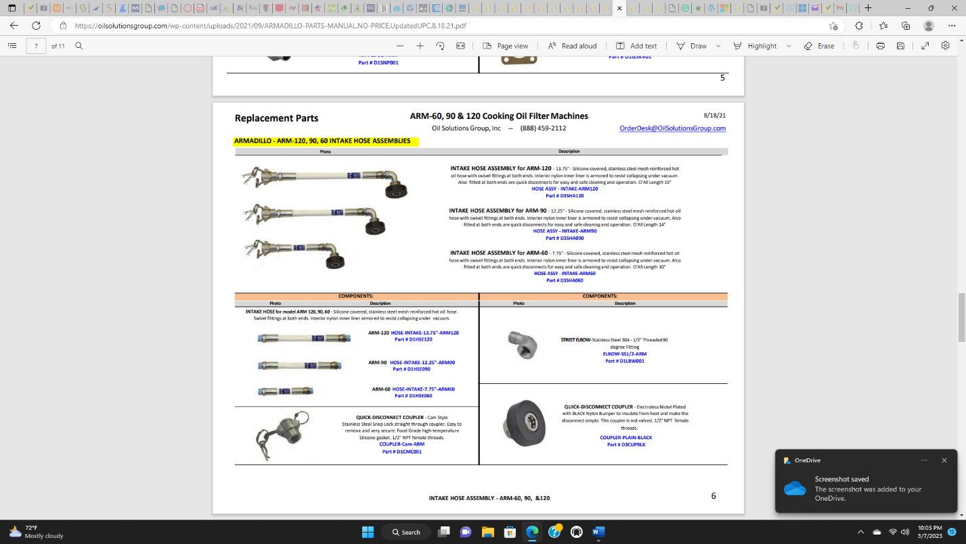 |  | COMPONENT | INTAKE HOSE | 1
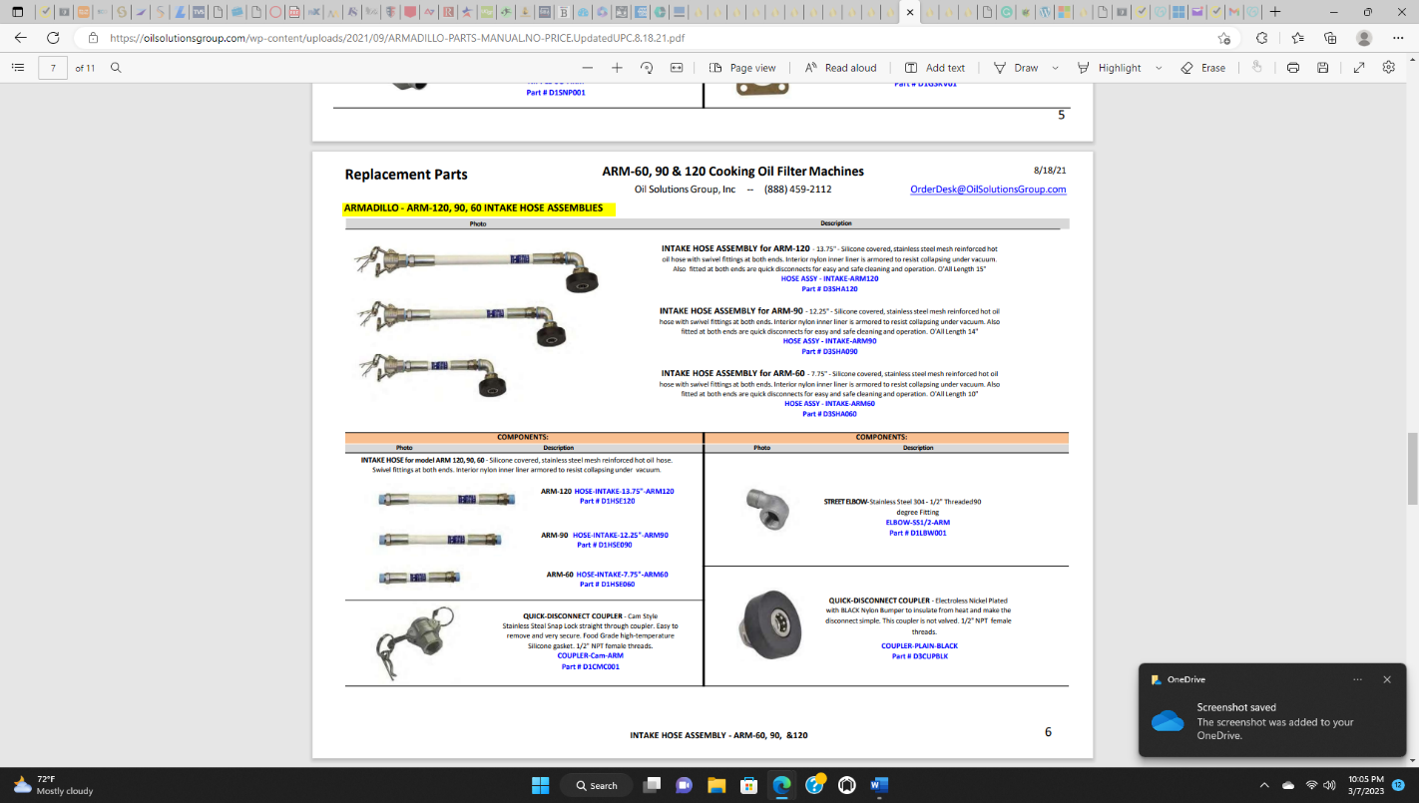 |  | COMPONENT | STREET ELBOW | 1
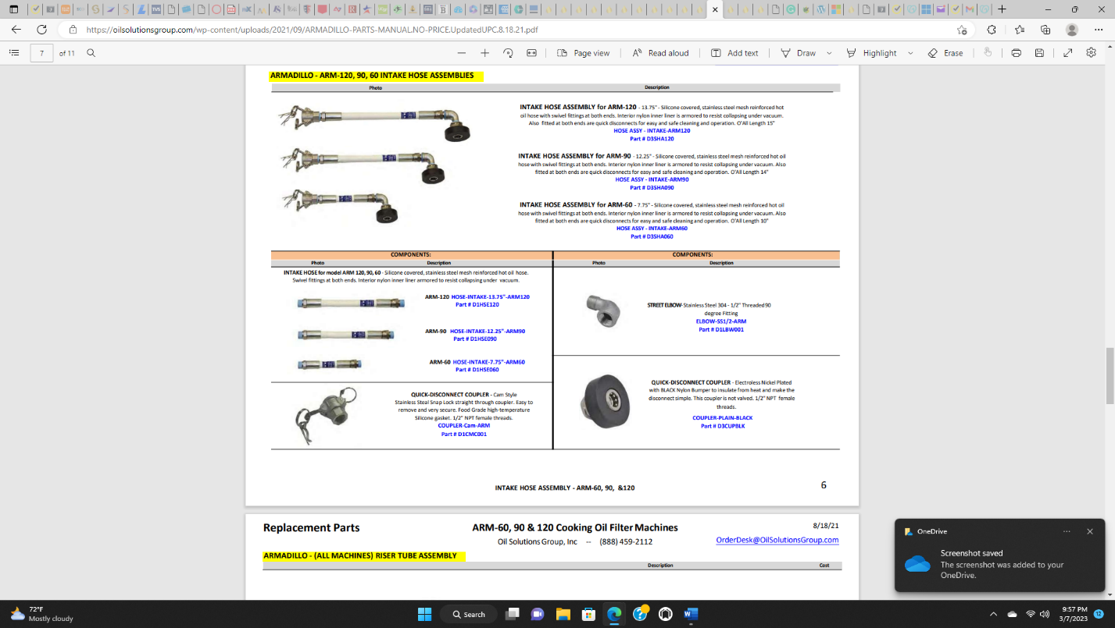 |  | COMPONENT | QUICK-DISCONNECT COUPLER-BLACK | 1
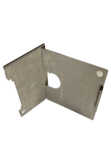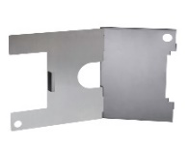 |  |  | LID - TWO PIECES  60LB or 90/120LB | 1
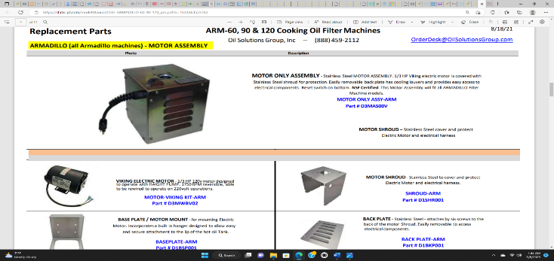 |  |  | MOTOR ASSEMBLY | 1
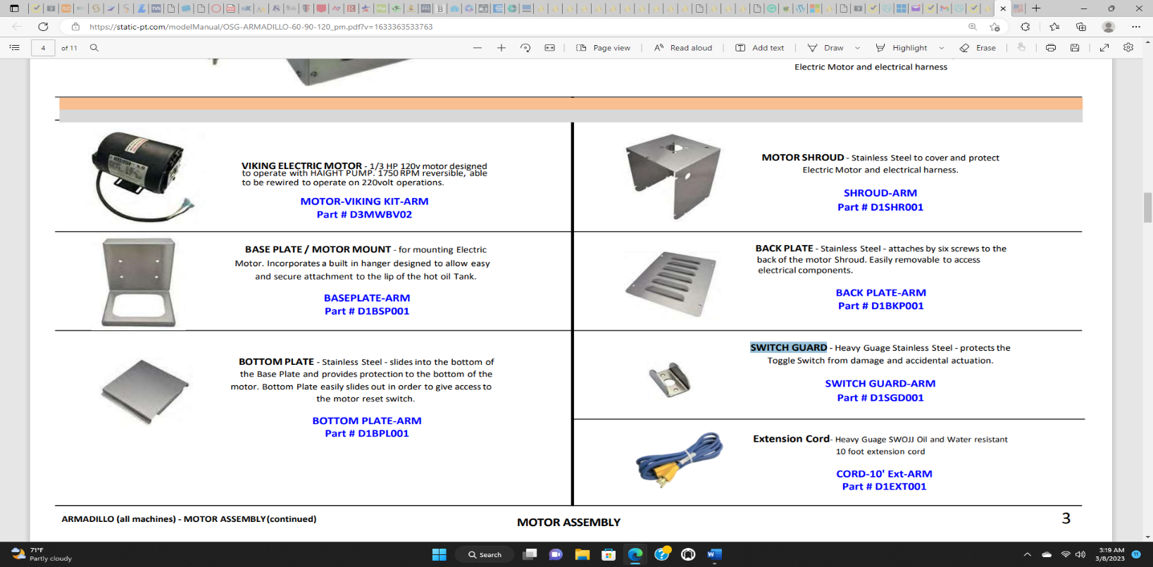 | COMPONENT |  | VIKING ELECTRIC MOTOR | 1
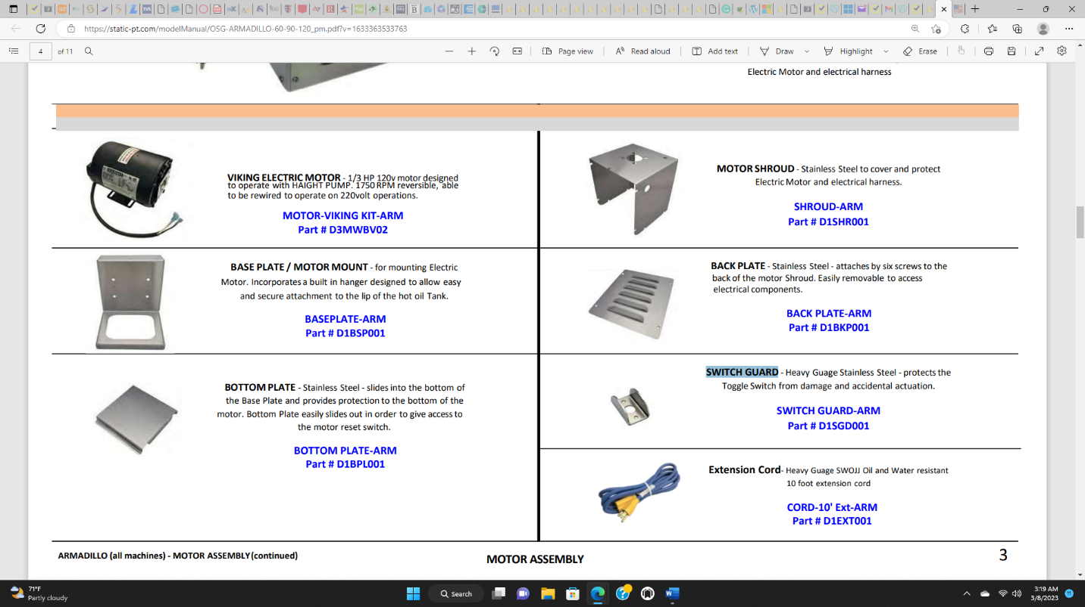 | COMPONENT |  | BASE PLATE / MOTOR MOUNT | 1
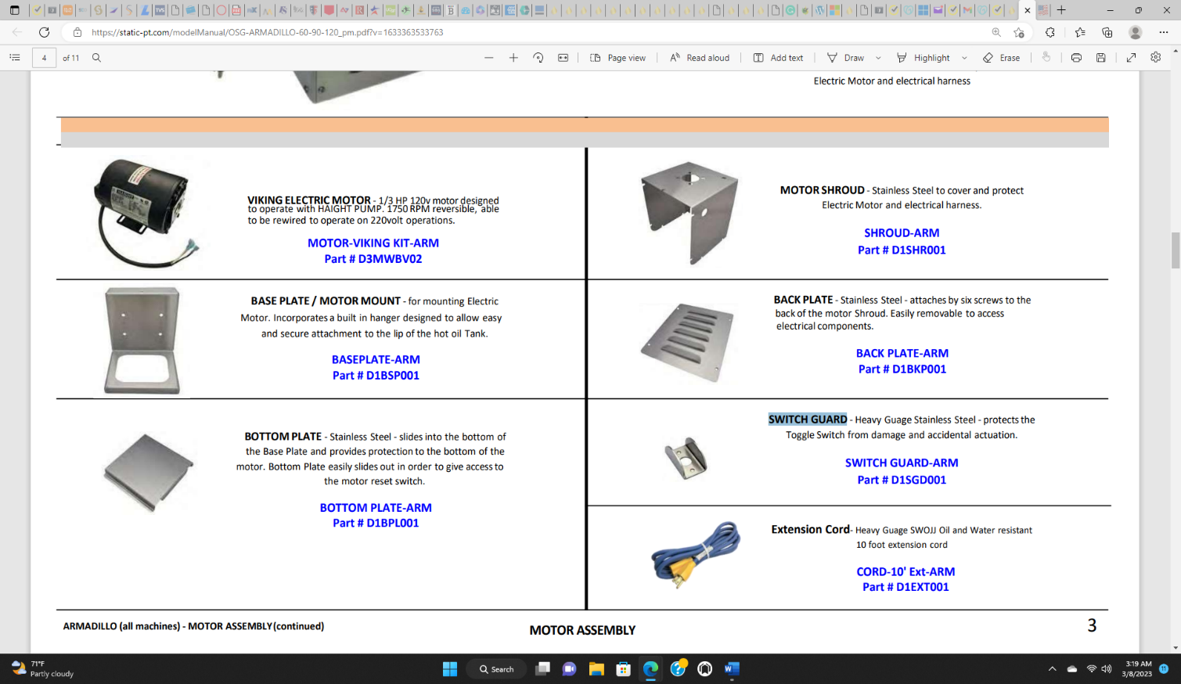 | COMPONENT |  | BOTTOM PLATE | 1
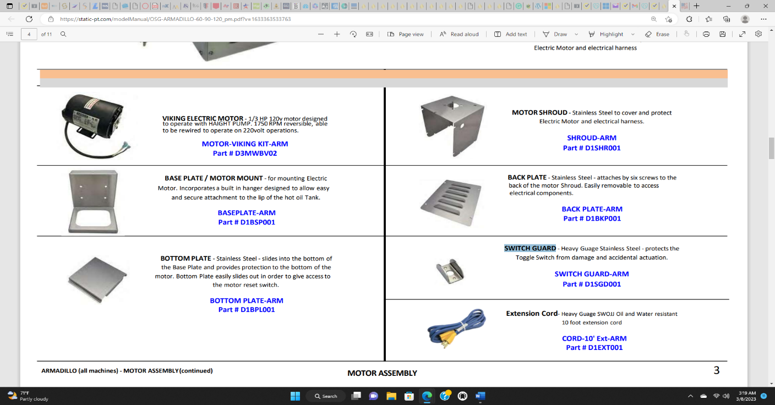 | COMPONENT |  | MOTOR SHROUD | 1
Photo |  |  | Inspection Item | Quantity | Outcome
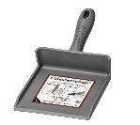 | COMPONENT |  | MasterScoop | 1
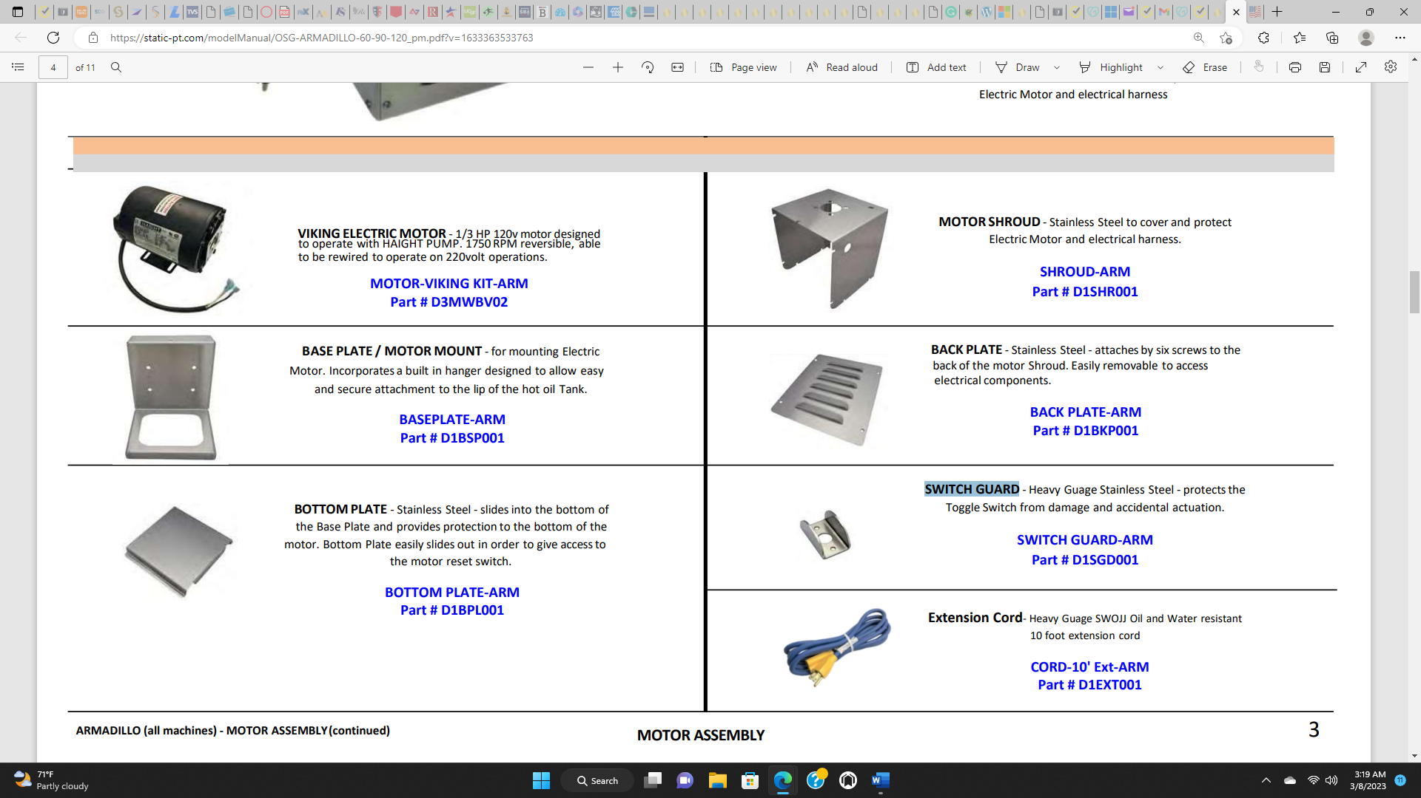 | COMPONENT |  | SWITCH GUARD | 1
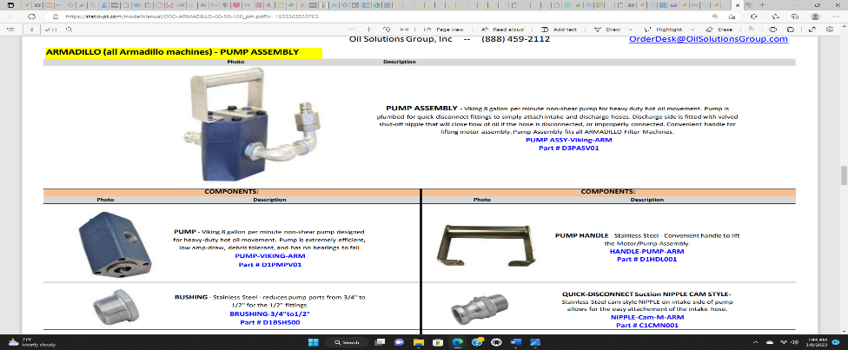 |  |  | PUMP ASSEMBLY | 1
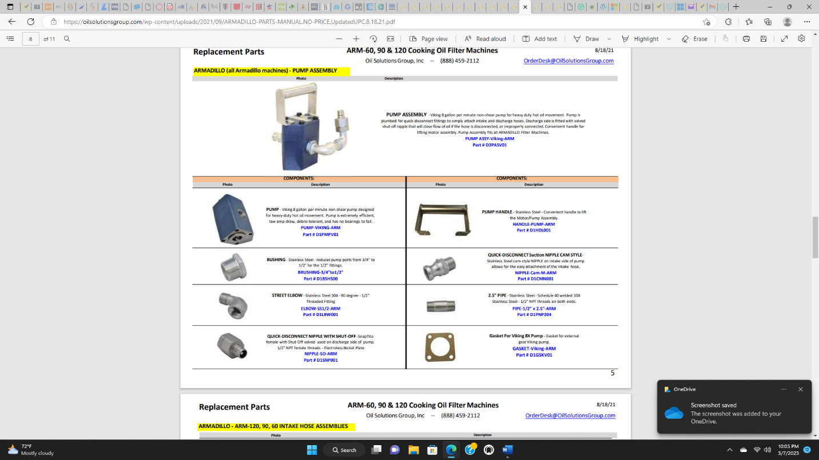 | COMPONENT |  | VIKING PUMP | 1
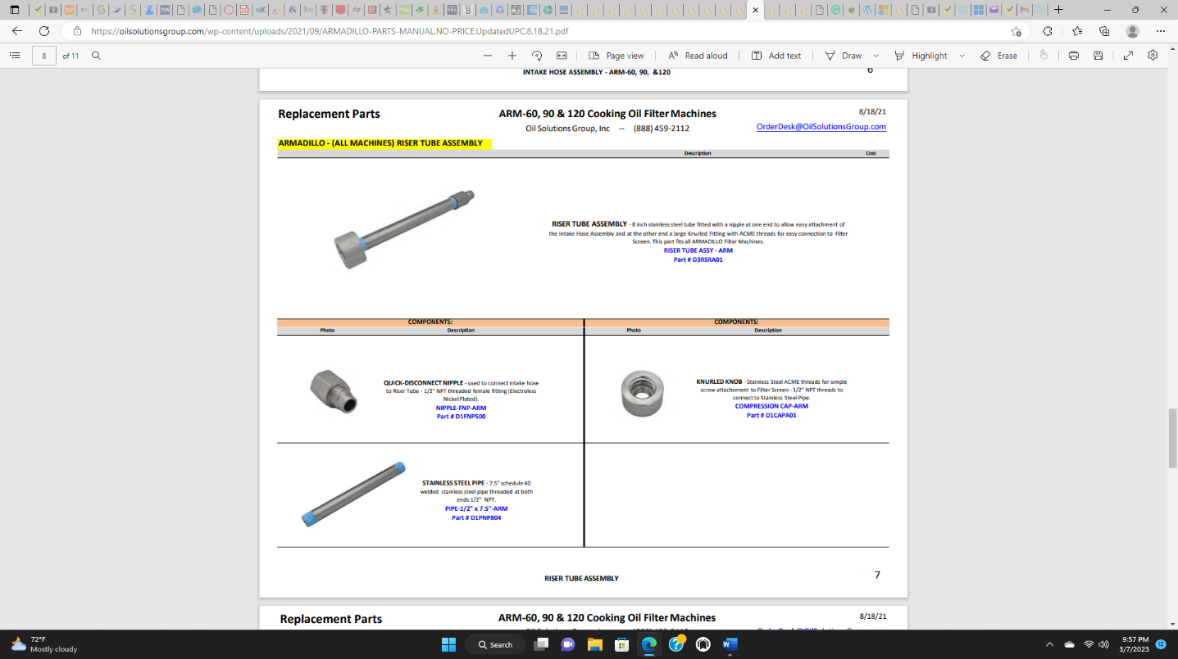 | COMPONENT |  | QUICK-DISCONNECT NIPPLE with SHUT-OFF | 1
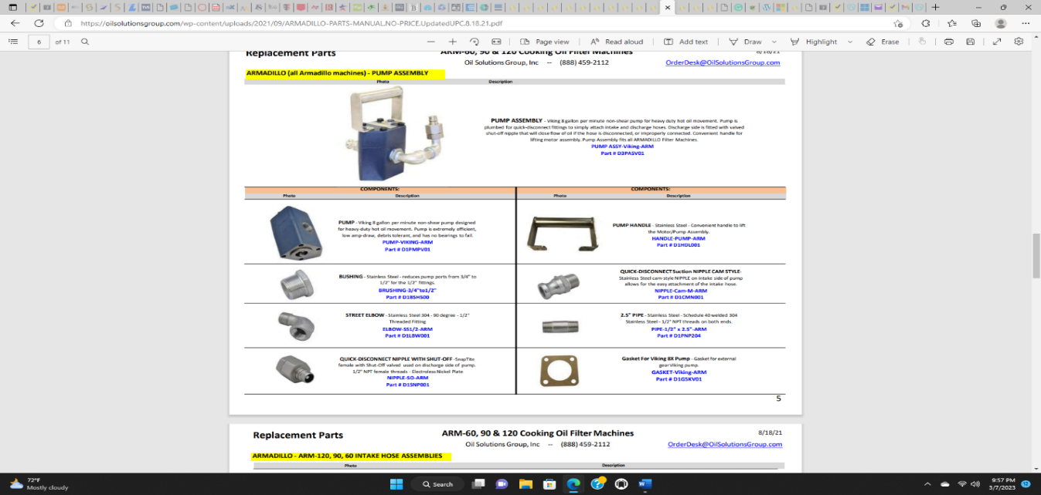 | COMPONENT |  | PUMP HANDLE | 1
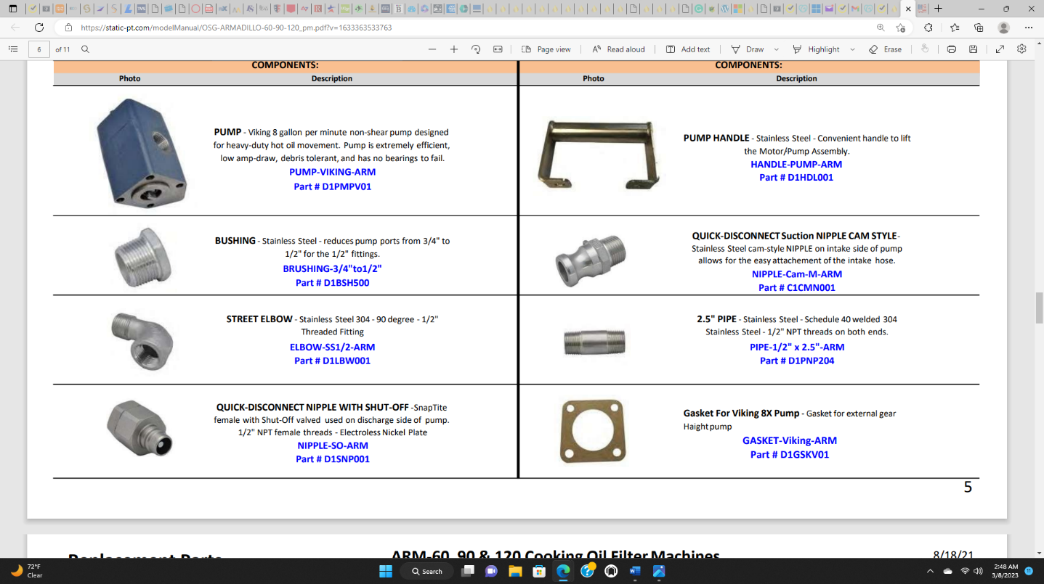 | COMPONENT |  | BUSHING | 1
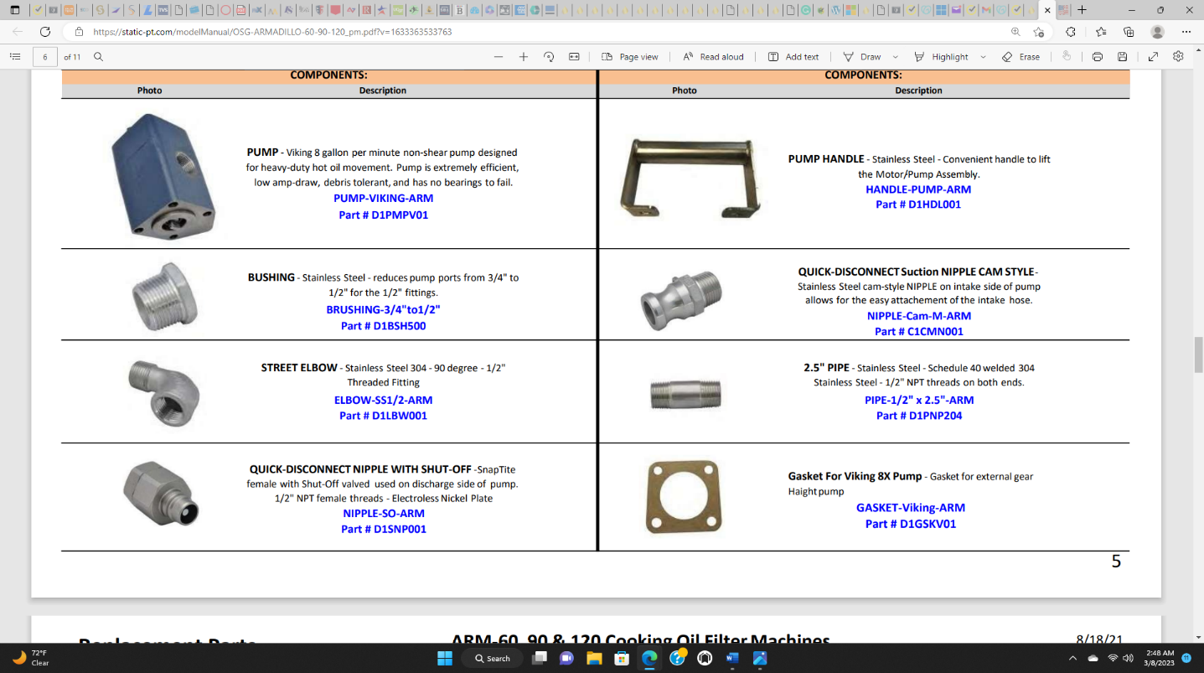 | COMPONENT |  | STREET ELBOW | 1
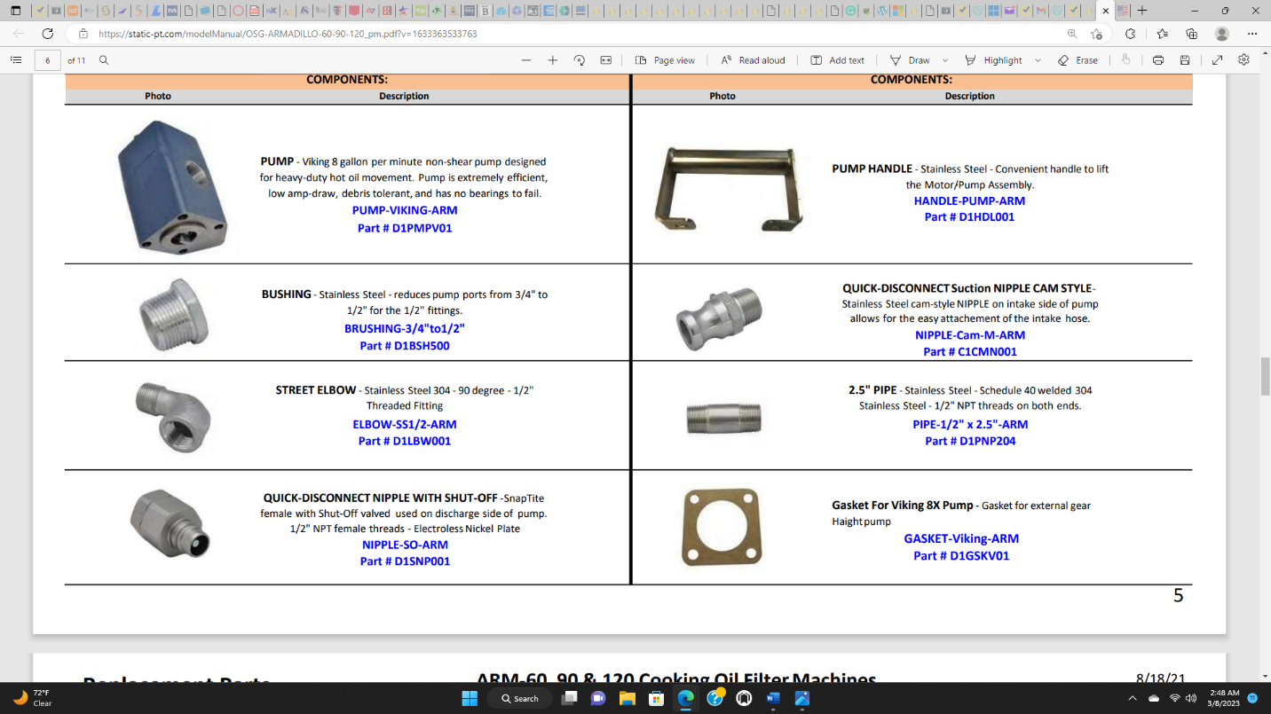 | COMPONENT |  | QUICK‐DISCONNECT Suction NIPPLE CAM STYLE | 1
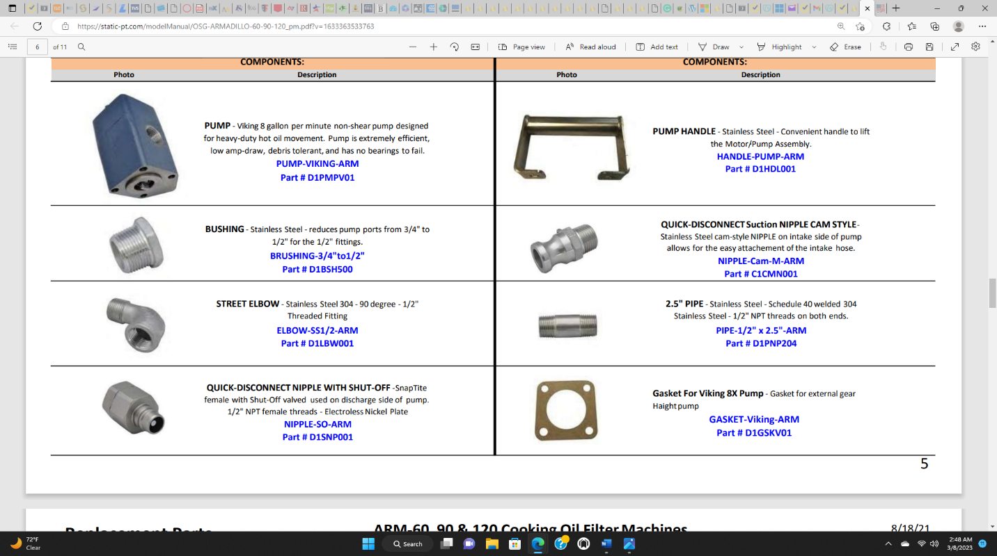 | COMPONENT |  | 2.5" PIPE | 1
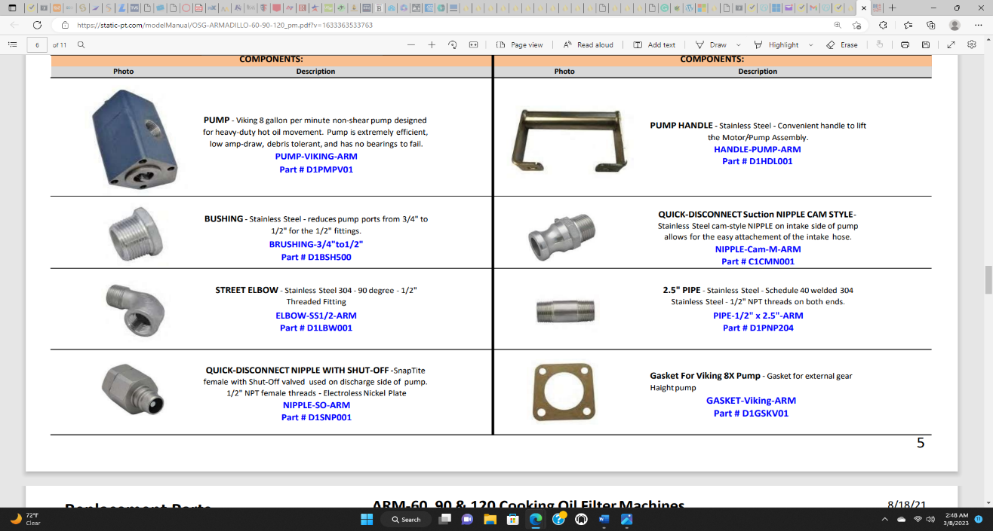 | COMPONENT |  | GASKET | 1
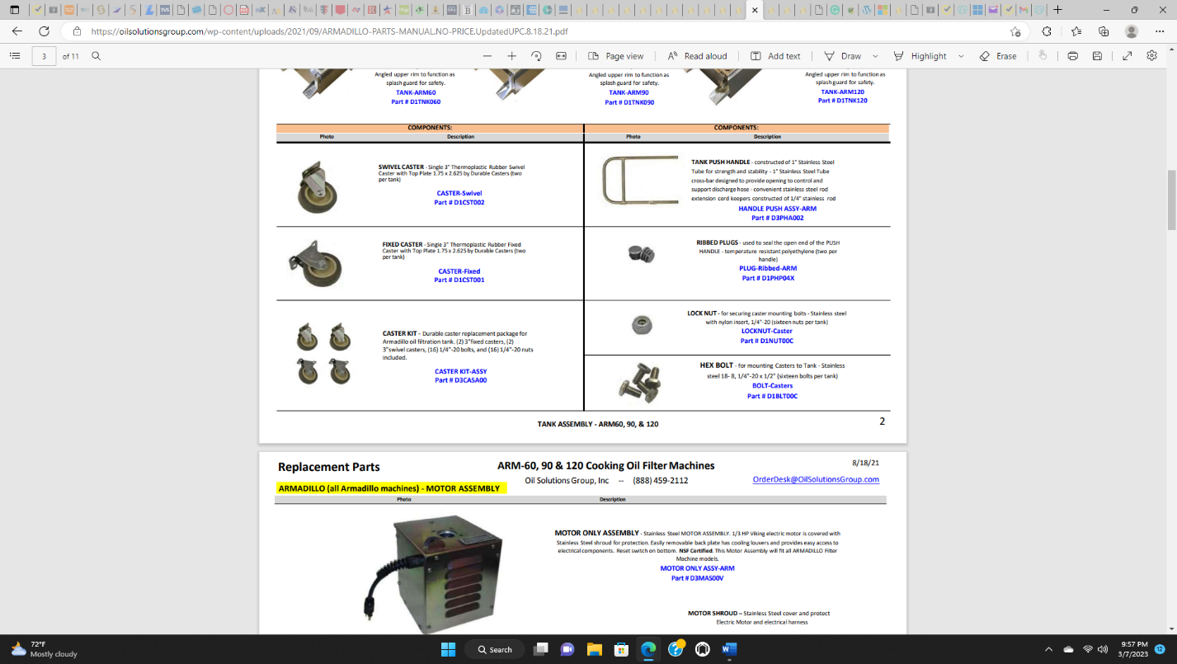 |  |  | PUSH HANDLE WITH POWER CORD KEEPER | 1
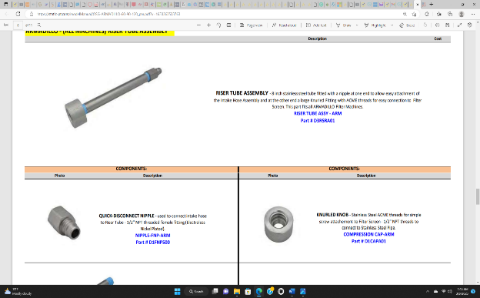 |  |  | RISER TUBE ASSEMBLY | 1
 | COMPONENT |  | QUICK‐DISCONNECT NIPPLE | 1
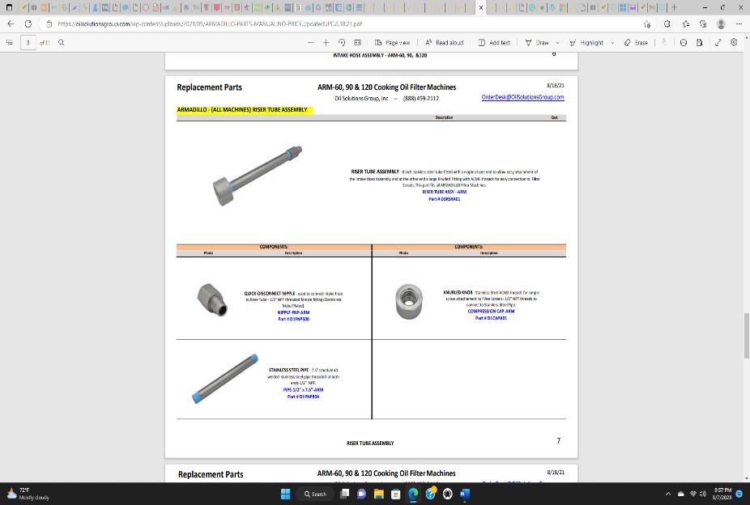 | COMPONENT |  | STAINLESS STEEL PIPE | 1
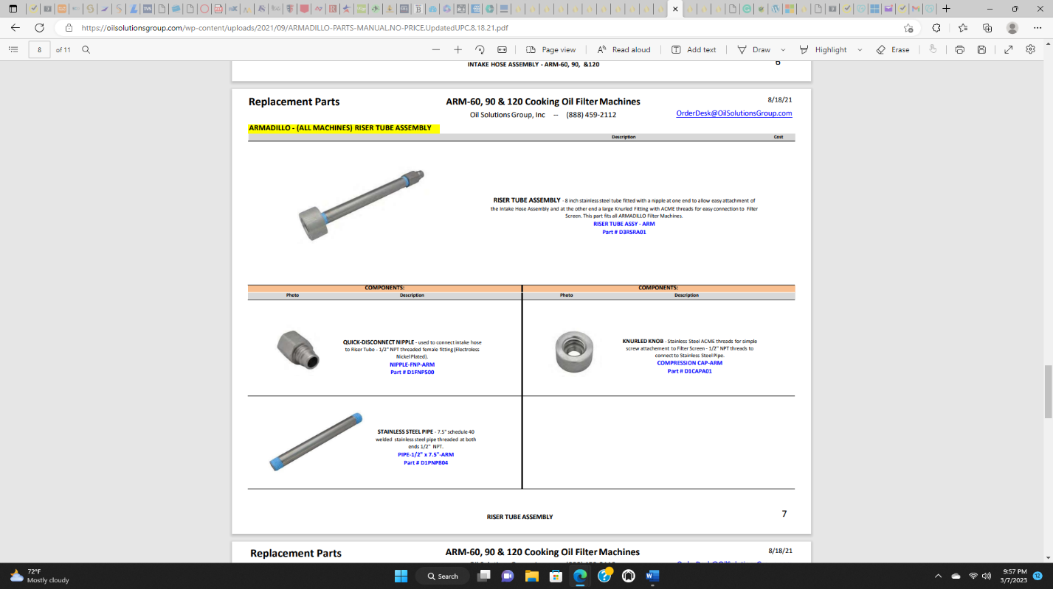 | COMPONENT |  | KNURLED KNOB | 1
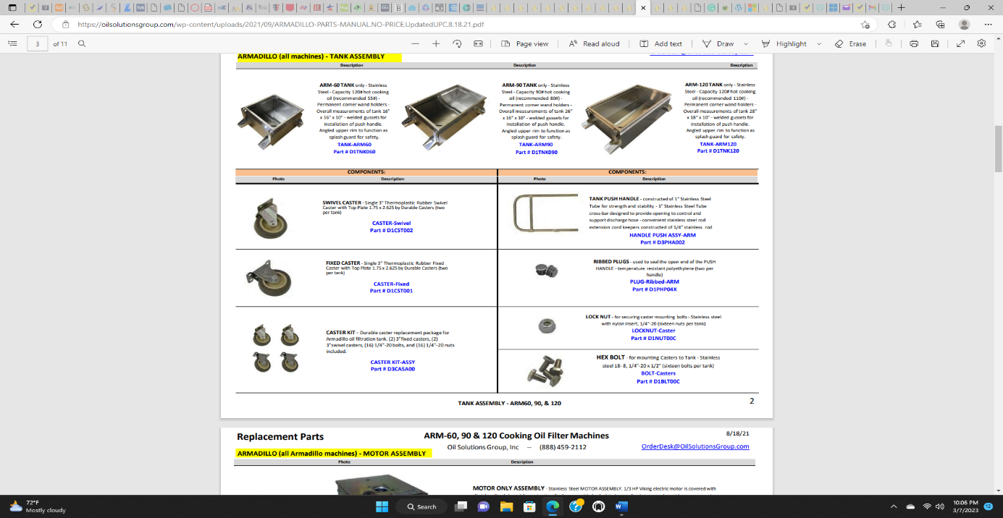 |  |  | TANK  60LB, 90LB or 120LB | 1

