 |  | THE LRIA NEWS
OFFICIAL NEWSLETTER of the LOCH RAVEN IMPROVEMENT ASSOCIATION, INC. WINTER 2018
Community Association Meetings  The Loch Raven Improvement Association meets the third Tuesday of every month, with the exception of  August and December.  Upcoming Meetings:  January 16th, 2018  February 20th, 2018  March 20th, 2018  Good Samaritan Hospital  Parker Conference  Rooms 3 and 4  7:00pm  All Residents Welcome  Christmas Tree Collection  The Dept. of Public Works will offer curbside tree collection through January 31st, 2018  Residents should set out trees on their regularly scheduled trash collection day at the same location where trash is collected.  Please remove all tinsel and ornaments prior to setting out.  And please, DO NOT place Christmas trees in the medians!  Business and correspondence to:  LRIA  P.O. Box 66226  Baltimore, MD 21239  410-435-5577  THELOCHRAVENIMPROVEMENT  ASSOCIATION @hotmail.com  www.LRIA.org | Happy New Year from the LRIA!  The Loch Raven Improvement Association continues our mission to maintain a stable, safe, and clean neighborhood in the New Year. We strongly believe that we have one of the finest neighborhoods in Baltimore City, but we also realize that there is still more work to be done.  As we enter 2018, the LRIA encourages all residents to get more involved in YOUR community by paying your dues, attending meetings, joining committees, and becoming active participants in making our neighborhood better.  With your help, the LRIA intends to significantly improve our membership base, continue the momentum for increased safety of our citizens, and to aggressively address and eliminate dilapidated housing conditions in our area.  Please join us in the New Year, in order that we may continue to preserve our great Loch Raven Improvement Association neighborhood.
 | Neighborhood News
SANTA’S HOLIDAY RIDE-AROUND
The LRIA thanks Santa, his elves, and the Cold Spring Lane Fire Engine Company for touring our neighborhood and spreading holiday cheer to our neighbors on December 22nd. Residents enjoyed the event and particularly appreciated the candy cane treats that were distributed. We hope to repeat the event next year with more volunteer participants.
LRIA / YORKWOOD STUDENT SAFETY INITIATIVE
In a continuing effort to protect our school children at the intersection of Hillen Road and Waveworth Way, the LRIA has requested the re-activation of the speed camera at 5800 Hillen Road. In addition, the Association has requested that Yorkwood Elementary School be placed on the priority list with the Safe Routes to Schools Program, in order that a flashing light be installed and activated during school hours to further calm the speeding traffic along this corridor.
CRIME UPDATES
Year-end police reports indicate that our area is experiencing an increase in burglary. All LRIA residents are encouraged to please be aware of odd behavior and suspicious activity in our neighborhood. If you observe persons knocking on doors to determine if anyone is home, strangers in your neighbor’s yard, or individuals frequenting areas where they should not be, please pick up the phone and call 911 immediately. You know who belongs and who doesn’t… please help keep our neighborhood safe!
IDLING VEHICLES
We understand that temperatures have dropped, but please do not leave your vehicle running unattended with keys in the ignition. Not only does this activity increase the chances of your vehicle being stolen, but you may also receive a significant fine and points on your driving record.
ILLEGAL PLACEMENT OF CONES, CHAIRS ETC. IN THE PUBLIC RIGHT-OF-WAY
After many attempts at requesting assistance from the Baltimore City Department of Transportation to address the illegal placement of objects in the street to reserve parking spaces, the Department has responded that this issue is unimportant. The LRIA is appalled by this response and asks that if any resident encounters problematic issues with obstacles in the street that prevent you and yours from legally parking, to please file a complaint by calling the Mayor’s Office at 410-396-4900. Similarly, if you are encountering confrontations with neighbors who are placing these objects in the street, please call the Baltimore Police at 911 immediately.

Blue Water Baltimore  a non-profit greening organization, is committed to increasing the tree canopy in Baltimore City.  The Loch Raven Improvement Association area has been tentatively selected for new tree plantings along the 1500 & 1600 blocks E. Belvedere Avenue (hospital side). Discussions will resume in Spring 2018.    SMOKE ALARMS  SAVE LIVES!  Call 311 to request a  FREE  SMOKE DETECTOR  Your call will be transferred to the Baltimore City Fire Department, who will make arrangements for installation in your home.  For more information, please visit:  fire.baltimorecity.gov  CODE BLUE ALERT  Code Blue is a multi-agency effort to reduce hypothermia deaths during the winter months by protecting our City’s homeless, seniors and other vulnerable populations.  Please call 311 to report specific concerns about vulnerable neighbors during Code Blue Alerts.  Call 911 to report a  cold-related emergency.  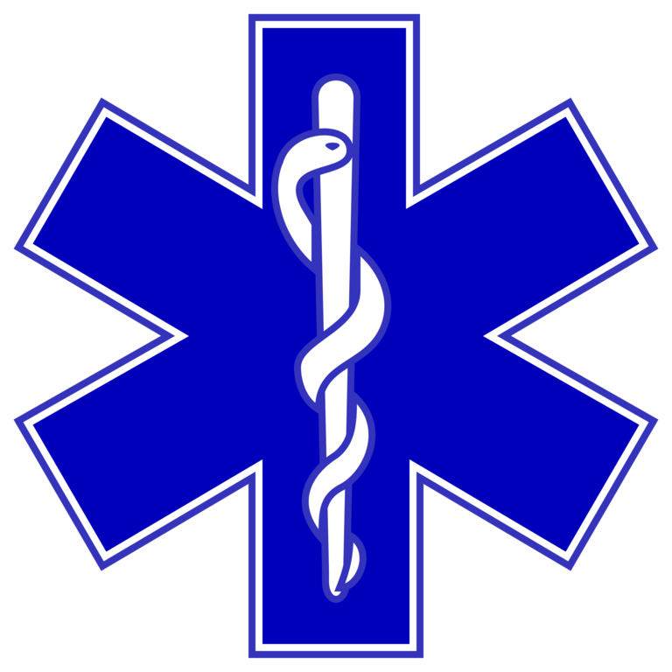  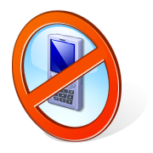 | Community Reminders  - It’s winter and roads may be slippery. SLOW DOWN! Speeding and aggressive driving put lives and property at risk. Stay off of your cell phone and stop texting while driving. It’s illegal AND dangerous!  - DON’T PILE SNOW IN THE MIDDLE OF THE STREET! This activity impedes the flow of traffic, especially for emergency vehicles that may be enroute to YOUR house! It is also every household’s responsibility to prevent slips, trips and falls by shoveling and salting your walkway.  - We love our pets, but please CLEAN UP AFTER YOUR ANIMAL! All dogs should be properly leashed while in public and dogs should not be allowed to continuously bark to disturb the peace.  - Illegally parked vehicles continue to tarnish the image of our neighborhood. Residents are encouraged to immediately notify 311 of all illegal parking issues, to include double-parking, vehicles blocking the alley, vehicles parked in the wrong direction of traffic flow, vehicles parked over 48hrs without being moved, derelict vehicles without valid tags, and commercial vehicles parked in a residential neighborhood .  - If you are engaged in the sale, use, distribution, storage, or transport of illegal substances, the LRIA will report all such activity to the Baltimore Police Drug Unit for investigation. We ask all residents to get involved as well, by calling 911 to report these illegal activities. You may remain anonymous!  - Do your part in keeping our neighborhood clean at all times. Please pick up trash from your property, including the front AND rear of your home, curbsides, and alleyways. Remember, all trash MUST be in cans with tight-fitting lids, or face a citation! It is also every household’s responsibility to remove your cans from the alley after trash collection. Non-compliance may also result in a citation being issued.
 | 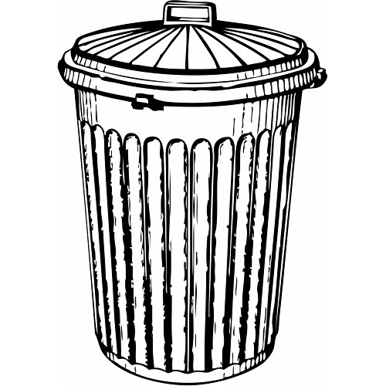  Other Notes  2018 BALTIMORE YOUTHWORKS APPLICATIONS NOW BEING ACCEPTED  Baltimore City's YouthWorks summer jobs program will match young people between the ages of 14 and 21 to five-week work experiences with non-profit, government, and private-sector employers. Get a head start… Online Applications being accepted starting Jan. 2, 2018. Please visit http://youthworks.oedworks.com for more information.  NORTHEAST DISTRICT COMMUNITY COUNCIL MEETING  Wednesday, January 17, 7pm, Northeast District Police Headquarters, 1900 Argonne Drive  This is an open, public meeting, relating to overall public safety in the northeast district… all interested parties are welcome.  DR. MARTIN LUTHER KING, JR. PARADE  The parade commemorates the life of civil rights leader and icon Dr. Martin Luther King, Jr. on Monday, January 15, 2018 at noon. The parade steps off at the intersection of Martin Luther King, Jr. Boulevard and Eutaw Street, proceeds south on Martin Luther King, Jr. Boulevard and disbands at Baltimore Street. Spectators are invited to view the parade from along the route or near the reviewing stand at Martin Luther King, Jr. Boulevard and Franklin Street. | 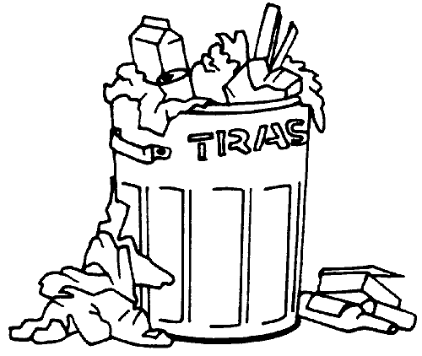  = CORRECT  = CITATION $$$

