 |  | THE LRIA NEWS
OFFICIAL NEWSLETTER of the LOCH RAVEN IMPROVEMENT ASSOCIATION, INC. FALL EDITION 2018
Business and correspondence to:  LRIA  P.O. Box 66226  Baltimore, MD 21239  410-435-5577  THELOCHRAVENIMPROVEMENT  ASSOCIATION @hotmail.com  www.LRIA.org  Community Association Meetings  The Loch Raven Improvement Association meets the third Tuesday of every month, with the exception of  August and December.  Upcoming Meetings:  September 18th, 2018  October 16th, 2018  November 20th, 2018  Good Samaritan Hospital  Parker Conference  Rooms 3 and 4  7:00pm  All Residents Welcome  In Memoriam and Tribute to:  Corey Curbeam  Loch Raven Improvement Association, Inc.  Executive Board Member  Corey was a well-respected, unselfish gentleman who worked diligently to ensure that all residents in our district were able to enjoy a safe, clean, and strong neighborhood.  Thank you, Corey, for your many years of service to your community.  You WILL be missed.  THANK YOU  - - - - - - - - - - - - - - - - - - - - - - - - - - - - - - - - - - - - - - - - - - - - - - - cut here - - - - - - - - - - - - - - - - - - - - - - - - - - - - - - - - - - - - - - - - - - - - - - - -  LRIA MEMBERSHIP FORM  * Please submit this form with your $20.00 membership payment at the LRIA General Meeting  or forward by U.S. Mail to:  LRIA, P.O. Box 66226, Baltimore, MD 21239  Name:  Membership Renewal? Y N or First-time Membership? Y N  Mailing Address:  Phone / Email: | 2018-2019 MEMBERSHIP DRIVE CONTINUES ARRIVED!  The Loch Raven Improvement Association extends a sincere “Thank You” to all community residents who have supported our efforts to sustain and improve the quality of life in our neighborhood. By submitting your dues, you have shown a vested interest in helping to preserve property values, promote high standards of cleanliness, address illegal activity and questionable zoning issues, and maintain an area that we regard as one of Baltimore’s Best neighborhoods.  The LRIA is a self-sustaining, non-profit organization and relies on membership dues as a primary method to generate funds. All funds are fully reinvested back into the community and used to offset operating expenses to include, but not limited to:  - Maintaining a community newsletter and website  - Promoting and stimulating community beautification projects  - Sponsoring community engagement and social events  - Providing a telephone hotline and postal lockbox  If you haven’t already, please complete the bottom portion of this newsletter and forward, along with your $20.00 annual membership dues, to the LRIA either by mail or at any community meeting, and help us continue our unwavering mission toward a neighborhood that is safe, clean, and strong.  THANK YOU AND WE APPRECIATE YOUR CONTINUED SUPPORT!
COMMUNITY NEWS

- The LRIA is experiencing an uptick in criminal activity in our neighborhood. While we know that many of these crimes are not random, we are aware of specific hotspots within our community that appears to be gravitating toward the criminal element. Rest assured, the LRIA is taking this matter seriously and is diligently collaborating with the Baltimore Police Department, the States Attorney’s Office, and the offices of our elected officials, for short-term and long-term strategies to address this issue. The LRIA is also in communication with BGE and the Department of Transportation to upgrade lighting in several areas, which are well-known hang-outs for derelict individuals.
Meanwhile, however, we need residents to GET INVOLVED! Residents are encouraged to be vigilant against all illegal activity in our area, to include individuals attempting to burglarize, individuals pulling on car handles, loitering of suspicious individuals, illegal gambling, illegal drug distribution, and strange vehicles in areas where they should not be. Also, please protect our kids… If you observe adults suspiciously approaching school-aged children, please do not hesitate to notify authorities. PLEASE CALL 911 FOR ALL CRIMINAL ACTIVITY!
- Residents are encouraged to be vigilant of illegal dumping activities along the entire Loch Raven Boulevard corridor and in the center median of the 2000 block E. Belvedere Avenue. Since this activity seems to be occurring in the late evening hours, we need the help of our citizens to observe, identify, and report perpetrators of this illegal activity in our community. Please call 911 when you see this activity occurring and give information as to individuals, vehicles, or addresses of the offenders.
- The LRIA has issued a Letter of Opposition for a zoning application relating to a Late Night Commercial License at the Exxon gas station, 1500 E. Northern Parkway, on the basis that continuous negative and illegal activity has been allowed to exist at this location. We will continue to oppose undesirable business practice in our neighborhood.
- Exciting things are happening in the Fundraising and Membership Committees, as we prepare for the fall / winter seasons. Several events are being planned, to include, “TRUNK OR TREAT” Halloween event (see next page), and “SANTA’S HOLIDAY TOUR”, where Santa and his elves spread cheer throughout our community.
WE NEED VOLUNTEERS!!! CALL 410-435-5577 or email the LRIA, to sign up!

 |  |  |  | THANK YOU

WorkBaltimore: Empowerment to Employment Convention  September 26-27, 2018  Baltimore Convention Center  The convention is designed to help thousands of unemployed Baltimore City residents secure and retain employment with some of the area’s top employers.  For more information or to register or volunteer,  please call 410-396-9897.  STILL LOOKING FOR VOLUNTEERS!  The LRIA has a need for new volunteers to join several committees and/or help distribute our community newsletter.  Sign-up today for:  Membership Committee  Fundraising Committee  Citizens on Patrol  Housing Inspection  Newsletter Distribution  NOTE: Some activities qualify for community service credit.  Call 410-435-5577  ARE YOU ELECTION READY?  2018 Gubernatorial General Election  Deadline for Voter Registration  October 16th  9pm  Early Voting  Oct. 25th - Nov. 1st  10am to 8pm  General Election  November 6th  7am to 8pm  - - - - - - - - - - - - - - - - - - - - - - - - - - - - - - - - - - - - - - - - - - - - - - - cut here - - - - - - - - - - - - - - - - - - - - - - - - - - - - - - - - - - - - - - - - - - - - - - - -  LRIA MEMBERSHIP FORM  I am also interested in joining the following committees: (check all that apply)  Membership Restoration Newsletter  Fundraising Citizens on Patrol Recycling  Sanitation Housing Other ________  Please include contact information on reverse side and submit with your dues payment to:  Loch Raven Improvement Association, Inc.  Also visit us at: www.LRIA.org  THANK YOU | 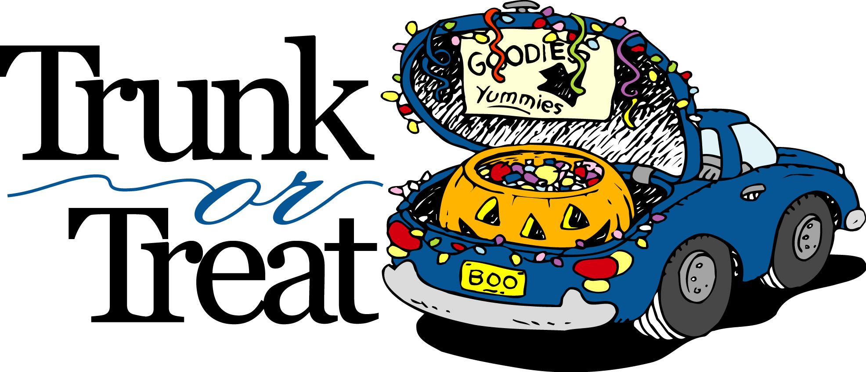
HALLOWEEN EVENT
Wednesday, October 31st, 2018, 6-8pm
Immanuel Lutheran Church Parking Lot
5701 Loch Raven Boulevard
Are you ready to have a great evening of fun?
This is the perfect event for all ages!
Please join the LRIA at Immanuel Lutheran Church’s
2018 Trunk or Treat Event for a fantastic night of fun! People gather and park their vehicles in the parking lot. They open their trunks, or backs of their vehicles, and decorate them. Then they pass out candy from their trunks. All kids travel through designated areas of the parking lot to visit decorated cars and collect a bunch of treats. And the coolest thing – you get to do this with your friends!
AND IT’S FREE! COME ON OUT!
All kids should bring a bag for collecting items and are encouraged to wear fun costumes. The event provides a safe and fun family environment for trick-or-treaters.

WE NEED DECORATED CARS!!! PLEASE JOIN IN ON THE FUN!!!
For more information, please call 410-435-6861, 410-435-5577 or email thelochravenimprovementassociation@hotmail.com.

COMMUNITY REMINDERS!!

- TRASH AND DEBRIS. Please help cut down on rodent activity in our neighborhood by maintaining your property in a clean, sanitary, and orderly manner. Place trash in a trash can with tight-fitting lids and dispose of bulk trash and debris by scheduling the appropriate pick-up or taking it to any one of Baltimore’s sanitation / recycling yards.
- RETRIEVAL OF TRASH CANS. It is each resident’s responsibility to remove your trash can(s) from the alley or public right-of-way after trash collection. If cans are NOT removed from the alleyway, property owners can receive a citation for negligence.
- BASKETBALL RIMS IN THE ALLEY. It is illegal to place basketball rims in the alley or any other area that impedes the public right-of-way. Please call 311 to have removed!
- ILLEGAL PARKING. Call 311 to report illegally parked vehicles. This includes all derelict vehicles without proper tags, vehicles parked on grass, vehicles blocking the alley, vehicles parked against the flow of traffic, vehicles parked over 48 hours without moving, and commercial vehicles parked in a residential neighborhood.
- ANIMAL CONTROL. If you routinely walk your dog or allow your dog freedom of your yard, PLEASE CLEAN UP AFTER YOUR ANIMAL AND PROPERLY DISPOSE! Also, you are required to leash your dog while in public and to ensure that it does not bark continuously to disturb the peace. Residents are encouraged to report all non-compliant pet owners to Animal Control by calling 311.
- ILLEGAL DIRT BIKES. Dirt bikes are dangerous and ILLEGAL in Baltimore City and we will not allow this nuisance activity in our LRIA neighborhood. Residents are encouraged to report the operation of illegal dirt bikes! If you know the address of where an illegal dirt bike is kept and/or operated, please call 911 or the Dirtbike Tipline at 443-902-4474.
- NEIGHBORHOOD DRUG ACTIVITY. If you are engaged in the sale, use, distribution, storage, or transport of illegal substances, please be advised that the LRIA will report all such activity to the Baltimore Police Drug Unit for investigation. This activity destroys lives, households, and neighborhoods, and we encourage ALL residents to report these illegal activities in our community. CALL 911! You may remain anonymous!

 |  |  | THANK YOU

