 |  | THE LRIA NEWS
OFFICIAL NEWSLETTER of the LOCH RAVEN IMPROVEMENT ASSOCIATION, INC. FALL EDITION 2019
Business and correspondence to:  LRIA  P.O. Box 66226  Baltimore, MD 21239  410-435-5577  THELOCHRAVENIMPROVEMENT  ASSOCIATION @hotmail.com  www.LRIA.org  Community Association Meetings  The Loch Raven Improvement Association meets the third Tuesday of every month, with the exception of  August and December.  Upcoming Meetings:  September 17th, 2019  October 15th, 2019  November 19th, 2019  Good Samaritan Hospital  Parker Conference  Rooms 3 and 4  7:00pm  All Residents Welcome  WE’RE LOOKING FOR VOLUNTEERS!  The LRIA is looking for new volunteers to join several committees and help distribute our community newsletter.  Sign-up today for:  Membership Committee  Fundraising Committee  Citizens on Patrol  Housing Inspection  Newsletter Distribution  NOTE:  Some activities may qualify for  Community Service Credit  Call 410-435-5577  THANK YOU  - - - - - - - - - - - - - - - - - - - - - - - - - - - - - - - - - - - - - - - - - - - - - - - cut here - - - - - - - - - - - - - - - - - - - - - - - - - - - - - - - - - - - - - - - - - - - - - - - -  LRIA MEMBERSHIP FORM  * Please submit this form with your $20.00 membership payment at the LRIA General Meeting  or forward by U.S. Mail to:  LRIA, P.O. Box 66226, Baltimore, MD 21239  Name:  Membership Renewal? Y N or First-time Membership? Y N  Mailing Address:  Phone / Email: | 2019-2020 MEMBERSHIP DRIVE CONTINUES ARIVED!  Civic engagement and community investment is a responsibility of every citizen, and is the key to strong neighborhoods. And while many people take living in a great community for granted, it actually takes dedicated residents and hardworking individuals to keep a neighborhood strong and stable.  The Loch Raven Improvement Association extends a sincere “Thank You” to all residents who have supported our efforts throughout the years, to sustain and improve the quality of life in our neighborhood. But more have to get involved!  While the LRIA continues its mission to preserving property values, promoting high standards of cleanliness, and maintaining an area that we regard as one of Baltimore’s Best neighborhoods, we are still a self-sustaining, non-profit organization that relies heavily on membership dues as a primary method to generate funds.  If you haven’t already, please take a moment to complete the bottom portion of this newsletter and forward, along with your $20.00 annual membership dues, to the LRIA either by mail or at any community meeting, and help us continue our unwavering commitment toward a neighborhood that is safe, clean, and strong.  All funds are fully reinvested back into the community and used to offset operating expenses to include, but limited to, The LRIA News newsletter, the LRIA.org website, and several ongoing community-sponsored events and beautification projects.  THANK YOU AND WE APPRECIATE YOUR CONTINUED SUPPORT!
COMMUNITY NEWS

As per our most recent 2019 Police Incident Report, the LRIA is experiencing an uptick in criminal activity in our neighborhood. While the report is a compilation of all Part 1 crimes in our area, the leading indicators show that larceny from auto, auto theft, and residential burglary are our leading areas of concern.
We also know that with the holiday season quickly approaching, the criminal element tends to get busy as well. The LRIA encourages all residents to get involved… to be vigilant against all illegal activity in our area. CALL 911 IMMEDIATELY if you observe individuals engaged in raucous behavior, individuals pulling on car door handles, individuals roaming the alleys, canvassing the area, or loitering for no apparent reason, and individuals illegally entering your neighbor’s property,
Also, please protect our kids… If you observe adults suspiciously approaching school-aged children, please do not hesitate to notify authorities.
Lastly, if you observe individuals engaged in the use, sale, distribution, storage, or transport of illegal substances, please CALL 911 IMMEDIATELY to report all such activity. This activity is NOT welcome in our neighborhood.
CAR SAFETY TIPS
- Ensure that your vehicle is locked at all times
- Never leave your keys in the car
- Never leave your car running and unattended
- Avoid leaving valuables inside your vehicle where passersby can see them. In fact, remove them from your vehicle.
HOME PROTECTION TIPS
- Secure all exterior doors with deadbolt locks
- Ensure all windows are locked
- Light up the landscape, use motion sensing lights, keep porch lights ON at night
- Set up a security system. Consider adding cameras.
- Eliminate hiding places by trimming bushes and eliminating debris

 |  |  |  | THANK YOU

The Department of Public Works warns:  Beware of Scammers posing as DPW employees!  Citizens should be cautious of imposters asking for payment of water bills, and attempting to enter your home for other  water-related issues.  Don’t be fooled!  Promptly report any and all suspicious activity to the Police Department by dialing 911 immediately.  Fire Safety Tips  A house can be engulfed in 60 seconds!  Stay Safe!!!  - Have working smoke and CO₂ detectors  - Use portable space heaters cautiously  - Don’t overload extension cords  - Don’t leave burning candles unattended  - Have an escape plan  - If you smoke, do it responsibly    It’s a Great Time to Start Recycling!  Recycling helps sustain our environment and reduces & saves energy  To learn how to get started, please call 311 or visit  http://publicworks.  baltimorecity.gov/  Recycling.aspx    - - - - - - - - - - - - - - - - - - - - - - - - - - - - - - - - - - - - - - - - - - - - - - - cut here - - - - - - - - - - - - - - - - - - - - - - - - - - - - - - - - - - - - - - - - - - - - - - - -  LRIA MEMBERSHIP FORM  I am also interested in joining the following committees: (check all that apply)  Membership Restoration Newsletter  Fundraising Citizens on Patrol Recycling  Sanitation Housing Other ________  Please include contact information on reverse side and submit with your dues payment to:  Loch Raven Improvement Association, Inc.  Also visit us at: www.LRIA.org  THANK YOU | 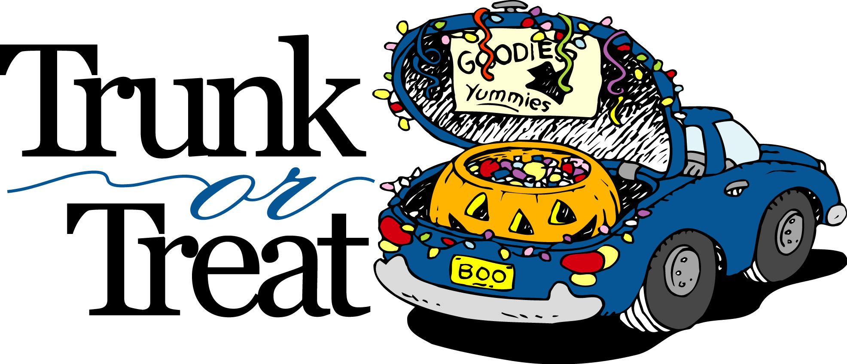
HALLOWEEN EVENT
Thursday, October 31st, 2019, 6-8pm
Immanuel Lutheran Church Parking Lot
5701 Loch Raven Boulevard
Are you ready to have a great evening of fun?
This is the perfect event for all ages!
Please join the LRIA at Immanuel Lutheran Church’s
2019 Trunk or Treat Event for a fantastic evening of fun!
How it works: People gather and park their vehicles in the parking lot. They open their trunks, or backs of their vehicles, and decorate them. Then they pass out candy from their trunks. Kids travel through designated areas of the parking lot to visit decorated cars and collect a bunch of treats. And the coolest thing… IT’S FREE!
All kids should bring a bag for collecting items and are encouraged to wear fun costumes. The event provides a safe and fun family environment for trick-or-treaters.
WE NEED PARTICIPANTS! PLEASE JOIN IN ON THE FUN!
For more information, please call 410-435-6861, 410-435-5577 or email thelochravenimprovementassociation@hotmail.com.

COMMUNITY REMINDERS!!

- TRASH & DEBRIS. Please pick up trash and debris where you live and maintain your property in a clean and sanitary manner at all times. This includes your portion of the alley and the curb in front of your residence. All garbage MUST BE PLACED in trash cans with tight-fitting lids.
If you require bulk trash removal, you may schedule the appropriate collection by calling 311, or you may take it to any one of Baltimore’s sanitation/recycling yards.
Baltimore City Code Enforcement will issue citations for non-compliance. BE ADVISED!
- RETRIEVAL OF TRASH CANS. It is each resident’s responsibility to remove your trash can(s) from the alley or public right-of-way within 24 hours after trash collection. If your cans are not removed from the alleyway, property owners can receive a citation for negligence.
- ILLEGAL PARKING. Please call 311 to report all illegally parked vehicles. This includes vehicles parked in “no parking” zones, inoperable / derelict vehicles, vehicles without proper tags, vehicles parked on dirt or grass, vehicles blocking the alley, vehicles parked against the flow of traffic, vehicles encroaching fire hydrants, vehicles parked over 48 hours, and trucks and other commercial vehicles parked overnight in a residential area.
- ANIMAL CONTROL. If you are a pet owner, PLEASE CLEAN UP AFTER YOUR ANIMAL! Also, if you routinely walk your dog, you are required to leash your animal while in public. Please also ensure that your dog does not bark continuously to disturb the peace. Residents are encouraged to report all non-compliant pet owners to Animal Control by calling 311.
- ILLEGAL DIRT BIKES. Not only are dirt bikes illegal in Baltimore City, but dirt bike operators are often rude and discourteous. We will not allow this nuisance activity in our neighborhood. Residents are encouraged to report the operation of illegal dirt bikes! If you know the address of where an illegal dirt bike is stored and/or operated, please call 911 or the Dirtbike Tipline at 443-902-4474.
- ILLEGAL DUMPING. When you see this activity occurring, please collect as much information as possible, including individual and vehicle description, and REPORT TO 911.

 |  |  | THANK YOU

