 |  | THE LRIA NEWS
OFFICIAL NEWSLETTER of the LOCH RAVEN IMPROVEMENT ASSOCIATION, INC. SUMMER EDITION 2018
Business and correspondence to:  LRIA  P.O. Box 66226  Baltimore, MD 21239  410-435-5577  THELOCHRAVENIMPROVEMENT  ASSOCIATION @hotmail.com  www.LRIA.org  Community Association Meetings  The Loch Raven Improvement Association meets the third Tuesday of every month,  with the exception of  August and December.  Upcoming Schedule:  June 19th, 2018  July 17th, 2018  Good Samaritan Hospital  Parker Conference  Rooms 3 and 4  7:00pm  All residents welcome  2018  Gubernatorial Primary Election  Regular Voting  June 26, 2018  7am until 8pm  Early Voting  June 14 – June 21, 2018  10am until 8pm  Are you Registered to Vote?  Voter Information?  Please visit:  https://elections.maryland.gov/voter_registration/  index.html    THANK YOU  - - - - - - - - - - - - - - - - - - - - - - - - - - - - - - - - - - - - - - - - - - - - - - - cut here - - - - - - - - - - - - - - - - - - - - - - - - - - - - - - - - - - - - - - - - - - - - - - - -  LRIA MEMBERSHIP FORM  * Please submit this form with your $20.00 membership payment at any LRIA General Meeting  or forward by U.S. Mail to:  LRIA, P.O. Box 66226, Baltimore, MD 21239  Name:  Membership Renewal? Y N First-time Membership? Y N  Mailing Address:  Contact Information: | 2018 – 2019 MEMBERSHIP DRIVE CONTINUES  Welcome All New Residents!  The Loch Raven Improvement Association, Inc. (LRIA) is a self-sustaining, non-profit organization that promotes resident empowerment and exceptional quality of life for all.  If you are not already a member, joining is one easy way to express your values and proactive commitment with your community. As a member, you are supporting an effort to maintain our neighborhood at the highest-possible level, inclusive of preserving property values, promoting superior standards of sanitation and neighborhood health, and combating crime and nuisance behavior. The more we grow our membership base, the more we’re able to positively impact our neighborhood.  Annual membership dues are $20 per household, and your contribution is directly reinvested back into the community. Restoration projects, neighborhood events, and a neighborhood newsletter and website are just a few interests in which we are engaged. Please help us continue these efforts by getting, and staying, involved.  You may forward your payment to the LRIA business office or make payment at any community association meeting. We appreciate your support.
COMMUNITY NEWS

- Please respect Baltimore City’s summer curfew regulations, which are in effect through August 26th. Youth under the age of 14, need to indoors from 9pm to 6am, while youth ages 14-16 have an 11pm to 6am curfew. Youth found violating the curfew will be transported home by the Baltimore Police Department. Outreach staff from the Mayor’s Office of Human Services and/or the Department of Social Services will then follow up with an assessment for any needed family support services. Residents are encouraged to keep our neighborhood safe by calling 911 for curfew infractions.
- Housing inspections of all 1200 homes in our catchment area were conducted in June 2018, with concentration on residences with excessive trash and debris, bulk trash items, high grass & weeds, derelict vehicles, and failure to display address markers at the rear of your property. Residences observed in violation of any of these housing regulations were referred to Baltimore Housing Code Enforcement for the appropriate notice and/or citation. Thank you for maintaining your property in inspection-ready condition at all times and for keeping our community clean.
- The LRIA has received an update for new occupancy of the old Mars Supermarket property, located at 1600 E. Northern Parkway. “You Fit” fitness club, is slated to open its doors soon, and occupy nearly the entire space of the old Mars. Updates to follow.
- Several issues of illegal dumping have been reported along the Loch Raven Boulevard corridor, as well as the 2000 block E. Belvedere Avenue, where trash is being deposited in the center median. Residents are encouraged to keep a watchful eye on illegal dumping activity along these routes and to immediately report such activity to 911, with as much information as possible.
- It is illegal to drive, ride, or possess any dirt bike or other unregistered motorcycle, or similar vehicle, on any public or private property that is located within the City of Baltimore. Any person who violates this ordinance within Baltimore City is subject to a fine of up to $1,000 for each offense or imprisonment for up to 90 days. Residents are encouraged to stand up against the operation of these nuisance and illegal dirt bikes. If you know the address of where an illegal dirt bike is kept and/or operated, please call 911, or call or text the Dirtbike Tipline at 443-902-4474.
- Please be vigilant against auto larceny and property crimes in our neighborhood. Lock your car doors, do not leave your automobile running and unattended, and do not leave articles of value in your vehicle. Similarly, please be observant of unusual or strange activity around your property, and your neighbor’s property, and do not hesitate to call 911. DO YOUR PART IN COMBATTING CRIME IN OUR NEIGHBORHOOD!

 |  |  |  | THANK YOU

VOLUNTEERS NEEDED  FOR  NEWSLETTER DELIVERY  The LRIA issues a special “THANK YOU”  to the several volunteers who have stepped forward to assist in delivering the newsletter.  However, we still need assistance for a few blocks. If you are interested in volunteering, please contact LRIA’s Newsletter Coordinator at  410-435-5577.  Immanuel Lutheran Church’s Compassion Center  continues to accept non-perishable food donations at the church office,  5701 Loch Raven Blvd., Monday through Friday, 9:00am to 2:00pm.  Gently-used clothing and houseware donations also being accepted, and should be delivered directly to the Compassion Center on Saturdays, 10-2pm.  Thank you for your assistance.  SUMMER SOUNDS AT BELVEDERE SQUARE ARE BACK!  Live music, with dining options from restaurants and merchants of Belvedere Square.  Friday nights,  through September 7th  6pm – 9pm  The series is free and open to the public.  - - - - - - - - - - - - - - - - - - - - - - - - - - - - - - - - - - - - - - - - - - - - - - - cut here - - - - - - - - - - - - - - - - - - - - - - - - - - - - - - - - - - - - - - - - - - - - - - - -  LRIA MEMBERSHIP FORM  I am also interested in joining the following committees: (check all that apply)  Membership Restoration Newsletter  Fundraising Citizens on Patrol Youth Programs  Sanitation Housing ^{NEW} Recycling  Please include contact information on reverse side and submit with your dues payment to:  Loch Raven Improvement Association, Inc.  Also visit us at: www.LRIA.org  THANK YOU | 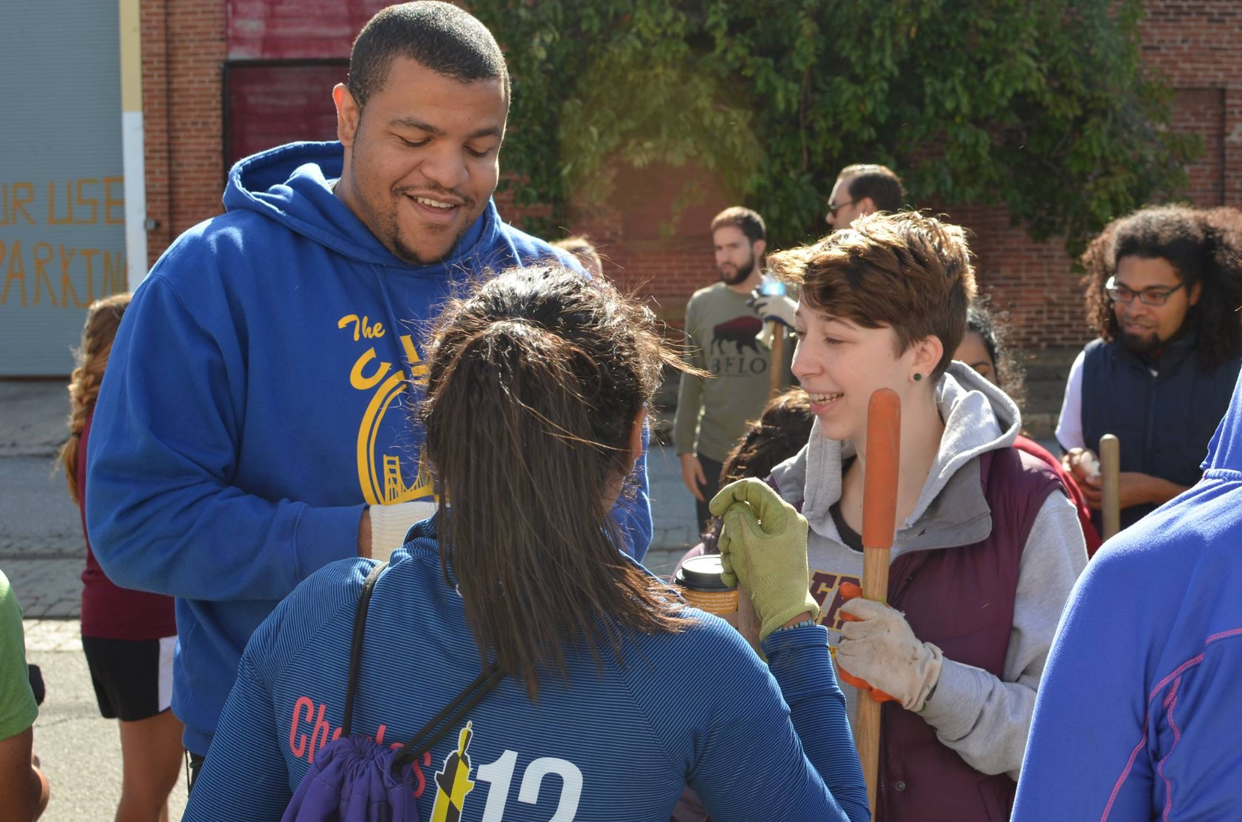  Meet Your Neighbors!  Introducing Corey H.  Resident - Loch Raven Community
Q. Hello, Corey. How long have you lived in northeast Baltimore?
A. Well, I grew up in northeast Baltimore for the majority of my life. I moved to Harford County when I was about 13. After finishing up college three years ago, I decided to move back to my community.
Q. What’s your favorite thing about living here?
A. Since I moved back to the neighborhood, I can tell that there is a big sense of community here! It is apparent that everyone’s pretty passionate about keeping their neighbors safe and keeping our local politicians accountable!
Q. Any cool stories about your neighborhood?
A. I don’t know if this counts, but I live pretty close to a bus stop. Sometimes at 2am or 3am, I’ll hear some pretty interesting conversations “laugh”. It’s not a problem though… it makes me feel closer to the community.

COMMUNITY REMINDERS!!
As a resident of our LRIA community, we count on you to maintain a level of responsibility and common courtesy that keeps our neighborhood strong.
PLEASE DO NOT SETTLE FOR LESS!
- NOISE NUISANCES. Warmer weather means cookouts and outdoor gatherings with family and friends. But please be considerate of your neighbors and lower the volume of your stereo equipment so that you do NOT disturb the peace. Everyone has a right to the peaceful enjoyment of their homes and with everyone’s help, we all can enjoy a great summer season without offending our neighbors. Residents should call 911 to report noise nuisances from either a home or a vehicle.
- NEIGHBORHOOD DRUG ACTIVITY. If you are engaged in the sale, use, distribution, storage, or transport of illegal substances, please be advised that the LRIA will report all such activity to the Baltimore City Police Drug Unit for investigation. This activity destroys neighborhoods and we encourage ALL residents to report this illegal activity. CALL 911!
You may remain anonymous!
- ILLEGAL BASKETBALL RIMS. Portable basketball rims are not allowed in any alley or public right-of-way. Report any illegally-placed basketball devices to 311. Also, any noise generated from the congregation of individuals engaging in ball play at any particular residence, can be considered a noise / disturbing the peace violation, which is a 911 call.
- AGGRESSIVE PANHANDLING. It is unlawful for any person to engage in aggressive soliciting, panhandling, or foot-peddling which impedes the public right-of-way, particularly at traffic intersections. Once an individual enters the street, it becomes “aggressive”, in addition to a safety risk. Known locations for aggressive panhandling are Loch Raven Blvd @ E. Northern Pkwy, and Perring Pkwy. @ E. Belvedere Ave. Please call 911 to report.
- ILLEGAL PARKING. Call 311 to report illegally parked vehicles. This includes all derelict vehicles without proper tags, vehicles parked on grass, vehicles being illegally offered for sale, vehicles blocking the alley, vehicles parked in the wrong direction, vehicles parked for extended periods of time, and commercial vehicles parked in a residential neighborhood.
- ILLEGAL SIGN POSTINGS. “We Buy Houses” is the most common nuisance and Illegal signage in Baltimore City. These signs make our community look horrible! Let’s send a strong message to these violators that these signs are unacceptable! Please call 311 to give a description and location of these illegal signs, which are punishable by a $500 Environmental Control Citation.
- ANIMAL CONTROL. If you routinely walk your dog or allow your dog freedom of the yard, PLEASE CLEAN UP AFTER YOUR ANIMAL AND DISPOSE OF IT PROPERLY! Also, you are required to leash your dog while in public and to ensure that it does not bark continuously to disturb the peace. Residents are encouraged to report all non-compliant pet owners to Animal Control by calling 311.

 |  |  | THANK YOU

