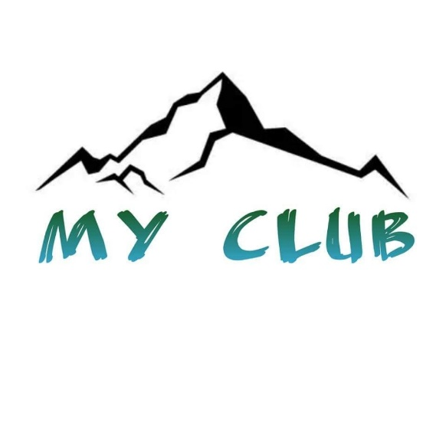

RELEASE OF LIABILITY

READ CAREFULLY - THIS AFFECTS YOUR LEGAL RIGHTS

For participation in the Summer Swimming Pool Program organized by Mountain Area Youth Organization - MY Club, of Oakhurst and Rivergold sites, the use of the property, facilities and services of Mountain Area Youth Organization - MY Club, I agree for my child or family member, to the following:

1. AGREEMENT TO FOLLOW DIRECTIONS. I agree to observe and obey all posted rules and warnings, and further agree to follow any oral instructions or directions given by MY Club, or the employees, representatives or agents of MY Club.
2. ASSUMPTION OF THE RISKS AND RELEASE. I recognize that there are risks associated with the above described program and I assume full responsibility for personal injury of my child and/or my family member, and further release and discharge Mountain Area Youth Organization - MY Club for injury, loss or damage arising out of my child or my family's use of or presence upon the facilities functioned by Mountain Area Youth Organization - MY Club, whether caused by the fault of my child, my family, MY Club or other third parties.
3. INDEMNIFICATION. I agree to indemnify and defend MY Club against all claims, causes of action, damages, judgments, costs, or expenses, including attorney fees and other litigation costs, which may in any way arise from my child or my family member use of or presence upon the facilities of Mountain Area Youth Organization - MY Club.
4. FEES. I agree to pay for all damage to the facilities of or use of facilities by MY Club caused by any negligent, reckless, or willful actions by my child or my family member.
5. CONSENT. I, ___________________, parent or legal guardian of _____________________, consent to the participation of named child in the Summer Swimming Pool Program and agree on behalf of the above minor to all of the terms and conditions of this Agreement. By signing this Release of Liability, I represent that I have legal authority over and custody of _________________.

6. MEDICAL AUTHORIZATION. In the event of an injury to the above minor during the above described activities, I give my permission to Mountain Area Youth Organization - MY Club or to the employees, representatives or agents of MY Club to arrange for all necessary medical treatment for which I shall be financially responsible. This temporary authority will begin on June 09, 2023 and will remain in effect until terminated in writing by the undersigned or August 09, 2023, whichever occurs first. Mountain Area Youth Organization - MY Club shall have the following powers:
a.) The power to seek appropriate medical treatment or attention on behalf of my child as may be required by the circumstances, including without limitation, that of a licensed medical physician and/or a hospital;
b.) The power to authorize medical treatment or medical procedures in an emergency situation; and
c.) The power to make appropriate decisions regarding clothing, bodily nourishment and shelter.
7. APPLICABLE LAW. Any legal or equitable claim that may arise from participation in the above shall be resolved under California law.

8. NO DURESS. I agree and acknowledge that I am under no pressure or duress to sign this Agreement and that I have been given a reasonable opportunity to review it before signing. I further agree and acknowledge that I am free to have my own legal counsel review this Agreement if I so desire.

9. EMERGENCY CONTACT. In case of an emergency, please call _________________ (Relationship: _________________) at (Phone #)_________________ (Day), or (Secondary #) _________________ (Evening).
I HAVE READ THIS DOCUMENT AND UNDERSTAND IT. I FURTHER UNDERSTAND THAT BY SIGNING THIS RELEASE, I VOLUNTARILY SURRENDER CERTAIN LEGAL RIGHTS.

Parent or legal guardian Signature: _________________________ Date:___________________

