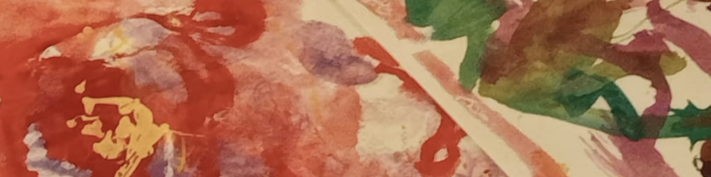

Exploring Munari's Book-Making Odyssey: Theory, Practice, and Inspiration

Join us as we gather as a community curious about the work and history of Bruno Munari through conversations, inquiry, and creative exploration, we hope you will reimagine the art of book making and storytelling through Munari’s work.

Date: August 15 and 17, 2024

Time: 9:30 am- 1 pm

Cost: $145 (payment accepted by e-transfer prior to workshops, receipt will be issued)

What is included: meet and greet and showcase, immersive encounters with materials facilitated by an artist and pedagogist, light lunch, Acorn Wonder Bag, giveaway, materials for sessions.

Location: Acorn Studio Richmond Hill. Address is send upon registration

Registration Attached

Participants will embark on a deep inquiry into Bruno Munari's life and works, examining key moments and influences that informed his approach to book design. Through engaging discussions and visual presentations, we will explore Munari's theories on typography, layout, and visual storytelling, uncovering the principles that revolutionized the way we perceive and interact with books.

We welcome a small group to be immersed in the Acorn Studio to come and collaborate,



Immersive Workshop Session Day 1

Day 1 will immerse participants in the life and works of Bruno Munari, delving into his revolutionary approach to book design, typography, and visual storytelling. This session combines theoretical exploration with practical, hands-on activities, setting the stage for an engaging and creative learning experience.

Session Breakdown

Morning Session: Exploring Bruno Munari’s Life and Theories

* Welcome and Introduction
* Brief introduction to the workshop’s schedule and experience with Munari’s work.
* Deep Inquiry into Bruno Munari's Life and Works
* -Visual Presentation: Overview of Bruno Munari’s biography, highlighting key moments and influences in his career.
* **Engaging Discussion and Hands-On Experiences: Examination of Munari's major contributions to book design, focusing on his innovative use of typography, layout, and visual storytelling.
* Interactive Segment: Participants will explore examples of Munari’s books, analyzing how his principles can be applied to modern book design and educational contexts.
* Mid-Morning Break
* Refreshments and Light Meal : Opportunity for participants to network and reflect on the morning session.
* Late Morning Session: Introduction to Paper Making
* The Art of Paper Making
* -Demonstration: Introduction to the materials (recycled paper, plant fibers), tools (molds, deckles, screens), and basic techniques of paper making.
* Hands-On Activity: Participants will prepare pulp from raw materials, learning the foundational steps of paper making.
* Embedding and Decorating: Techniques for embedding decorative elements
* These paper making pieces will be dried at the Acorn Studio and ready for the next session.



Session 2-August 17

Morning meet and greet.

Opening conversations about previous session and reflections

Applying Munari’s Methods

* Fostering Creativity and Critical Thinking through Book Making
* Discussion: Exploration of Munari’s methods for fostering creativity and critical thinking in educational settings.
* Demonstration: Basic book making techniques inspired by Munari, including accordion books and simple stitched bindings.
* -Hands-On Activity: Participants will begin creating their own handmade books using the paper they made previously. They will explore different layouts and binding methods, emphasizing Munari's principles of play and exploration.
* Mid-Morning Break:
* Refreshments and Light Meal: Opportunity for participants to network and reflect on the morning session.
* Light Refreshments: Brief break for snacks and informal discussions.
* Integrating Book Making into Practices
* Facilitated discussions: strategies for incorporating book making into various areas in programs
* Group reflection on the day’s activities, discussing key takeaways and how they plan to apply Munari’s theories and techniques in their contexts.
* Materials Provided
* A variety of recycled paper and plant fibers for paper making.
* Bookbinding tools (molds, deckles, screens, needles, thread).
* Decorative materials (flower petals, leaves, threads).
* Notebooks and pens for notes and sketches.
* Other Materials and Giveaway (TBA)
* Acorn Wonder Bag to take away
* Refreshments and lunch.

*The two-day immersive sessions will be unique and as a participant you will experience and encounter creativity, imagination and sustainability all through interactions and hands on experiences guided by an artist and pedagogist. We are excited for you to join and thank you for being part of these sessions.*



Upcoming In Person Sessions and Online/Virtual Sessions

Our next two-day session is on Nature and the Digital, **August 22 and 24, 2024 9 am-1pm at Acorn Studio. ($135/person)**

Starting in June, Acorn Collaborative along with special guests broadcasting live sessions from the Acorn Studio. These virtual sessions are unique to Acorn as they include interactive and participatory elements. We will do some of these sessions live and in person, an opportunity for participants to join virtually or in person. Our first session will engage in inquiries about the possibilities offered to us when we orient ourselves toward relationship and care -centric ways of being, when we explore learning and teaching “together with” rather than “to” or “about”. in our everyday work alongside children and other adults.

Our next virtual session TBA will be about the Environment. What is it to be in a pedagogy of immersive environments for all? What is an environment for us and children? Join us for this experience and the inspiration towards building an image of schools, educators, and children that aligns with a world we hope for. How do we see ourselves? We will be exploring many questions that reflect how we see ourselves, children, learning, teaching, how this translates into our everyday living environments, and inspire our work.

Stay connected! We will be posting about these virtual sessions soon.

Looking forward in engaging with you!

Rosalba Bortolotti

[rosalba@rogers.com](mailto:rosalba@rogers.com)

[www.acorncollaborative.com](http://www.acorncollaborative.com)

