The Languages of Clay

Resource Package

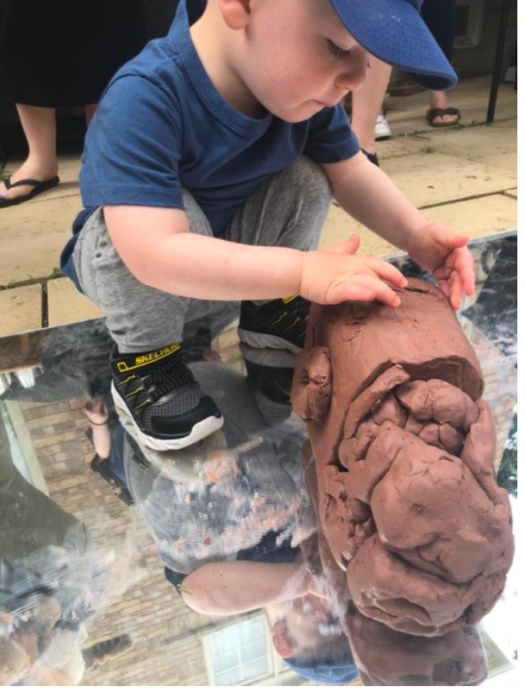

Written by: Rosalba Bortolotti B.Ed. RECE

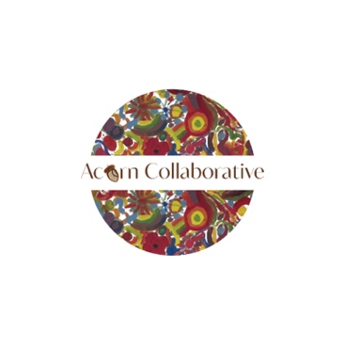

What is Clay?

Clay is a soft, loose, earthy material containing particles with a

grain size of less than 4 micrometres. It forms as a result of the

weathering and erosion of rocks that contain the mineral group

feldspar (known as the mother of clay) and takes place over vast

spans of time. During weathering, the feldspar

content is altered by hydrolysis to form clay. Clay is continuously being

formed. Clays develop plasticity when wet, due to a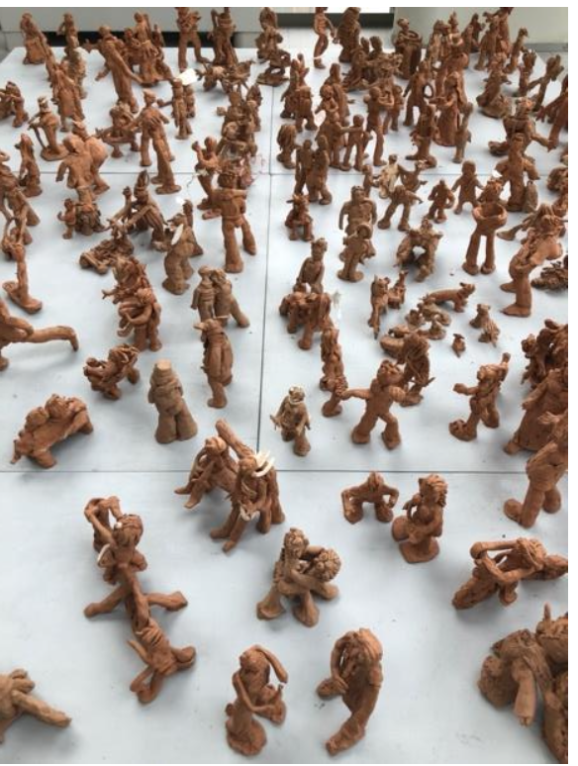

molecular film of water surrounding the clay particles, but become hard, brittle and non–plastic upon drying

or firing. Most pure clay minerals are white or light-coloured, but natural clays show a variety of

colours from impurities, such as a reddish or brownish colour from small amounts of iron oxide.

Prehistoric humans discovered the useful properties of clay and used it for making pottery. Clay continues to be a medium used by artists. If we believe in the capacity and competence of children, clay is a way to demonstrate this. Clay has more affordances than home-made or purchased doughs.

Benefits of Clay

• Clay is natural and can be left outside.

• Clay has a natural appeal.

• A line with a crayon is unchangeable, however a long coil of clay can become a snake, then a bowl, then a

snow person.

• The possibilities seem endless because clay is open-ended and can easily be added to other materials.

• Clay has more form and function than

playdough.

Clay and Children

Children use their fine motor skills to pound, pinch, roll, flatten, poke, tear, squeeze, coil, stretch, squash, twist, and bend their clay into all sorts of shapes and

sizes. When children stand while they engage with clay, they use their whole bodies.

Children connect to clay in a multi-sensory way. It can feel slimy and wet, or it can be hard, powdery, and dry. Different clays have different smells and colours. Clay emits unique sounds when children squeeze wet clay though their fingers or when they pound dry clay onto the table. Clay has therapeutic and self-regulatory benefits for children and adults of all ages. Like many other art forms, clay provides a means for children to express their thoughts and feelings. Pounding a block of clay is a way to express big feelings. Clay offers the opportunity for children to create three-dimensionally. Drawing or painting on paper, is a two-dimension experience. Since children live in a three-

dimensional world, it may be easier for them to use clay to

represent their world. They are able to create clay families and friends who can interact. This kind of creation and play helps children work through their emotions and feelings.

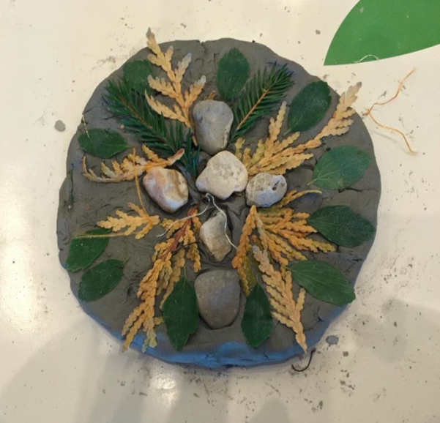

Every Day is a Good Day for Clay

Offering children clay on a daily basis (continuous provision) will support them in assessing the multiple benefits that are inherent in the medium. Clay should be readily available for children from toddlers to school age. Children move through the stages based

on experience. Encouraging an end product is not necessary and can be considered teacher directed. Have the clay available.

Observe and listen to what happens during encounters with clay. It will offer insight into the ways that you can enhance their experiences and their curiosities. Children can use and reuse the clay rather than having it dry for the children to name and take home. The clay can be a community experience. 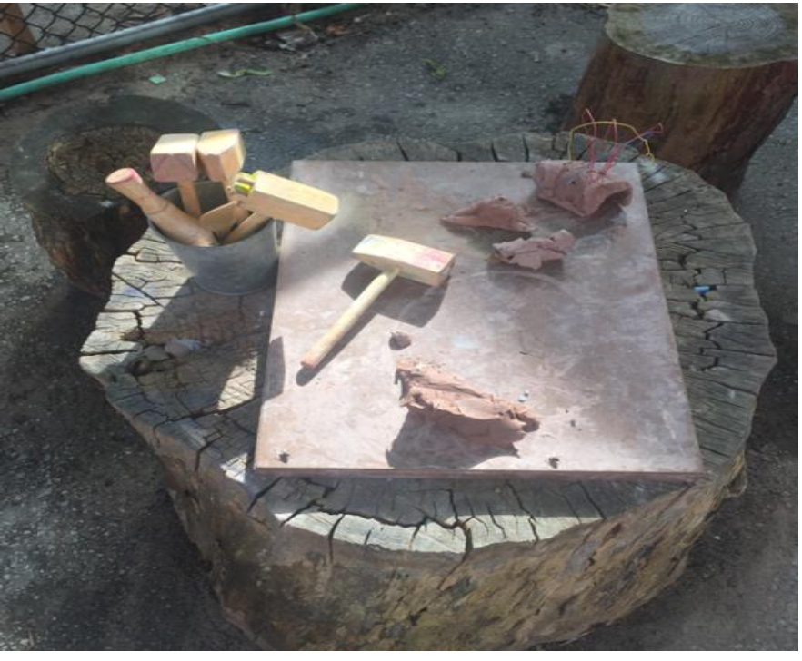

Clay Tips

Tucker’s Pottery Supplies in Richmond Hill , Ontario is a good place to purchase clay. We recommend clay that can be air dried and does not need a kiln. The clay is sold by the box and each box contains two 10-kilogram bags for a total of 20 kilograms and will cost approximately $30-50.00 per box.(prices vary depending on the clay types) The clay can be used and reused multiple times by multiple children making it well worth the investment especially if you follow these tips to keep the clay moist. Even if the clay dries, it can still have a life!

1. Keep a spray bottle of water and a clean sponge close-by.

Spray the clay if it becomes a little dry or to soften it. Lightly spritz the clay all over to keep it wet and malleable. As long as the clay is hydrated and stored it properly, it will stay moist and workable.

2. Use a small container of water instead of the spray bottle to wet the clay (use a sponge to dip in the water to wet the clay). Use just enough water to dampen without getting the clay so wet that it will fall apart or become a ‘slip’. Slips made from water and clay can be used as an adhesive for clay creations.

3. Wrap damp paper towels or a cloth around your piece when you’re notworking on it. Place the piece in a sealed plastic bag to keep it moist between work sessions. Place the bag somewhere away from light sources, ideally where it’s slightly cooler than room temperature.

4. When using clay with children, wrap individual pieces or

one larger piece in a plastic wrap and keep in a dark, cool

place. It is important to keep it sealed (containers, plastic

wrap, and plastic bags, or both can be used). If you want to keep a collaborative clay project that the children have

been working on, store it in a dark, cool place.

According to Marvin Bartel (2002), a potter, father, grandfather, teacher, artist, and art educator, most children, up to ages six to eight are by nature curious and self-confident about everything. While they instinctively love to use their hands, many children have been acculturated to worry about getting "dirty." Show

them how easy it is to rinse and sponge the clay off their hands and they lose all inhibitions and plunge in. Gadgets like extruders, molds, cookie cutters, or any design suggestions or pattern books take away from original thinking, problem solving, and creativity. Too often children rush over to the rolling pins and cookie cutters. That is why, we suggest beginning with hands, the most important tools we have.

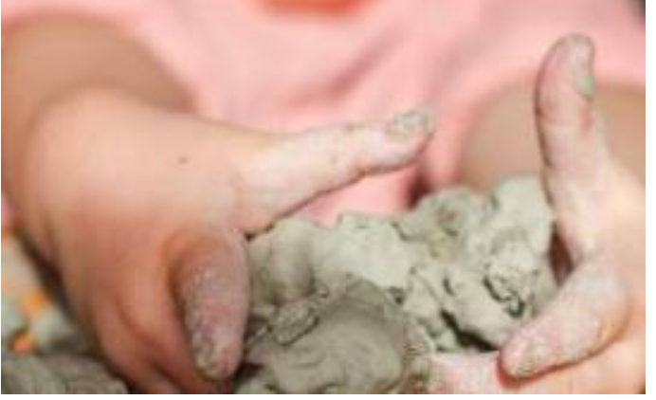

The Pedagogy of Clay Experiences

Artistic creations are the visible evidence of an expressive

language. These expressions demonstrate the connection

between rationale thought and imagination, between cognition and the sense. The work a child does as an artist invites contemplation, imagination, and symbolic invention. Expression through materials and clay is a window into a child’s strategy of thinking, their knowledge-building processes, and the relationship they are developing with the materials in their world. Using clay and the multitude of possibilities it affords will help create pedagogical pathways that support the foundational conditions for learning. Clay is about well-being. Clay engages the child to explore with all their senses. Clay experiences support a sense of belonging. Clay is an expressive way of demonstrating and experiencing art. 