Unraveling Play: Rosalba Bortolotti [1]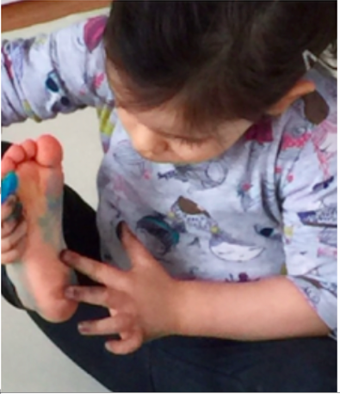

We can consider the definition of play with young children transcends conventional boundaries, incorporating principles of social justice, environmental awareness, relationships, responsibility, and a holistic understanding of the world. Play, in this context, serves as a gateway to a myriad of possibilities, offering children a lens through which they explore and make sense of their surroundings.

Within this framework, play is not confined to mere amusement; rather, it becomes an intricate process of inquiry, questioning, and action. These elements act as catalysts, propelling children into the profound depths of larger ideas and theories. The emphasis is on fostering a dynamic environment where ideas circulate freely, sparking curiosity and encouraging children to engage with the world around them.

Play can serve as a powerful tool for cultivating a sense of social justice and environmental responsibility. Through play, children develop an understanding of

interconnectedness, empathy, and the impact of their actions on both the human and natural aspects of their environment. It becomes a means of nurturing not only cognitive development but also social and ethical awareness.

The Reggio Emilia perspective envisions play as a holistic experience that goes beyond traditional educational boundaries. It invites children to explore, question, and act in ways that foster a deep understanding of the world, promoting a lifelong love of learning and a commitment to responsible citizenship.

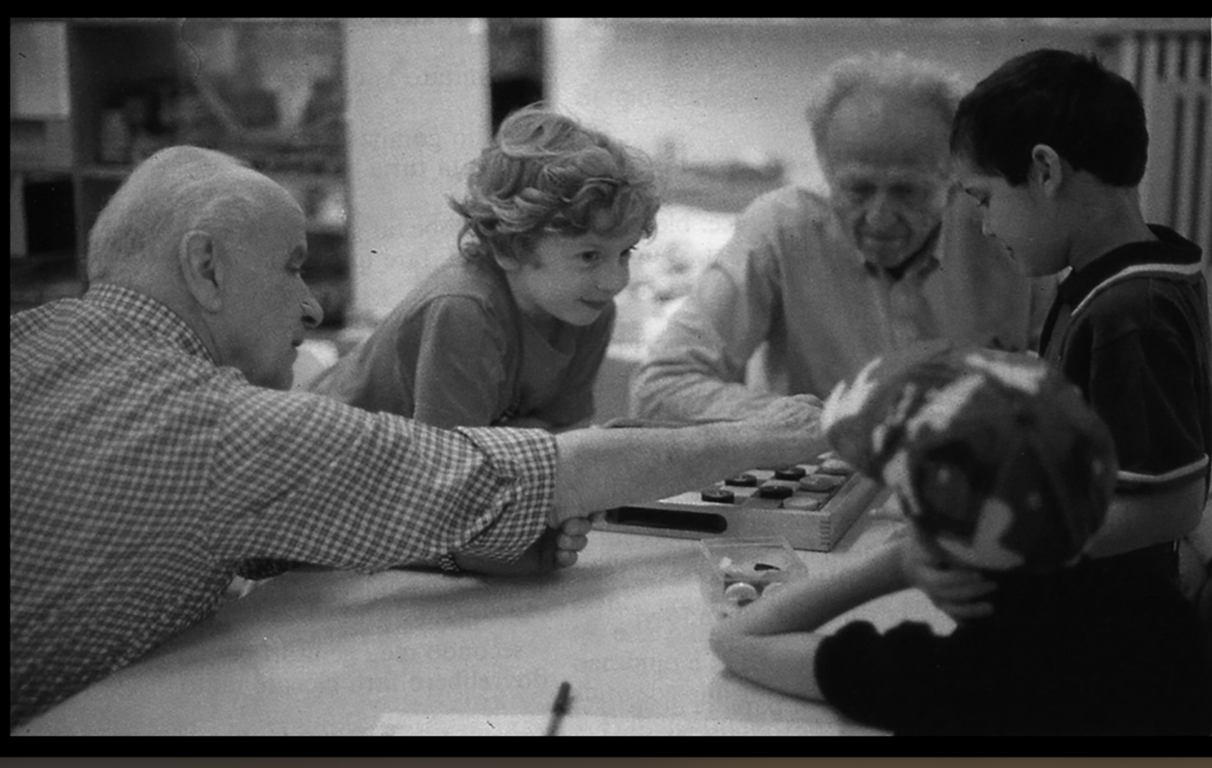

Loris Malaguzzi and David Hawkins- at the Diana municipal preschool, Reggio Emilia 1990.

If we can think how play is intricately woven into the fabric of relationships. It extends beyond the individual child and encompasses connections with others, the world, and even in relation to various objects and elements. This emphasis on relationships serves as a foundational element in fostering holistic development.

1. Relationships with Others: Play becomes a social endeavor, providing opportunities for children to interact, collaborate, and negotiate with their peers. Through play, they learn the dynamics of communication, cooperation, and the importance of understanding and respecting the perspectives of others.

2.Relationships with the World: Play serves as a medium through which children explore their connection to the broader world. It allows them to make sense of cultural, environmental, and societal elements, fostering a sense of global awareness and appreciation for diversity.

3. Relationships with Things: Objects and materials in the play environment become tools for exploration and understanding. Through interactions with various items, children develop a relationship with the physical world, gaining insights into textures, shapes, and functionalities.

4. In Relation to... Play in the Reggio Emilia concept often involves situating oneself in relation to different contexts and scenarios. This could include considering one's role in a pretend play scenario, understanding cause-and-effect relationships, or exploring how individual actions contribute to the collective experience.

By emphasizing these multifaceted relationships, the Reggio Emilia approach recognizes that play is not only a vehicle for cognitive development but also a holistic process that shapes a child's social, emotional, and ethical understanding of the world. Through play, children build the foundations for meaningful and interconnected relationships that extend beyond the confines of the classroom or play space.

Looking beyond traditional developmental perspectives, there is theorists who challenge and disrupts conventional meanings of play with young children. It redefines play as a multifaceted and dynamic process that extends far beyond mere developmental milestones. Here are a few ways in which this perspective disrupts traditional notions:

1. Agency and Empowerment: children not just as passive recipients of play experiences but as active agents who can shape and construct their own learning. Play becomes a vehicle for empowering children to make choices, express their ideas, and actively participate in shaping their understanding of the world.

2. Critical Thinking and Inquiry: Instead of viewing play solely as a tool for skill acquisition, play as a space for critical thinking and inquiry. Children are encouraged to ask questions, explore hypotheses, and engage in meaningful investigations, challenging the idea that play is only about entertainment or simple skill-building.

3.Expressive Languages: Play is considered a language through which children express themselves. It disrupts the notion that play is limited to verbal or written communication, recognizing that children communicate and make sense of the world through various forms of expression, including art, movement, and symbolic play.

4.Sociocultural Context: The approach places play within a broader sociocultural context, acknowledging that the meaning and significance of play are deeply influenced by cultural and social factors. This disrupts the idea that play is a universal and static concept, highlighting its variability across different contexts.

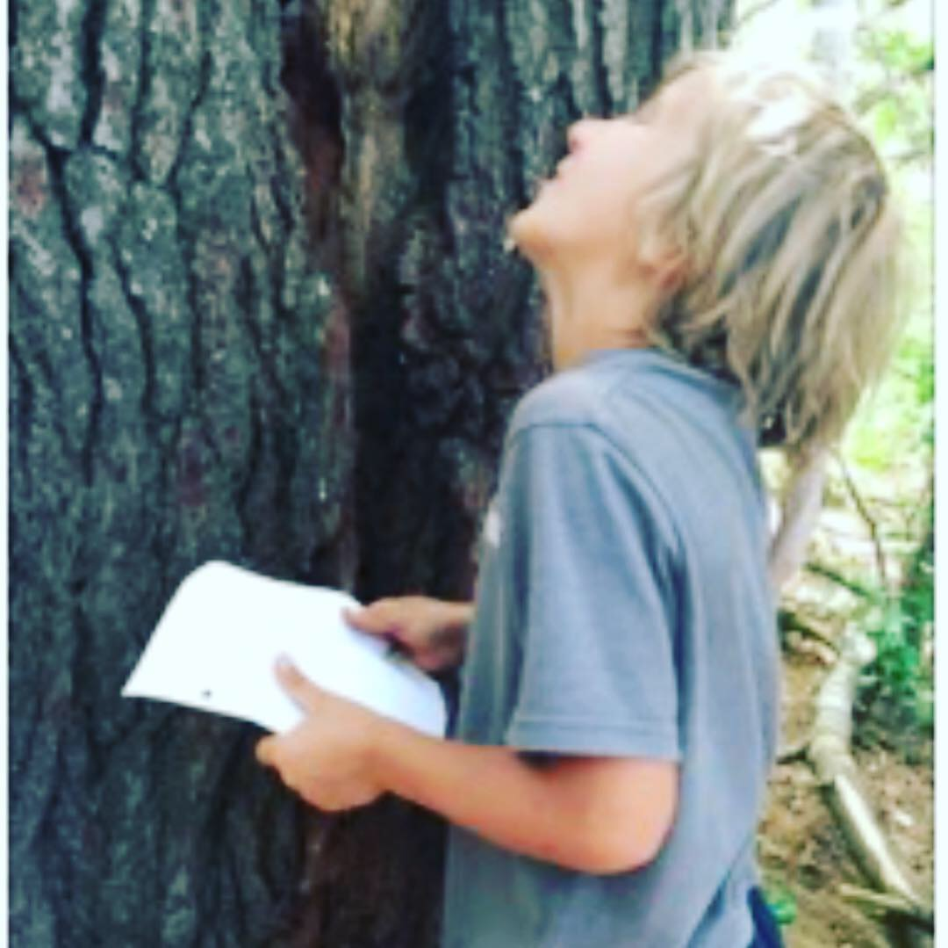\

5.Holistic Learning: Challenging the compartmentalization of learning into separate domains. Play is seen as a holistic experience that integrates cognitive, social, emotional, and physical aspects of development. This disrupts the traditional view that learning occurs in isolated, predetermined categories.

6.Collaboration and Community: Play often involves collaboration and community engagement. It disrupts the individualistic perspective of play by emphasizing the social and communal aspects, where children learn from and with each other, fostering a sense of shared experiences and knowledge construction.

By disrupting traditional meanings of play, looking at various theories offers a more expansive and inclusive view, recognizing the richness and complexity of children's experiences as they engage with the world through play.

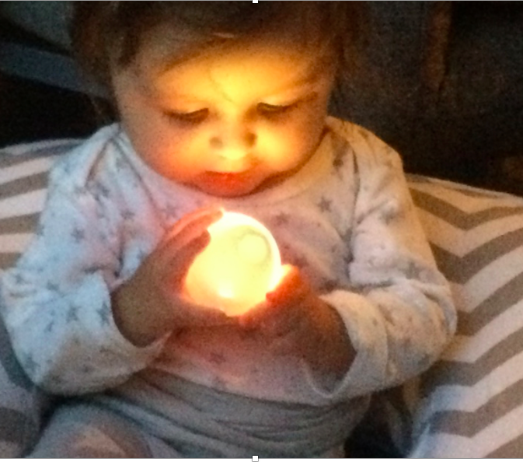

Children harbor a diverse array of interests, and as educators, it is our responsibility to actively seek out and comprehend these ideas. Facilitating and supporting children's thinking is a complex undertaking that requires careful listening, observation of play, and allocating adequate time for the educator to engage in this process. This task is not a straightforward one, and its complexity underscores the need for educators to invest time and attention to truly understand and nurture the unfolding interests and thoughts of the children under their care.

Taking the time to reflect on play is a crucial step in the educational process. It allows educators to plan and design experience that support and facilitate children's inquiries. The observations recorded or documented by educators serve as valuable insights into children's interests, behaviors, and learning.

Rather than simply being archived, these observations can be strategically utilized to enhance the ongoing process of play. Educators can relaunch certain documented observations to children, presenting them with new materials or ideas that build upon their previous experiences. Sometimes the children have ideas to continue with the ideas. This approach serves to provoke further thinking, encouraging children to explore and expand upon their initial interests.

By revisiting and extending these documented observations, educators contribute to the continuity of the play over time. This intentional and reflective approach ensures that children are engaged in a dynamic and evolving environment, where their interests are nurtured, and new possibilities for exploration continue to evolve.

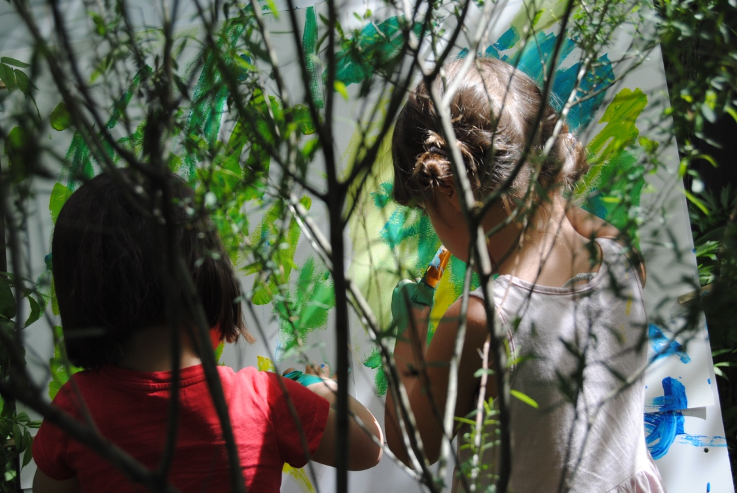

1.