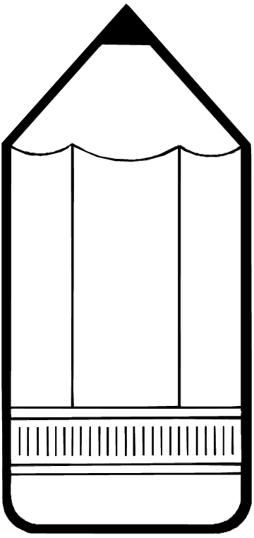

**Miss Christensen’s Supply list for both Kindergarten and 1st grade**:

**For school**, your child will need the following supplies:

           __  Backpack with child’s name written on the inside pocket. It should be large enough to hold 9” x 12” folders.

           __  #2 Beginner (“fat”) pencils-

           __  Box of crayons (24)

           __ Big Pink eraser

__ Small, “Pocket pack” of tissues for desk

*** I will provide a box to trap your child’s pencils and crayons

(Please don’t sent markers, colored pencils, binders, or individual pencil sharpeners to school. Those can be used at home, if you wish.)

**For completing homework (keep at home):**

__ Pencils, crayons, scissors, erasers, glue sticks or white glue, and

writing paper. 1st graders will need a folder or binder to keep spelling lists safe. Both K and 1st will need a folder for sight word lists at home.

**Optional** items for homework, but not required:

__ Markers or colored pencils, pencil sharpener, plain paper.

I welcome (Optional) donations to be used by our entire class:

      __      Family size boxes of facial tissue

      __       Kindergarten or First grade lined writing paper

      __      Glue sticks

__ Ziploc bags - snack, sandwich and gallon sizes

__ Latex free Band-Aids - any brand

Class donations are welcomed throughout the year.

Thank you!