Yoga for the Arthritic Joint
Do your knees creak when you try to squat to pick up your shoes? Does your neck sound like rice crispy’s when you turn your head to look over your shoulder when driving? Do you have to take an extra 5 minutes just to get out of bed in the morning because your back and hips are stiff as a board? Well you are not alone! According to the Centers for Disease Control (CDC) and the National Health Interview Survey (NHIS) 50 million adults have doctor diagnosed arthritic conditions. What!? Arthur who you say? The word “Arthritis” can be broken down into “arthron” which is Greek for joint. The other half of the word is the all too familiar “itis” which is Latin for inflammation. Thus, arthritis means "inflammation of the joint.” There are over 100 different types of arthritis with the most common being Osteoarthritis (OA), Rheumatoid Arthritis, Gout, and Fibromyalgia. Sound familiar yet? While there are many ways to treat an arthritic joint, I have come across a common question of “Should I be doing Yoga?” Yoga it seems has been around since the age of dinosaurs, so it seems like this ancient practice would be good. I think it is important to educate oneself on the body and “what is a joint?” in order to remedy the symptom. So let us begin.
Healthy Joint
Let us explain how healthy joints work and then the not so healthy joint. Within a joint there is a nice smooth and slick surface called articular cartilage that covers the surfaces of the joint. A natural producing fluid called synovial fluid also assists in the fluidity of a joint when it moves. The joint is then held together by strong fibrous bands called ligaments. Tendons connect the muscle to the bone while the surrounding muscles work to provide strength and support for the joint. Sounds like a wonderful working machine right?
The Not So Healthy Joint
The not so healthy joint is something of the opposite. Instead of having a nice smooth and slick articular cartilage, the cartilage may begin to deteriorate and become rough. When this happens, the joint surfaces rub against each other, which is painful. The body then responds with inflammation. The surrounding fluid may not be as abundant to provide joint fluidity. Due to the pain and joint swelling, the surrounding muscles tend to “shut off” and become weak. This can result in activity limitations, gait disturbances of limping and causing pain elsewhere. Not so much of a well working machine now is it? This is what we call Osteoarthritis (OA) or basically “wear and tear” on the joint.
Osteoarthritis
Apparently more women (80%) than men suffer from Osteoarthritis. Men suffer more from Gout which is also a form of arthritis. While doctors are still on the process of determining what exactly causes arthritis, many believe that the deterioration may be caused by the pressure of gravity on the joints. . Also, obesity and heredity factors contribute to deterioration of the joint. According to the CDC, due to the ageing population an estimated 67 million adults will have doctor diagnosed arthritis by the year 2030.

Treatment
So now that your bones crack, grind and need WD-40 just to get out of bed in the morning, what can you do? There are many wonderful treatments and forms of exercise that can help with an arthritic joint. However, within my years of practice I had many patients stating that they took up yoga because their best friend’s neighbor had arthritis and it helped them or just because their physician told them to join a yoga class. But ironically they were finding themselves injured rather than improving. This didn’t make sense to me as in the science of Yoga there seemed to be many people of all ages that could easily twist themselves into a pretzel. Over the years I have incorporated safe and modified yoga stretches to my arthritic patients ‘ treatments and have success in gaining flexibility, mobility and reducing pain. The ultimate goal of course is to regain or at least maintain ones quality of life. So to answer the question if yoga is helpful for arthritis, I would say “YES!” Yes yoga is beneficial to an arthritic joint or multiple joints if performed safely and correctly. In addition to yoga, tai chi classes can improve balance, movement patterns, and strength. Non-weight bearing exercises such as pool therapy and recumbent bike are beneficial as well. First, of course, a visit to your primary care physician or orthopedic physician is advised before beginning any form of treatment or exercise plan. Secondly, a visit to one of our knowledgeable physical therapists would be appropriate. Our skilled hands and knowledgeable minds can assist in decreasing any joint inflammation, increase muscle strength and flexibility. We can also provide education on further exercise and strengthening techniques.
So now that you cannot move so well, don’t worry as “movement” is the key to a “stiff” joint. Some of my favorite poses are as follows. Feel free to check out our Yoga and Tai Chi classes offered on Fridays or ask one of our trained staff to assist you in gaining your “movement.’
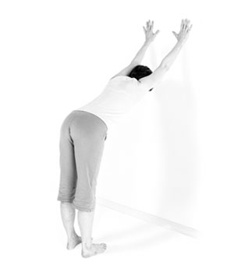. Wall Dog
Purpose: To extend the spine and stretch the chest and hamstring muscles.
Props: Wall
Tips: Retract shoulder blades firmly into the back. Keep knees bent if you’re stiff.

Instructions:
1. Place your hands on the wall at eye level with your index fingers pointing up, arms shoulder-width apart and elbows straight.
2. Place your feet hip-width apart and parallel.
3. Straighten your arms and move your chest a little toward the wall. Keep your elbows straight and pull your shoulder blades in toward your spine. Your chest will move a little toward the wall and shoulders will move back.
4. Bend forward through your trunk until there is one long diagonal line from hands to hips, stepping back as needed.
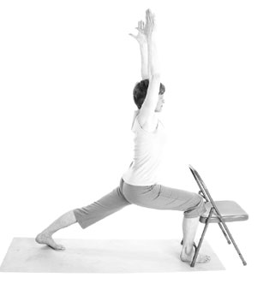 Standing Lunge with a Chair
Purpose: Stretches the hips, chest, and back, strengthens the quadriceps and promotes balance.
Props: A yoga mat and a chair.
Tips: Set the pelvis carefully, squarely facing the back of the chair, and keep it that way as you perform the pose. Do not let the back leg droop. Align the front knee with the second toe.
Instructions:
1. Stand facing the back of your chair.
2. As you step the left foot back, bend the right knee until the right shin is vertical.
3. Lean forward toward the chair and fully stretch your back leg, firming the muscles from foot to hip.
4. Retaining the forward lean, lengthen your tailbone down and draw the lower belly in to stabilize your pelvis.
5. Bring your torso upright and retract shoulders back until they are just above your hips.
6. Let go of the chair when ready, and stretch arms up parallel to ears. Breathe fully and confidently as you maintain this pose.

