**Recap of Second Precinct CAC Meeting of September 13, 2023**

Meeting held at VBVRS Station #14 Conference Room. Eighteen (18) people attended in person with another one online for the concurrent Zoom session hosted by **CAC Secretary Lynn Hightower** of the Atlantic Wildfowl Heritage Museum.

**Mr. Agresti** opened the meeting with a number of comments:

**National Suicide Prevention Month:** September is National Suicide Prevention Month. Please ensure that your loved ones know that if they are in crisis, they can call the National Suicide & Crisis Lifeline at 9-8-8.

**Get-It-Together (GIT)** campaign at Hampton Roads schools is aimed at increasing usage of seatbelts among teenagers. Last year, 63 teens (aged 15 – 19) died on Virginia roads – two of those were local. Of the fatalities, more than half (35) were not wearing seatbelts. Nearly 1,500 more were injured.

**Volunteer Recognition Event:** Ms. Stephanie Bissell, Administrative Assistant to D/Chief Sean Adams ([sbissell@vbgov.com](mailto:sbissell@vbgov.com) or 757-385-4970), requested assistance from the CACs – especially CAC business members, to provide donations (e.g., gift cards, gift baskets) for VBPD Volunteer Recognition Event to be held at the Military Aviation Museum on October 15. Please contact her directly.

**E-Cycling Event at Aquarium:** on Saturday, September 23 the Virginia Aquarium will hold (in conjunction with VBPD, AAA Tidewater, Goodwill, and TFC Recycling) an Electronics Recycling (E-Cycling) event. This event runs from 9:00 AM and closes promptly at noon. Please see eVite for details on <Https://www.virginiaaquarium.com>

**City Seeks Resident Input – Vote Online:** Make your voice heard.

1. **Fiscal Year 2024-26 Focused Action Plan - Open NOW:** – visit City of Virginia Beach | SpeakUpVB: Share Your Thoughts on Two-Year… to cast your vote on where you feel the city’s funding and management priorities should be focused for the next two years. Type “SpeakUpVB” in the search feature of virginiabeach.gov or vbgov.com.
2. **Recycling Options – Vote starting October 2:** The Virginia Beach contract with their recycling company is up for renewal. Local government leaders are seeking public input to influence their decisions on how to proceed. Visit “SpeakUpVB” after October 2 to cast your vote for one of four options:

• **Option 1:** Same services as present with increased cost (estimated at $2.50 - $4.00 per household per month).

• **Option 2:** Eliminate curbside recycling and increase number of recycling centers (currently only two) at an estimated cost of $400,000 each.

• **Option 3:** Develop an opt-in/opt-out recycling process. Cost increase would be a factor of how many households opt-in.

• **Option 4:** Other options not already offered.

**Air Show Traffic Alert:** Mr. Agresti mentioned that London Bridge Rd would be closed between 3:00 – 4:30 PM due to the Oceana Air Show on Thursday – Sunday, September 14 - 17. Check Nextdoor or virginiabeach.gov for further notices.

Finally, Mr. Agresti addressed the near-miss of Hurricane Lee and stressed that **Hurricane Season** is not over and runs through November 30. Warmer ocean temperatures could even extend that season.

**Officer George W. Annunziata** was recognized as **Officer of the Quarter** (2QCY23)

**Captain Harry McBrien,** Commander of the Second Precinct**,** mentioned that firearm thefts from vehicles remains one of this top concerns. Thefts from within the Second Precinct were twice those elsewhere in the city (10 vs. 15 city-wide) last month. **He urged residents to not leave firearms in their vehicles and requested that all civic league attendees stress this within their communities**.

Elsewhere, violent crime was again down in the Second Precinct. He repeated his strategic vision that if one targets the sources of drugs and weapons, one can reduce crime. Capt. McBrien’s success in “walking-the-talk” has led to rehabilitation of several run-down residential complexes through partnership with owners, city agencies, philanthropic organizations, and community businesses. These efforts have improved the quality of life of residents and shown that someone does, in fact, care about their livelihood.

Capt. McBrien also mentioned that Virginia Beach had experienced such an alarming increase in overdose deaths that VBPD felt it necessary to issue notices on social media to be aware of **bad batches of crack cocaine and pills** making their way through the area.

Capt. McBrien mentioned that the **21st Street substation** was officially opened to fanfare and thanked **Ms. Jenny Perry**, Adopt-a-Muster Coordinator, for providing a well-catered and appreciated repast. **Mr. Bruce Doyle** asked if the substation was large enough for the CAC to hold a meeting there. Capt. McBrien said he would see if that could be accommodated with an influx of chairs.

Capt. McBrien also mentioned that VBPD would be opening a **second substation in the Hilltop Regency area**. He praised Oceanfront Community Policing officers and local business owners for this proposal emphasizing the initiative shown by relatively junior personnel. Mr. Agresti lauded police leadership for listening to and acting upon suggestions of the rank-and-file.

**Ms. Ruth Ann Steenburgh, VB Crime Solvers,** provided recent statistics that have led to four arrests and resulted in $995 in reward money being provided for tips. (Reminder: Crime Solvers’ **40th Annual Golf Tournament,** will be held on October 5. A copy of the notice and registration form are attached. Sponsors and participants are also sought).

**Mr. Mark Stevens, Human Rights Commission [HRC],** speaking as a business owner and concerned citizen stated that unless complainants are willing to go the extra mile and press charges against those who violate the law, lawlessness will continue. He cited an incident that very day where a victim of an indecent exposure declined to press charges and the perpetrator then entered his business and exposed himself to a teenage female employee. Mark asserted that “absolutely, he would press charges.”

Mark also stated that the 1st Annual ViBe Creative District Golf Cart Parade was a success and much fun for all participants.

**Chaplain Steve Gray** mentioned that he was back in the Second Precinct. He stated that VBPD Chaplains made 14 calls during the month of August.

**Mr. Bobby Hill, VB Volunteer Rescue Squad**, said that the unit is on pace to break 60,000 emergency calls during 2023. He mentioned that there are still spaces for the **free CPR and Stop the Bleed** training sessions of October 21, November, 18, and December 16. These are held at VBVRS Station #8 at 1243 Bayne Drive, 23454. Register at vbvrs.org – click on CPR/STB in top banner.

**CAC Treasurer Lisa McDonnell** reported that there is $2,055 in the CAC General Fund.

In her role as a member of **Animal Control Advisory Board,** she mentioned that **Captain Marcie Fox,** the new unit Commander, is working to change the organization’s name to **Animal Care and Adoption** to more accurately describe their functions. Lisa mentioned that she has done the paperwork to enable citizens to make **tax-deductible donations** to Animal Care and Adoption by marking them appropriately and sending them payable to Citizens Advisory Committee, c/o VBPD Second Precinct, 820 Virginia Beach Blvd, 23451.

**Ms. Nancy Parker** addressed a spray-painting incident that damaged three private vehicles in her neighborhood. She also mentioned that Residential Parking Permit (RPP) program that had apparently lapsed in some areas. This has the unintended consequence of allowing individuals to park overnight on residential streets. Capt. McBrien promised to look into this program with appropriate city offices.

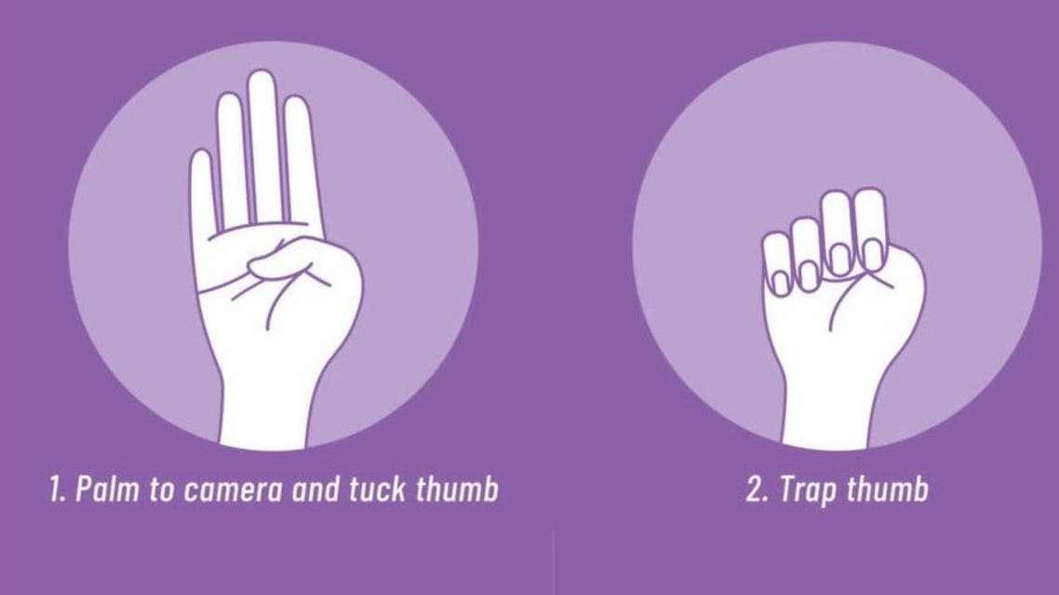Ms. Parker also asked how residents and businesses can be alert to and identify human trafficking. Capt. McBrien mentioned that all hoteliers are required to attend training. Mr. Bruce Doyle mentioned that he recalled a hand gesture that can covertly signal that someone is a victim. See adjacent graphic: **Signal for Help** (or the **Violence at Home Signal for Help**) is a one-handed gesture that can be used over a video call or in person by an individual to alert others that they feel threatened and need help. The signal is performed by holding one hand up with the thumb tucked into the palm, then folding the four other fingers down, symbolically trapping the thumb by the rest of the fingers.

The next CAC meeting will be Wednesday, October 11, 2023 at 7:00 PM in the conference room of VBVRS Station #14 (740 VB Blvd). Chaplain Gray indicated that he would ask if **Samaritan House** could present at that meeting.