**Mindfulness, Grounding and How I can Help Myself when Struggling**

Choosing to use exercises to ground us: These are things we can choose to do to bring our self into contact with the present moment – the here and now.   
The aim of using these strategies is to keep us rooted in our body rather than get all caught up in struggles of our mind (in the past, future or another place).  
Different strategies work for different people, and there is no “wrong” way to ground ourselves in the present. The main aim is to keep our mind and body connected and working together.

mindfulness is helpful for many situations where we find ourselves becoming overwhelmed or distracted by distressing memories, thoughts or feelings.  
Often when we are having a "psychache" our mind and body are hurting, overwhelmed and in need of something. Doing mindfulness strategies can help at this time to give our mind and body a break from the struggles.  
  
  
Examples of fast mindfulness strategies:  
Stamp your feet, and notice the sensation and sound as you connect with the ground.  
Cup or gently tap body from toes to head  
Hug self  
Talk to self "I am in 2019, I'm in the room, I am sitting on a chair, I am safe", i am ok".  
Drink a glass of water  
Pat a pet  
Controlled breathing. Focus your attention fully on each breath, on the way in and on the way out say "calm" or "relax"  
Swing legs or walk  
Splash some water on face. Notice how it feels. Notice how the towel feels.  
Feel the clothes on your body. Notice how your feet feel to be encased in shoes or socks.  
If you are sitting, feel the chair under you and the weight of your body and legs pressing down onto it.   
Stop and listen. Notice and name what sounds you can hear nearby.  
Look around you, notice what is front of you and to each side.   
Clap and rub your hands together. Hear the noise and feel the sensation in your hands and arms.  
Stretch.  
Use senses: Notice five things you can see, five things you can hear, five things you can feel, taste, or smell.  
  
  
Examples of other mindfulness strategies which take a bit more time:  
Have a cup of tea (non caffeine)  
Seek out comfort items (photos of loved ones, heat pack, blanket etc.)  
Progressive muscle relaxation (tighten muscles then let tension go)  
Swim or float at a pool  
Put on a piece of instrumental music. Give it all of your attention.  
If you have a garden or some plants, tend to them for a bit. Plants, and actual soil, can be an excellent “grounder!”  
  
Examples of more expensive mindfulness strategies:  
Float in bath salts or magnesium   
Massage  
Mindfulness or yoga class  
Join a sport  
Aromatherapy or essential oil or perfume spray

YouTube clips

**Yin yoga** <https://youtu.be/T2gMDDZTv9k>  
**Progressive muscle relaxation** <https://youtu.be/ihO02wUzgkc>  
**Breathing exercises** <https://youtu.be/395ZloN4Rr8>

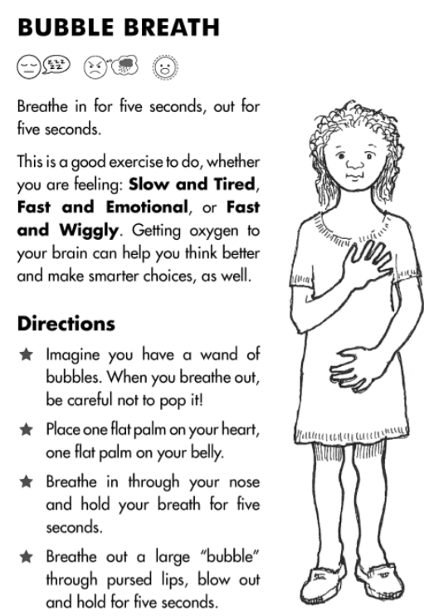

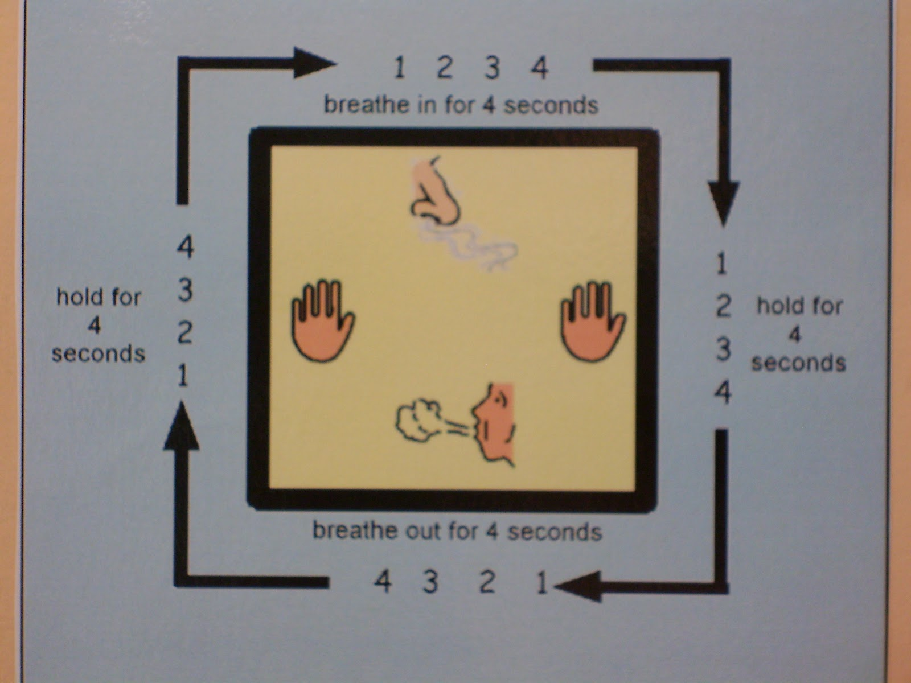

**How I can Help Myself when Struggling**

In struggling time these exercises can help me to get back into my body, live in the here-and-now (not in the past or future, soothe myself and be compassionate to myself.

Ill try Buddha belly breathing. For a few moments ill focus on my breathing and my belly. Ill try not to move my shoulders. First ill take a big breathe out through my mouth. Ill hear the air release. Ill feel my belly-button moving inwards towards my spine. Then ill take a breathe in through my nose. Ill feel my belly move out away from my spine like a Buddha belly full of air. Ill repeat this 10 times. Controlled breathing slows the respiration rate. Our breathing rate has an impact on our heart rate, blood pressure and the rest of our body. Breathing at the correct rate slows bodily processes, lowers arousal, and in turn reduces tension and stress and helps turn off the ‘fight/flight’ response.

Say "This is my body, my container". Stamp my feet on the ground. Say: "Every human being has a body. This is what it feels like to have a human body. Tap my body lightly from my toes to my head to remind my brain that I’m in my body, not in my past memories, future worries or daydreams.

Say "I’m not in the past I’m here today.”

Ill use my senses to reassure my brain that I’m not in the past. Say: "4 things I can see around me are... 3 things I can feel are... (touch/rub things like my skin, clothes & stamp feet on the ground) 2 things I can hear around me are... 1 thing I can smell is..."

When my mind wanders off into the past or future I wont bully myself. Its normal and natural for minds to wander. Ill say "Isn’t that interesting my mind has wandered off". Ill gently un-hook and bring myself back to the here-and-now. I can do this anywhere. I may be in conversation, meditation, doing housework or driving. The more I gently bring myself back to the present the more I am living and not missing out on my life.

Scan the body from head to toes and send love and soothing to tense/painful areas. Say: “In this this moment may this pain/tension ease. I care about this pain/tension. Thousands of other people feel pain/tension like this. For this moment may this body be at ease".

Be mindful: I can eat a raisin mindfully. Pick it up, noticing how it feels in your hand. Look at it carefully; see the asymmetries and think about the changes the grape went through. Roll the raisin in your fingers and notice the texture; try to describe it. Bring the raisin up to your mouth, paying attention to how it feels to move your hand that way. Smell the raisin; what does it remind you of? How does a raisin smell? Notice that you're beginning to salivate, and see how that feels. Open your mouth and put the raisin in, taking time to think about how the raisin feels to your tongue. Chew slowly, noticing how the texture and even the taste of the raisin change as you chew it. Are there little seeds or stems? How is the inside different from the outside? Finally, swallow.

Relax myself: I can take a hot bath/shower, take a walk, listen to calm music (neutral and gentle music which doesn’t remind me of struggling times or even exciting times). Meditate. Search YouTube for short meditations.

Ill nurture my body through kind touch with caring intentions towards myself. Ill simply put a hand on my heart, head and/or stomach. Ill hug myself. Ill gently squeeze my arms. Ill gently stroke my arms or legs. Ill massage tense areas. Ill gently rock my body. We are hard-wired for supportive touch. E.g. physical touch, like cuddling myself or others, can release the cuddle/love hormone "oxytocin" which can help comfort me. Physical touch also reduces cortisol and calms cardiovascular stress.

Say a coping thought to myself: "I’m strong enough to handle what is happening to me right now.” Say a kind and compassionate sentence or a word to myself like: "I deserve kindness" or "I have good intentions" or "I’m a good person" or "I’m doing my best, and I’m making progress even if I’m not entirely where I want to be yet.” Send a wish to myself like: "May I be calm" or "may I have patience" or "may I learn to love myself". I don’t need to believe these messages but it is helpful to say this to myself. Because thoughts and emotions have the same effect on our bodies whether they’re directed to ourselves or to others, words of self-compassion may be a powerful trigger for the release of oxytocin. Behind intense sadness, rage, and despair there is a caring, loving, and strong person who is capable of handling intense negative situations in a healthier way.

I will be active. My mind will be here with my body 100% while I’m being active. Exercise, Walk, Jog, Gym, Weights, Exercise class, Boxing, Cleaning, Washing, Dishes, Vacuuming, Dusting, Gardening, Cooking, Call a friend, Go out to lunch or dinner, a coffee, Shopping, Favourite movie, Favourite book, Favourite music, Favourite TV show, Books/movies/music that create a different emotion, Magazines, Newspaper, Games, Puzzles, Volunteer somewhere, Give someone a present, Do something thoughtful, Make something for someone.

Ill soothe myself. Have a good meal, Have a nice snack, Favourite drink (non-alcohol), Have a picnic, Light a candle, Look at beautiful art or scenery, Watch the stars, Go to a beautiful place, Soothing or invigorating music, Enjoy sounds of nature, Singing, Be aware and let sounds come and go, Favourite perfume, Favourite lotion, Enjoy smells of nature or flowers, Bubble bath, Shower, Massage, Pat dog or cat, Soak feet, Brush hair, Do nails, Create meaning/purpose from distress, Read/think of your spiritual values, focus on any positive aspects in your life, Pray or think of things I am grateful for, Relaxation tape, Tense and release muscles, Slow breathing, Count to 10, Smile, watch comedy or laugh out loud, Take a break (stay in bed for 20mins). Ill remember there is no point in doing these activities unless my mind is there with my body 100%

I can use my imagination: Imagine a relaxing scene/safe place Imagine coping/distress flowing away/distress passing Imagine my emotions sitting with me in the corner. They are not my best friend nor my enemy. They are an acquaintance. I can imagine a vacation where I can take a break from all your stressors and return home ready to take on the challenges you left behind. I will "return" better able to tolerate my circumstances.

I can do progressive muscle relaxation where I tighten/clench different muscles in my body for 6 seconds and then release/relax/rest muscles for 3 seconds. E.g. clench my jaw then release and relax my jaw. The muscle will become more relaxed than it was before it was tightened. Relaxed muscles require less oxygen, so your breathing and heart rate will slow down.

Distraction can help me feel better by diverting my attention away from my distressing thoughts, emotions and body reactions. It works even better if I find meaningful activities or important people to distract me. helpful to make a list of some pros and cons of tolerating distress (i.e. not acting impulsively)

I can focus on long-term goals, the light at the end of the tunnel. I can remember times when I have tolerated distress (without acting out or being self-destructive or acting impulsively) and the pain has ended. There are positive consequences of tolerating distress without reacting behaving in unhelpful ways).

I can try ‘Look, Think, Act’ process: 1. Look: Ill observe. What’s going on? What’s happening inside me? 2. Think: How do I feel about that? What’s the main problem? Why is this happening? How am I behaving (e.g. are my responses defensive, grounded in my past)? What are the consequences? Which area/s can I move forward with? When and How should I do it? 3. Act: Take action, or do something. What could/should be done differently to get a good outcome?

Ill cool down. When I’m upset my body can often feel hot. To counter this, ill splash my face with cold water, hold an ice cube, or let the car’s AC blow on my face.

I can do intense exercise to match my intense emotion. Sprint down to the end of the street, jump in the pool for a few laps, or do jumping jacks. Increasing oxygen flow helps decrease stress levels. It’s hard to stay dangerously upset when I’m exhausted.

I can try “box breathing”. Each breath interval will be four seconds long. Take in air four seconds, hold it in four seconds, breathe out four, and hold four. And then start again. Focus on this breathing pattern until I feel more calm. Steady breathing reduces body’s fight or flight response.

I can contribute: I can do something kind for another person. Giving service can help relieve emotional distress by getting my mind off of the problem and help me feel good about supporting someone else. I can help cook dinner, mow the neighbour’s lawn, or bake cookies for a friend or relative etc.

Distress tolerance strategies to use when I’m angry or frustrated: I can try something physical and violent, something not directed at a living thing: Slash an empty plastic soda bottle or a piece of heavy cardboard or an old shirt or sock. Make a soft cloth doll to represent the things you are angry at. Cut and tear it. Flatten aluminium cans for recycling, seeing how fast I can go. Hit a punching bag.

Use a pillow to hit a wall, pillow-fight style. Rip up an old newspaper or phone book. On a sketch or photo of myself, mark in red ink what you want to do. Cut and tear the picture. Make Play-Doh or other clay models and cut or smash them. Throw ice into the bathtub or against a brick wall hard enough to shatter it. Break sticks.

Distress tolerance options to use when I’m feeling sad, depressed, unhappy: Do something slow and soothing, like taking a hot bath with bath oil or bubbles. Curl up under a comforter with hot chocolate and a good book. Baby myself. Do whatever makes me feel taken care of and comforted. Light sweet-smelling incense. Listen to soothing music. Smooth nice body lotion onto the parts of myself that I might want to hurt. Call a friend and just talk about things that I like. Make a tray of special treats and tuck myself into bed with it and watch TV or read. Visit a friend. Play a friendly, easy computer game. Make a list of the things I’m grateful for.

Distress tolerance options to use when I’m feel overwhelmed or obsessed with negative thoughts: Watch a funny movie. Watch a cartoon movie. Watch children’s programs. Watch educational programs. Watch programs about nature. Avoid watching violent television

Distress tolerance options to use when feeling out of my body, depersonalized, dissociating or unreal: Do something that creates a sharp physical sensation: Squeeze ice hard (this really hurts). (Note: putting ice on a spot I want to burn. It gives a strong painful sensation and leaves a red mark afterward, kind of like burning would.) Put a finger into a frozen food (like ice cream) for a minute. Bite into a hot pepper or chew a piece of ginger root. Rub liniment under my nose. Slap a tabletop hard. Snap my wrist with a rubber band. Take a cold bath. Stomp feet on the ground. Focus on how it feels to breathe. Notice the way my chest and stomach move with each breath. Claim my breath and body parts, like “this is my hand, this is my nose.” Touch those parts and notice how they feel as if I’d never touched them before. Cover my arms with a layer of Elmer’s glue and let it dry (or dry it with a hairdryer if I am impatient). Slowly, gradually pick the glue off my skin.

Distress tolerance options when I want to focus:Do a task (a computer game like Tetris or minesweeper, writing a computer program, needlework, etc.) that is requires focus and concentration. Try to balance an egg on it’s short side. Eat or drink something that I really like, but I can do it slowly and notice every sensation - taste, texture, aroma, etc. Memorize a poem or prayer. Choose an object in the room. Examine it carefully and then write as detailed a description of it as I can. Include everything: size, weight, texture, shape, colour, possible uses, feel, etc. Choose a random object, like a paper clip, and try to list 30 different uses for it. Pick a specific subject and research it on the web. Don’t go off in any direction except my specific research.

If I can’t get my mind off unhelpful/distressing memories or flashback, try changing perspectives: I can write about my situation as if I was another person or a piece of furniture or a pet looking at it from a distance. I can write letters to people who I’d like to say something to. Ill be bold and won’t hold back. Then rip it up or dissolve it in water. Journal about my experience. Find an old photo of myself and make up a completely new fictional story about what is happening in the picture. Write a story where the subject is empowered and strong. Write my life story as if I had the happiest, most unique life in the world. It doesn’t have to be fiction. I can use real examples but pretend to see it from a different point of view. Leave out all the bad stuff. The more trauma I leave out, the funnier or playful the story starts to seem. In my mind, play out my life worries as cartoon characters. I can make the characters ridiculous and give them silly voices. Read a children’s story or any other story that’s not too complex out loud as if I was a storyteller.