Roman attitudes on the Gladiator Games

Source A: Cicero on the games:

To Atticus, April, 56 B.C. on the games and politics:
My word! You have purchased a fine troop! Your gladiators, I am told, fight superbly. If you had chosen to let them out you would have cleared your expenses by the last two spectacles.
I realize that in our country it has become a custom to expect magnificent entertainments from the very best men. Crassus gave most magnificent entertainments. And my friend Pompey's exhibitions were the most magnificent of all.

If such entertainment is demanded by the people, men of right judgment must at least consent to provide them, even if they do not like the idea. But in so doing they should keep within their means, as I myself did.

SOURCE B: Cassius Dio on Julius Caesar’s games:

As for the men, he not only pitted them one against another singly but he also made them fight together in companies in the Circus, horsemen against horsemen, men on foot against others on foot, and sometimes both kinds together in equal numbers.

There was even a fight between men seated on elephants, forty in number. Finally he produced a naval battle; not on the sea nor on a lake, but on land; for he hollowed out a certain tract on the Fields of Mars and after flooding it introduced ships into it.

In all the contests the captives and those condemned to die took part; yet some even of the citizens, and, not to mention others, the son of one who had been in office fought in single combat.

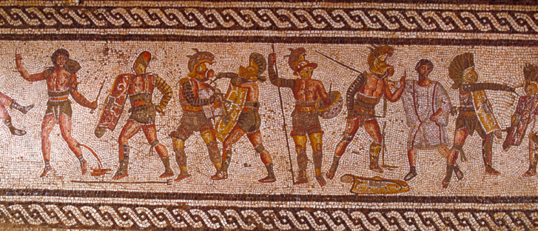

SOURCE C: Seneca on the games
“In the morning men are thrown to bears or lions, at midday to those who were previously watching them.

The crowd cries for the killers to be paired with those who will kill them, and reserves the victor for yet another death. This is the only release the gladiators have.

The whole business needs fire and steel to urge men on to fight. There was no escape for them. The slayer was kept fighting until he could be slain.

'Kill him! Flog him! Burn him alive!' (the spectators roared) 'Why is he such a coward? Why won't he rush on the steel? Why does he fall so meekly? Why won't he die willingly? "

SOURCE D: Suetonius writing about the games of Augustus

No one before had ever provided so many, so different or such splendid shows. He records the presentation of twenty seven games. Gladiators fought not only in the Forum or amphitheatre, but in the Circus and Saepta as well; or the show might, on the contrary, be limited to a wild beast hunt. He also dug an artificial lake beside the Tiber for a mock sea battle. No person of good family appeared in the show, with the exception of Lycius: he was a drawf, less than two feet tall, but had a tremendous voice. Whenever a strange or remarkable animal was brought to the city, he used to exhibit it in some public space, for instance a rhinoceros in the market, a tiger at the theatre, and a seventy-five foot long serpent in front of the Comitium.

Augustus had seduced the army with bonuses, and his cheap food policy and games were successful bait for civilians. Indeed, he attracted everybody's good will by the enjoyable gift of peace.

