Ancient Egypt Week
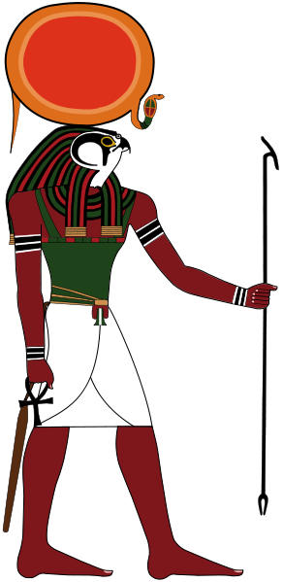

Why Egypt?

Most civilisations have been influenced by their environment. Ancient Egypt owed much of its character to the nature of the river Nile, the shape and length of the Nile valley, the enclosing deserts and the climate. The Nile River and the sun were the two great forces, which dominated the lives of the ancient Egyptians. Their gifts of water, fertile soil and warmth created life. On the other hand, they also had the potential to bring destruction and death.
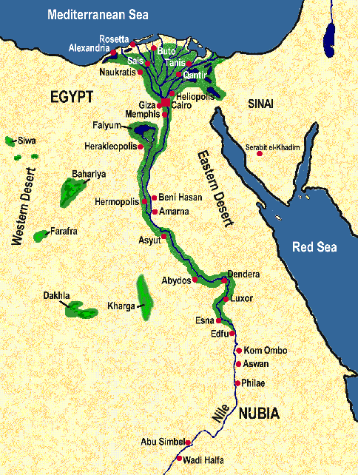
The Nile River

The Nile, referred to by ancient Egyptians as simply the Iteru or The River transformed an almost waterless waste of desert into one of the most fertile places on earth due to the accumulation of alluvium or alluvial soil (silt carried and deposited by rivers and steams). The Nile’s life giving waters and annual deposits of rich black soil enabled the Egyptians to develop a prosperous agricultural society.

The Nile’s source is in tropical Africa. The White Nile begins in Lake Victoria in east Africa, while the Blue Nile starts in Lake Tana in the snow covered Ethiopian mountains. These two large rivers merge in the Sudan to form the Nile.
Until the construction of the Aswan Dam in 1970, the Nile cut its way for over 1300 kilometers through the deserts of Nubia. Its flow was interrupted six times by rocky cataracts (rapids) before it entered Egypt.

The Nile in Egypt is hemmed in by sandstone and then limestone cliffs. In places the fertile strip of land bordering the Nile was so narrow that the desert hills almost rose up out of the river. At other places the muddy river flats extended many kilometers on either side of the Nile.

Further north, a branch of the Nile flowed westward into a depression 50 metres below sea level. This depression caught the surplus floodwater and acted as a reservoir when the water level of the Nile was low. The land, which was periodically reclaimed from this huge lake, was fertile and rich in wildlife. Today it is called the Faiyum.

Just north of the ancient capital of Memphis, the river divided into a number of large branches (seven according to Herodotus) and many smaller ones as it wound its way to the Mediterranean Sea. Silt was deposited in a large triangular or fan shaped formation which the Greeks called the delta because it resembled the shape of the fourth letter of their alphabet.

It has been observed, that the valley, Faiyum and delta areas looked and still look like the long stem, bud and flower of the lotus that played that important part in Egyptian symbolism for 3000 years. According to the myth, it was the opening of the lotus flower from which the sun god (Horus) was born.

The annual flood of the Nile

Every year, at the same time, the Nile flooded. This annual flood, referred to as the inundation of the Nile, was without doubt the most important event in the lives of the Egyptian people. It sustained life along the valley.

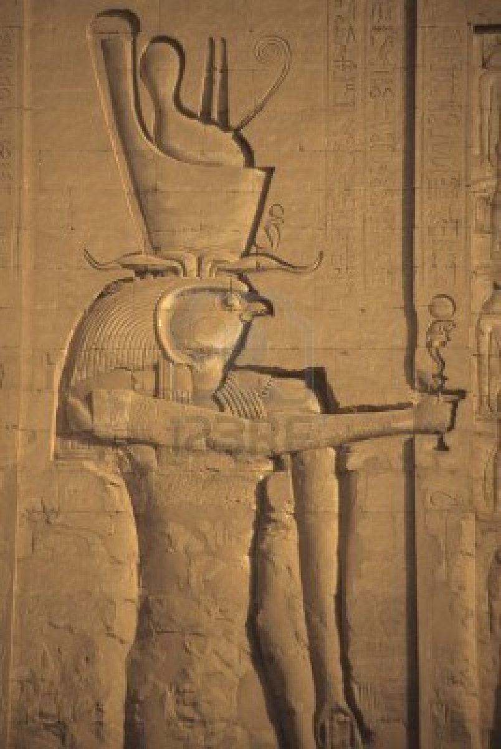
During June, the Nile began to rise and green water (containing vegetable matter) appeared everywhere along the valley between Aswan and Memphis. The waters continued to rise and by August they were a dark, muddy colour, due to the eroded material it contained. The floodwaters reached their peak during September and after several weeks began to drop. By May the following year, the river levels were at their lowest.

The timing of the flood and the height of the waters were critical for the inhabitants of the valley. Ancient records indicate that when the river rose by seven and a half metres at Elephantine Island there was enough water for the needs of the country. However, a flood over eight metres was dangerously high while a height of six metres was perilously low.

The Nile made Egypt. As Herodotus remarked, ‘Egypt is the gift of the river’.
Horus – the sun god

The Black Land

The land known as Egypt in antiquity was called the Black Land or Kemet because of the fertile black silt or soil which the Nile, in flood, deposited over the valley every year.

The Black land consisted of:

- The long narrow river valley enclosed by desert cliffs (Upper Egypt)
- The huge, lush, fan-shaped lowland are known as the delta (Lower Egypt)

In ancient times these two distinct physical regions were known as the Two Lands – The Land of Upper Egypt and the Land of Lower Egypt. Although these lands were eventually united, they both had distinctive characteristics. They spoke different dialects and would probable have felt like foreigners in each other’s land.

Upper Egypt or Shemau

Upper Egypt extended from the first cataract to just north of the ancient capital of Memphis, a distance of approximately 800 kilometres. It comprised a long narrow trough, between three and eighteen kilometres wide. It was somewhat isolated from the outside world by the deserts on either side. The amount of land available for agriculture was limited and life depended on the annual flood for survival. The perpetual sunshine produced a brilliant light. The emblem of Upper Egypt was the sedge (a type of reed) and its chief god was the vulture goddess, Nekhbet.

Lower Egypt or To-Mehu

Lower Egypt was a broad triangular or fan shaped area of land with its apex just north of Memphis and its base extending along the Mediterranean coastline. It covered an area twice the size of Upper Egypt and was more fertile. Its marshes were thick with Papyrus reeds and teemed with birds and wildlife. The climate was milder than Upper Egypt.
Because of its coastline it was more open to contact and attack from the outside world. The emblem of Lower Egypt was the bee and the main god was Wadjet, the cobra goddess.
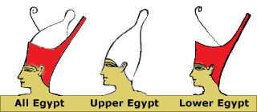
Before the two lands were united in 3100BC, the ruler of Upper Egypt wore a tall conical white crown, whereas the ruler of Lower Egypt wore a red crown.

The Red Land

In contrast to the fertile Black Land of the valley and delta, the deserts were referred to as the Red Land or Deshret because of their dominant colour.

It was in the deserts were the Egyptians buried their dead, built some of their temples and hunted wild animals. The deserts to the west (Libya) provided little interest for the ancient Egyptians apart from some trade links. However, the deserts to the east were massively exploited by the Egyptians for minerals, building materials and semi-precious stones.
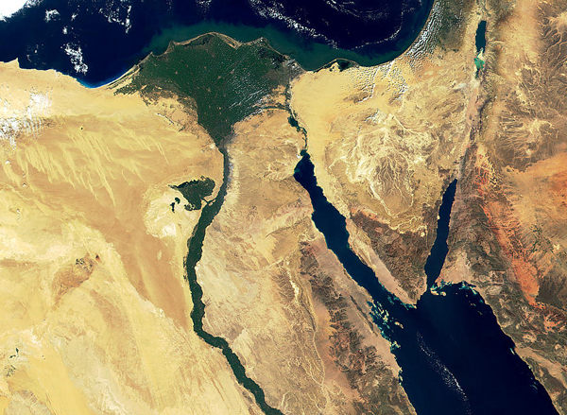

The effect of the physical environment on Egyptian lifestyle

The ancient Egyptians developed a distinctive lifestyle and belief systems because:

- They lived in a long, narrow valley and marshy delta enclosed by barren, inhospitable deserts
- They were totally dependent on the life giving Nile
- They enjoyed a climate where the sun shone constantly and where there was virtually no rain

The yearly calendar

There were three seasons in the yearly calendar:

- Akhet
- Perit
- Shemu

Akhet was the season of the flood, which began sometime in July. The first day of the inundation was one of only two days when a king could hold his coronation.
At this time, most of the large scale building projects were carried out, since the floodwaters allowed barges to transport building materials closer to the building sites. While the land was under water farmers were conscripted to work in gangs on the construction of temples and other major works. Normally, as their land was under water, they had very little to do anyway.

Perit, which began in November was called the season of coming forth. It was the time of sowing the seeds. The first day of this season was the other time a king could have his coronation. This was the period of the most intensive activity along the Nile. Farmers raced against time to conserve the floodwaters by repairing dykes and cleaning out ditches and canals, spreading the rich silt, ploughing the fields and sowing the seeds before the land became too dry.

Shemu was the season of harvest and began sometime in early March. A yearly festival to the god of fertility, Min, was probably the highlight of the year for most Egyptians.
Farmers harvested, threshed, winnowed, stored and transported the grain while scribes recorded the harvest, carried out the census, assessed and collected taxes.

Administration
As all Egyptians depended on the Nile for their survival it was necessary to have a central authority to control water supplies. The jobs which needed doing were – predicting the time and nature of the flood, planning irrigation works, organising the local community to restore the land after the flood and remark farm boundaries which had disappeared with the floodwaters.

A normal flood could be easily controlled, but a flood of 1.5 metres lower than normal meant food shortages and a flood 30 to 60 centimetres higher than normal was destructive.

The work gangs made up of locals to build, repair and maintain irrigation schemes was onerous but necessary.

Taxes were assessed based on the height of the flood. For example, some land always received the benefit of the flood whilst others were covered with water some years and not others. Nilometres were built along the Nile to measure the maximum, minimum and average flow of the flood. Usually these were in the form of a staircase leading up from the river. The Greek geographer Strabo commented:

“There are marks which measure the height of the water for irrigation. They are used by the farmers to measure the flow of the water and by the officials to establish the amount of taxes. In fact, the higher the water the higher the taxes.”

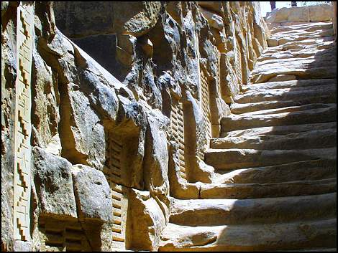

Communication and transportation
The river was the chief highway of the ancient Egyptians. It linked all the villages and towns together. Additionally, the Egyptians did not have wheeled vehicles or horses until approximately 1600BC.

Travel up and down the river was made easier by the wind and current of the Nile. As the wind blew upstream, boats could use their sails to move from north to south and of course the current helped travel downstream to the Mediterranean. Interestingly, the Egyptian Hieroglyph for travelling up stream was a boat with sails, and travelling downstream was a boat with oars.

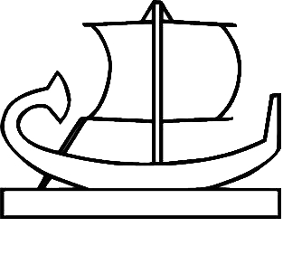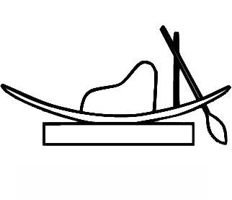
Building, crafts and decorative arts
The rich alluvial soil and the swamps and marshes of the Black Land provided building materials for domestic architecture, resources for Egyptian crafts and decorative themes for Egyptian art.

Nile mud was used for brick making; Sun-dried mud-brick was the main building material for all domestic buildings, including the royal palaces. It was ideal in a land, which was virtually rainless. It was quick and cheap. Unfortunately, only very few of these buildings have survived.
Limestone and sandstone from the desert cliffs bordering the Nile were the chief building material in temples and tombs. Granite was also used for the sarcophagi of royalty.

The papyrus reed which grew profusely along the marshy banks of the Nile provided the raw materials for many everyday items – flat bottomed fishing boats, sandals, ropes, baskets, mats and fine white paper – called simply papyrus.

The deserts were exploited for metals (such as copper and gold) and jewels to make jewellery and funerary items. Fine statues were sculpted from basalt and reddish quartzite. Many of the motifs (paintings) used in decorating public and private buildings were taken from the river landscape.
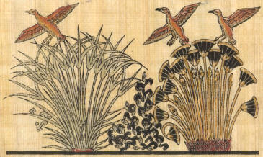
The effect of the physical environment on Egyptian beliefs and morality

Egyptian religious beliefs were partly inspired by the nature of the land and its climate. The physical environment was reflected in:

- Their view of creation
- The nature of the Gods
- Their belief in life after death and the nature of the afterlife

The Egyptian concept of creation

This was expressed in a number of myths and stories. Although they varied from one another in certain details, the message was always the same.

Elements of the myths | Features in the environment
At first the whole earth was covered with water (the waters of chaos)  A mound of earth or an island emerged from the waters  The first god appeared on this mound and created life | During the annual inundation the Nile valley was covered with water  The floodwaters receded leaving small hills or mounds of earth  From the rich silt which covered the land, new life sprang up

The Egyptian Gods (the main ones)

Many of the Egyptian gods symbolised some aspect of the natural environment such as the sun, the Nile River and the rejuvenating flood. Some gods represented the qualities found in the creatures that lived along the Nile valley such as the cobra and the falcon.

Re/Ra – the sun god was the most important deity throughout Egyptian history. He was depicted in many forms – I.e. As a falcon headed man with a sun disk on his head, as a child arising from a lotus flower (Horus was the main god before Re came to prominence and both were combined form Re-Horus)

Hapi – was the spirit of the Nile. He was depicted as a man with a pendulous belly ( a sign of a prosperous, well fed man), the breasts of a woman (fertility and nourishment), a cluster of lotus and papyrus plants on his head, a girdle or belt and a table of offerings

Osiris – symbolised the energy behind the life giving flood and the new growth. Unfortunately for him he was killed by his brother Seth, chopped up and scattered all over Egypt. His wife Isis (Isis and Osiris were Horus’ parents) found all his body parts and put him back together…that is all except his penis…which had been thrown into the Nile and eaten by a catfish! Osiris was the god of the afterlife. Oh, and Horus was conceived after Osiris’ corpse had been patched back together. Nice. And…Isis and Osiris were sister and brother.

Seth/Set – was always associated with the deserts and was a bit of a git (see above). To the Egyptians, the desert was a dangerous place full of wild animals. It was also where the dead were buried. Seth was god of the desert and almost everything else which terrified the Egyptians – storms, wind, rain and thunder. He is depicted as having the head of a jackal. He had a war with Horus and some myths describe Set poking out Horus's left eye, and Horus retaliating by castrating Set.

The afterlife

To the Egyptians, the cycle of life, death and rebirth was apparent in the patterns of nature: the sun appeared to die each evening in the west and be reborn each morning in the east. The flood of the Nile valley and then the rebirth.

The western desert became the Land of the Dead where the necropolis (cemeteries) were located. The jackal, which roamed the desert, became the symbol of Anubis, god of the dead and guardian of the necropolis.

During the New Kingdom, most people believed they would spend eternity in the Fields of Reeds, a place which closely resembled the delta with its lush meadows, water courses and canals. Kings were thought to spend eternity riding across the sky in the boat of the sun god, Re.
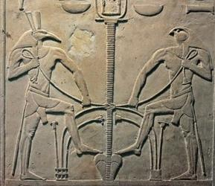

Herodotus on ‘Mummies’ – Book 2: 83

‘Mummification is a distinct profession. The embalmers, when a body is brought to them, produce specimen models in wood, painted to resemble nature and graded in quality; the best and most expensive kind is said to represent Osiris, the next best is somewhat inferior, while the third is cheapest of all. The most perfect process is as follows: as much of the brain is extracted through the nostrils with an iron hook, and what the hook cannot reach is rinsed out with drugs; next the side of the body is opened with a flint knife and the whole contents of the abdomen removed; the cavity is then thoroughly cleansed and washed out, first with palm wine and again with an infusion of spices. After that it is filled with pure bruised myrrh, and every other aromatic substance with the exception of frankincense, and sewn up again, after which the body is placed in natrum, covered entirely over, for seventy days – never longer.

When this period, which must not be exceeded, is over, the body is washed and then wrapped from head to foot in linen cut into strips and smeared on the other side with gum. In this condition the body is given back to the family, who have a wooden caste made, shaped like the human figure, into which it is put. The case is then sealed up and stored in a chamber, upright against the wall.

When for reasons of expense, the second quality is called for, the treatment is different: no incision is made and the intestines are not removed, but oil of cedar is injected with a syringe into the body through the anus which is afterwards stopped to prevent the liquid from escaping. The body is then pickled in natrum for the prescribed period of days, on the last of which the oil is drained off. The effect of it is so powerful that as it leaves the body it brings with it the stomach and intestines in a liquid state, and as the flesh, too, is dissolved by the natrum, nothing of the body is left but the bones and skin. After this treatment it is returned to the family without further fuss.

The third method, used for embalming the bodies of the poor, is simply to clear out the intestines with a purge and keep the body seventy days in natrum. It is then given back to the family to be taken away.

When the wife of a distinguished man dies, or any woman who happens to be beautiful or well known, her body is not given to the embalmers immediately, but only after the lapse of three or four days. This is a precautionary measure to prevent the embalmers from violating the corpse, a thing which is said actually to have happened in the case of a woman who had just died. The culprit was given away by one of his fellow workmen. If anyone, either an Egyptian or a foreigner, is found drowned in the river or killed by a crocodile, there is the strongest obligation upon the people of the nearest town to have the body embalmed in the most elaborate manner and buried in a consecrated burial place; no one is allowed to touch it expect for the priests of the Nile – not even relatives or friends.

Sources for Egyptian history

In the fifth century BC the Greek historian Herodotus, on a visit to Egypt, marveled at the number and size of the monuments, some of which were already 2000 years old

“About Egypt I shall have a great deal more to relate because of the number of remarkable things which the country contains, and because of the fact that more monuments which beggar description are to be found there than anywhere else in the world.”

Visitors to Egypt today can still marvel at many of the sites Herodotus would have seen – the pyramids, the massive stone statues, temples and tombs. With their painted hieroglyphic texts they provide a wealth of information on the ancient Egyptians. However, there are few reliable records of those events which affected Egyptian development and the lives of individual people. One Egyptologist, Gardiner, says that “what is proudly advertised as Egyptian history is merely a collection of rags and tatters.”

Written sources

The written records left by the ancient Egyptians are to be found:

- Carved into walls of temples
- Inscribed onto stelae (stone pillars) found in tombs and temples and wherever Egyptians felt the need to commemorate a military victory, the founding of a new city, or a successful mining expedition
- Painted or inscribed onto coffins and sarcophagi
- Written on papyrus
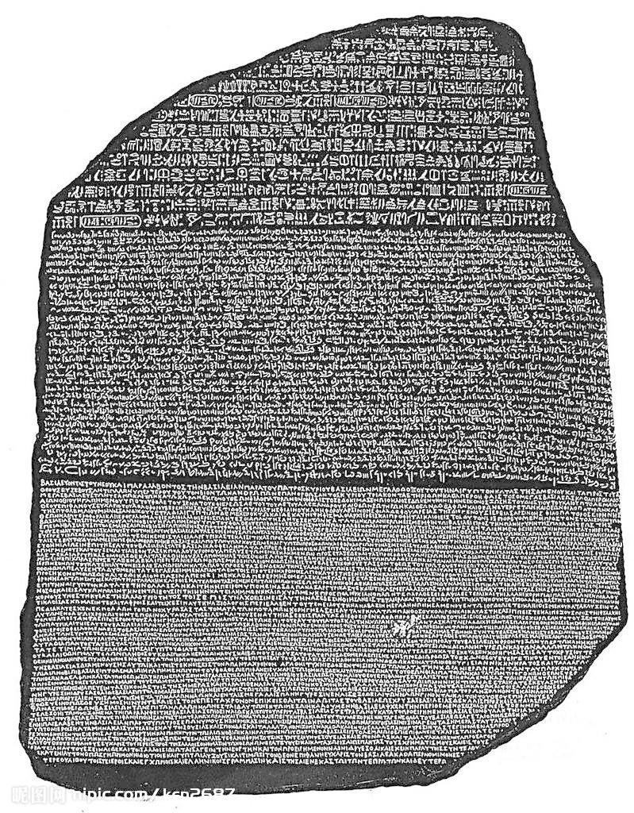
- Written onto ostraca (broken pieces of pottery)

None of these could be read before the nineteenth century and the discovery of the Rosetta Stone.

The Rosetta Stone

A black basalt stone, discovered in 1798 at Rosetta in the Egyptian delta, provided the key to understanding the mysterious Egyptian picture writing – hieroglyphics.

The Rosetta stone was an inscription in honour of an Egyptian pharaoh named Ptolemy Epiphanes (196BC). It was written in Greek and in two Egyptian scripts – hieroglyphics and demotic/hieratic (shorthand). Since the Greek could be read it allowed the Egyptian scripts to be translated. It took many years of dedicated work before Jean Francois Champollion cracked the code in 1824.

Hieroglyphic script

Hieroglyphics means sacred cravings. However, the term is now applied to all Egyptian writing, which uses pictures.
One of the reasons hieroglyphic script was so difficult to decode was because it is a combination of ideograms (pictures which stand for exactly what they are), phonograms (pictures which stand for sounds) and alphabetic consonants. No vowels were written

For example, a billowing sail means wind, a picture of a loaf stands for the letter t, a swallow stands for the sound wr as well as the word great and a beetle stands for the sound hpr but also means to become.

Because many of the pictures are ambiguous it was often necessary to add another sign, called a determinative, to clarify what was actually meant. The deciphering of hieroglyphic script is made even more complicated by the fact that sometimes it is read from top to bottom, sometimes from right to left and sometimes from left to right.

Hieratic script was a simplified form of hieroglyphics, developed to make writing quicker and easier. It was particularly suited to writing on papyrus.

Cartouches

This is a rope loop or royal ring, which surrounds the names of kings and queens and helped decipher the hieroglyphs. Each king hag 5 names, and two of these – the one he was given at birth and the one he assumed when he became king – were surrounded by a cartouche. The rope rings were thought to magically protect the king and were also a symbol of the king’s authority over the world.
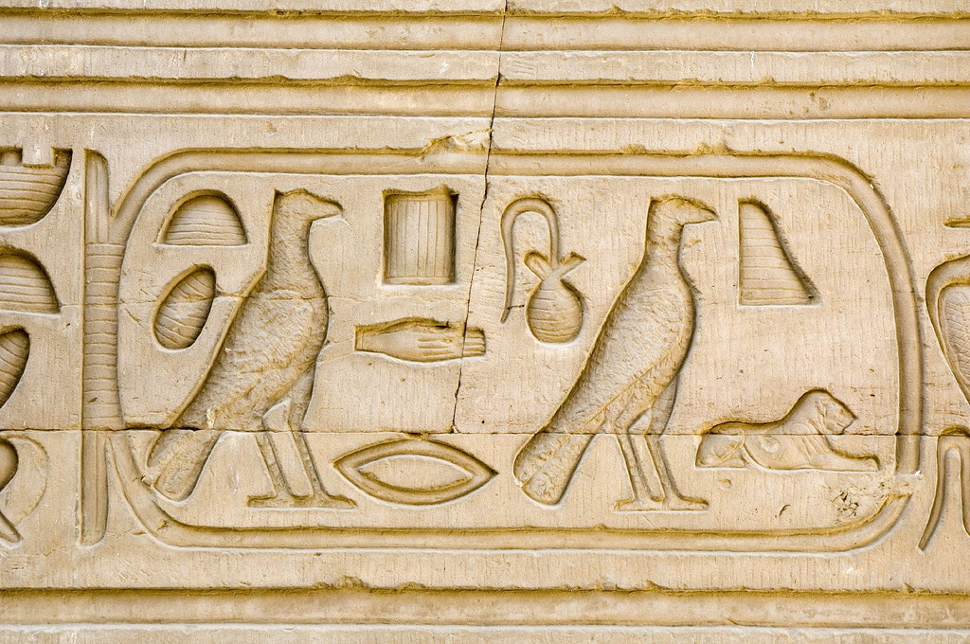

Monumental inscriptions
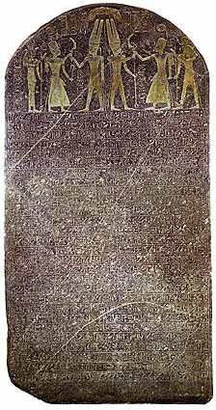
The hieroglyphic records carved on the walls of temples and on freestanding stelae are called monumental inscriptions. The purpose of these was to glorify the pharaoh by commemorating his deeds and virtues and to honour the gods. It was a form of propaganda and they were always displayed in public places.

The royal inscriptions reflected the Egyptian belief in the king as a god, the protector of his people, the leader of the nation during war and the intermediary between the gods and the people.

They included records of military victories, treaties and decrees, building activities, mining, trading expeditions, endowments to the people and offerings made to the gods. They also depicted the king in his role as high priest and highlighted the monarch’s physical prowess.

Funerary texts

The Egyptians believed in life after death and in order to pass safely from one side to the other they relied on a whole collection of magical spells and prayers – funerary texts. These were written on the walls of royal burials – in tombs and pyramids (pyramid texts) – and also on the coffins (coffin texts) of well to do Egyptians in the Middle Kingdom era (2040-1640BC).

During the new kingdom, 1550-1070 BC, these texts were written on papyrus rolls and placed near the body of those people who could afford it. The papyrus book was referred to as The Book Of Coming Forth By Day but is more commonly known today as The Book of the Dead. Those who could afford it had individual copies, and others had of the shelf copies.

Other written records

Autobiographies of officials – Egypt was run by a vast bureaucracy of officials, the head of which was the vizier – first under the king. Like the king, these men wanted to record their achievements, but could only do so in their tombs. These autobiographies list titles and achievements, but always give credit to the king.

Official dispatches and records of judicial proceedings – Egyptian scribes kept careful records. Most official documents date from the late New Kingdom era. These dealt with water resources, taxes, grain supplies and building projects. There are some surviving letters between the Pharaoh and foreign princes, which tells us something about Egypt’s relationship with places such as Syria, Palestine and Babylon.

Instructions – This type of text is found in all Egyptian periods and reflects the ethical standards of society. The instructions were brief teachings aimed at guiding the members of the noble/official class in correct behaviour.

Domestic records – Written records about daily life in Egypt are sadly lacking. Thousands of Ostraca have been found which reveal something of the concerns and humour of the people. These fragmentary records include personal letters, complaints about neighbours, stories, laundry lists, the brewing of beer, getting drunk and offerings to the gods.

The problems associated with the written records

- The inequality in the preservation of records from one era to another and one area to another
- The disproportionate amount of funerary texts – these survived as they were in stone temples or tombs. Royal palaces and normal houses made of mud brick have all but vanished
- The idealized and distorted view of events – propaganda – in the monumental inscriptions. No failures are mentioned and Pharaohs sometimes stole the great deeds of previous Pharaohs and some went as far as to obliterate the scenes and texts of their predecessors to claim the achievements as their own
- The conservatism that led many Egyptians to record what was traditional rather than what actually happened – all Pharaohs are shown smashing the skulls of their enemies (traditional scene) whether they actually went to war or not
- The focus on upper class men, where women are mentioned it is from a male perspective
- The lack of chronology on the part of the Egyptian scribes – they did not see the point. They would record events according to a specific year in a king’s reign such as ‘in the year of fighting and smiting the northerners’ or in the year of the second census of all the large and small cattle.
- Also, as Pharaohs used 5 names and different records use a different name, it is difficult to ascertain who’s who.

In conclusion, the famous Egyptologist James says, “…the raw material for the writing of a satisfactory Egyptian history is insufficient and sketchy.”

The forming of Egypt

The years 5000 – 3100 BC are referred to as the Predynastic Period of Egyptian civilisation – that long period of time before the Two Lands of Egypt were united under the rule of one king/Pharaoh.

About 3100BC, the land of Upper and Lower Egypt were clearly united under one king. Menes is the traditional name given to this king, although the inscriptions point to a king named Narmer – these were probably the same person.

The period covering the first two dynasties of rulers is often referred to as the Archaic Period (3000 – 2705BC). These were the formative years of Egypt, a time of trial and discovery when most of the Egyptian traditions and institutions were established. During these years, a centralised state was established with a king at its centre. It is generally believed that the concept of divine kingship (a god king) was carefully worked out in detail at this stage and was to last for the next 3000 years. Memphis was established as the capital of the Two Lands.

War between Upper and Lower Egypt

There is much evidence of war between the peoples of Upper and Lower Egypt before unification. A number of Palettes (carvings) depict a king represented as a bull or lion, driving captives before him or holding them by a rope.
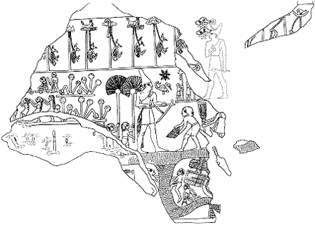
The Scorpion Mace-head – found in 1897
White crown of Upper Egypt
King Scorpion – holding a hoe
Official receiving the first basket of silt
An irrigation canal
Animal tail – worn by primitive chiefs
Lapwings – symbols of conquered people

The Scorpion King and Pharaoh Narmer

The first king of Upper Egypt that there is any evidence for is referred to as the scorpion king. A decorated mace-head from this period depicts a larger than life king, wearing the white crown of Upper Egypt with a hieroglyph of a scorpion above his head – hence the name. Historians believe he campaigned against Lower Egypt and paved the way for his successor, Narmer, to unit the two lands.

About 3100 BC, a king of Upper Egypt, believed to be Narmer, conquered Lower Egypt. The evidence for this comes from a commemorative palette, the Narmer Palette, found in near perfect condition at Hierakonopolis.
Obverse/front side

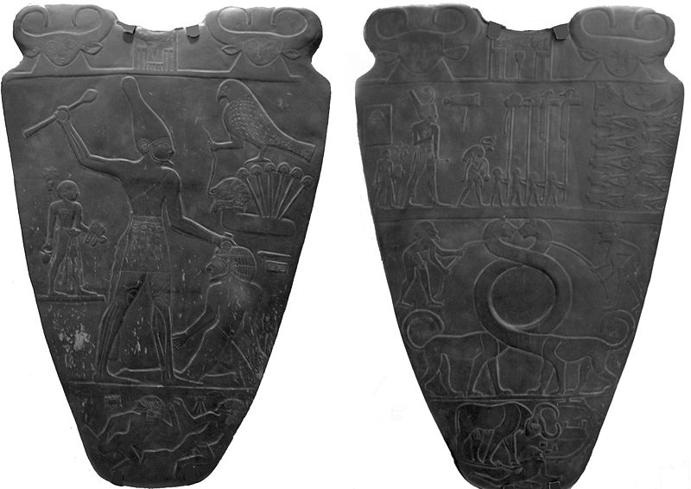

On the obverse side there are two heads of the goddess Hathor (depicted as a cow) surrounded by a very early form of a cartouche, enclosing Narmer’s name. Narmer, proportionally larger than the other figures is wearing the Red crown of Lower Egypt and is accompanied by his sandal-bearer and foot-washer. There is a priest and four standard bearers in front of the king. Roes of bound and decapitated bodies indicate Narmer’s victory. Two serpent-like creatures with intertwined necks may represent the two lands of Egypt. The King at the bottom, depicted as a mighty bull is trampling an enemy.

On the reverse side a huge figure of the king wearing the white crown of Upper Egypt holds a mace ready to smash the skull of his enemy. Again, the sandal-bearer is here. The falcon, which represented the king as the incarnation of the god Horus, is holding another captive by a rope. The captives are from the delta region (Lower Egypt), which is indicated by the papyrus plant. Two of the kings enemies are shown either fleeing or drowning.

The unification of Egypt was probably a series of campaigns and wars. Unification was regarded by later Egyptians as an event parallel to the creation of the universe.

The Pharaoh

Every king was regarded as the incarnation of Horus and given this as part of their name. Falcons were a common sight in Egypt and must have been a magnificent sight to the early Egyptians. They represented everything that was mysterious in nature and it is easy to see why Horus was the supreme god for the early Egyptians. Horus’ wings represented the sky and his eyes the sun and moon and regarded as the Lord of Heaven. Horus was the sun god and the supreme god until he was replaced and merged with Re, approximately 2400-2200 BC.

Although the two lands were united into one kingdom, each retained its on distinctive identity and emblems. This is reflected in the double crown work by all Egyptian kings after unification. Kings also wore an artificial beard (a symbol of a god), a tail of a bull or lion from their belt to symbolically protest their back, a shemset girdle with an apron made of pendent beads or marrow strips of leather which covered the kings loins and a crook (staff) – a symbol of a primitive shepherd.

The Egyptians believed in the concept of ma’at or divine order. They believed that without ma’at there would be chaos in both the physical and spiritual world. The king represented divine order and when he died the people feared chaos so a new king had to be crowned as soon a possible. Since the king represented ma’at, there was no need for a list of laws as the king knew best.

At the beginnings of the united Egypt it was thought only kings could have eternal life after death, but this would soon change.
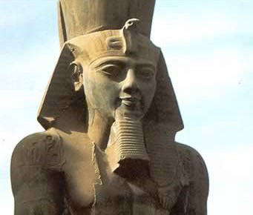

The Pyramid Age – King Djoser

The Third Dynasty (2649-2575 BC) marked the beginning of a new era. With the reign of its second king, Djoser (Netjerykhet), the age of the pyramids began. Djoser’s vizier (chief official) and architect, the famed Imhotep, began the experimentation in pyramid building which culminated in the magnificent Giza pyramids of the Fourth Dynasty. These pyramids provide evidence of the growing power and status of the king/pharaoh.

The great Pyramid complex at Sakkara was built for Djoser. The design of the complex was unique. The design emphasised the Two Lands of Upper and Lower Egypt over which the king ruled. The 15 hectare sire was selected as it was on the edge of the western desert and overlooked the capital of Memphis.

The complex comprised these main features:

- The step pyramid, the mortuary temple and the serdab (a small room which enclosed the Ka Statue – a statue which was thought the spirit of the deceased could reside to accept offerings)
- A large mastaba-type tomb and chapel
- The great court
- The jubilee or Sed court (the Sed festival celebrated a 30 year rule of a pharaoh and was believed to rejuvenate him) , a podium and vestibule
- The palace-façade enclosure with 13 false doors and white limestone walls a huge 1500 metres in circumference and ten metres high ( a copy of the walls around Memphis?)

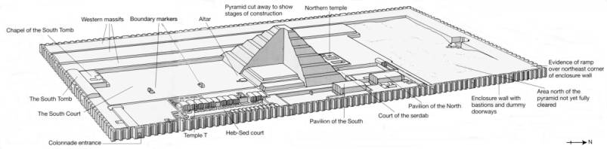

All previous royal tombs were made of mud brick, but this was made of limestone blocks, not much larger than mud bricks as the technique for quarrying huge blocks had not yet been developed. It was the first building in Egypt to be made entirely of stone.

Why did Djoser have a pyramid instead of a mastaba (a tomb with a flat top)? It is possibly due to the belief that pharaohs were expected to ascend into the sky after death to spend eternity with the gods or accompany the sun god Re as he rowed across the heavens. The height of the pyramid would help with this. A spell from the pyramid texts (found in later pyramids) says:

A staircase to heaven is laid for him (the king) so that he may mount up to heaven thereby.”

Underground chambers

The subterranean structures were the most complex of any pyramid. The burial chamber was at the bottom of a 28 metre shaft and was designed as a huge sarcophagus. A labyrinth of corridors, chambers and galleries led away from the burial chamber in all directions.

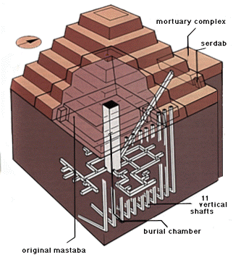
There are 11 vertical shafts sunk into the rock to a depth of 33 metres. These were probably meant for members of Djoser’s family. It has been estimated that there were 400 rooms and 5.7 kilometres of passageways.

Unfortunately, the royal burial chamber was robbed in ancient times. However, in one gallery, 40 000 cups, bowls, dishes and goblets were stacked on top of one another and made of the finest polished stone. A mummified eight year old boy was also found in the fifth burial chamber.

Mortuary temple and serdab

Attached to the north side of the pyramid was a mortuary temple, which was connected to the burial chamber by a tunnel. This was where mortuary priests would pray for the deceased and make daily offerings of food and drink. The serdab was a small room which contained a life size statue of Djoser. It was believed the king’s life force or ka would inhabit the statue in order to receive gifts.

The rest of the complex

The rest of the pyramid complex at Sakkara was probably a copy of his palace at Memphis, so Djoser could rule in the afterlife as he had in real life. There were dummy buildings – temples and shrines – especially in the Sed court of which each building was duplicated, probably to represent Upper and Lower Egypt. Much of the decoration consisted of paintings and carvings of the papyrus plant and lotus flower.

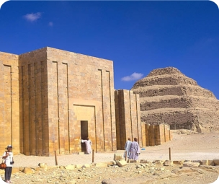
No other pyramid was surrounded with such an extensive and impressive array of imposing building to supply the king in the afterlife.

The entrance and pyramid of the Step pyramid complex

The Great Pyramid at Giza and Khufu

King Khufu is believed by Egyptologists to be the builder of the Great Pyramid at Giza. According to ancient records, he reigned for 23 years from approx. 2580BC, had several wives and many children. Most of our information for him comes from secondary sources in the Middle Kingdom and ancient Greek historians.

Herodotus says of him – “…Cheops (what the Greeks called Khufu) brought the country into all sorts of misery. He closed all the temples…compelled his subjects without exception to labour as slaves for his own advantage. It took ten years oppression of the people to make the causeway for the conveyance of the stones…The pyramid itself was twenty years in the building…But no crime was too great for Cheops: when he was short of money, he sent his daughter to a bawdy house (brothel) with instructions to charge a certain sum – they did not tell me how much.”

How accurate is this? Herodotus was writing 2000 years after the death of Khufu and he opinion was based on his own standards and those of the fifth century BC. It is a mistake to judge the past by present standards. The same must be said of the priests who gave Herodotus much of his information.

Herodotus could not understand how a massive monument could have been built without slave labour and failed to understand the Egyptian attitude to their king. To them, the king was a god on earth, who was responsible for maintaining order, fertility and prosperity of the land, and they were willing to repay this by working on his eternal resting place. If they helped now, they may also be of service in the afterlife as well. Also, much of the work was probably carried out during the flood when farmers had little to do anyway.

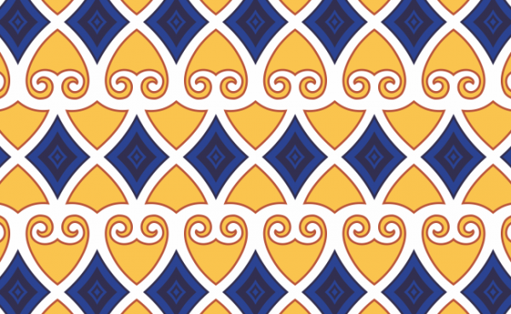
Other information which refutes Herodotus’ account is the stable economic situation Khufu left after his death, the continuation of the cult of Khufu for many centuries and the fact that the name Khufu inscribed on protective scarabs in later ages was thought to be a very powerful charm.

The God King and the Pyramid

During the fourth dynasty the solar cult became even more closely associated with the concept of supreme rule of the king. This was reflected by the building of true pyramids which were symbols of the sun god, Re.
Government bureaucracy
Resources, manpower and skills
Priestly colleges and religious cults
The spiritual and material hopes of all Egyptians were centered on the continuing well-being of the king after death
The royal family and favoured nobles could hope to enjoy immortality only if the king provided them with tombs or funerary goods and showed that he needed them in the next life to serve him
The peasants who worked on the king’s tomb and provided a regular supply of food hoped that they would be needed in the next life to serve the king and nobles
Craftsmen, who used their skills to create the tombs and their contents might hope to participate in the afterlife with their lords
The God-King
The power of a god on earth
An eternal life traversing the sky

The chief of the Seven ancient wonders of the world

Khufu chose the plateau of Giza as the site for his pyramid complex. His successors, Khafre and Menkaure, followed his example. Giza, like the other sites chosen by the kings of the Old Kingdom (2649-2150 BC) was on the western side of the Nile, on the edge of the desert above the valley but not too far from the river and within reasonable distance from the capital city and home of the Pharaoh, Memphis.

Why was it important to build pyramids in the west? The Egyptians believed that where the sun died every day, was the land of the dead. Therefore, most royal cemeteries throughout Egyptian history are located on the west bank of the Nile. It was also important to build on high ground to avoid the sites being flooded each year when the Nile broke its banks. However, the Nile was also important as when it flooded, it allowed huge blocks of stone to be transported by boat closer to the pyramid complex. Additionally, Giza’s rock base on the plateau was free from defects which might cause subsidence and cracking of the buildings and there was also an abundant supply of local limestone for the core of the pyramid.

How was the Great Pyramid built?

Khufu’s pyramid was an incredible leap forward in terms of size, technical expertise and organisation.

The architect/s had to find ways to:

- Quarry the limestone and the harder granite and basalt
- Transport the huge blocks to Giza by boat and over land
- Level the surface of the base and ensure a perfect square
- Achieve an exact orientation on the four cardinal points
- Raise and lay the blocks to the required height and lay them so they held together

There was no standard manual for pyramid building in the early, experimental era of giant pyramids.

It has been estimated that the Great Pyramid complex contains about 2 700 000 cubic metres of stone. Since the ancient Egyptians used tools made of wood, stone and copper, how they cut through stones as hard as granite and basalt is still unsolved. There is some suggestion that they did have iron tools, but it is speculation.

Approximately 2 300 000 blocks of limestone, weighing on average 2.5 tonnes, made up the core of the pyramid. This came from Giza and Tura, across the river. Hard pink granite was obtained from Aswan (up the Nile) for the internal passage ways and chambers as well as for temples. Nine great granite beams in the roof of the burial chamber are over 5.5 metres long and weigh between 25 and 40 tonnes. It has been calculated that it would take 1212 men to cut 322 cubic metre stones daily for 23-30 years. Mark Lehner, an Egyptologist who researched this, concluded that the skill of the ancient Egyptians was not the result of “some mysterious technology or secret sophistication but of generations of practice and experience.”

Some idea of how the ancient Egyptians transported these massive stone blocks from the quarries to the pyramids can be gained from:

- The discovery of the worlds oldest paved road at Lisht in the Faiyum area – it was 12 kilometres long and up to 11 metres wide. An modern experiment showed that 20 men could easily pull along a 2 tonne block (there were no wheeled carts) using wooden rollers
- Tomb and temple scenes showing the transportation of huge blocks of stone on specially built barges and the use of manpower for hauling the blocks across land

How the Egyptians ensured the base of the pyramid was level, is not known but they may have used some sort of water leveling system. Nor is how they managed to align the axes and diagonals of the pyramids. How the blocks were lifted into place is also unknown. It may have been a system of ramps or a lever system. It is generally accepted that pulley systems had not been invented at the time of the building of the pyramids.

Khufu’s successors, Djedefre and Khafre also built magnificent pyramids at Giza.
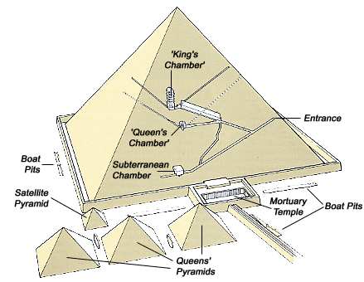

The Great Pyramid of Khufu

The end of the Fourth Dynasty

During the Fourth Dynasty, the resources of the kingdom and the energies of the people were devoted to providing for the welfare of the god-king in this life and the next. In such a centralised system, the king’s power was absolute and he was the focus of the sun cult. There were signs of the waning power of the priests at Heliopolis (the centre for worship of the sun-god, Re). However, by the fifth dynasty the priests of Re not only regained their influence but acquired unprecedented authority.

Despite some minor dynastic troubles, the Fourth Dynasty was a time of considerable economic and political stability. The evidence for this is the massive building projects that were carried out. All the greatest pyramids were built at this time and this would have been impossible under chaotic conditions. Never again would the Egyptians build on such a monumental scale and with such technical precision.

The Fifth and Sixth Dynasties

Fifth Dynasty pyramids were made of poorer quality limestone and have therefore aged badly. The Fifth Dynasty kings were more interested in elaborate wall paintings and spells and this reflects the change in attitude towards how to achieve the afterlife. Most kings of the Fifth Dynasty worshipped the sun-god, Re, and adopted the title son of Re and more rulers than previously adopted Re as part of their name. This explains the elaborate sun temples built during this period.

Most pyramids of the Sixth Dynasty have pyramid texts, which are a collection of hundreds of spells, prayers and utterances carved into the white alabaster and limestone walls. The hieroglyphs were filled with blue paint to make them stand out more. A total of 759 pyramid spells have been identified, but no one pyramid contained them all. In this age, the ancient Egyptians believed in the power of the written word. For example, one spell said…

Rise up, o [king’s name]
Take your head
Collect your bones
Gather your limbs
Shake the earth from your flesh

And the Egyptians believed that the king would be resurrected with his body intact.

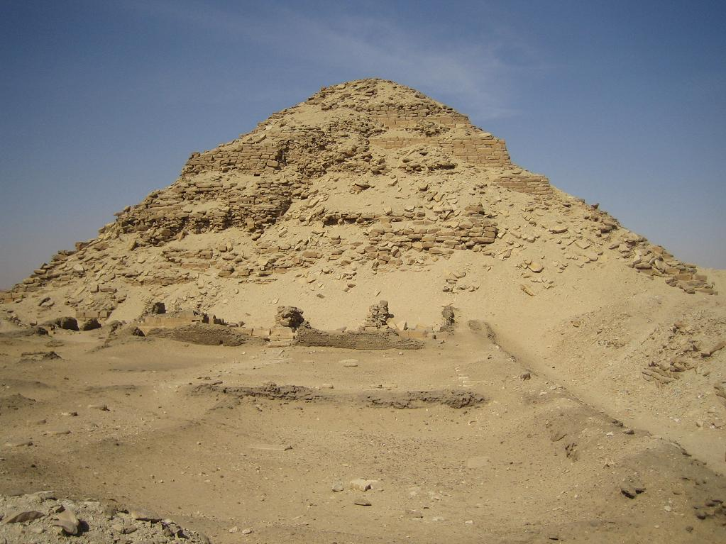
They also believed that the written word could harm as well as protect, so any hieroglyphs with potentially dangerous entities – snakes, scorpions, lions and humans – were drawn as though unfinished to render them harmless. For example, the image of a snake may be drawn as if cut in two, a scorpion may not have its tail and a wild beast or a man may be depicted with no limbs. These spells, though only appearing in the late Fifth Dynasty, seem to have come from the distant past and passed down Egyptian generations by word of mouth.

The collapse the Old Kingdom

The Old kingdom collapsed in approximately 2150 BC. The possible reasons for this are the huge amounts of revenue spent on the pyramids and sun temples. Also, the perpetual granting of land to religious cults which could not be taxed and the exemption of towns from tax by the king as a thank you for helping in the construction of his pyramid. This again reduced the amount of taxation and put a strain on the royal treasury.

It has also been suggested that in 2350 BC, Egypt started to experience drier conditions and this would have ruined the harvests. There had definitely been some low Niles during the reign of Unas in the Fifth Dynasty as his tomb is decorated with reliefs showing starving people. Foreign trade also seems to have fallen and this reduced the kings revenue further.

The king was also weaker than he had been. Nobles had increased their power and provincial governorships had become hereditary positions. The administration of Egypt became increasingly independent and filled with men who no longer felt they owed their position to the king and therefore were not concerned to be buried with him. The cult of the sun also grew in influence at the expense of the king.

The Middle Kingdom

The years between the Old and Middle kingdom, 2150-2040 BC, is referred to as the First intermediate Period. It was a time of political, social and economic upheaval resulting in despair and bewilderment. There were definitely civil wars, however, as there is a lack of records for this time, it is hard to judge exactly what occurred.

The Twelfth dynasty restored the prestige of Egypt and the kings of this age seem to have been fairer to their people. Also, there were major religious changes. A previously unknown Theban god, Amun, comes to prominence, and was to become the chief god.

However, the Thirteenth dynasty had 60 kings in 153 years and must have been a time of great political crisis and is evidence Egypt went back into decline. It was during this decline that foreign invaders from Palestine, called the Hyksos, invaded Egypt and conquered the north.

The Hyksos domination of Egypt 1640-1532 BC

After the brilliance of the Middle Kingdom, Egypt had declined into a state of havoc and confusion, its rulers murdering and replacing on another with extreme rapidity. During this time of weak and divided rule (13th and 14th Dynasties) a group of foreign invaders from Palestine moved into the delta area. Eventually, they seized Lower Egypt, including the city of Avaris, which they turned into their stronghold.

The Egyptians referred to these people as Hikau-khoswet (rulers of foreign lands) from which the name Hyksos originated. After about 45 years, they forced the Egyptians out of Memphis. For about 100 years they controlled Egypt as far south as Cusae.

A dynasty (the seventeenth) of Egyptian princes from Thebes continued to rule in semi-independence in the south but paid allegiance and tribute to the Hyksos kings in the north.

The Hyksos were able to maintain their power for se long because they were militarily stronger than the divided Egyptians. Their chief fighting advantage came from their use of horse-drawn chariots, unfamiliar to the Egyptians. These chariots gave the Hyksos greater mobility on the battle field. Other advantages included:

- Superior weapons, such as bronze swords, scimitars and daggers
- Powerful composite bows built up of layers of wood, sinew and horn, glued together. These had far greater striking distance and penetration than the bows used by the Egyptians.
- Scaled armour and war helmets
- Fortified camps

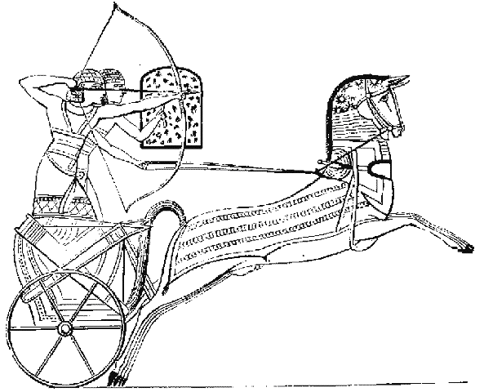
Egyptian sources which have survived depict the Hyksos as barbarians whose rule was totally disastrous for Egypt. In truth, they were probably not as harsh as depicted. They adopted traditional Egyptian names, included Egyptians in their administration and modeled the official religion on that of the Egyptians. They also introduced the use of bronze instead of copper, improved methods of spinning and weaving and brought olive and pomegranate trees to Egypt.

The war of Liberation

The sources for this period are few and far between. It is not known exactly which of the Theban princes started the liberation or why.

King Kamose of Thebes is generally regarded as the last king of the seventeenth dynasty and with starting the war of liberation against the Hyksos. When he became king in Thebes, he outlined he plan to retake all Egypt.

“Let me understand what this strength of mine is for! There is one prince in Avaris, another in Ethiopia (Nubia), and here I sit associated with an Asiatic and a Negro! Each man has his slice of this Egypt, dividing up the land with me. No man can settle down, being despoiled by the demands of the Asiatics. I will grapple with him, so that I may cut open his belly! My wish is to save Egypt and to smite the Asiatics.”

Kamose sailed north with a powerful army and raided deep into Hyksos territory. Although they failed to take the enemies stronghold of Avaris, they captured hundreds of Hyksos ships, weapons, timber and other valuables.

The Hyksos king sent an urgent letter to his allies in Nubia promising that if they defeated the Egyptians together they would divide the conquered territory. However, the letter was intercepted and returned to the Hyksos with an account of what the Egyptians had done to Hyksos territory.
However, it appears from his burial site that Kamose died unexpectedly.

King Ahmose (Amosis) kicks some Hyksos butt

Ahmose was either the son or brother of Kamose. He has been hailed as the fonder of the Eighteenth dynasty and father of the New Kingdom. As he was a child when he came to the throne he did not attack the Hyksos for at least a decade, and his mother Ahhotep acted as his regent, crushing rebellions.

Eventually, King Ahmose liberated Egypt from the Hyksos after 3 campaigns and captured the Hyksos stronghold of Avaris. He then campaigned as far as Palestine and besieged the city of Sharuhen. This campaign was probably meant as a warning, that a new force had emerged in Egypt. Ahmose may also have pushed the Hyksos all the way into Syria. He also campaigned south of Egypt into Nubia and conquered part of that also.

Ahmose built and dedicated many temples to the god Amun-Re in thanks for his victories. He died after 25 years on the throne and was probably buried in a mud brick pyramid on the west bank of Thebes.

The Hyksos domination provided the Egyptians with the incentive and the means towards world expansion, and so laid the foundations of the New Kingdom, which is often referred to as the Empire.
The New Kingdom

Thutmose I was the first of a line of kings referred to as the Thutmosids, who were “ambitious, intelligent and energetic as rulers, vain, self indulgent, headstrong, and occasionally ruthless individuals.”

He conquered upper Nubia (Kush) and then campaigned in western Asia. He marched through Syria and reached as far north as the upper reaches of the Euphrates river. The Egyptian troops, familiar with the flow of the Nile from south to north, were amazed at this great river which they believed flowed upside down. The Egyptians referred to it as the ‘inverted river which flows downstream in going upstream.”

Thutmose led his troops into the territory of the Matanni of Naharin and defeated their army. However, he made no attempt to bring the area under Egyptian control.

