Hector vs Achilles

Rage – sing, goddess, the anger of Achilles son of Peleus, that accursed anger, which brought the Greeks endless sufferings and sent the mighty souls of many warriors to Hades, leaving their bodies as carrion for the dogs and a feast for the birds; and Zeus’ purpose was fulfilled…

Achilles is the greatest of the Greeks besieging the town of Ilium – the capital of Troy. Hector, the champion and prince of the Trojans, has killed in battle Achilles’ lover, Patroclus. Achilles has arrived at Ilium to seek revenge by challenging Hector to single combat.

Book 22: 70 -

King Priam, Hector’s father and king, spoke and tore at his grey locks and pulled the hair from his head; but it did not shake Hector’s resolve. And now his mother Hecabe in her turn began to weep and lament: ‘Hector, my son, pity me! Deal with your enemy from here inside the walls and do not go out to meet that man in single combat. He is ruthless; and if he kills you, I shall never lay you out on a pyre and weep for you, dear child of my flesh, nor will you wife, but far away from the both of us beside the Greek ships the swift dogs will consume you.

So they spoke in tears to their dear son but all their entreaties did not shake Hector’s resolve: he stayed where he was, awaiting the approach of awe-inspiring Achilles. As a mountain snake waits for a man besides its hole: it has swallowed poisonous herbs, its anger is dreadful and it stares intimidatingly at him, wreathing its coils around its lairs – so Hector, his determination unquenchable, refused to retreat he leaned his glittering shield against the projecting tower and, deeply troubled, reflected on the situation: ‘it will be far better for me to stand up to Achilles and either kill him and come home alive, or be killed by him gloriously in front of Ilium. Let’s find out to which of us Zeus intends to hand the victory.’

As Hector paused and considered the matter, Achilles came on at him. looking like the God of war, the warrior with the nodding helmet. Hector saw him and shook. He left the gate and ran in panic. But Achilles, counting on his speed, was after him. Like a mountain hawk, when it effortlessly swoops after a timid dove – so Achilles started off in hot pursuit. All the Gods were looking on while swift Achilles continued his relentless pursuit of Hector – so Hector could not shake off swift footed Achilles.

“Achilles, I am not going to run from you anymore. But now, I have made up my mind to fight you man to man and kill you or be killed. But let us call on the Gods to witness an agreement: if Zeus grants me staying power and I kill you, I will not violently maltreat you. All I shall do, Achilles, is to strip you of your famous armour. Then I will give up your body to the Greeks. You do the same.” Swift footed Achilles gave him a black look and replied, “Hector, I am never going to forgive you. So don’t talk to me about agreements. Lions don’t come to terms with men, the wolf doesn’t see eye to eye with the lamb – they are enemies to the end. There will be no truce of any kind. “

Achilles spoke, balanced his long spear and hurled it. Hector was on the look out and avoided it. He crouched and it flew over him and stuck in the ground. But Athena snatched it up and brought it back to Achilles without Hector noticing. Hector hurled his spear. He hit the centre of Achilles’ shield but the spear rebounded from it. Hector drew the sharp, long, heavy sword hanging down at his side. He gathered himself and swooped like a high flying eagle that drops to earth through black clouds to pounce on a cowering hare. Achilles sprang to meet him, his heart filled with savage rage with murder in his heart, searching Hector’s body for its most vulnerable spot.

Hector’s body was completely covered by the fine bronze amour he had taken from Patroclus., except from the flesh that could be seen at the windpipe, where the collar bones hold the neck from the shoulders, the easiest place to kill a man. As Hector charged him, swift Achilles drove at this spot with his spear and the point went right through Hector’s soft neck. Hector crashed in the dust, and God-like Achilles triumphed over him. Achilles spoke to Hector “this at least is certain: nobody is going to keep the dogs off your head and the birds of prey will divide you up. DIE!”

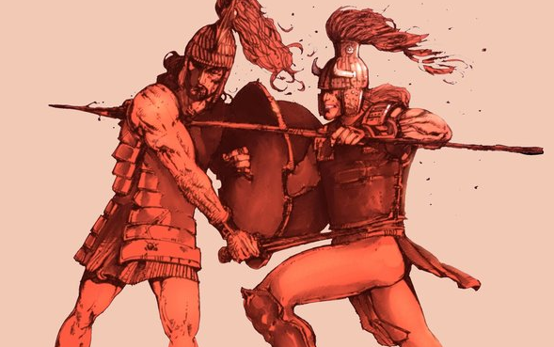
He spoke and foully maltreated god-like Hector. He sliced into the tendons of both his feet between the heel and the ankle, inserted leather straps and ties them to his chariot leaving the head to drag. Then he lifted his famous armour into the chariot, got in himself, and lashed he horses with the whip to get them moving. Dust rose from the body they dragged behind them; Hectors’ hair streamed out on either side and his whole head, so graceful once, lay in the dirt.

