Milo of Kroton
- Wrestler
- Six-time Olympic victor:
- Won once in boys' wrestling, 60th Olympiad, 540 BCE
- Five-time wrestling champion from 62nd to 66th Olympiad, 532 to 516 BCE

It is no great thing to possess strength, whatever kind it is, but to use it as one should. For of what advantage to Milo of Kroton was his enormous strength of body?... Diodorus Siculus, Historical Library, 9.14.1

One of the most legendary athletes in the ancient world, Milo of Kroton, wore the victor's crown at Olympia no less than six times. Born in southern Italy, where Greece had many colonies, Milo won the boys' wrestling contest in 540 BCE.
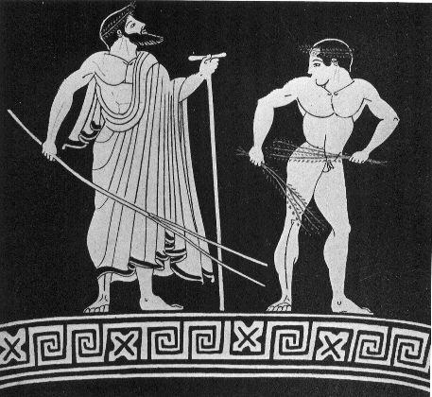
He returned eight years later to win the first of five consecutive wrestling titles, a feat that seems incredible by modern standards. Rarely do modern-day Olympians compete in more than two or three Olympiads over the course of a career. Much like the boxer George Foreman, Milo resisted retirement: By the time of the 67th Olympiad in 512 BCE, Milo was probably forty or more years old but he competed anyhow. The challenger won not by overpowering Milo, but by avoiding the older wrestler and wearing him out.
According to our ancient sources, Milo enjoyed showing off his unrivaled strength. For instance, he would clasp a pomegranate in his hand and have others try to take it away from him. Even though he was holding it so tightly that no one could remove it, he never damaged the fruit.

Sometimes, he would stand on a greased iron disk and challenge others to push him off of it. Another of his favorite exhibitions was tying a cord around his forehead, holding his breath, and breaking the cord with his bulging forehead veins. Other times, the wrestler would stand with his right arm at his side, his elbow against him, and hold out his hand with thumb pointed upwards and fingers spread. No one could successfully bend even his little finger.

Milo excelled even in warfare. When a neighboring town attacked Kroton, Milo entered the battle wearing his Olympic crowns and dressed like Herakles, in lion's skin and brandishing a club, and led his fellow citizens to victory. A follower of the famous philosopher Pythagoras, Milo once saved his friends. It happened that the roof of the hall where the Pythagoreans were meeting began to collapse. Milo stood and supported the central pillar until the others escaped to safety and then dashed out, saving himself.
In the end, however, all of this fame and strength did not save Milo from a less than glorious death. Milo was wandering through the forest when he found an old tree trunk with wedges inserted into it. In an attempt to test his strength, Milo placed his hands and, perhaps his feet, into the cleft of the trunk and tried to split apart the wood. He succeeded in loosening the wedges, which fell out, but the trunk closed on his hands, trapping him. There, according to the tale, he fell prey to wild beasts.

Theagenes of Thasos

- Boxer, Pankratiast & Runner
- Victor in boxing in the 75th Olympiad, 480 BCE
- Victor in the pankration in the 76th Olympiad, 476 BCE

His ambition was, I think, to rival Achilles by winning a prize for running in the fatherland of the swiftest of those who are called heroes. The total number of crowns that he won was one thousand four hundred. ... Pausanias, Description of Greece, 6. 11. 5

At the young age of nine, Theagenes of Thasos became famous throughout Greece. It seems the boy was walking home from school, when he noticed a bronze statue of a god in the marketplace of Thasos. For some, strange reason, but probably out of admiration, Theagenes tore the statue from its base and took it home. This act outraged the citizens, who perceived it as highly disrespectful, and they debated whether or not they should execute the child for his deed. One elder, however, suggested that they have the boy return the statue to its proper place. Theagenes did this, his life was spared, and word of this amazing feat spread across Greece.
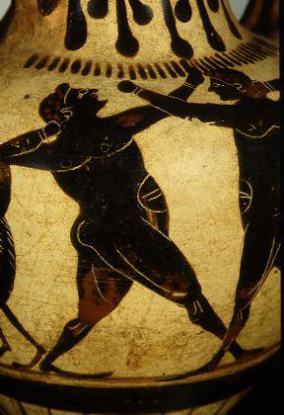
At the 75th Olympiad, Theagenes had designs on winning both the boxing prize and the pankration prize.
After defeating the boxer Euthymos, Theagenes was too tired to win a second crown for the pankration. Interestingly, the judges fined Theagenes for entering the boxing competition merely to spite Euthymos. Furthermore, Theagenes did not box in the 76th Olympiad. Pausanias implies that this was what we might nowadays call "unsportsmanlike conduct."

In addition to his two Olympic victories, one in boxing and one in the pankration, Theagenes won numerous victories in other games. When he traveled to Phthia, the traditional home of the legendary hero of the Iliad, "swift-footed" Achilles, Theagenes decided to compete in the footrace. Of course, he won.

Following his death, the people of Thasos memorialized Theagenes with a bronze statue. Allegedly, a man who never won a match against Theagenes came every night to the statue and beat it. One night, the statue came loose, fell on the angry opponent, and killed him. His sons prosecuted the statue for murder, a perfectly reasonable action under Greek law. (The Greeks felt that all murders must be punished, whether or not the murderer was a person, animal, or even an object!)

The Thasians dropped the guilty statue of Theagenes into the ocean, presumably settling the matter. Then, in later years, famine and plague struck Thasos, and the people sought the advice of the oracle, who told the islanders to welcome back all exiles. The Thasians followed this command, but the crops still did not grow. Once more, they asked the oracle for assistance. The priestess replied that they had forgotten the great Theagenes. After some fishermen retrieved the statue of the athlete, the people of Thasos repositioned the statue in its original place, and they sacrificed to him as a healing god.

Diagoras of Rhodes

- Boxer
- Victor in the 79th Olympiad, 464 BCE.

And now, with the music of flute and lyre alike I have come to land with Diagoras, singing the sea-child of Aphrodite and bride of Helios, Rhodes, so that I may praise this straight-fighting, tremendous man who had himself crowned beside the Alpheus and near Castalia, as a recompense for his boxing... Pindar, Olympian 7, lines 13-17

The boxer Diagoras of Rhodes embodied every quality of the noble ancient athlete. Immortalized in one of the most famous odes of the poet Pindar, Diagoras was victorious in not only the Olympic games, but in every other major Greek athletic festival as well. The extent and number of his triumphs certainly contributed to his fame, but the virtuous character of Diagoras was as important to the ancient Greeks as his success as a boxer.

We know that Diagoras' family was of the noble, ruling class on Rhodes, and the Rhodians claimed that the boxer himself was the son of the god Hermes. Such legends were a common means of explaining how mortal men could perform "super-human" athletic achievements.
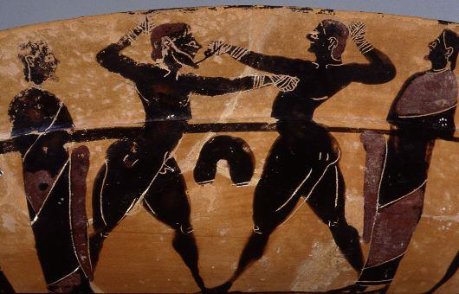
In his Ode for Diagoras, Olympian 7, Pindar praises the boxer as a "fair-fighter" and a "gigantic" man. Diagoras also "walks a straight course on a road that hates arrogance." In addition to his Olympic victory, Diagoras won four times at the Isthmian games, twice at Nemea, and at other games held in his native Rhodes, Athens, and elsewhere throughout the Greek world. We have no exact record of his career, but it is clear that Diagoras was a legend in his own time.

Moreover, Diagoras lived to witness the Olympic victories of his two sons Damagetos and Akousilaos. At the 83rd Olympiad in 448 BCE, Damagetos won the second of his two prizes for the pankration, and Akousilaos won the boxing victory. Then, the sons carried their father on their shoulders while the adoring crowd showered them with flowers and congratulated Diagoras on his sons. Another of his sons, Dorieus, won no less than three successive Olympic titles in the pankration, along with eight Isthmian victories and seven at Nemea. Two of the sons of Diagoras' daughters were also Olympic boxing champions.

Olympia crowned three generations of Diagoras' family, adding to the fame that the boxer won in his own right and no doubt fueling other legends of the immortal ancestry of the Diagoras family. Even baseball's Griffey and Ripken families fall a generation short of imitating the achievements of Diagoras, his sons, and grandsons.

Polydamas of Skotoussa

- Pankratiast
- Victor in the 93rd Olympiad, 408 BCE

The death of Polydamas...made it clear to all men how precarious it is to have great strength but little sense. ... Diodorus Siculus, Historical Library, 9.14.2

We know little about the Olympic victor Polydamas (also spelled "Pulydamas") of Skotoussa, a city in Thessaly. His background, family life, and even the details of his Olympic triumph are mysteries. Aside from the fact that Polydamas' statue was remarkably tall, we have no information on his appearance.

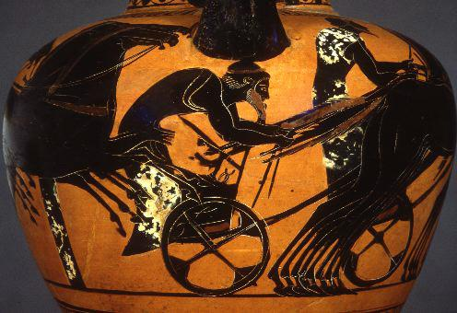

Like many modern athletes, Polydamas the pankratiast was as well known for non-athletic exploits as he was for his prowess in the Olympic games. Ancient authors tend to compare his feats to those of the legendary Greek hero Heracles. Polydamas once killed a lion with his bare hands on Mount Olympus in a quest to imitate the labors of Heracles, who slew the Nemean lion.

Pausanias adds that: Polydamas ...went among a herd of cattle and seized the biggest and fiercest bull by one of its hind feet, holding fast the hoof in spite of the bull's leaps and struggles, until at last it put forth all its strength and escaped, leaving the hoof in the grasp of Polydamas.
In a similar way, Polydamas once stopped a fast-moving chariot and kept it from going forward.

Such exploits reached the ears of the Persians, and the king Dareius sent for Polydamas. There the athlete challenged three Persians, nicknamed the "Immortals" to fight him, three against one, and Polydamas was victorious.

In the end, however, Polydamas' strength could not prevent his demise. One summer, Polydamas and his friends were relaxing in a cave when the roof began to crumble down upon them. Believing his immense strength could prevent the cave-in, Polydamas held his hands up to the roof, trying to support it as the rocks crashed down around him. His friends fled the cave and reached safety, but the pankratiast died there.

Melankomas of Caria

- Boxer
- Victor in the 207th Olympiad, 49 AD

Now since his was beauty of body, his was courage and a stout heart and, besides, self-control and the good fortune of never having been defeated, what man could be called happier than he? ... Dio Chrysostom, Discourses, 29.16

The boxer Melankomas was from Caria, a region of what the Greeks called Asia Minor and is now known as Turkey. Born to an outstanding father, Melankomas was known for his handsome body and good looks.
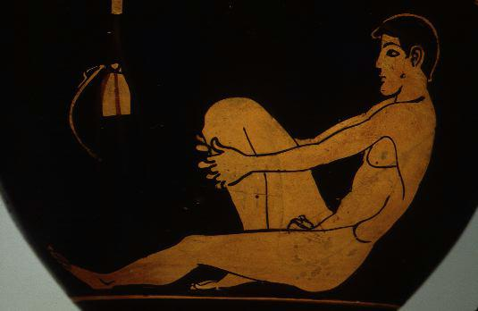

This athlete, we are told, had a soul as brave as his body was beautiful. In an effort to prove his courage, Melankomas chose athletics, since this was the most honorable and most strenuous path open to him. Evidently some men believed that the training a soldier must endure is less difficult than that of an athlete, particularly that of a boxer.

Amazingly enough, Melankomas was undefeated throughout his career yet he never once hit an opponent or was hit by one.

His boxing style was to defend himself from the blows of the other boxer and avoid striking the other man. Invariably, the opponent would grow frustrated and lose his composure. This unique style won Melankomas much admiration for his strength and endurance. He could allegedly fight throughout the whole day, even in the summer, and he refused to strike his opponents even though he knew by doing so he would quickly end the match and secure an easy victory for himself.

No doubt his success was due in large part to his rigorous training. Melankomas exercised far more than the other athletes. Indeed, one story relates that the boxer went for two straight days with his arms up, not once putting them down or resting.

Unfortunately, Melankomas died at a young age. Always the eager competitor, the boxer, lying on his deathbed, asked a friend how many days of the athletic meet were left. He would not live to compete again. Even so, his name lives on for his remarkable boxing skills.

