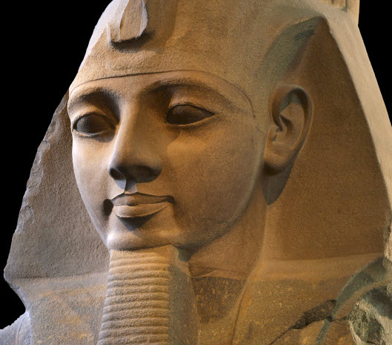
Ramses II

Ramesses II was the third Egyptian pharaoh (reigned 1279 BC – 1213 BC) of the Nineteenth dynasty. He is often regarded as the greatest, most celebrated, and most powerful pharaoh of the Egyptian Empire. His successors and later Egyptians called him the "Great Ancestor."

At age fourteen, Ramesses was appointed Prince Regent by his father Seti I. He is believed to have taken the throne in his late teens and is known to have ruled Egypt from 1279 BC to 1213 BC for 66 years and 2 months. Ramesses II celebrated an unprecedented 14 sed festivals (the first held after thirty years of a pharaoh's reign, and then every three years) during his reign—more than any other pharaoh. On his death, he was buried in a tomb in the Valley of the Kings.

Ramesses II led several military expeditions into the Levant (modern day Syria and Israel), re-asserting Egyptian control. He also led expeditions to the south, into Nubia (modern Sudan). Early in his life, Ramesses II embarked on numerous campaigns to return previously held territories back from Nubian and Hittite hands and to secure Egypt's borders. He was also responsible for suppressing some Nubian revolts and carrying out a campaign in Libya. Although the famous Battle of Kadesh (Egypt vs Hittites – largest chariot battle ever fought 5-6,000 chariots!) often dominates the view of Ramesses II's military prowess and power, he nevertheless enjoyed more than a few outright victories over the enemies of Egypt. During Ramesses II's reign, the Egyptian army is estimated to have totaled about 100,000 men; a formidable force that he used to strengthen Egyptian influence.

The early part of his reign was focused on building cities, temples and monuments. Ramesses’ monuments were in part built to push his religious ideas – Ramesses wanted to get back to traditional Egytpian religion on multiple gods. He established the city of Pi-Ramesses in the Nile Delta as his new capital and main base for his campaigns in Syria. Ramesses constructed many large monuments, including the archeological complex of Abu Simbel, and the Mortuary temple known as the Ramesseum. He built on a monumental scale to ensure that his legacy would survive the ravages of time. Ramesses used art as a means of propaganda for his victories over foreigners. Ramesses II also erected more colossal statues of himself than any other pharaoh. He also usurped many existing statues by inscribing his own cartouche on them.

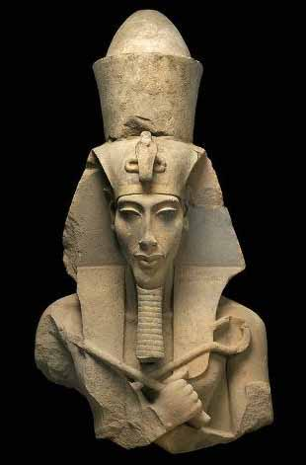
Akenhaten
Akhenaten was a Pharaoh of the Eighteenth dynasty of Egypt who ruled for 17 years and died perhaps in 1336 BC or 1334 BC. He known for a religious revolution, in which he worshiped one god only, Aten, or the sun disc. In the end this would not be accepted. After his death, traditional religious practice was gradually restored, and when some dozen years later rulers without clear rights of succession from the Eighteenth Dynasty founded a new dynasty, they discredited Akhenaten and his immediate successors, referring to Akhenaten himself as "the enemy" in records.
He was all but lost from history until the discovery, in the 19th century, of Amarna, the site of Akhetaten, the city he built for the Aten. Modern interest in Akhenaten and his queen, Nefertiti, comes partly from his connection with Tutankhamun (his son?), partly from the unique style and high quality of the arts he patronized, and partly from ongoing interest in the religion he attempted to establish.

Important evidence about Akhenaten's reign and foreign policy has been provided by the discovery of the Amarna Letters. This correspondence comprises a priceless collection of incoming messages on clay tablets, sent to Akhetaten from various foreign rulers of the kingdom of Mitanni (Northern Syria), Babylon and Assyria. The governors of Egypt's outer provinces also wrote frequently to plead for gold from Pharaoh, and also complained of being snubbed and cheated by him.
Early on in his reign, Akhenaten fell out with the king of Mitanni, Tushratta. Tushratta complains in numerous letters that Akhenaten had sent him gold plated statues rather than statues made of solid gold; the statues formed part of the bride price which Tushratta received for letting his daughter Tadukhepa be married to Amenhotep III and then Akhenaten.
While Akhenaten was certainly not a close friend of Tushratta, he was evidently concerned at the expanding power of the Hittite Empire. Some of Egypt's vassals switched their allegiances to the Hittites. A group of Egypt's allies who attempted to rebel against the Hittites were captured, and wrote letters begging Akhenaten for troops, but he did not respond to most of their pleas.

Tutankhamun
Tutankhamun was the son of Akhenaten and one of Akhenaten's sisters. As a prince he was known as Tutankhaten. His original name, Tutankhaten, means "Living Image of Aten", while Tutankhamun means "Living Image of Amun".He ascended to the throne in 1333 BC, at the age of nine or ten, taking the throne name of Tutankhamun.
When he became king, he married his half-sister, Ankhesenamun. They had two daughters, both stillborn.
Given his age, the king probably had very powerful advisers, presumably including General Horemheb and the Vizier Ay. Horemheb records that the king appointed him "lord of the land" as hereditary prince to maintain law. He also noted his ability to calm the young king when his temper flared.
In the third year of his reign, Tutankhamun reversed several changes made during his father's reign. He ended the worship of the god Aten and restored the god Amun to supremacy. The ban on the cult of Amun was lifted and traditional privileges were restored to its priesthood. The capital was moved back to Thebes and the city of Akhetaten abandoned. This is also when he changed his name to Tutankhamun.
As part of his restoration, the king initiated building projects, in particular at Thebes and Karnak, where he dedicated a temple to Amun. Many monuments were erected, and an inscription on his tomb door declares the king had "spent his life in fashioning the images of the gods". The traditional festivals were now celebrated again.
The country was economically weak and in turmoil following the reign of Akhenaten. Diplomatic relations with other kingdoms had been neglected, and Tutankhamun sought to restore them, in particular with the Mitanni. Evidence of his success is suggested by the gifts from various countries found in his tomb. Despite his efforts for improved relations, battles with Nubians and Asiatics were recorded in his mortuary temple at Thebes. His tomb contained body armour and folding stools appropriate for military campaigns. Tutankhamun died around 18 years of age.
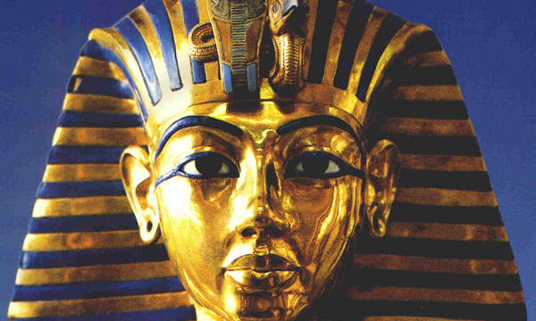

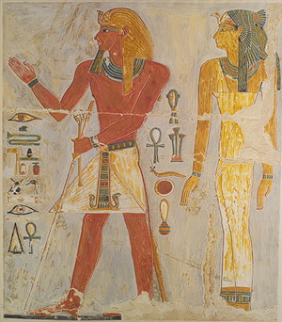
Thutmose I
Thutmose I was the third Pharaoh of the 18th dynasty of Egypt. During his reign, he campaigned deep into the Levant (modern day Syria and Israel) and Nubia (Sudan), pushing the borders of Egypt further than ever before.

Upon Thutmose's coronation, Nubia rebelled against Egyptian rule. Thutmose traveled down the Nile and fought in the battle, personally killing the Nubian king. Upon victory, he had the Nubian king's body hung from the prow of his ship, before he returned to Thebes. After that campaign, he led a second expedition against Nubia in his third year in the course of which he ordered a canal to be built in order to facilitate easier travel upstream from Egypt to Nubia. This helped integrate Nubia into the Egyptian empire.

His Syrian campaign was the farthest north any Egyptian ruler had ever campaigned. During this campaign, the Syrian princes declared allegiance to Thutmose. However, after he returned, they discontinued tribute and began fortifying against future incursions.

He also built many temples in Egypt and built a tomb for himself in the Valley of the Kings; he is the first king confirmed to have done this (though Amenhotep I may have preceded him). Thutmose I organized great building projects during his reign, including many temples and tombs, but his greatest projects were at the Temple of Karnak under the supervision of the architect Ineni
Mini task: google search the Temple of Karnak for images.

He was succeeded by his son Thutmose II, who in turn was succeeded by Thutmose II's sister, Hatshepsut. His reign is generally dated from 1506 to 1493 BC

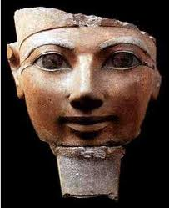
Hatshepsut
Hatshepsut was the fifth pharaoh of the Eighteenth dynasty of Ancient Egypt and was the daughter of Thutmose I.
Hatshepsut established the trade networks that had been disrupted during the Hyksos occupation of Egypt, building the wealth of the eighteenth dynasty. She oversaw the preparations and funding for a mission to the Land of Punt (modern Somalia). Many trade goods were bought in Punt, notably myrrh. Most notably, however, the Egyptians returned from the voyage bearing thirty-one live myrrh trees, the roots of which were carefully kept in baskets for the duration of the voyage. This was the first recorded attempt to transplant foreign trees.. Egyptians also returned with living Puntites (people of Punt). This trading expedition to Punt was roughly during Hatshepsut's nineteenth year of reign.
She had the expedition commemorated in relief at Deir el-Bahri, which also is famous for its realistic depiction of the Queen of the Land of Punt, Queen Iti. Hatshepsut also sent raiding expeditions to Byblos and Sinai shortly after the Punt expedition. Very little is known about these expeditions. Although many Egyptologists have claimed that her foreign policy was mainly peaceful, there is evidence that Hatshepsut led successful military campaigns in Nubia, the Levant, and Syria early in her career.

Hatshepsut was one of the most prolific builders in ancient Egypt, commissioning hundreds of construction projects throughout both Upper Egypt and Lower Egypt. Arguably, her buildings were grander and more numerous than those of any of her Middle Kingdom predecessors'. Later pharaohs attempted to claim some of her projects as theirs.
She employed the great architect Ineni, who also had worked for her father, her husband, and for the royal steward Senemut. During her reign, so much statuary was produced that almost every major museum in the world has Hatshepsut statuary among their collections; for instance, the Hatshepsut Room in New York City's Metropolitan Museum of Art is dedicated solely to some of these pieces.

In comparison with other female pharaohs, Hatshepsut's reign was much longer and prosperous. She was successful in warfare early in her reign, but generally is considered to be a pharaoh who inaugurated a long peaceful era. She re-established international trading relationships lost during a foreign occupation and brought great wealth to Egypt. That wealth enabled Hatshepsut to initiate building projects that raised the calibre of Ancient Egyptian architecture to a standard, comparable to classical architecture, that would not be rivaled by any other culture for a thousand years. She managed to rule for about 20 years.
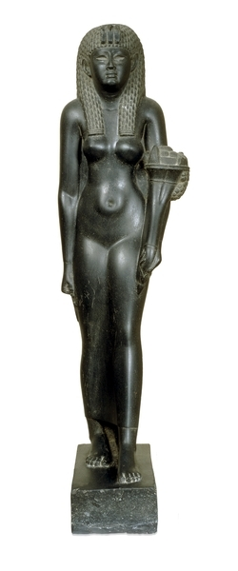
Cleopatra
Cleopatra VII Philopator was the last pharaoh of Ancient Egypt. She was a member of the Ptolemaic dynasty, a family of Macedonian origin that ruled Egypt after Alexander the Great's death during the Hellenistic period. The Ptolemies, throughout their dynasty, spoke Greek and refused to speak Egyptian, which is the reason that Greek as well as Egyptian languages were used on official court documents such as the Rosetta Stone. By contrast, Cleopatra did learn to speak Egyptian and represented herself as the reincarnation of an Egyptian goddess, Isis.
Cleopatra originally ruled jointly with her father, Ptolemy XII Auletes, and later with her brothers, Ptolemy XIII and Ptolemy XIV, whom she married as per Egyptian custom, but eventually she became sole ruler. As pharaoh, she had a relationship with Julius Caesar that solidified her grip on the throne. She later elevated her son with Caesar, Caesarion, to co-ruler in name.
After Caesar's assassination in 44 BC, she aligned with Mark Antony in opposition to Caesar's legal heir, Gaius Octavian. With Antony, she bore the twins Cleopatra Selene II and Alexander Helios, and another son, Ptolemy Philadelphus (her marriages with her brothers had produced no children.) After losing the Battle of Actium to Octavian's forces, Antony committed suicide. Cleopatra followed suit, according to tradition killing herself by means of an asp bite on August 12, 30 BC. She was briefly outlived by Caesarion, who was declared pharaoh by his supporters, but soon killed on Octavian's orders. Egypt became the Roman province of Aegyptus.

