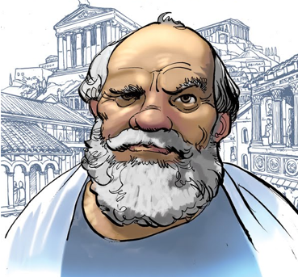
Who was Socrates?

Extract 1
Our best sources of information about Socrates' philosophical views are the works of his student Plato, who attempted to provide a faithful picture of the methods and teachings of the master. In the Socratic dialogues, his extended conversations with students, statesmen, and friends invariably aim at understanding and achieving virtue through the careful application of a dialectical method that employs critical inquiry to undermine the plausibility of widely-held doctrines. Destroying the illusion that we already comprehend the world perfectly and honestly accepting the fact of our own ignorance, Socrates believed, are vital steps toward our acquisition of genuine knowledge, by discovering universal definitions of the key concepts governing human life.

Extract 2
The beliefs of Socrates, as distinct from those of Plato, are difficult to discern. Little in the way of concrete evidence exists to separate the two. The lengthy theories given in most of the dialogues are those of Plato, and some scholars think Plato so adapted the Socratic style as to make the literary character and the philosopher himself impossible to distinguish. Others argue that he did have his own theories and beliefs, but there is much controversy over what these might have been, owing to the difficulty of separating Socrates from Plato and the difficulty of interpreting even the dramatic writings concerning Socrates.
The matter is complicated by the fact that the historical Socrates seems to have been notorious for asking questions but not answering, claiming to lack wisdom concerning the subjects about which he questioned others.

Socrates’ Quotes

1. An honest man is always a child.
2. As for me, all I know is that I know nothing.
3. As to marriage or celibacy, let a man take which course he will, he will be sure to repent.
4. By all means, marry. If you get a good wife, you'll become happy; if you get a bad one, you'll become a philosopher.
5. Death may be the greatest of all human blessings.
6. From the deepest desires often come the deadliest hate.
7. He is richest who is content with the least, for content is the wealth of nature.

Extract 3
The philosopher Socrates remains, as he was in his lifetime (469–399 B.C.E.) an enigma, an mysterious individual who, despite having written nothing, is considered one of the handful of philosophers who forever changed how philosophy itself was to be conceived. All our information about him is second-hand and most of it disputed, but his trial and death at the hands of the Athenian democracy is nevertheless the founding myth of philosophy, and his influence has been felt far beyond philosophy itself, and in every age.

Because his life is widely considered a model for the philosophic life and, more generally, for how anyone ought to live, Socrates has been burdened with the admiration normally reserved for founders of religious sects—Jesus or Buddha—strange for someone who tried so hard to make others do their own thinking, and for someone convicted and executed on the charge of disrespect toward the gods. Certainly he was impressive, so impressive that many others were moved to write about him, all of whom found him strange by the conventions of fifth-century Athens: in his appearance, personality, and behavior, as well as in his views and methods.

Extract 4
What seemed strange about Socrates is that he neither labored to earn a living, nor participated voluntarily in affairs of state. Rather, he embraced poverty and, although youths of the city kept company with him and imitated him, Socrates adamantly insisted he was not a teacher and refused all his life to take money for what he did. The strangeness of this behavior is mitigated by the image then current of teachers and students: teachers were viewed as pitchers pouring their contents into the empty cups that were the students. Because Socrates was no transmitter of information that others were passively to receive, he resists the comparison to teachers. Rather, he helped others recognize on their own what is real, true, and good - a new, and thus suspect, approach to education. He was known for confusing, stinging and stunning his conversation partners into the unpleasant experience of realizing their own ignorance, a state sometimes superseded by genuine intellectual curiosity.

