Is this Sparta?!

The Battle of Thermopylae
The battles between the Greeks and the Persians in the first days of August 480 BC played out on and to the west of Hill I, and it was here that Leonidas fell. The last defenders retreated to Hill II, where they were annihilated by the arrow-storms of the Persians

Vast quantities of arrowheads have been found here. A flat stone circle bearing the famous T. epigram is today in the ground of Hill II, and a monument to Leonidas and the fallen of 480 BC has stood since 1955 north of the hill beyond the modern road. Archaeologists have yet to find the graves of the fallen. 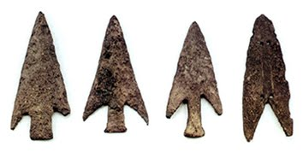
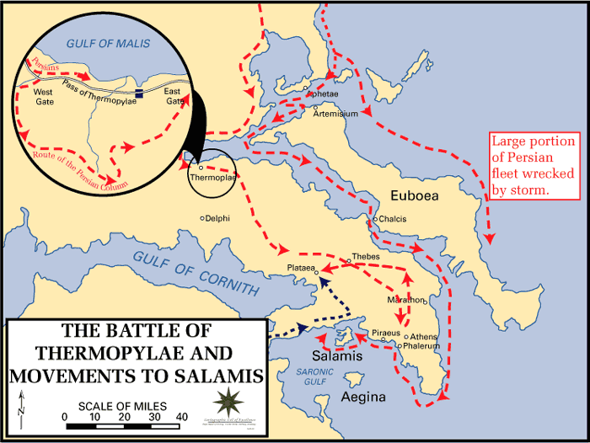

Who Fought?
300 Spartans
700 Thespians, from Boioita
900 helots (Spartan’s “slaves” from Laconia and Messania)
400 Thebans
1000 Phocians from (Phocis/ Fokis)

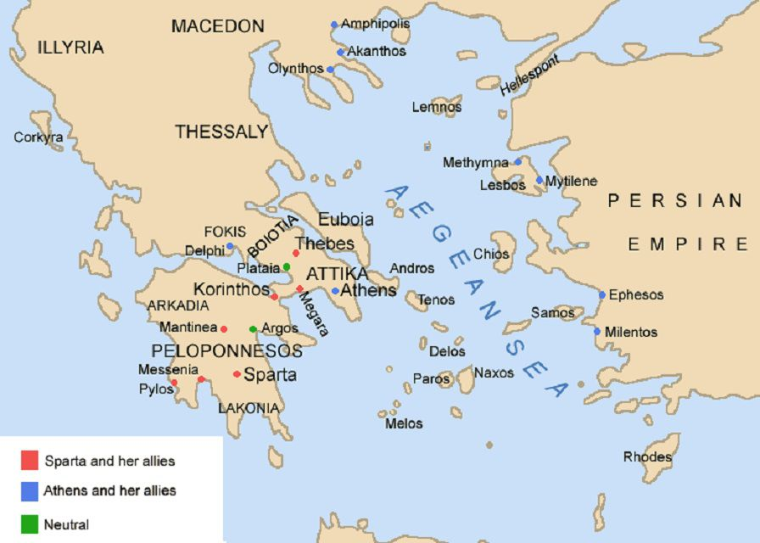

Label the map with arrows and numbers showing each region’s support for the Spartans at Thermopylae.

The star shows where the battle took place.
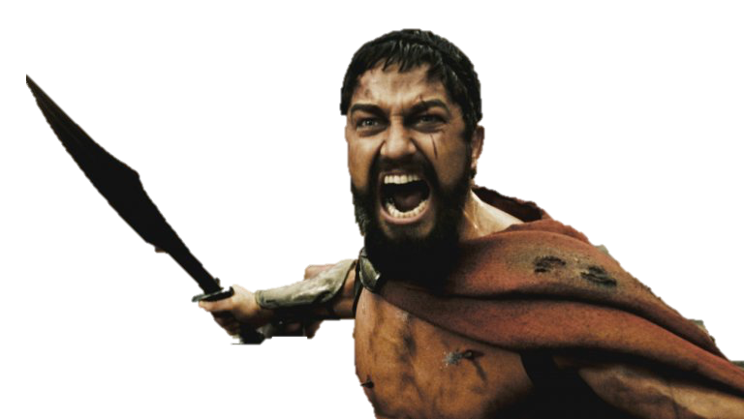

Herodotus’ History Book 7
Written in the c424 BC in classical Greek, The Histories records of the ancient traditions, politics, geography, and clashes of various cultures that were known in Western Asia, Northern Africa and Greece at that time. Herodotus was from Asia Minor, but discusses the Persian wars throughout his History.

“When the Greeks saw that they (the Persians) had come, the contest turned, for they retired to the narrow part of the way, passed behind the wall, and took their position crowded together on the hill, all except the Thebans. This hill is at the mouth of the pass, where the stone lion in honor of Leonidas now stands.

There is an inscription written over these men, who were buried where they fell, and over those who died before the others went away, dismissed by Leonidas. It reads as follows: “Here four thousand from the Peloponnese once fought three million. That inscription is for them all, but the Spartans have their own: “Foreigner, go tell the Spartans that we lie here obedient to their commands. That one is to the Lacedaemonians, this one to the seer:
“This is a monument to the renowned Megistias,
Slain by the Medes who crossed the Spercheius river.
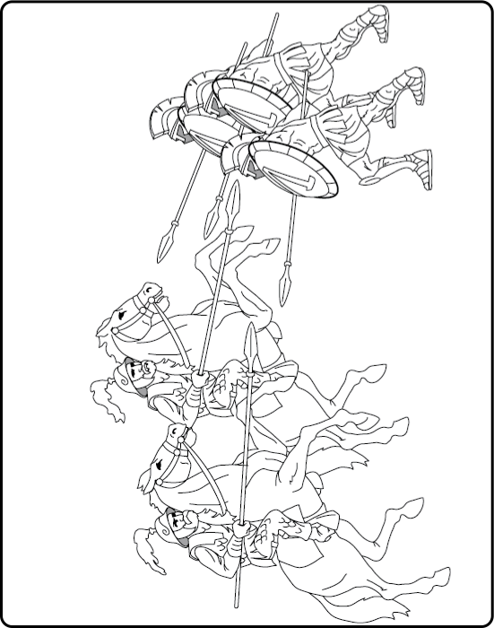
The seer knew well his coming doom,
But endured not to abandon the leaders of Sparta.”

Betrayal

Herodotus The Persian Wars Book 7
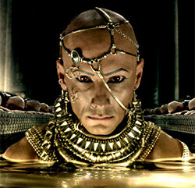
King Xerxes (left) being at a loss how to deal with the present difficulty, Ephialtes son of Eurydemus, a Malian, came to speak with him, thinking so to receive a great reward from Xerxes, and told him of the path leading over the mountain to Thermopylae; whereby he was the undoing of the Greeks who had been left there.
[…]
Xerxes, having at sunrise offered libations, waited till about the hour of marketing and then made his assault, having been so advised by Ephialtes; for the descent from the mountain is more direct and the way is much shorter than the circuit and the ascent. So the foreigners that were with Xerxes attacked; but the Greeks with Leonidas, knowing that they went to their death, advanced now much farther than before into the wider part of the strait.

Look at how Ephialtes id depicted in the 300 film.
- Why does his costume change?
- Compare the costumes to the vase on the right- which is Greek and which is Persian?
- How does his appearance perhaps make him not fit in with the Spartan soldiers?
- Does this justify his actions, in your opinion?
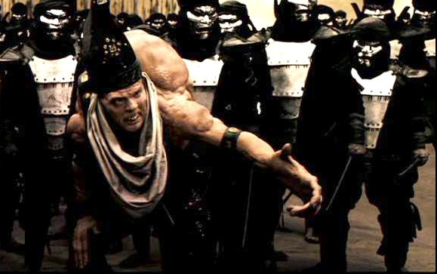

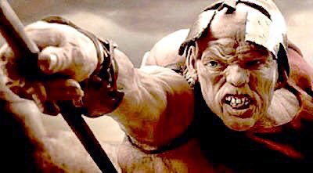
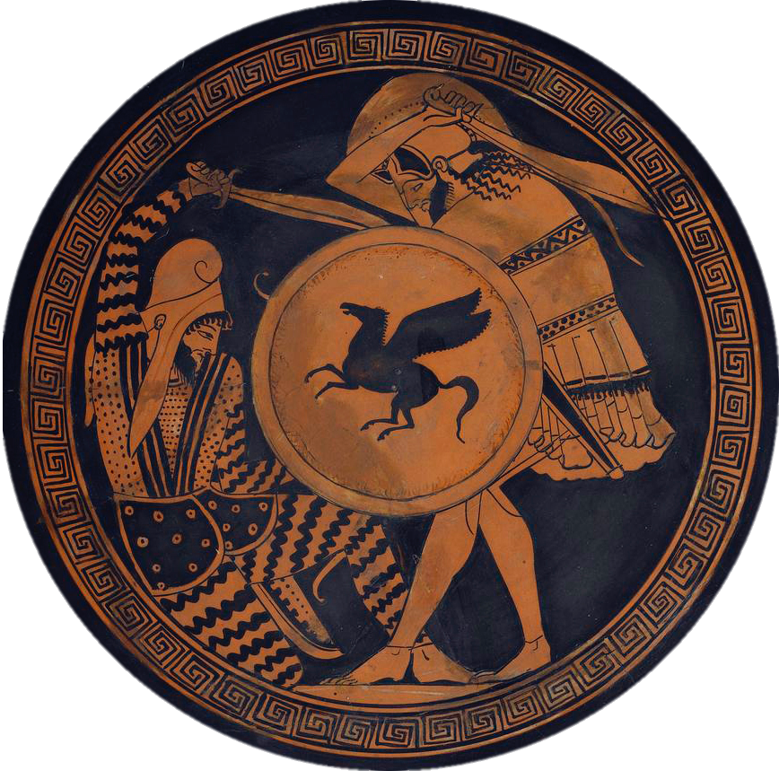

Memory

Strabo Geography
Born. ca. 62 BC d. ca. AD 24 in Amaseia, Asia Minor. Strabo was a geographer who gave accounts of sites of interest across the Greek world.
It was at these Narrows that Leonidas and his men, with a few who came from the neighborhood there, held out against all those forces of the Persians, until the barbarians, coming around the mountains through by-paths, cut them down. And today their Polyandrium is to be seen, and pillars, and the oft-quoted inscription on the pillar of the Lacedaemonians, which is as follows”
"Stranger, report to the Lacedaemonians that we lie here in obedience to their laws."

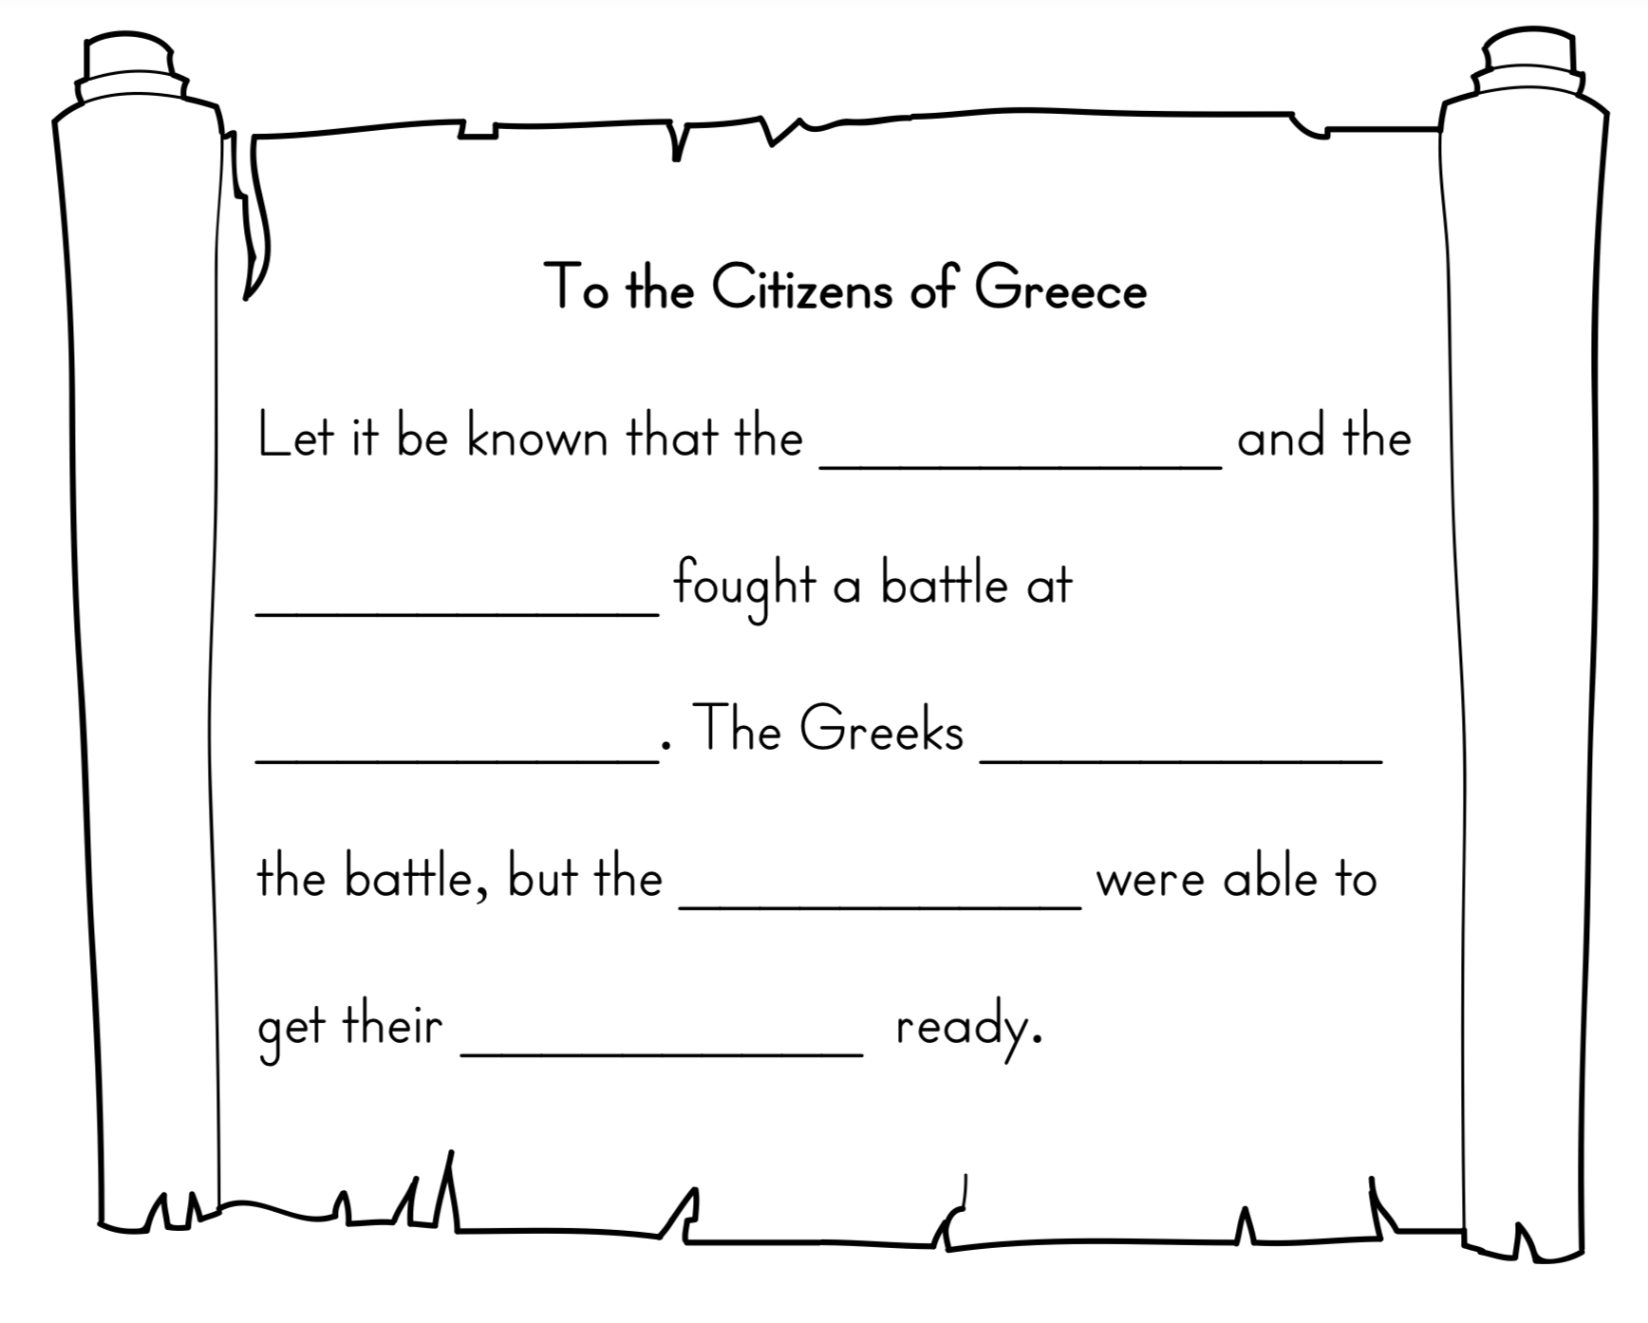

Read Strabo’s account of Thermopylae and fill in the message back to the citizens of Greece.
Who won the Battle?

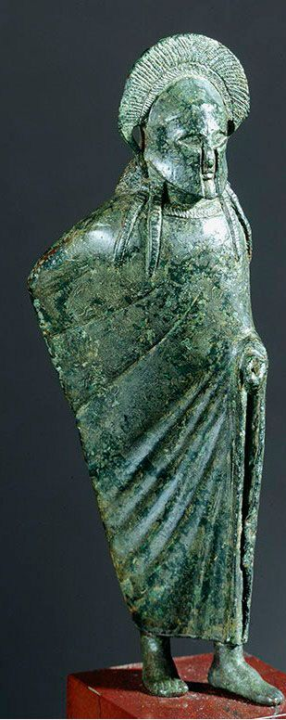

Spartan warrior wears his cloak around him as if sitting a night-watch.

Bronze Spartan made statue.
c 500 BC.

Spot the Difference

How is this statue different from the image of the Spartans we are used to?

How is it the same?

