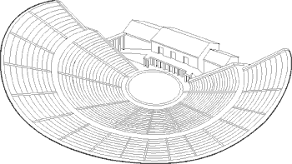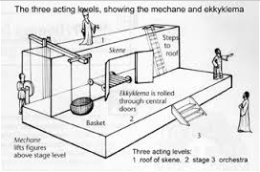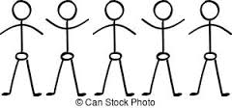

Chorus

This is a masked group that represents a community in the play. They sing and dance in between the dialogue of the main characters.

Theatron

The seating area for the audience.

Skene

Building in which actors change costumes and masks, if the roof was flat they could also use it as an etxra stage level.

Orchestra

This is area in front of the stage where the chorus would dance and sing.

Statue of Dionysus/ Priest of Dionysus’ seat

The Dionysia was dedicated to the god of wine, art and revelry, who presided over performances

_______________________________________________________________________________________________________________________________________________________________________________________________________________________________________________________________________________________________________________________________________________________________________________________________________________________________________________________________________________________________________________________________________________________________________________________________________________________________________________________________________________________________________________________________________________________________________________________________________________

Eisodos/ Parados

Entrance ways onto stage.

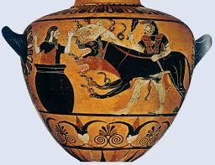

________________________________________________________________________________________________________________________________________________________________________________________________________________________________________________________________________________________________________________________________________________________________________________________________________________________

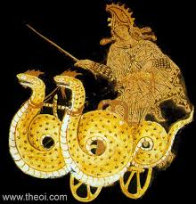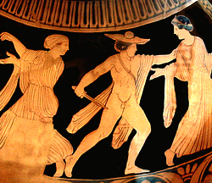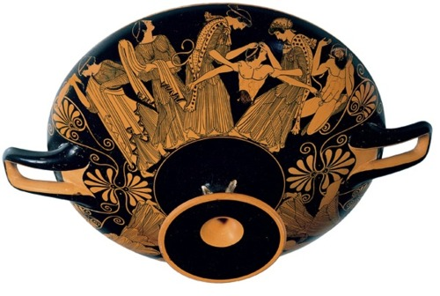

**1**

**4**

**3**

**2**

________________________________________________________________________________________________________________________________________________________________________________________________________________________________________________________________________________________________________________________________________________________________________________________________________________________

________________________________________________________________________________________________________________________________________________________________________________________________________________________________________________________________________________________________________________________________________________________________________________________________________________________

________________________________________________________________________________________________________________________________________________________________________________________________________________________________________________________________________________________________________________________________________________________________________________________________________________________

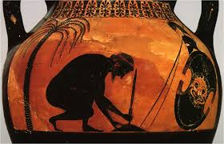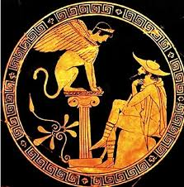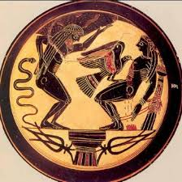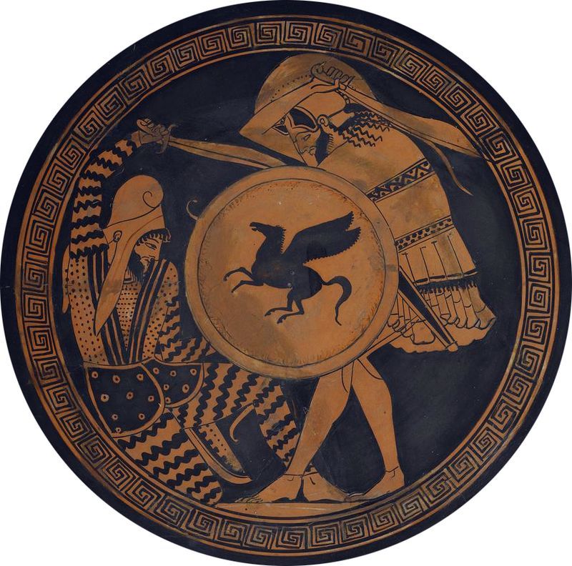

**8**

**7**

**6**

**5**

________________________________________________________________________________________________________________________________________________________________________________________________________________________________________________________________________________________________________________________________________________________________________________________________________________________

________________________________________________________________________________________________________________________________________________________________________________________________________________________________________________________________________________________________________________________________________________________________________________________________________________________

____________________________________________________________________________________________________________________________________________________________________________________________________________________________________________________________________________________________________________________________________________________________________________________

____________________________________________________________________________________________________________________________________________________________________________________________________________________________________________________________________________________________________________________________________________________________________________________

**Who Dunnit?**

Match the playwright to their works and add in the dates!

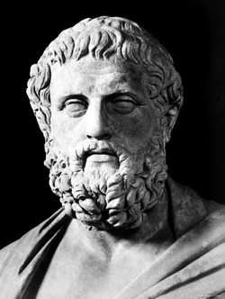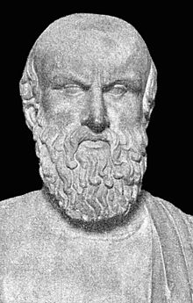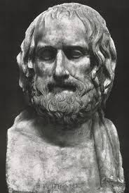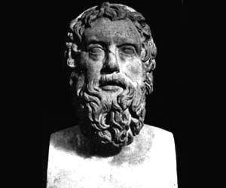

Aeschylus

Sophocles

Euripides

Aristophanes

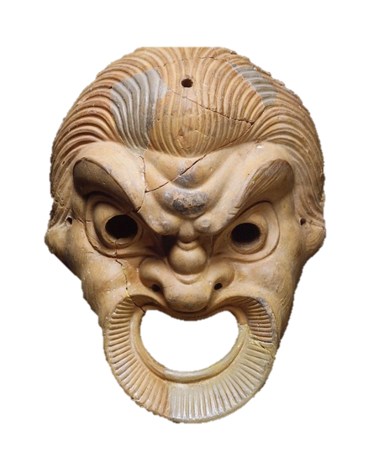

**Spot the Difference**

Look at how the Romans refurbished the Greek theatres. What did they change? What did they add?

