The Trial of Jason v Medea

Team Jason You need to be looking for evidence to suggest:
- Medea’s poisoning of Glauce was unjustified
- Medea’s infanticide was unjustified
- Medea’s crimes were premeditated rationally and unemotionally
- Jason’s suffering is undeserved

Team Medea You need to be looking for evidence to suggest:
- Medea’s slaughter of Glauce was justified
- Medea’s infanticide was justified
- Medea’s crimes are acts of passion or a madness that might diminish her own responsibility
- Jason’s suffering is deserved

Both teams need to look at the following evidence:
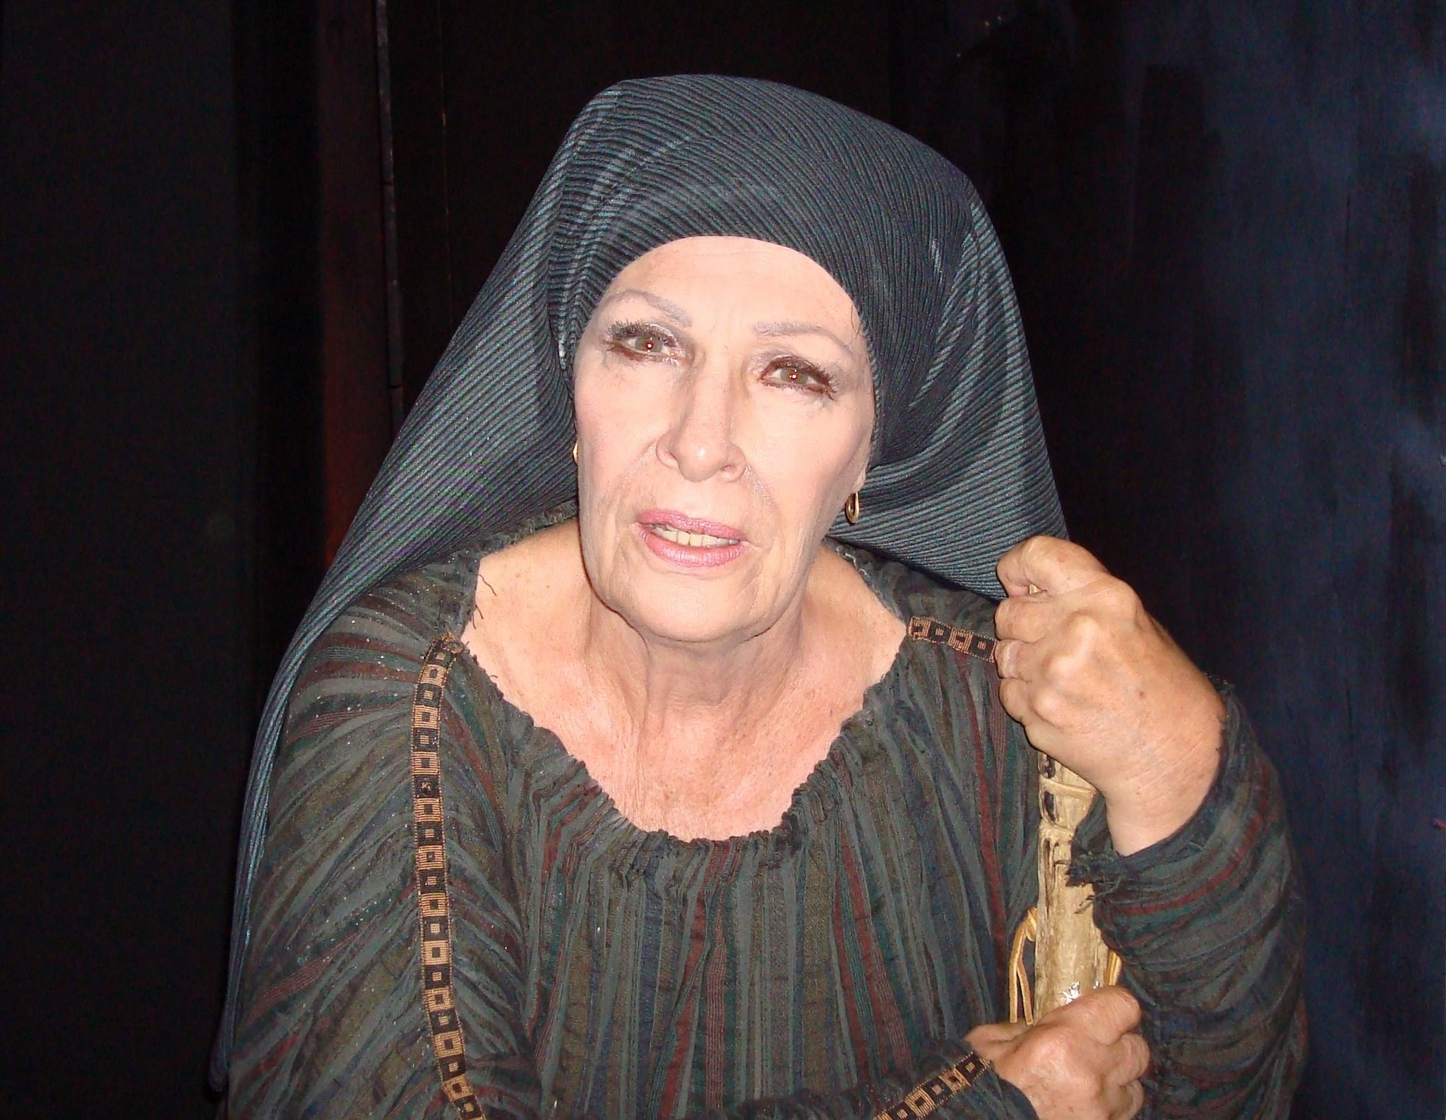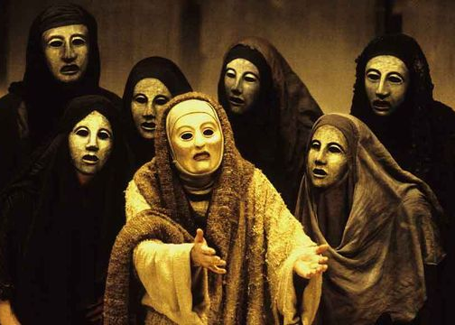
Witness Nurse: 1-48, 115-30 Witness Chorus: 410-45, 629-62,
824-65.

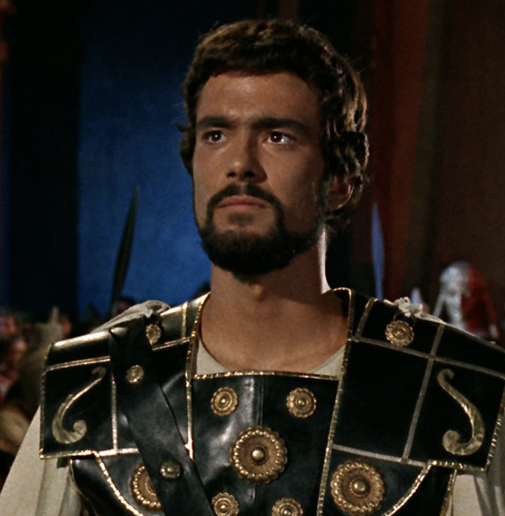
Defendant Medea: 214-66, Prosecution Jason: 522-75
465-519, 764-810.

You can split your team up and take a passage each then bring your ideas together, make a note orientating each passage, who is it spoken to/ in front of and at what point is this speech made?

 | Medea is Guilty | Medea is Not Guilty
Nurse
Chorus
Medea
Jason

