The Trial of Jason v Medea

Team Jason You need to be looking for evidence to suggest:
- Medea’s poisoning of Glauce was unjustified
- Medea’s infanticide was unjustified
- Medea’s crimes were premeditated rationally and unemotionally
- Jason’s suffering is undeserved

Team Medea You need to be looking for evidence to suggest:
- Medea’s slaughter of Glauce was justified
- Medea’s infanticide was justified
- Medea’s crimes are acts of passion or a madness that might diminish her own responsibility
- Jason’s suffering is deserved

Both teams need to look at the following evidence:
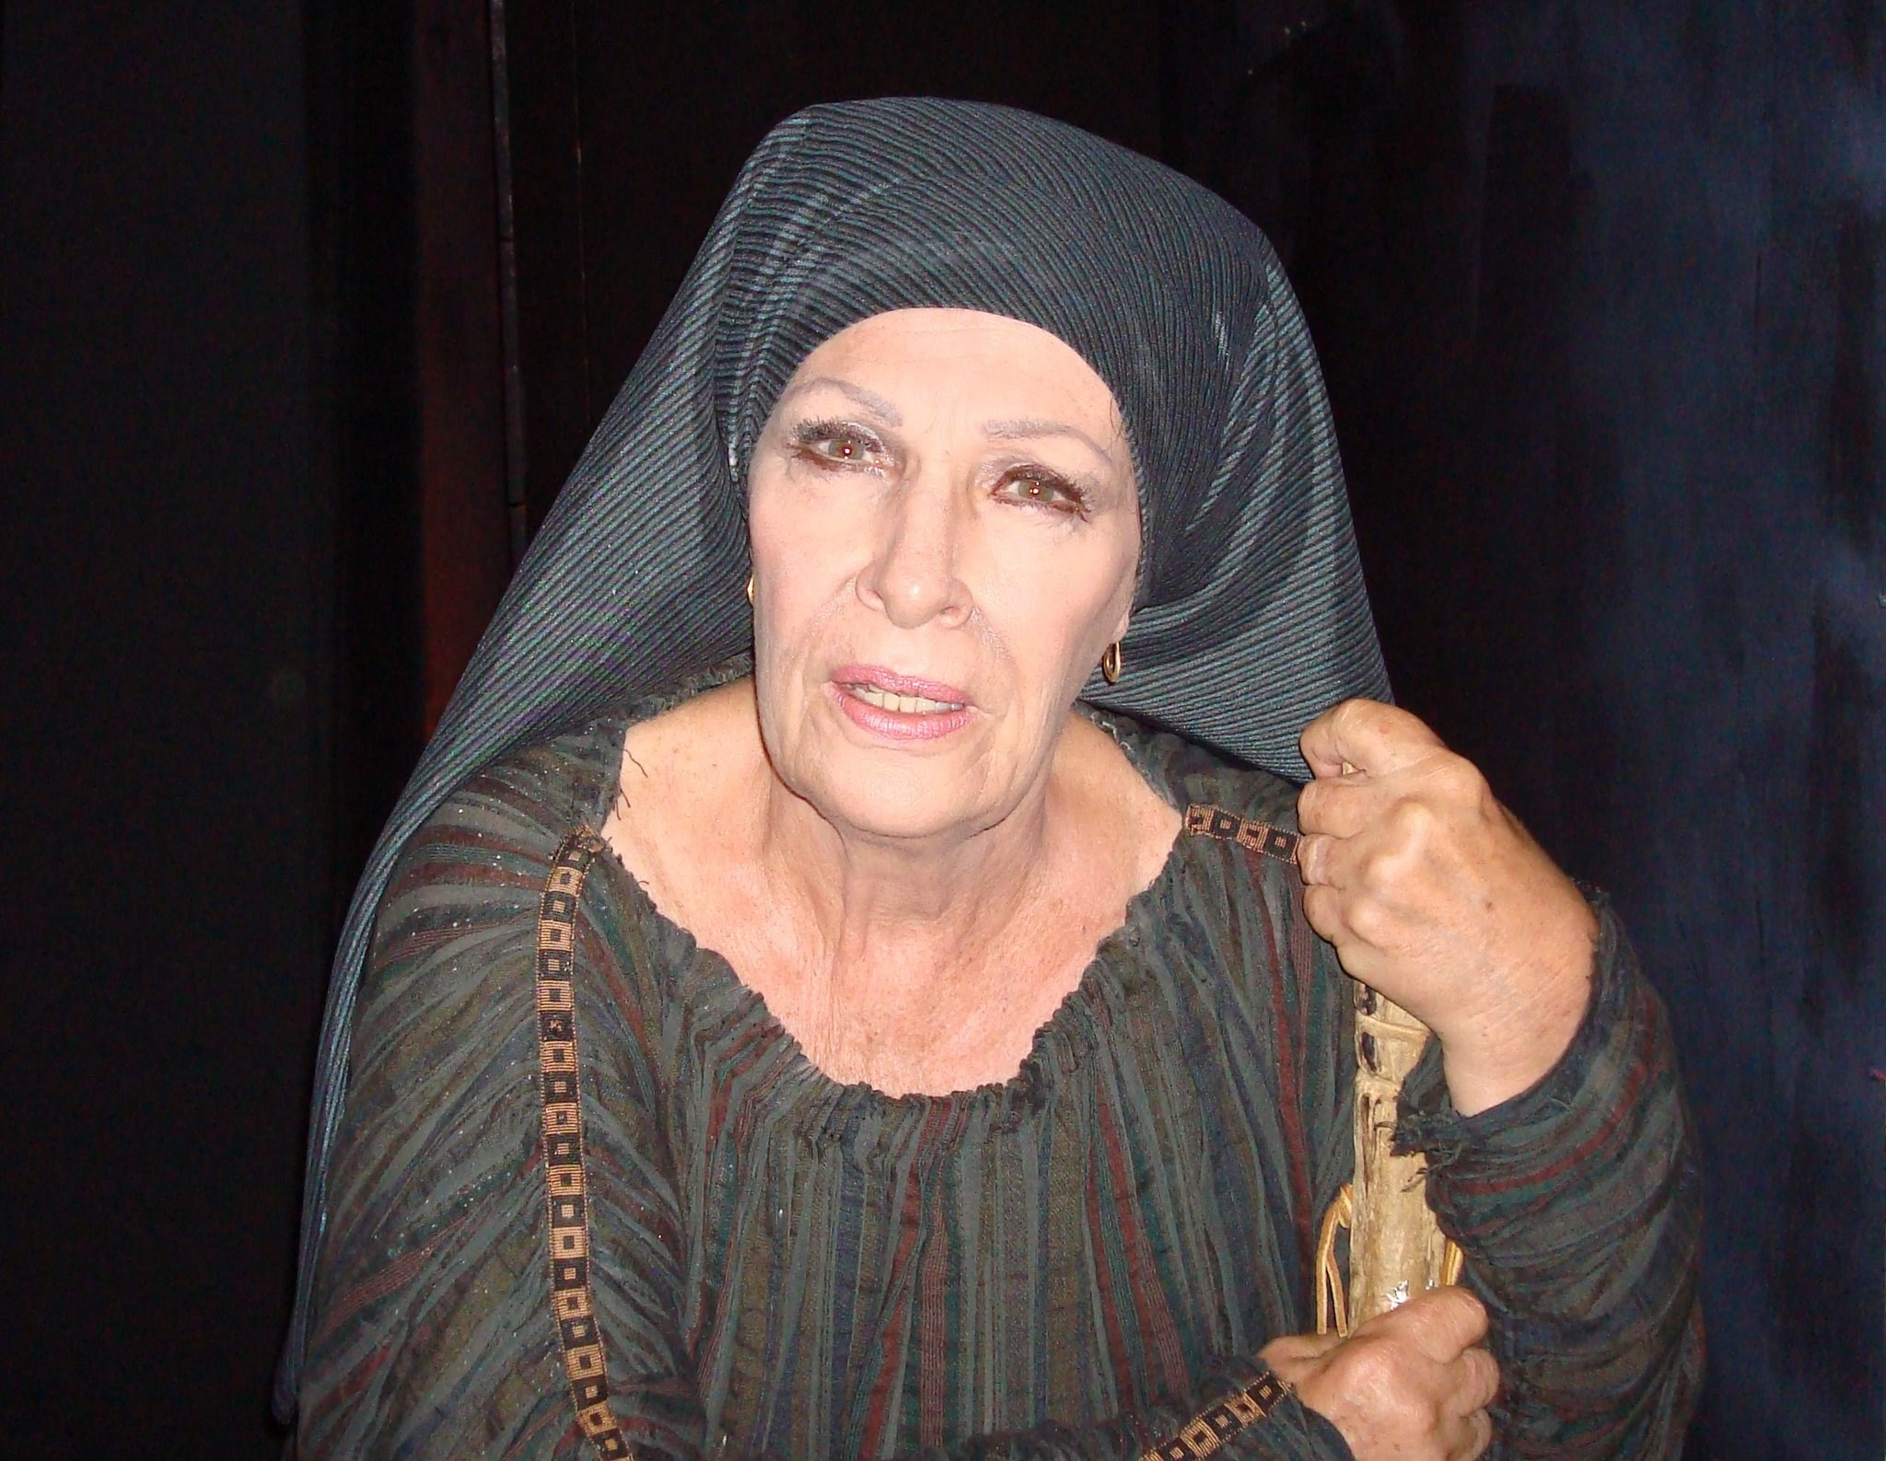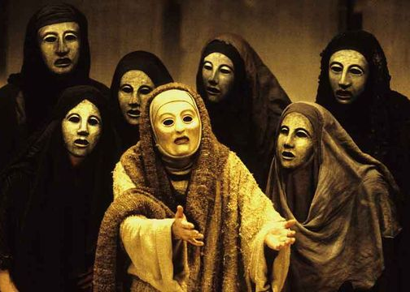
Witness Nurse: 1-48, 115-30 Witness Chorus: 410-45, 629-62,
824-65.

Defendant Medea: 214-66, Prosecution Jason: 522-75
465-519, 764-810.

You can split your team up and take a passage each then bring your ideas together, make a note orientating each passage, who is it spoken to/ in front of and at what point is this speech made?

 | Medea is Guilty | Medea is Not Guilty
Nurse | - persuaded the daughters of Pelias to kill their father and hence now be inhabiting this land of Corinth,  - Her temper is violent, and she will not put up with bad treatment (I know her), and I fear she may thrust a whetted sword through her vitals, [slipping quietly into the house where the bed is laid out,] or kill the royal family  - she is dangerous.  - Why do you make the children sharers in their father’s sin?  - The minds of royalty are dangerous: | - her heart smitten with love for Jason  - an exile loved by the citizens  - Jason, abandoning his own children and my mistress, is bedding down in a royal match  - Poor Medea, finding herself thus dishonored, calls loudly on his oaths, invokes the mighty assurance of his sworn right hand, and calls the gods to witness the unjust return she is getting from Jason.
Chorus | - the killer of your children, stained with their blood, in the company of her citizens? Think on the slaying of your children, think what slaughter you are committing! Do not, we beseech you by your knees and in every way we can, do not kill your children!  - When your children fall as suppliants at your feet, you will not be hardhearted enough to drench your hand in their blood. | - their oaths by the gods do not hold fast.  - Honor is coming to the female sex: no more will women be maligned by slanderous rumor.  - love-maddened heart  - poor wretch, and you are being driven from this land a dishonored exile.  - Loves that come to us in excess  - May that man die unloved who cannot honor his friends
Medea | - when she is injured in love, no mind is more murderous than hers.  - I betrayed for your sake when I came here? Or to the wretched daughters of Pelias? A fine reception they would give me in their house since I killed their father!  - I have made foes of those I ought not to have harmed.  - I shall ask that the children be allowed to stay, not with the thought that I might leave them behind on hostile soil for my enemies to insult, but so that I may (deception)  - he will die a painful death, and likewise anyone who touches her: with such poisons will I smear these gifts.  - I shall kill my children: there is no one who can rescue them.  - that wretch must die a wretched death by my poisons. Let no one think me weak, contemptible, untroublesome. | - this sudden blow that has struck me has destroyed my life. I am undone, I have resigned all joy in life, and I want to die. For the man in whom all I had was bound up, as I well know—my husband—has proved the basest of men.  - I would rather stand three times with a shield in battle than give birth once.  - This is not boldness or courage—to wrong your loved ones and then look them in the face—but the worst of all mortal vices, shamelessness.  - I saved your life  - Respect for your oaths is gone, and I cannot tell whether you think that the gods of old no longer rule  - What a fine reproach for a new bridegroom, that his children are wandering as beggars, and she who saved him likewise!  - Now I may confidently expect that my enemies will pay the penalty.
Jason | - you so exaggerate your kindness to me  - but to tell how Eros forced you with his ineluctable arrows to save me would expose me to ill will.  - I wanted to raise the children in a manner befitting my house, to beget brothers to the children born from you, | - So far as you did help me, you did well. But in return for saving me you got more than you gave, as I shall make clear.  - But you women are so far gone in folly that if all is well in bed you think you have everything, while if some misfortune in that domain occurs, you regard as hateful your best and truest interests.

