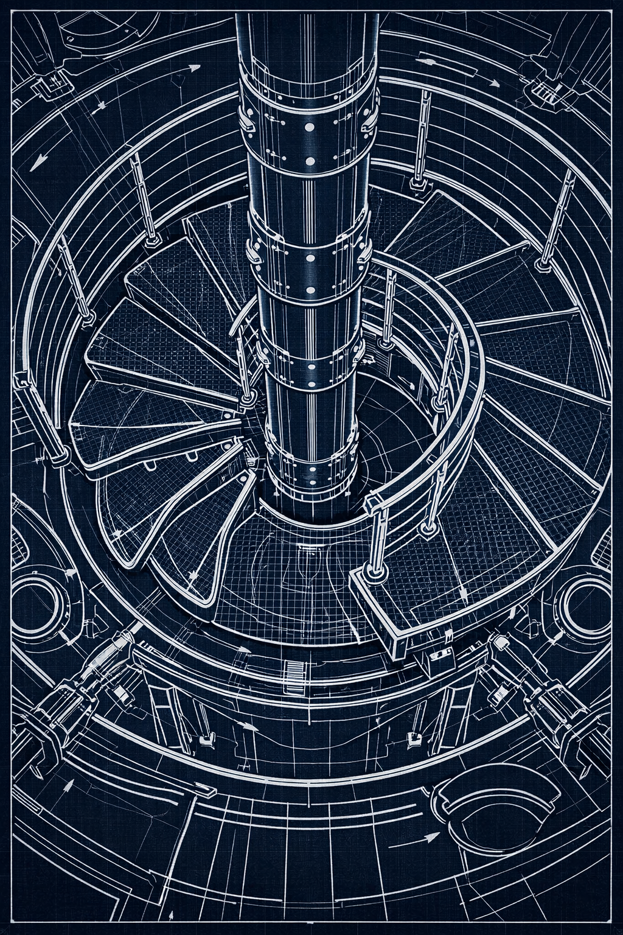

BALL4D EXECUTIVE LIBRARY — COMPLETE EDITION
(All shelves, all domains, all sections — clean long‑form text.)

TAB 1 — EXECUTIVE SUMMARY

The Ball4D Pod Mechanical Entry System is a next‑generation emergence platform engineered for precision, stability, and controlled atmospheric synchronization within the CVG architecture. It integrates titanium mast engineering, asymmetric stairwell geometry, and controlled pressurization logic to create a predictable and safe mechanical emergence pathway.

The system is designed for executive‑level operations requiring reliability, environmental control, and structural predictability. Its architecture supports controlled pod ascent or descent through a pressure‑rated stairwell environment.

The Ball4D Pod is a mechanical ovoid capsule that transitions through a clamshell release collar mounted to the titanium mast. This mechanism provides a controlled and predictable method for pod deployment within a pressurized cabin environment.

This executive summary establishes the foundation for the engineering, atmospheric, operational, financial, and risk‑mitigation frameworks that follow in subsequent tabs.

TAB 2 — ENGINEERING & STRUCTURAL INTEGRATION

The titanium mast serves as the central load spine for the Ball4D system. It includes dual‑bolt segmented collars, a tri‑channel conduit spine, and a pressure‑rated cradle ring that supports the pod during pressurization and emergence.

The spiral staircase uses asymmetric tread geometry to create a widened entry corridor. This offset design allows the Ball4D Pod to pass through the stairwell without requiring symmetrical clearance.

Boomerang counterweights beneath selected treads neutralize torque generated by pod movement. These counterweights maintain floor stability and prevent rotational drift during pressurization cycles.

The carbon‑mesh floor plate and CF‑PB reinforcement layers provide structural rigidity and vibration damping. These components ensure that the stairwell remains stable during pod ascent or descent.

The mast’s tri‑channel conduit spine routes oxygen feed lines, pressure‑sensor wiring, and inflator redundancy lines. This internal routing prevents cross‑contamination and maintains system integrity during atmospheric transitions.

TAB 3 — ATMOSPHERIC & PRESSURIZATION LOGIC

The Ball4D Pod operates within a synchronized atmospheric envelope shared with the dome and stairwell. The system uses a forty percent oxygen mixture and a controlled pressurization ramp from one atmosphere to three atmospheres over ten minutes.

The secondary glass seal engages at two point seven atmospheres and locks fully at three point zero atmospheres. This ensures that the pod experiences no differential pressure during emergence.

Acoustic venting reduces ear‑pressure discomfort during pressurization. These vents maintain a safe pressure gradient and enhance user comfort.

The continuous ramp curve eliminates step‑jumps or sudden pressure changes. This ensures predictable atmospheric behavior and minimizes thermal and acoustic stress.

TAB 4 — OPERATIONAL TIMELINE & LEAD TIMES

The Ball4D Pod system follows a structured deployment timeline with defined lead times for each operational phase. This ensures predictable readiness for executive‑level operations.

Pre‑seal preparation requires twenty‑four hours for mast and cradle verification. This includes structural checks, collar alignment, and conduit integrity testing.

Oxygen enrichment requires twelve hours of system readiness. During this phase, the oxygen feed lines are primed and the atmospheric envelope is stabilized.

The pressurization ramp requires forty‑eight hours of environmental calibration. This ensures that the dome, stairwell, and pod share a synchronized atmospheric profile.

The secondary seal requires seventy‑two hours of structural verification. This includes glass‑seal alignment, mast‑collar pressure testing, and clamshell integrity checks.

Pod emergence requires ninety‑six to one hundred twenty hours of system alignment and clearance checks. This phase ensures that the pod can transition through the stairwell without obstruction.

TAB 5 — QUALITATIVE, QUANTITATIVE & RISK ANALYSIS

Quantitative analysis confirms that the asymmetric tread geometry and boomerang counterweights maintain structural equilibrium during pod movement. The titanium mast exhibits minimal torsional deviation under three‑atmosphere pressurization.

The forty percent oxygen mixture provides optimal seal acceleration without exceeding thermal thresholds. The ten‑minute ramp curve ensures predictable atmospheric behavior and minimizes acoustic discomfort.

Qualitative evaluation indicates that the Ball4D Pod system provides a smooth and predictable emergence experience. The asymmetric stairwell design enhances visual clarity and spatial awareness.

Risk analysis identifies three primary categories: structural load variance, atmospheric synchronization failure, and mechanical obstruction. Each risk is mitigated through mast reinforcement, continuous pressure monitoring, and clearance verification.

Overall system risk is classified as low when operated within defined tolerances. The Ball4D Pod system is suitable for executive‑level operations requiring precision, reliability, and controlled environmental transitions.

TAB 6 — FINANCIAL MODELING

The financial model for the Ball4D Pod system evaluates capital expenditure, operational expenditure, maintenance cycles, and long‑term asset value. The model is designed for executive‑level budgeting and strategic planning.

Capital expenditure includes titanium mast fabrication, pod shell manufacturing, pressurization hardware, acoustic venting systems, and carbon‑mesh reinforcement. These costs represent the initial investment required to deploy the system.

Operational expenditure includes oxygen supply, pressurization energy consumption, maintenance labor, and periodic structural inspections. These recurring costs determine the long‑term financial footprint of the system.

Maintenance cycles are modeled on a one‑hundred‑twenty‑hour operational window, with major inspections every five hundred hours. This ensures predictable budgeting and minimizes unexpected downtime.

Long‑term asset value is derived from system reliability, structural longevity, and integration with the broader CVG architecture. The Ball4D Pod system is classified as a high‑value, low‑depreciation asset.

TAB 7 — MANUFACTURING & SUPPLY CHAIN

Manufacturing of the Ball4D Pod system requires precision machining, composite fabrication, and pressure‑rated assembly. Titanium mast segments are produced using dual‑bolt collar tolerances and tri‑channel conduit routing.

The ovoid pod shell is manufactured using CF‑PB composite layers with clamshell hinge integration. This ensures structural rigidity and predictable behavior under pressurization.

Supply chain requirements include titanium alloy sourcing, composite resin procurement, oxygen system components, and acoustic venting hardware. All materials must meet aerospace‑grade specifications.

Quality assurance includes pressure testing, structural load testing, and atmospheric synchronization verification. Each component undergoes certification before integration.

TAB 8 — FULL RISK‑MITIGATION MATRIX

Risk Category: Structural Load Variance
Mitigation: Reinforced mast collars, boomerang counterweights, asymmetric tread stabilization.

Risk Category: Atmospheric Synchronization Failure
Mitigation: Continuous pressure monitoring, redundant oxygen feed lines, ten‑minute ramp curve.

Risk Category: Mechanical Obstruction
Mitigation: Clearance verification, pod alignment sensors, clamshell integrity checks.

Risk Category: Pressurization Seal Failure
Mitigation: Secondary glass seal engagement at two point seven atmospheres, full lock at three point zero atmospheres.

Risk Category: Acoustic Overpressure
Mitigation: Vent manifold tuning, ear‑safe equalization ports, gradual pressure transitions.

