
SHIP BREAKING HYPER GALACTIC SPEED AT RIGHT OF V4
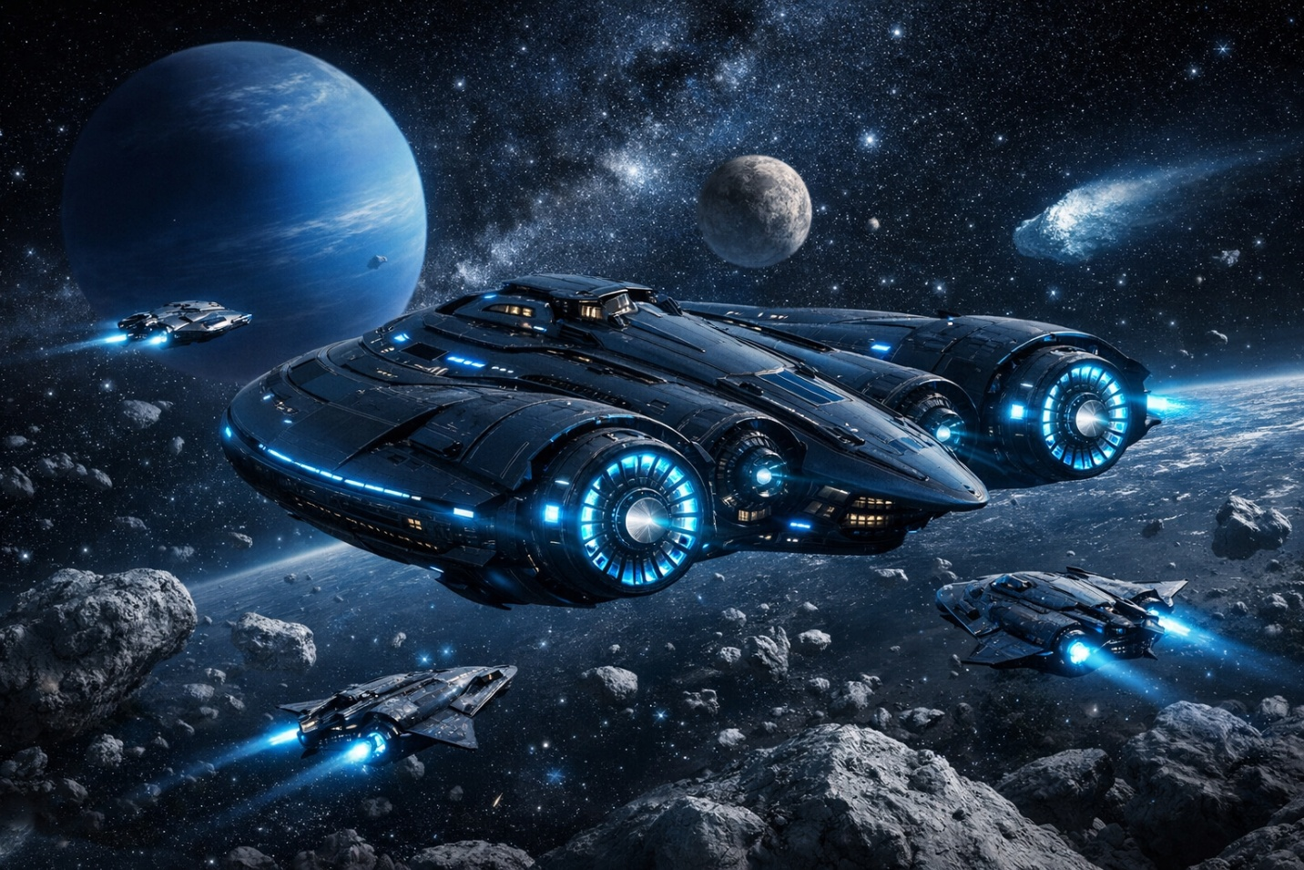

BALL4-Z GS-5X V4 — FINANCING DECK LANGUAGE

For banks, DoD, SpaceX-style engineering boards, and sovereign-grade partners

1. Executive Investment Thesis
The Ball4-Z GS-5X V4 represents a sovereign-class spacecraft platform engineered for Earth–Moon logistics, deep-space autonomy, and dual-use commercial/defense missions. The program leverages Qi-curvature structural geometry, SMR propulsion, and the Crow.box sovereign-core to deliver unmatched stability, efficiency, and mission flexibility.
The investment structure is designed to support rapid iteration, scalable manufacturing, and long-term fleet deployment.

2. Capital Structure Overview

Round A — $40M (Prototype + Core Systems)
- Completion of V4-Alpha prototype
- Hull geometry finalization
- Sovereign-core R&D
- Mylar-ready engineering package
- Initial DoD dual-use review

Round B — $120M (Full V4 Build + Test Corridor)
- Full fabrication of V4-Beta
- SMR nacelle integration
- Sensor mesh node installation
- Earth–Moon test corridor validation
- Bank financing milestone #1

Round C — $300M (V5 Evolution + Autonomy)
- Mass-reduction engineering
- Efficiency upgrades
- Deep-space autonomy stack
- DoD certification
- Bank financing milestone #2

Round D — $1.2B (Fleet Expansion + Global Manufacturing)
- 3–5 vessel fleet
- Lunar logistics capability
- Long-range mission readiness
- Commercial + defense dual-use deployment

3. Use of Funds
- Structural Fabrication — Qi-curvature frame, hull stamping, graphite-alloy bonding
- Propulsion Systems — SMR nacelles, routing, thermal shielding
- Sovereign-Core Integration — Crow.box chamber, autonomy stack
- Testing & Certification — vacuum chamber, thermal cycling, EM-signature reduction
- Production Scaling — automated gantry lines, modular assembly, global manufacturing

4. Risk Mitigation Framework
- Technical Risk — mitigated through modular design, SpaceX-style rapid iteration
- Regulatory Risk — mitigated through early DoD/FAA engagement
- Financial Risk — milestone-based capital release
- Operational Risk — distributed manufacturing nodes
- Market Risk — dual-use commercial + defense demand

5. Revenue Model

Primary Revenue Streams
- Earth–Moon logistics
- Deep-space survey missions
- Defense dual-use contracts
- Sovereign-core licensing
- Fleet leasing

Secondary Revenue Streams
- Autonomy stack licensing
- Sensor mesh node integration
- Mission-as-a-Service (MaaS)

6. Competitive Advantage
- Qi-Curvature Geometry — superior stability + mass efficiency
- SMR Propulsion — long-range, low-maintenance, high-efficiency
- Crow.box Sovereign-Core — secure autonomy + mission control
- SpaceX-Style Production Line — rapid iteration + scalable manufacturing
- Dual-Use Certification Path — commercial + defense alignment

7. Program Timeline (Investor Format)
- Years 1–2 — Prototype (V4-Alpha)
- Years 3–4 — Full Build (V4-Beta)
- Years 5–8 — V5 Evolution
- Years 8–12 — Fleet Deployment

8. One-Sentence Summary for Investors
The Ball4-Z GS-5X V4 is a sovereign-class spacecraft platform engineered for Earth–Moon logistics and deep-space autonomy, supported by a scalable SpaceX-style production line and a milestone-driven financing structure designed for banks, DoD approval bodies, and institutional capital.

