Sourdough bread
Only 10 minutes of your time
December 1, 2024
B2yroots, vuelve a tus raices
www.b2yroots.org
INGREDIENTS FOR TWO LOAVES:
1. 1 Kg of flour (you can mix several types, my favorite is 30% rye and 70% white)
2. 0.9-1 liter of water
3. Sourdough starter (approximately 150g)
4. Salt (a handful)
PROCEDURE:
1. Put the salt, water, flour and sourdough starter (leave about a tablespoon in the jar) in the bowl of your mixer and let it knead for about 5 minutes.

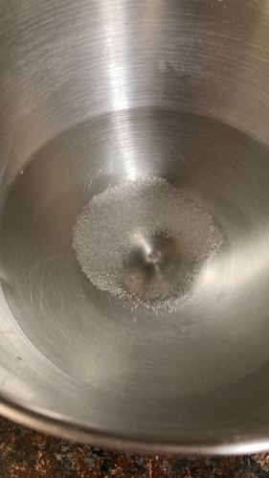 | 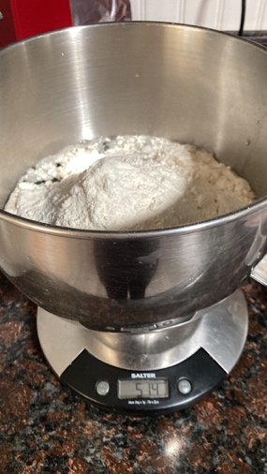 | 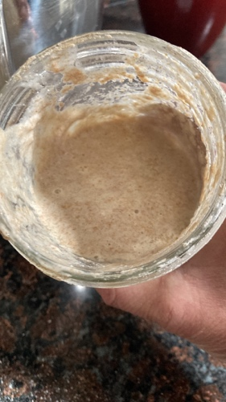 | 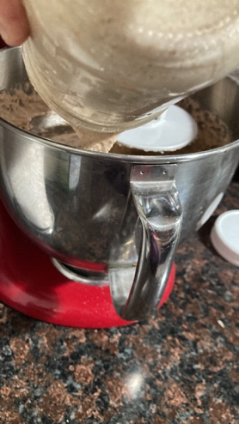 | 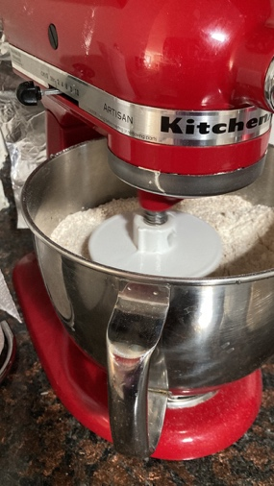

2. While the machine kneads, we renew the sourdough starter. Use a pint glass jar (half a liter). Add 3-4 tablespoons of wholemeal flour (I like to use rye). Add water and stir until it has a porridge texture.

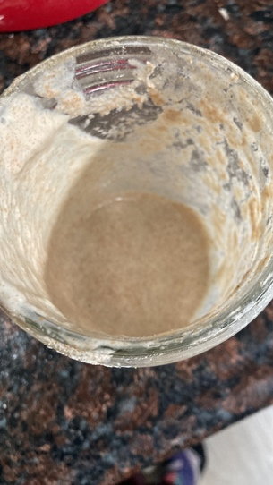 | 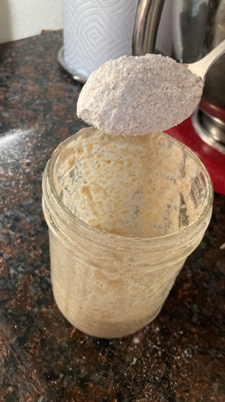 | 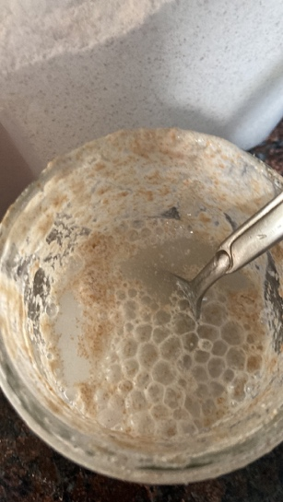 | 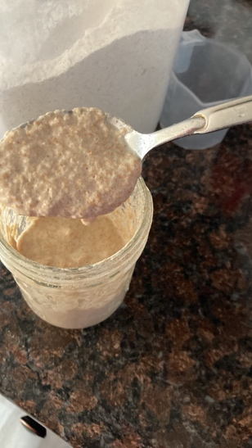

3. Let it rest on the counter:
- The starter 2-5 hours depending on the temperature of your kitchen. We want it to activate but not overflow. If you're not going to be home, put it in the fridge but then take it out about 2 hours before you make bread again to make sure it activates.

- Leave the bread 10-12 hours before putting it in the fridge, adapting it to your lifestyle (I mix it in the morning and put it in the fridge at night until the next day; but you can also mix it at night, leave it on the counter until you get up the next day and then put it in the fridge). It can be in the fridge for 8-16 hours.
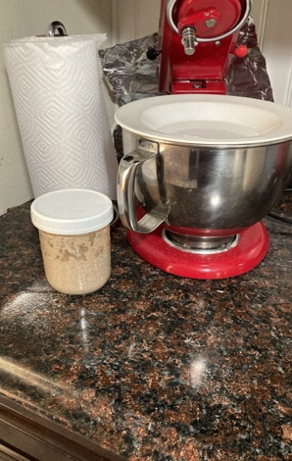 | 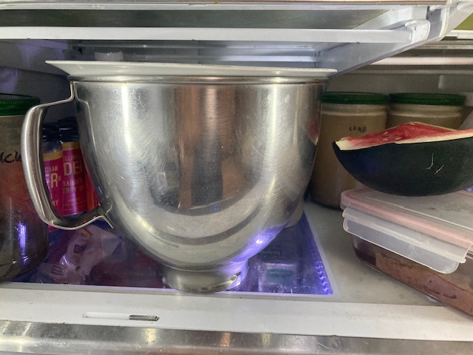

4. Take it out of the fridge, sprinkle a little flour on the counter to shape it (no need to knead again), put it in the tins or give it the shape you want, score with a knife and let it rise for 3-5 hours. I use another tin to cover it and create “an oven within the oven” (it retains the water that evaporates to create steam inside the “lid”) so that the crust comes out crispier.

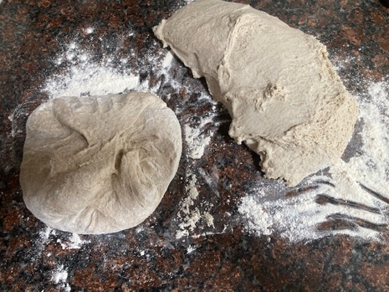 | 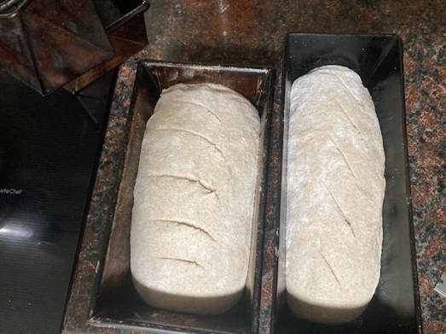 | 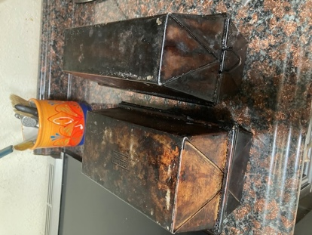

5. Place in a cold oven at 425ºF (200ºC) for about 45 minutes. Remove the “lid” and leave for 5-8 more minutes. Place on racks as soon as they come out of the oven so that the crust becomes nice and crispy.

