PETER WARREN BOOKS
ORDER FORM
Peter Warren
PO Box 6
Southbury, CT 06488
Cell (203) 982-8652
Website: www.readpete.com
Email: peterwarrenbooks@yahoo.com
LIKE Peter Warren Books on Facebook

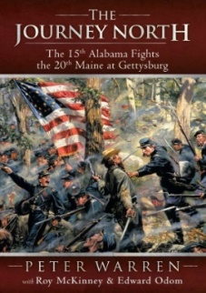
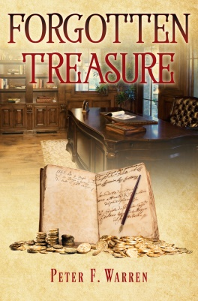

To order copies of: One Brother’s REVENGE, MURDER in Murrells Inlet, The Horry County Murders, The Parliament Men, Forgotten Treasure, Confederate Gold and Silver, or The Journey North, please complete this form and return it with your payment to the address above.
Please make checks payable to: Peter Warren Books

Name: ___________________Address: __________________________
City/State: _______________________________ Zip Code: _________
Phone w/area code: ______________ Email: ______________________

“I am interested in purchasing the following book(s).”

__ One Brother’s REVENGE (Soft Cover) $20.00 each* Total $_______

__ MURDER in Murrells Inlet (Soft Cover) $20.00 each* Total $_______

__ The Horry County Murders (Soft Cover) $20.00 each* Total $_______

__ The Parliament Men (Soft Cover) $20.00 each* Total $_______

__ Confederate Gold and Silver (Soft Cover) $22.00 each* Total $_______

__ Forgotten Treasure (Soft Cover) $22.00 each* Total $_______

__ The Journey North (Soft Cover) $14.00 each* Total $_______

__ Shipping Cost of 1 or 2 books ADD $4.00 $_______

__ Shipping Cost of 3 or more books ADD $6.00 $_______

Total Purchase $_______
(*Tax included)

I would like the following added to the front section of my book:
(please check the appropriate box)
_____ Please just have the author sign the book(s).
_____ Please have the author sign the book(s) and address an appropriate remark to:

____________________________________________________________
(The name of the person(s) who the book(s) is being purchased for.)
_____ Just send me the book(s) with no signature or remarks.

Additional Instructions for the Author:

* Please clearly print the name(s) that you would like the author to sign the book(s) for.
* The author is not responsible for misspellings of names, or for other similar mistakes.
* Refunds will not be given for any books that have been signed.

