DEPARTMENT OF MASSACHUSETTS

VETERANS OF FOREIGN WARS

**All State Program**

**2025-2026**

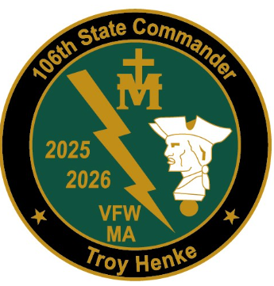

***Prepared by: Troy W. Henke, State Commander***

**The All-State program recognizes Posts and leaders who excel in VFW membership growth, administration, programs, and support Department events.**

Posts may earn All-State status by meeting all of the criteria listed within the gold box and by meeting at least nine (9) of the 12 criteria listed in the blue box:

|  |
| --- |
| * Achieve 100% + 1 in membership by June 30, 2026 * Successfully submit all four (4) quarterly audits on time beginning with June 2025 * Quartermaster is bonded no later than August 31, 2025 * Copy of current IRS 990 filing submitted to the Quartermaster, or proof submitted that the Post has taken affirmative steps to have their 990 status reconstituted if it has been revoked * Copy of Post annual filing of their Incorporation with the MA. Secretary of State’s Office submitted to the Department no later than November 30, 2025 * Successfully submit all four (4) quarterly community service reports via the OMS All-American dashboard |

|  |
| --- |
| * Achieve 101% membership by June 30, 2026 * Attend OTI * National Home Donations:   CIC Special Project--$50 or more and  General Fund or MA. House Fund--$100 or more   * Attend State Convention Saturday session * Participate in State Commander’s Special Project * Submit one (1) Patriot’s Pen Essay to District * Submit one (1) Voice of Democracy Essay to District * Submit one (1) of the following: Teacher of the Year nomination to District or   First Responder nomination or Scout of the Year nomination to Department   * Conduct two membership events * Purchase Buddy Poppies through the Department * VMS Donation of $125 or more * Purchase two (2) tickets prior to the event date for one or more of the following: VOD/PP Banquet, the CIC Banquet, and/or the State Convention Banquet |

**ALL-STATE POST COMMANDERS AWARD**

***Post Commanders achieving All-State status will receive the following:***

* All-State Commander’s Cap or $75 prize
* All-State Commander’s Lapel Pin

**ALL-STATE POST QUARTERMASTERS AWARD**

***Post Quartermasters achieving All-State status will receive the following:***

* All-State Quartermaster’s Cap or $75 prize
* All-State Quartermaster’s Lapel Pin

Districts may earn All-State status by meeting all of the following criteria:

|  |
| --- |
| * Achieve 101% membership by June 30, 2026 * Inspect all Posts within their District by March 31, 2026 * Quartermaster is bonded no later than August 31, 2025 * Copy of current IRS 990 filing submitted to the Quartermaster, or proof submitted that the District has taken affirmative steps to have their 990 status reconstituted if it has been revoked * Copy of District annual filing of their Incorporation with the MA. Secretary of State’s Office submitted to the Department no later than November 30, 2025 * Conduct one (1) District level membership event * Submit one (1) Patriot’s Pen Essay to Department * Submit one (1) Voice of Democracy Essay to Department * Submit one (1) Teacher of the Year nomination to Department * At least one Post within the District submit one (1) First Responder nomination to Department * At least one Post within the District submit one (1) Scout of the Year nomination to Department * VMS Donation of $125 or more * National Home Donations:   CIC Special Project--$50 or more **and**  General Fund or MA. House Fund--$100or more |

**ALL-STATE DISTRICT COMMANDERS AWARD**

***District Commanders achieving All-State status will receive the following:***

* All-State Commander’s Cap
* All-State Commander’s Lapel Pin
* $250 prize

**ALL-STATE DISTRICT QUARTERMASTERS AWARD**

***District Quartermasters achieving All-State status will receive the following:***

* All-State Quartermaster’s Cap or $75 prize
* All-State Quartermaster’s Lapel Pin