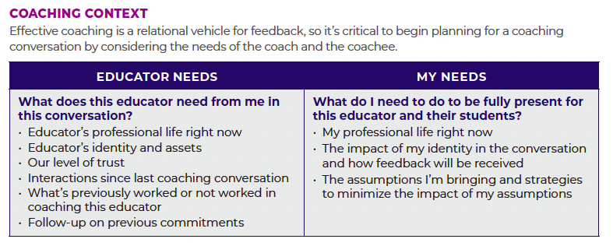

Clarify Message

Situation or Content | Behavior or Strategy | Impact

Desired Result of Feedback

What does success look like and sound like if the person addresses this issue? | What evidence would demonstrate to you that the issues is addressed?

Improving Your Feedback

Where do you think your feedback practices could benefit from improvement?

