[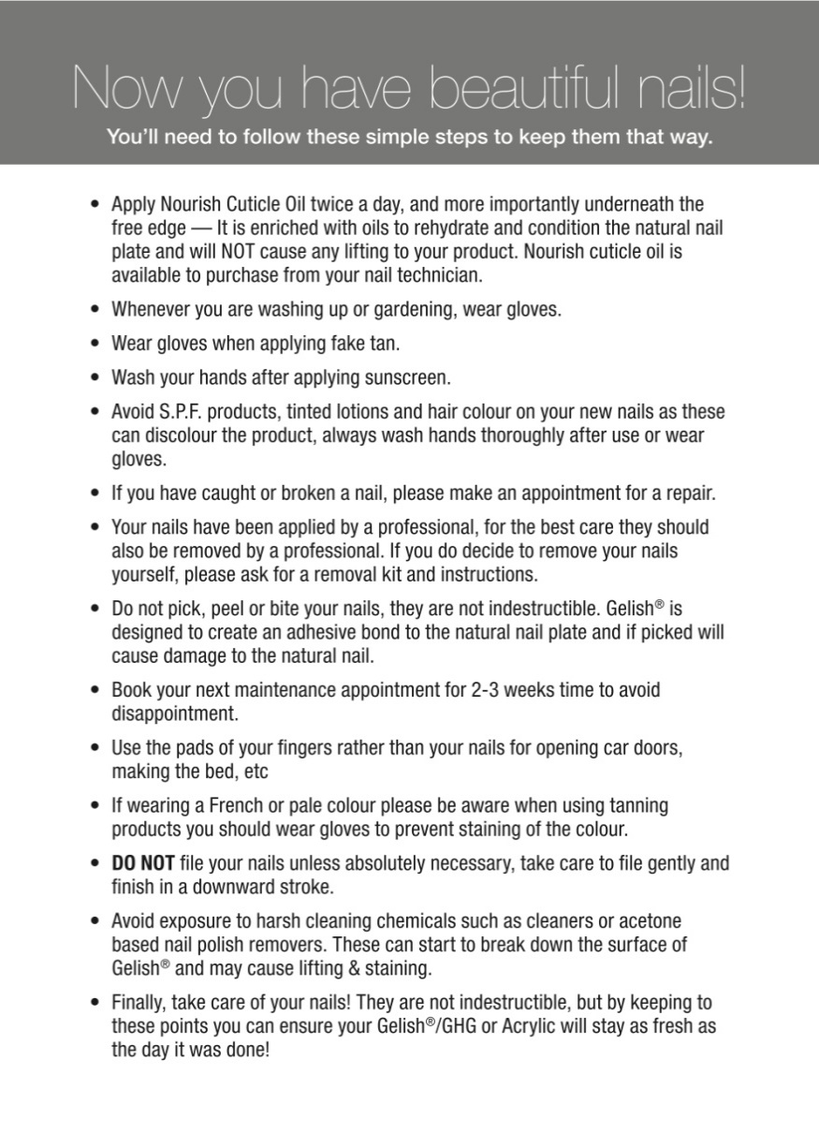](http://www.nailharmonyuk.co.uk/product-images/2159/1.htm)