# 2018 Great Wall Hike September 15, 2018

**Hiking Trail: Zhuangdaokou Village and Huanghuacheng Great Wall**

## Hike statistics

* Distance: older Scouts 5 km, younger Scouts 4 km
* Time to complete: 2 hours
* Drive time: 1.5 hours each way

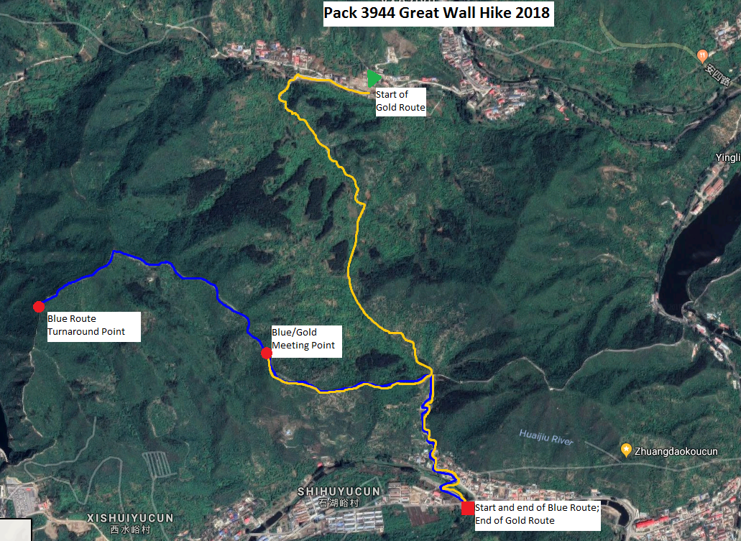

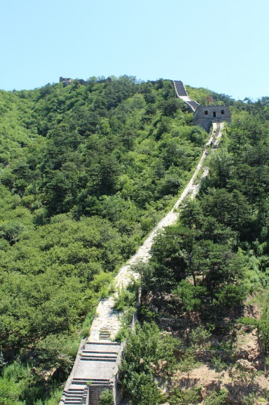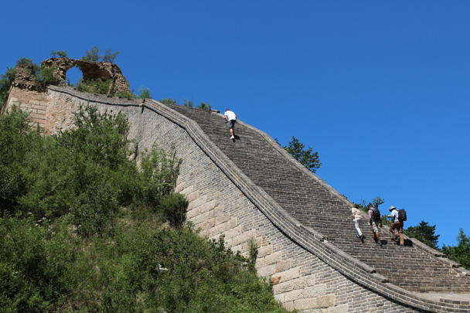

For older Scouts (Bears and Webelos), the Blue Route hike begins with a fairly challenging climb up a hillside path to reach the Great Wall. This climb is steep in a few places, and it will take us 30-40 minutes.

For the younger Scouts (Lions, Tigers and Bears), the Gold Route hike begins with a walk through a chestnut grove. This walk is easy, and will take approximately 60 minutes to complete.

After reaching the wall, both routes go westward up a steep section of the Great Wall where we will get excellent views with mountains, villages and other stretches of the Great Wall on nearby mountains.

After reaching the end of the Blue Route, older Scouts will turn around and head back the way they came, meeting up with the Gold Route at the Meeting Point indicated on the map, where we will have an early lunch break. Finally, the entire group will hike back down the Great Wall, through a hole in the wall, and finish our hike by going through Zhuangdaokou village.

**Itinerary**

*These times are approximate and depend on traffic and the speed of the group.*

07:30 Arrive at ISB

07:45 Begin loading buses

08:00 Depart from ISB

09:30 Arrive at trailhead, begin hiking (10 minutes later for younger Scouts)

11:30 Break for Lunch / Pack gathering

12:00 Continue Hiking

12:45 Arrive at final destination, load buses

13:00 Depart for ISB

14:30 Arrive back at ISB

**What to bring**

Blue Scout T-shirt

Comfortable, sturdy shoes (hiking boots or shoes with tough soles are strongly recommended)

Comfortable layers of clothing

Hat with a wide brim for sun protection

Rain gear in case of rain

Sun screen

Toilet paper and hand sanitizer

Plenty of snacks, and a light lunch

Plenty of water for everyone in your family

**Notes**

The hiking trail crosses loose rocks and bricks at certain points. Good hiking boots or shoes are required for this hike. At the beginning of the older Scouts’ hike, there is a relatively rigorous climb.

Adult Leaders will carry First Aid kits.

We request that you refrain from smoking while we’re out on the trail.

Bus reservations are dependent on time, distance, and size. ***It is critical that we have an accurate, final head count from your den leaders by September 11, 2018.*** We cannot reserve the buses if we do not know the total number of passengers from each location. Also, please be on time arriving at ISB for the hike, so that you do not delay the entire group.

**Price**

The price for the hike will be **100 RMB** per participant. Please pay your den leaders by ***September 11***.  *Late payments will not be accepted*.