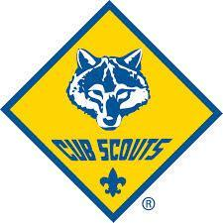

Pack 3944 Fall Campout 2019

Scout’s Name:

Den:

Informed Consent Agreement

I understand that participation in the 2019 Fall Campout offered through Cub Scout Pack 3944, Far East Council, Boy Scouts of America, involves a certain degree of risk.

I have carefully considered the risk involved and have given my Scout,

____________________________, my consent to participate in the Fall Campout
September 21-22, 2019.

_________________________________
Parent’s Name (Please Print)

_________________________________
Parent’s Signature

_________________________________
Date

Telephone Number(s): _______________________________________________________

Additional family members camping:

________________________________ ________________________________
Name Signature (or Parent’s, if under 18)

________________________________ ________________________________
Name Signature (or Parent’s, if under 18)

________________________________ ________________________________
Name Signature (or Parent’s, if under 18)

________________________________ ________________________________
Name Signature (or Parent’s, if under 18)

Please give this form to your Den Leader when completed.

