# Confession and Absolution

Please stand for the last stanza

500 Creator Spirit, by Whose Aid

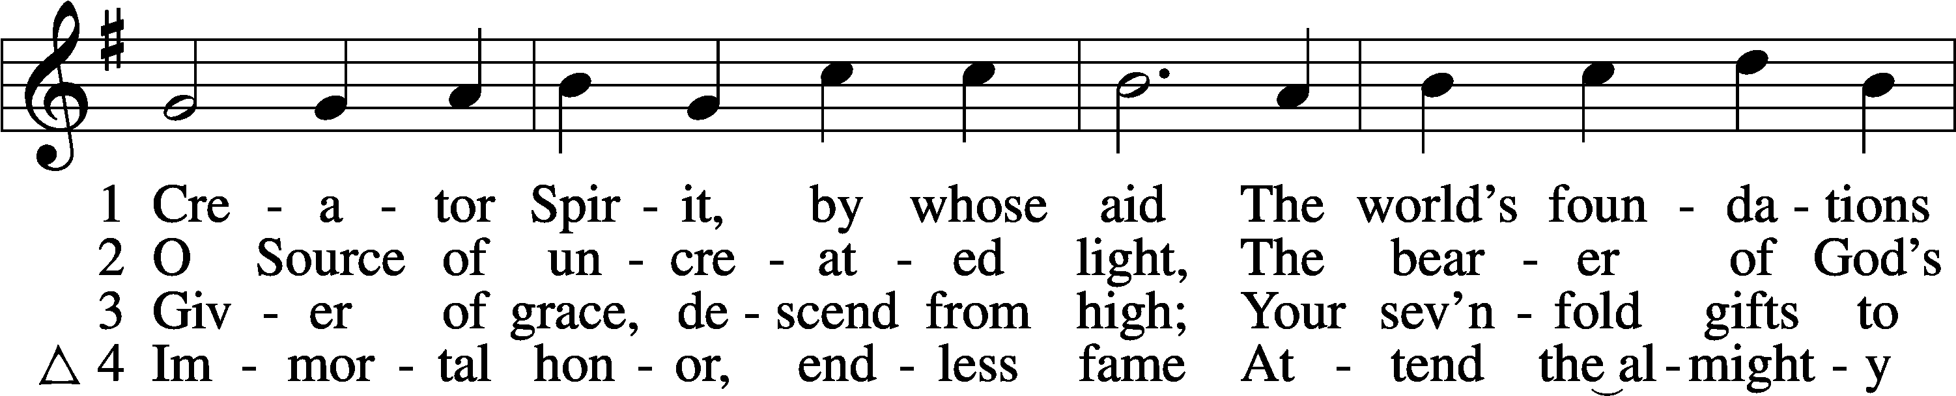

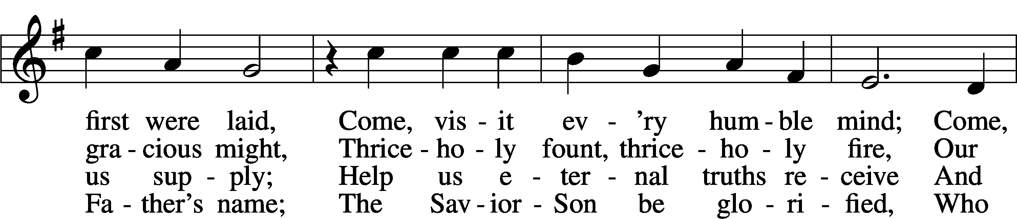

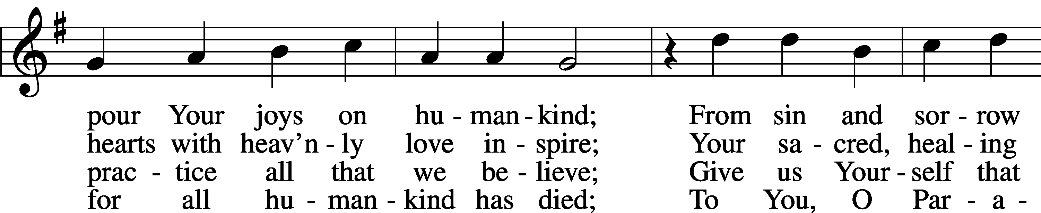

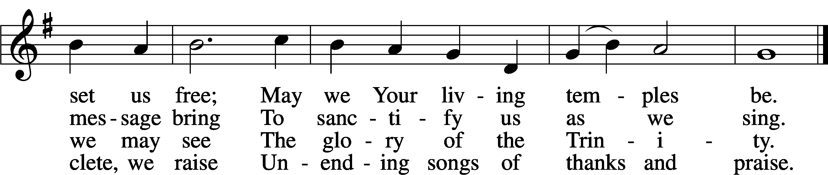

Text: attr. Rabanus Maurus, 776–856; tr. John Dryden, 1631–1700, alt.  
Tune: Gesangbuch . . . Psalmen, Geistliche Lieder, 1541, Strassburg, alt.  
Text and tune: Public domain

The sign of the cross may be made by all in remembrance of their Baptism.

P In the name of the Father and of the T Son and of the Holy Spirit.

C **Amen.**

P Beloved in the Lord! Let us draw near with a true heart and confess our sins unto God our Father, beseeching Him in the name of our Lord Jesus Christ to grant us forgiveness.

P Our help is in the name of the Lord,

C **who made heaven and earth.**

P I said, I will confess my transgressions unto the Lord,

C **and You forgave the iniquity of my sin.**

Kneel/Stand

Silence for reflection on God’s Word and for self-examination.

P O almighty God, merciful Father,

C **I, a poor, miserable sinner, confess unto You all my sins and iniquities with which I have ever offended You and justly deserved Your temporal and eternal punishment. But I am heartily sorry for them and sincerely repent of them, and I pray You of Your boundless mercy and for the sake of the holy, innocent, bitter sufferings and death of Your beloved Son, Jesus Christ, to be gracious and merciful to me, a poor, sinful being.**

P Upon this your confession, I, by virtue of my office, as a called and ordained servant of the Word, announce the grace of God unto all of you, and in the stead and by the command of my Lord Jesus Christ I forgive you all your sins in the name of the Father and of the T Son and of the Holy Spirit.

C **Amen.**

Stand

# Service of the Word

Introit Psalm 68:1, 4a, c, 11a, 33b, 35a; antiphon: Liturgical Text; Psalm 68:3



The Spirit of the Lord fills the world. Alle- | luia.*  
 The righteous | shall be glad.  
**They shall exult be- | fore God;*  
 they shall be jubilant with joy! Alle- | luia.**  
God shall arise, his enemies shall be | scattered;*  
 and those who hate him shall flee be- | fore him!  
**Sing to God, sing praises | to his name;*  
 exult be- | fore him!**  
The Lord | gives the word;*  
 behold, he sends out his voice, his | mighty voice.  
**Awesome is God from his sanctu- | ary;*  
 the God of Israel—he is the one who gives power and strength to his | people.**  
**Glory be to the Father and | to the Son**\*  
 **and to the Holy | Spirit;**  
**as it was in the be- | ginning,**\*  
 **is now, and will be forever. | Amen.**  
**The Spirit of the Lord fills the world. Alle- | luia.*  
 The righteous | shall be glad.**  
They shall exult be- | fore God;*  
 they shall be jubilant with joy! Alle- | luia.

Kyrie LSB 186

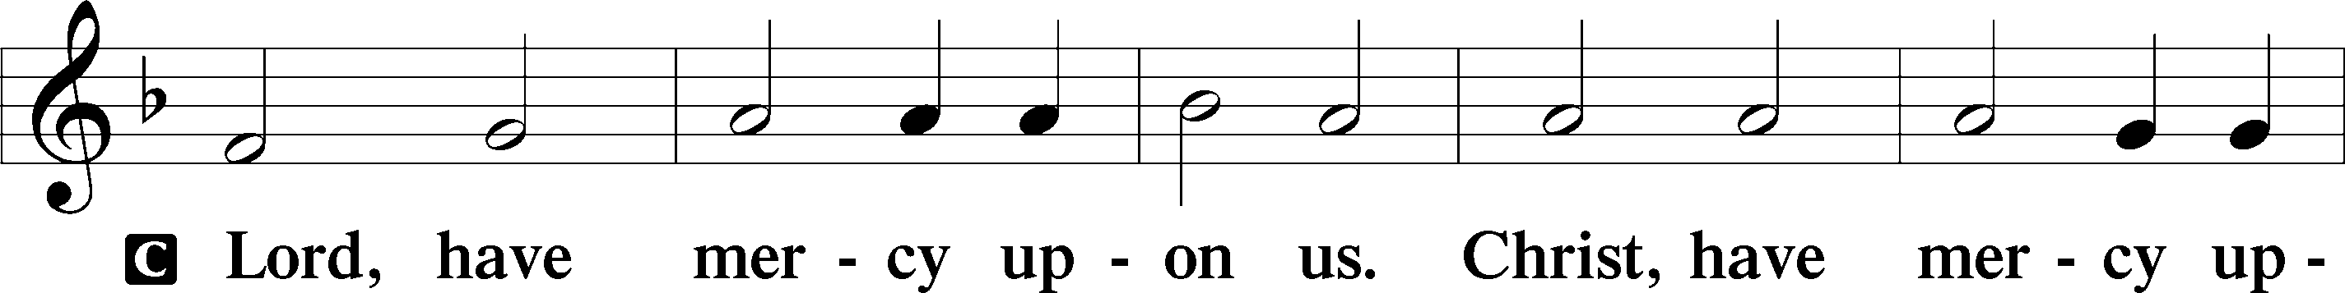

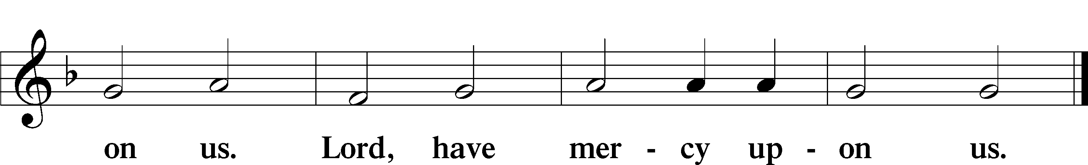

Gloria in Excelsis LSB 187

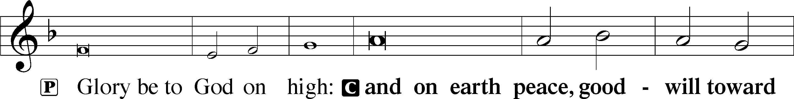

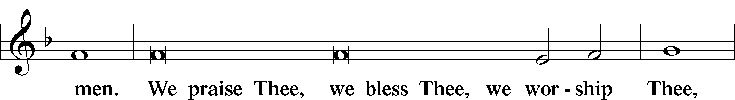

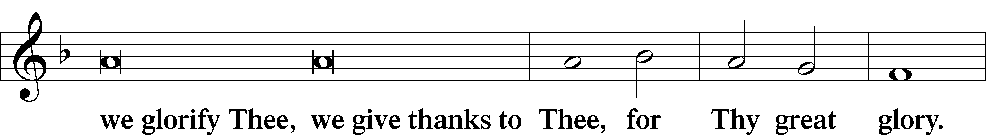

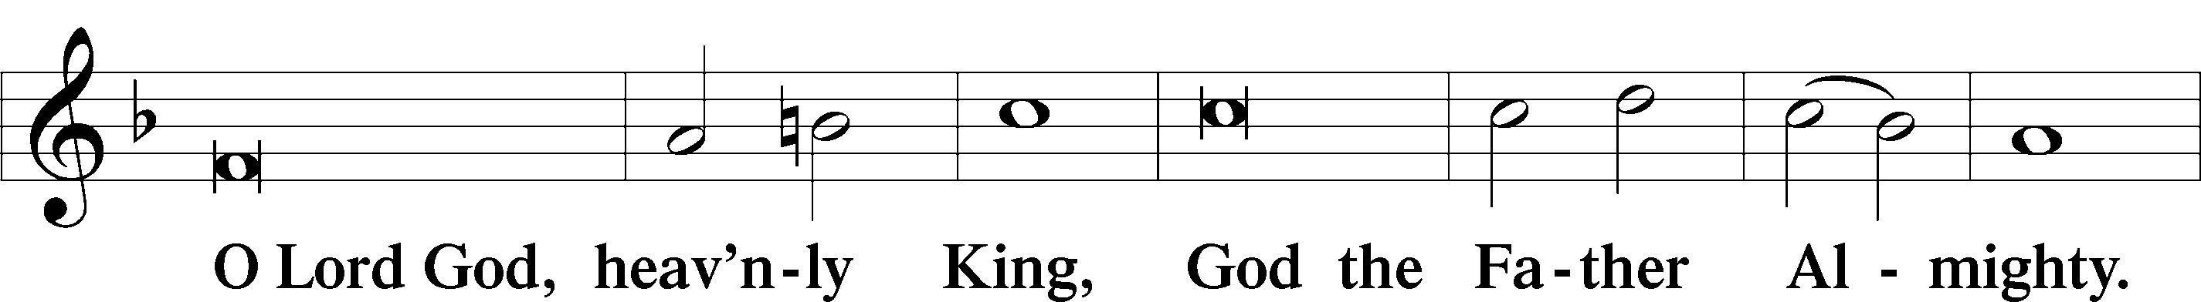

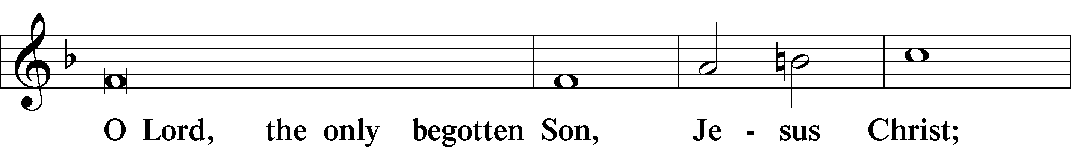

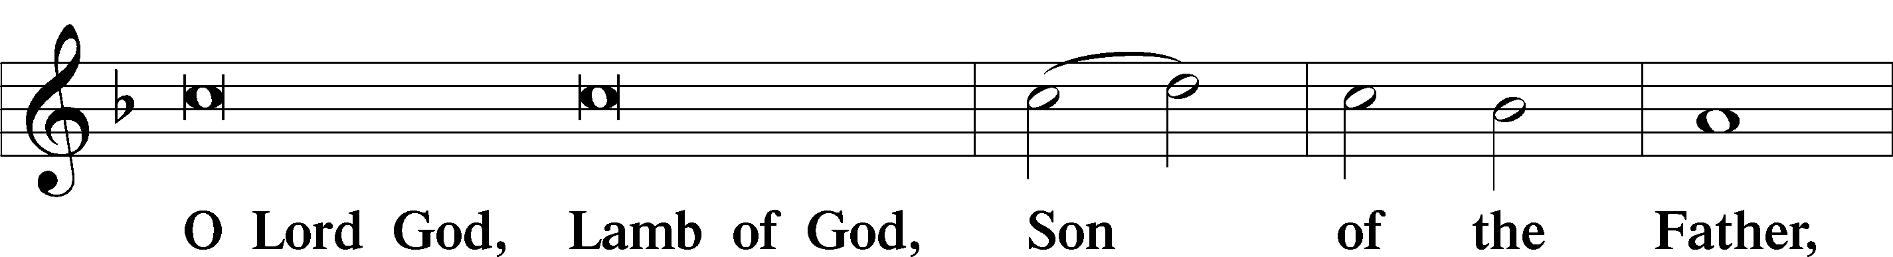

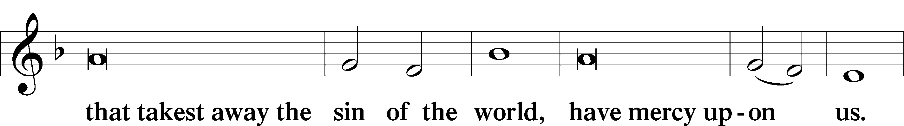

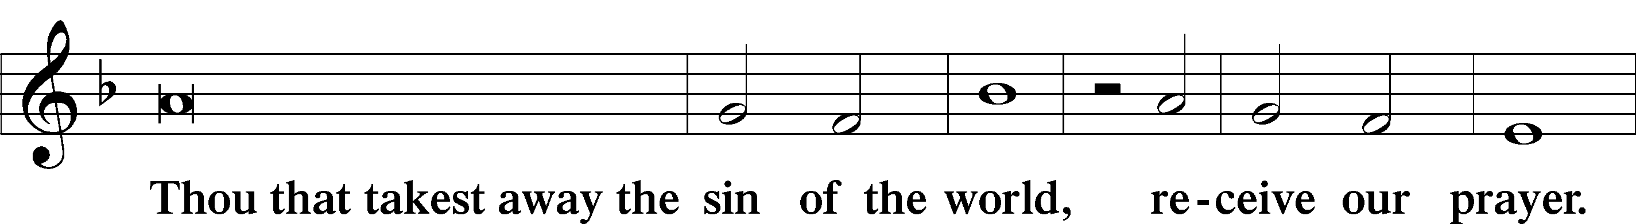

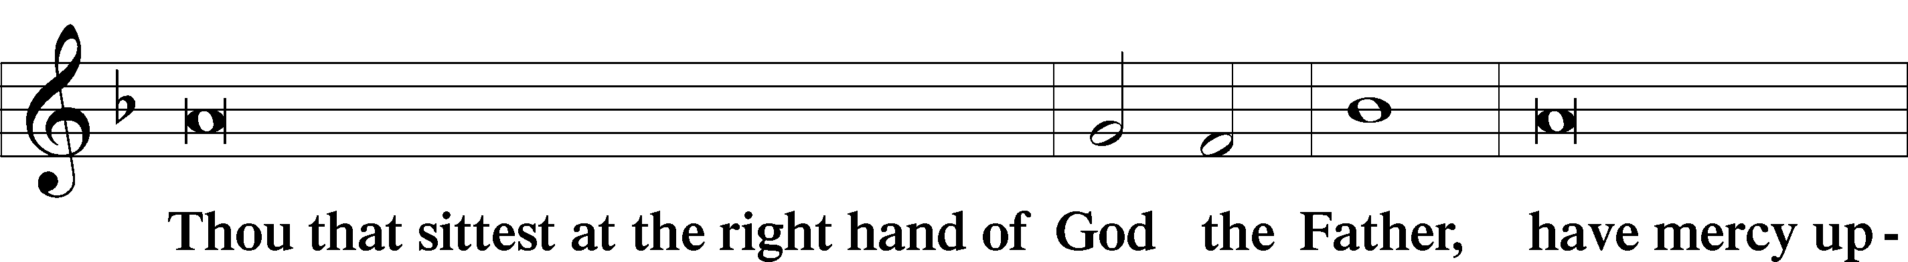

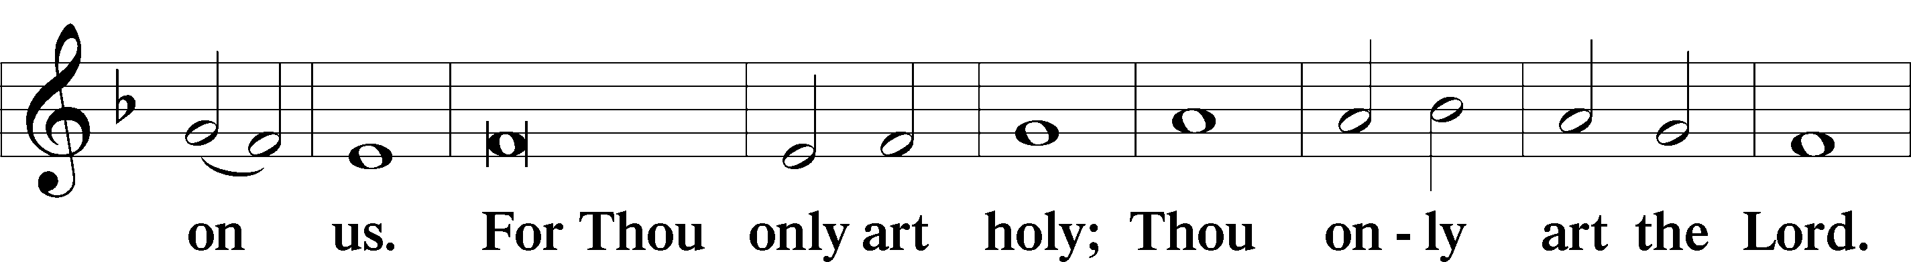

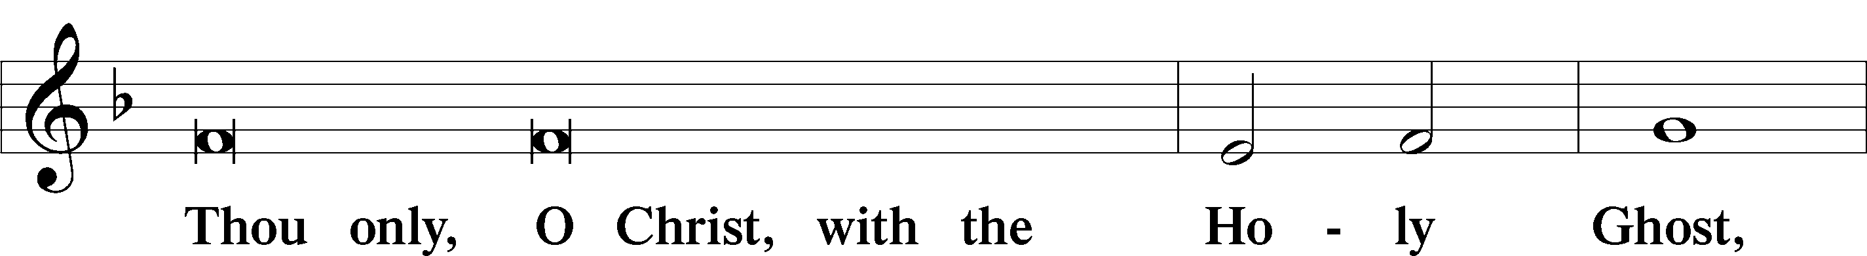

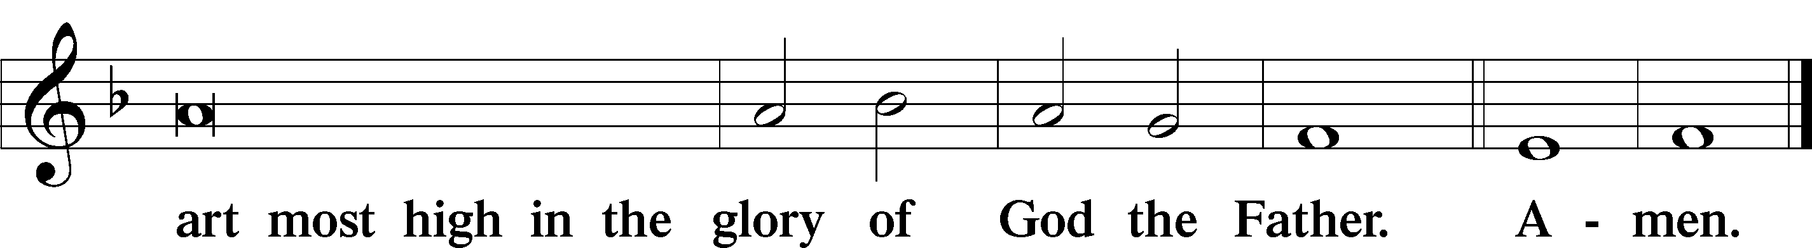

Salutation and Collect of the Day

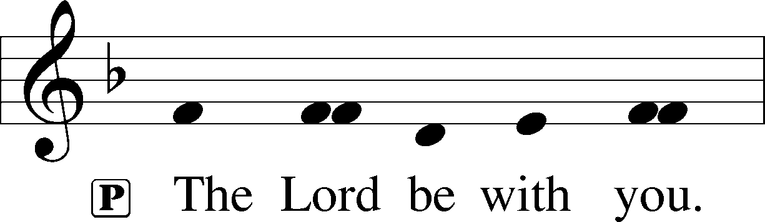

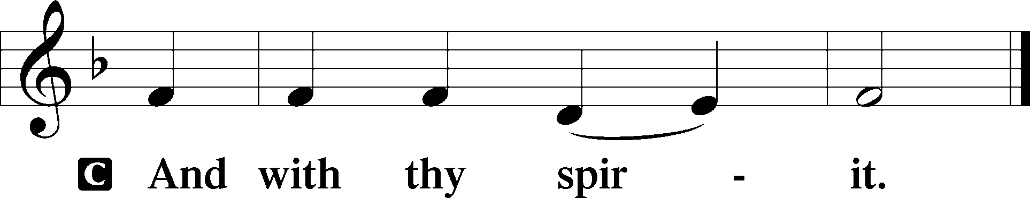

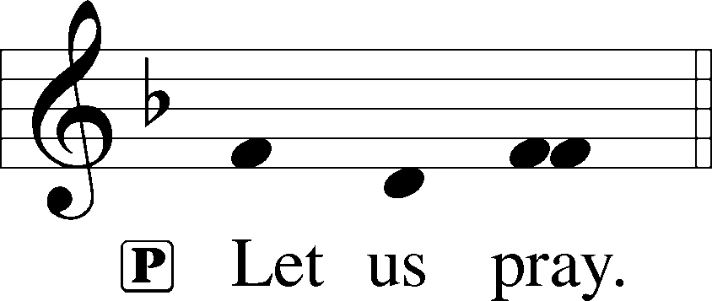

P O God, on this day You once taught the hearts of Your faithful people by sending them the light of Your Holy Spirit. Grant us in our day by the same Spirit to have a right understanding in all things and evermore to rejoice in His holy consolation; through Jesus Christ, Your Son, our Lord, who lives and reigns with You and the Holy Spirit, one God, now and forever.

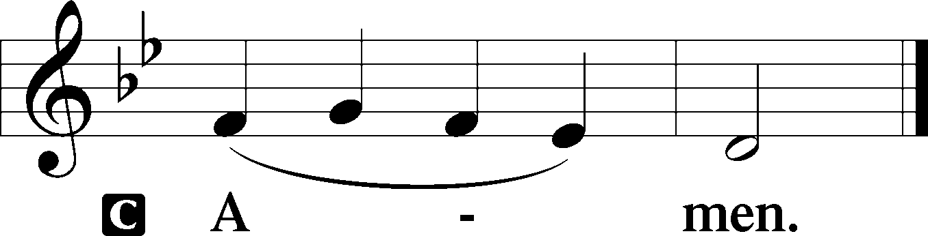

Sit

Old Testament Reading Genesis 11:1–9

1Now the whole earth had one language and the same words. 2And as people migrated from the east, they found a plain in the land of Shinar and settled there. 3And they said to one another, “Come, let us make bricks, and burn them thoroughly.” And they had brick for stone, and bitumen for mortar. 4Then they said, “Come, let us build ourselves a city and a tower with its top in the heavens, and let us make a name for ourselves, lest we be dispersed over the face of the whole earth.” 5And the Lord came down to see the city and the tower, which the children of man had built. 6And the Lord said, “Behold, they are one people, and they have all one language, and this is only the beginning of what they will do. And nothing that they propose to do will now be impossible for them. 7Come, let us go down and there confuse their language, so that they may not understand one another’s speech.” 8So the Lord dispersed them from there over the face of all the earth, and they left off building the city. 9Therefore its name was called Babel, because there the Lord confused the language of all the earth. And from there the Lord dispersed them over the face of all the earth.

P This is the Word of the Lord.

C **Thanks be to God.**

Verse Psalm 104:30; Liturgical Text

Alleluia. When you send forth your Spirit, they are created, and you renew the face of the ground. Alleluia. Come, Holy Spirit, fill the hearts of the faithful, and kindle in them the fire of your love. Alleluia.

Second Reading Acts 2:1–21

1When the day of Pentecost arrived, they were all together in one place. 2And suddenly there came from heaven a sound like a mighty rushing wind, and it filled the entire house where they were sitting. 3And divided tongues as of fire appeared to them and rested on each one of them. 4And they were all filled with the Holy Spirit and began to speak in other tongues as the Spirit gave them utterance.

5Now there were dwelling in Jerusalem Jews, devout men from every nation under heaven. 6And at this sound the multitude came together, and they were bewildered, because each one was hearing them speak in his own language. 7And they were amazed and astonished, saying, “Are not all these who are speaking Galileans? 8And how is it that we hear, each of us in his own native language? 9Parthians and Medes and Elamites and residents of Mesopotamia, Judea and Cappadocia, Pontus and Asia, 10Phrygia and Pamphylia, Egypt and the parts of Libya belonging to Cyrene, and visitors from Rome, 11both Jews and proselytes, Cretans and Arabians—we hear them telling in our own tongues the mighty works of God.” 12And all were amazed and perplexed, saying to one another, “What does this mean?” 13But others mocking said, “They are filled with new wine.”

14But Peter, standing with the eleven, lifted up his voice and addressed them, “Men of Judea and all who dwell in Jerusalem, let this be known to you, and give ear to my words. 15For these men are not drunk, as you suppose, since it is only the third hour of the day. 16But this is what was uttered through the prophet Joel:

17“‘And in the last days it shall be, God declares,  
that I will pour out my Spirit on all flesh,  
 and your sons and your daughters shall prophesy,  
and your young men shall see visions,  
 and your old men shall dream dreams;  
18even on my male servants and female servants  
 in those days I will pour out my Spirit, and they shall prophesy.  
19And I will show wonders in the heavens above  
 and signs on the earth below,  
 blood, and fire, and vapor of smoke;  
20the sun shall be turned to darkness  
 and the moon to blood,  
 before the day of the Lord comes, the great and magnificent day.  
21And it shall come to pass that everyone who calls upon the name of the Lord shall be saved.’”

P This is the Word of the Lord.

C **Thanks be to God.**

Stand

Alleluia LSB 190

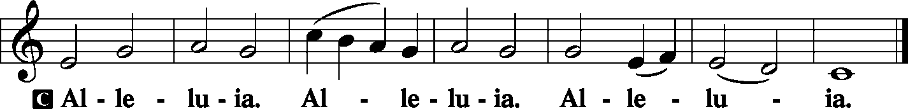

Holy Gospel John 14:23–31

P The Holy Gospel according to St. John, the fourteenth chapter.

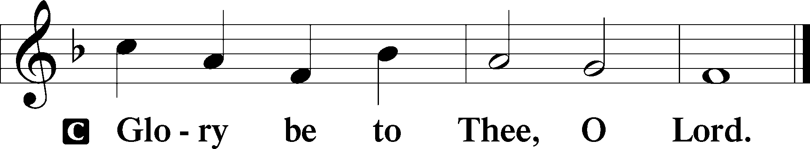

23Jesus answered him, “If anyone loves me, he will keep my word, and my Father will love him, and we will come to him and make our home with him. 24Whoever does not love me does not keep my words. And the word that you hear is not mine but the Father’s who sent me.

25“These things I have spoken to you while I am still with you. 26But the Helper, the Holy Spirit, whom the Father will send in my name, he will teach you all things and bring to your remembrance all that I have said to you. 27Peace I leave with you; my peace I give to you. Not as the world gives do I give to you. Let not your hearts be troubled, neither let them be afraid. 28You heard me say to you, ‘I am going away, and I will come to you.’ If you loved me, you would have rejoiced, because I am going to the Father, for the Father is greater than I. 29And now I have told you before it takes place, so that when it does take place you may believe. 30I will no longer talk much with you, for the ruler of this world is coming. He has no claim on me, 31but I do as the Father has commanded me, so that the world may know that I love the Father. Rise, let us go from here.”

P This is the Gospel of the Lord.

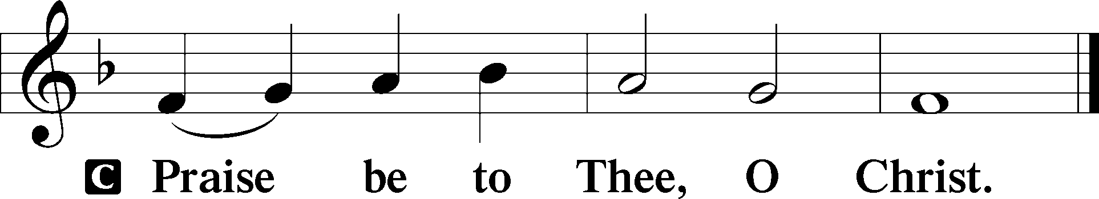

Nicene Creed

C **I believe in one God,**

**the Father Almighty,**

**maker of heaven and earth**

**and of all things visible and invisible.**

**And in one Lord Jesus Christ,**

**the only-begotten Son of God,**

**begotten of His Father before all worlds,**

**God of God, Light of Light,**

**very God of very God,**

**begotten, not made,**

**being of one substance with the Father,**

**by whom all things were made;**

**who for us men and for our salvation came down from heaven**

**and was incarnate by the Holy Spirit of the virgin Mary**

**and was made man;**

**and was crucified also for us under Pontius Pilate.**

**He suffered and was buried.**

**And the third day He rose again according to the Scriptures**

**and ascended into heaven**

**and sits at the right hand of the Father.**

**And He will come again with glory to judge both the living and the dead,**

**whose kingdom will have no end.**

**And I believe in the Holy Spirit,**

**the Lord and giver of life,**

**who proceeds from the Father and the Son,**

**who with the Father and the Son together is worshiped and glorified,**

**who spoke by the prophets.**

**And I believe in one holy Christian and apostolic Church,**

**I acknowledge one Baptism for the remission of sins,**

**and I look for the resurrection of the dead**

**and the life** T **of the world to come. Amen.**

Sit

497 Come, Holy Ghost, God and Lord

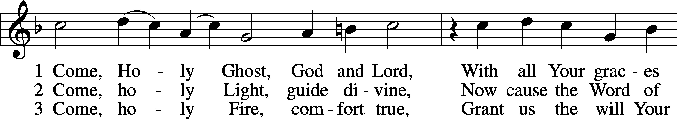

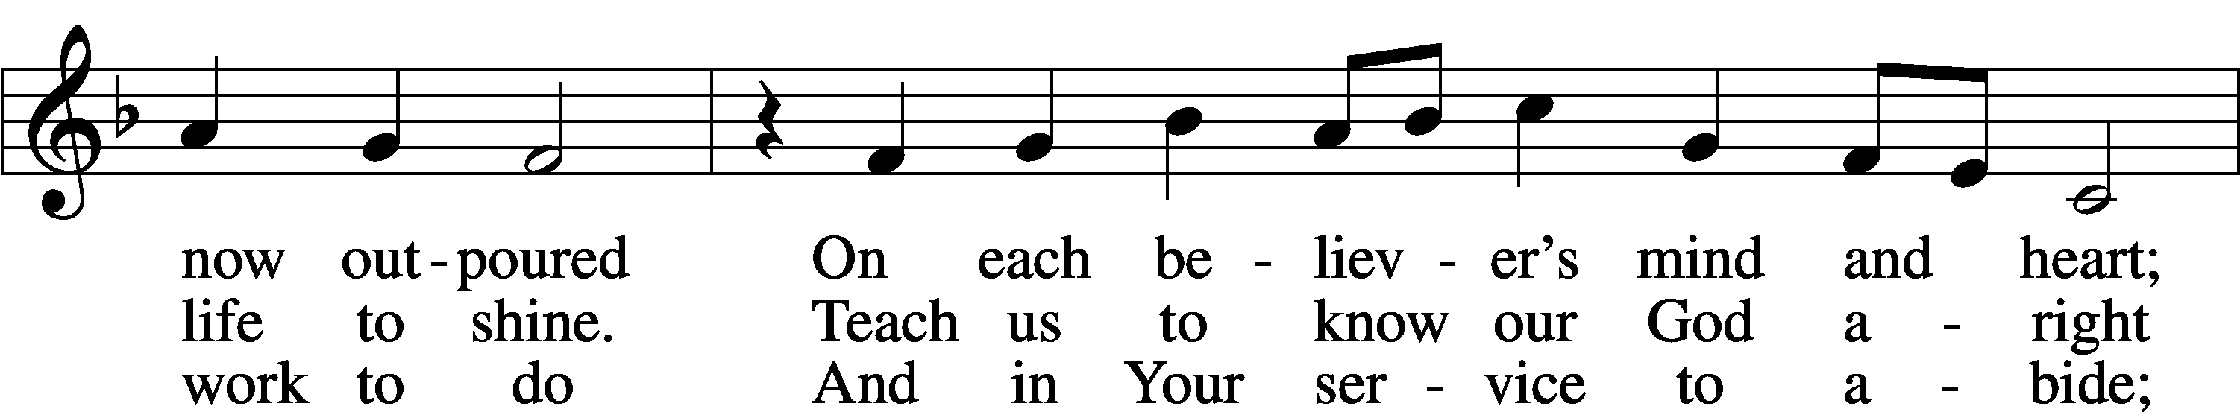

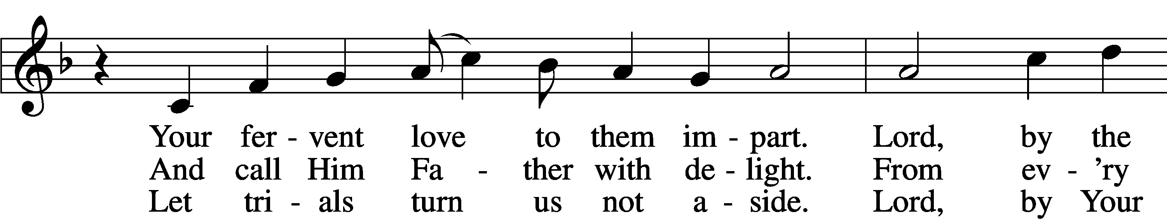

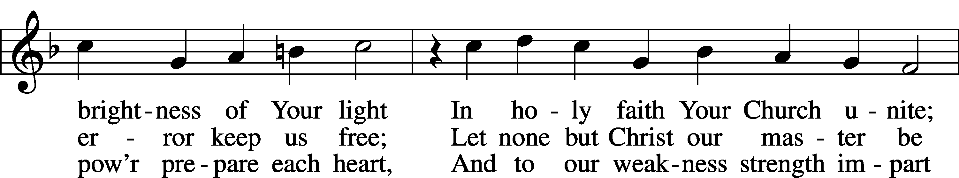

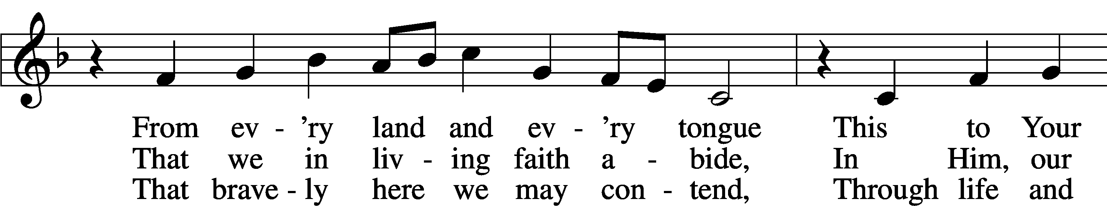

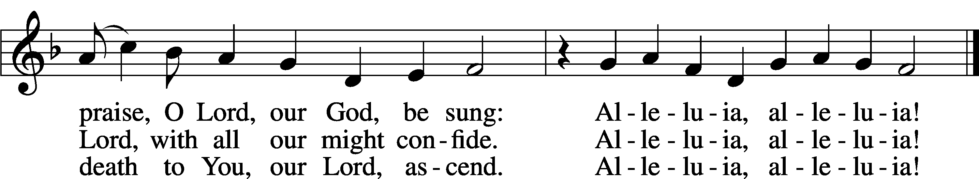

Text: tr. The Lutheran Hymnal, 1941, alt.; (st. 1): German, 15th cent.; (sts. 2–3): Martin Luther, 1483–1546  
Tune: Eyn Enchiridion oder Handbüchlein, 1524, Erfurt  
Text: © 1941 Concordia Publishing House. Used by permission: LSB Hymn License no. 110005212  
Tune: Public domain

Sermon: *Do You Love Jesus?*

Stand

Offertory LSB 192

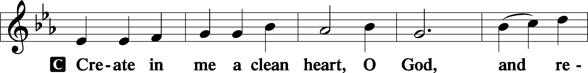

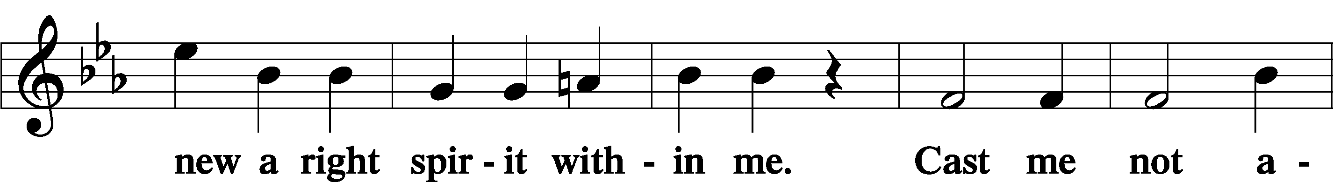

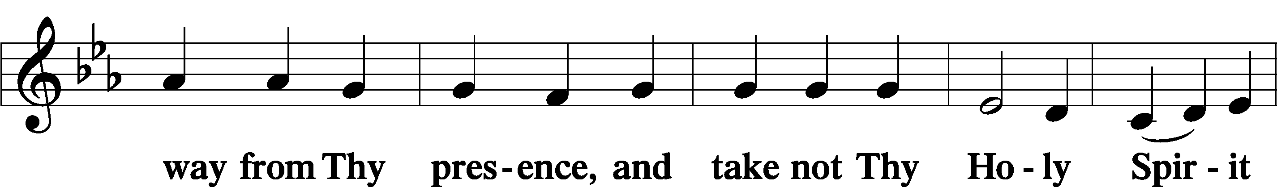

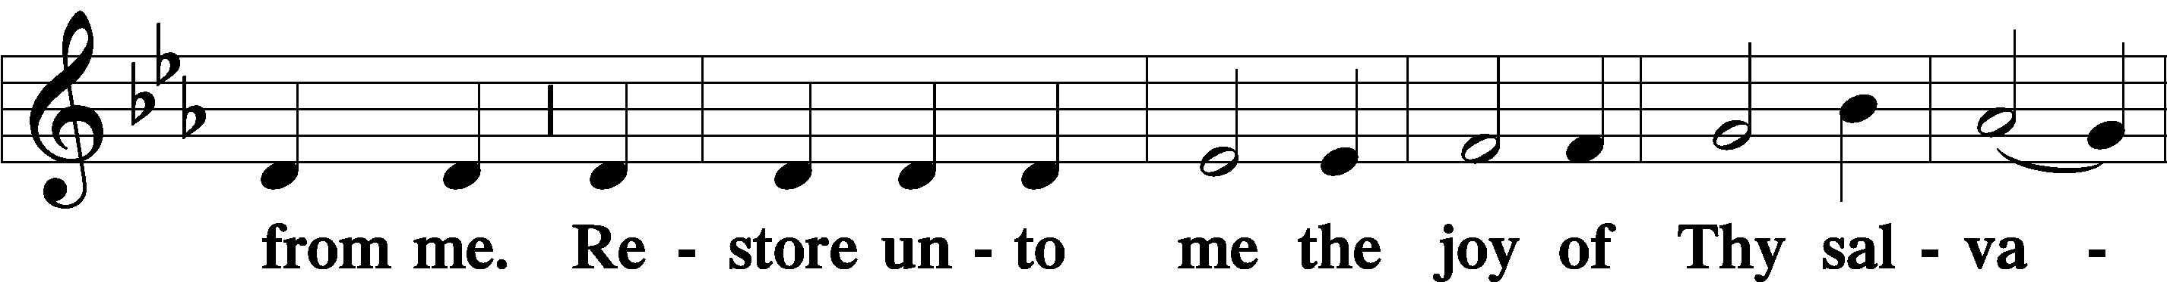

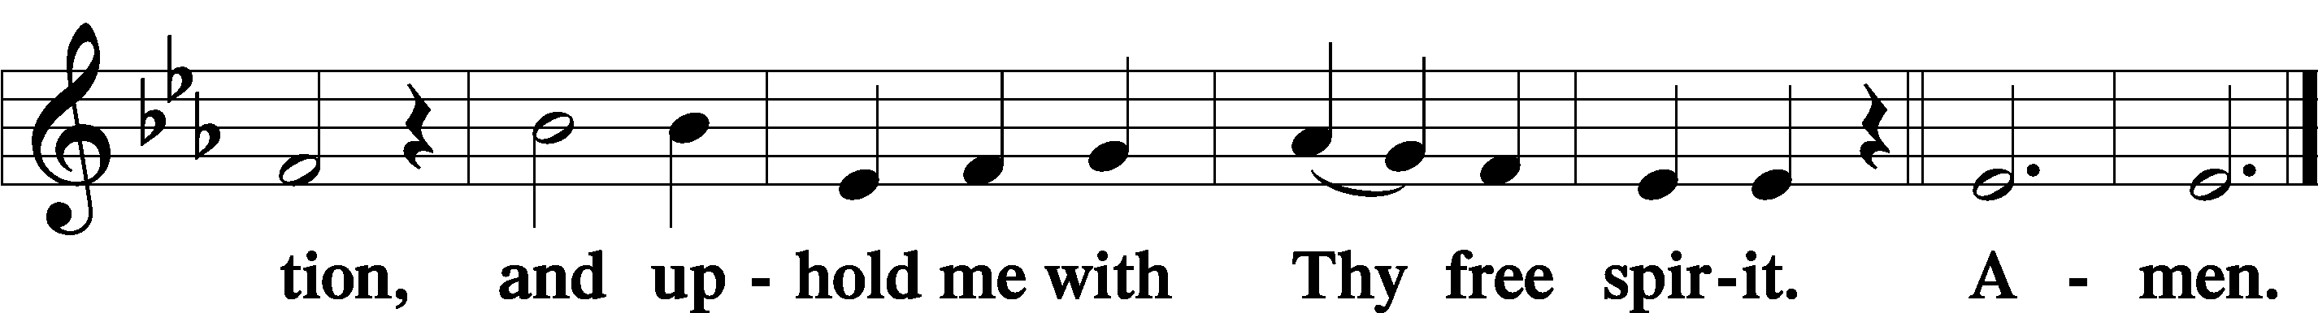

Sit

Offering

Stand

Prayer of the Church

**\*\*\* Prayer of the Church Response \*\*\***

P Lord, in Your mercy,

C **hear our prayer.**

P now and forever.

C **Amen**

# Service of the Sacrament

Preface LSB 194

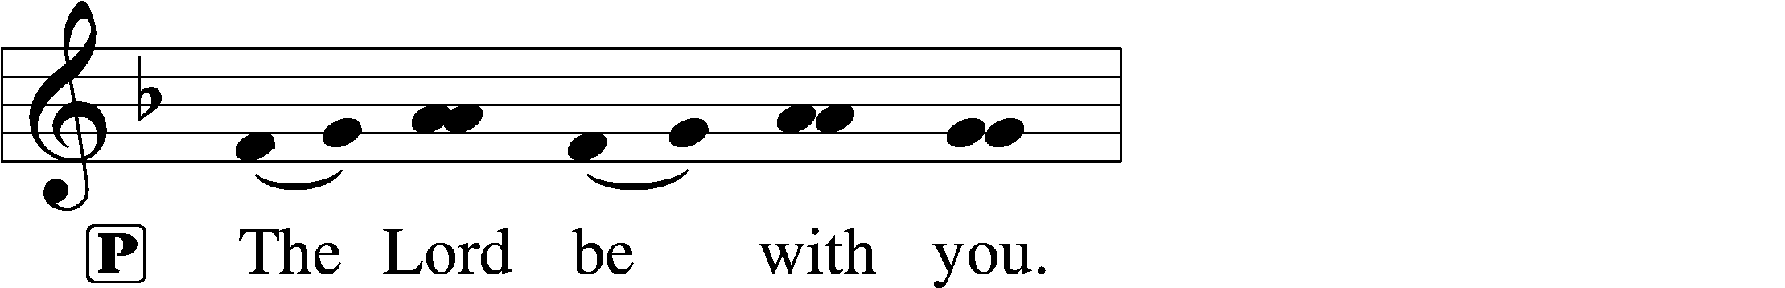

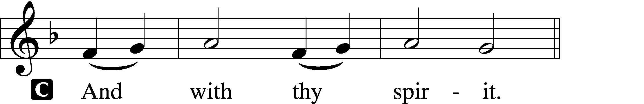

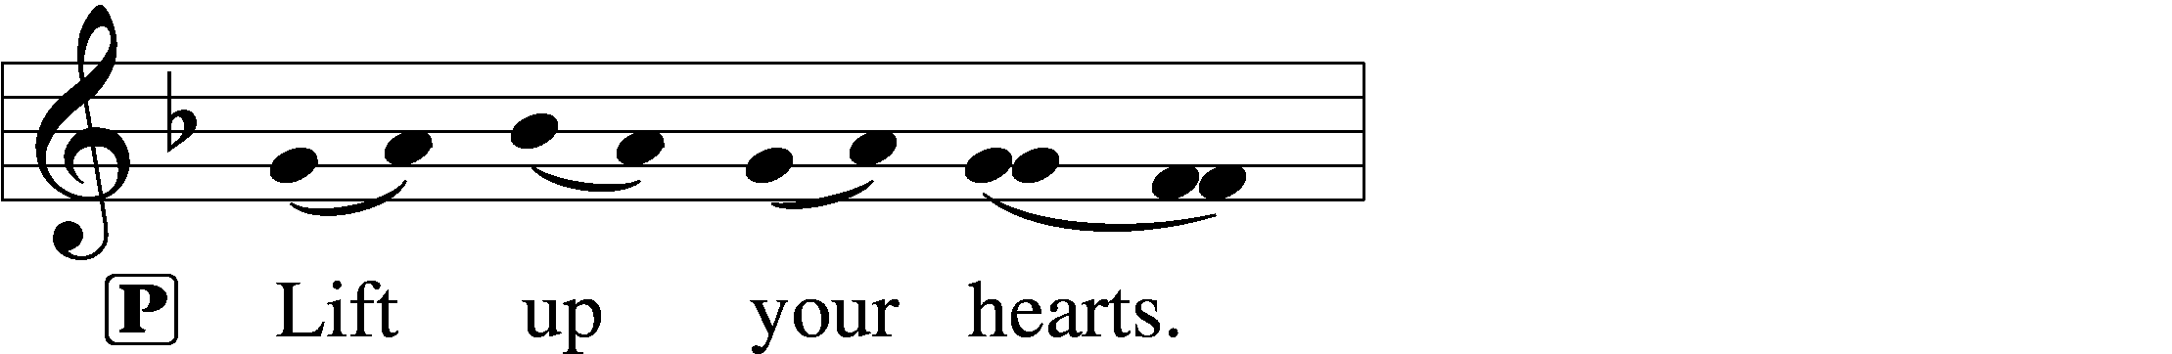

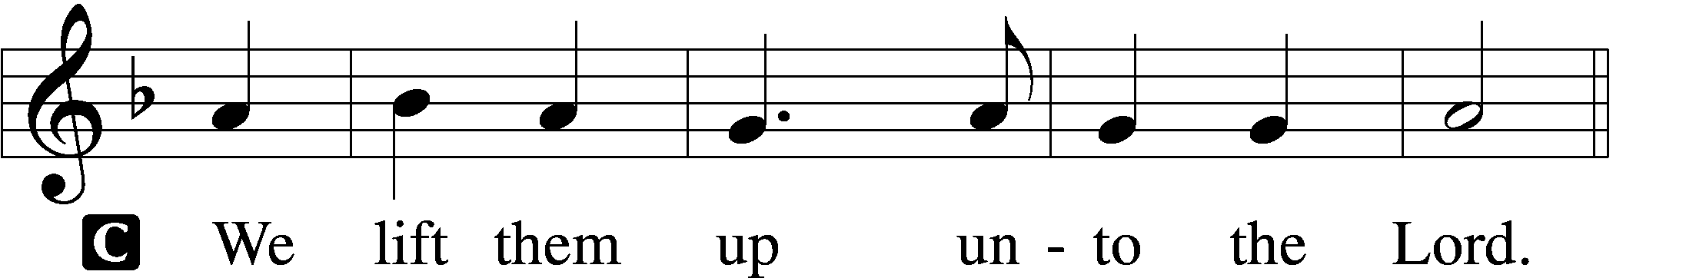

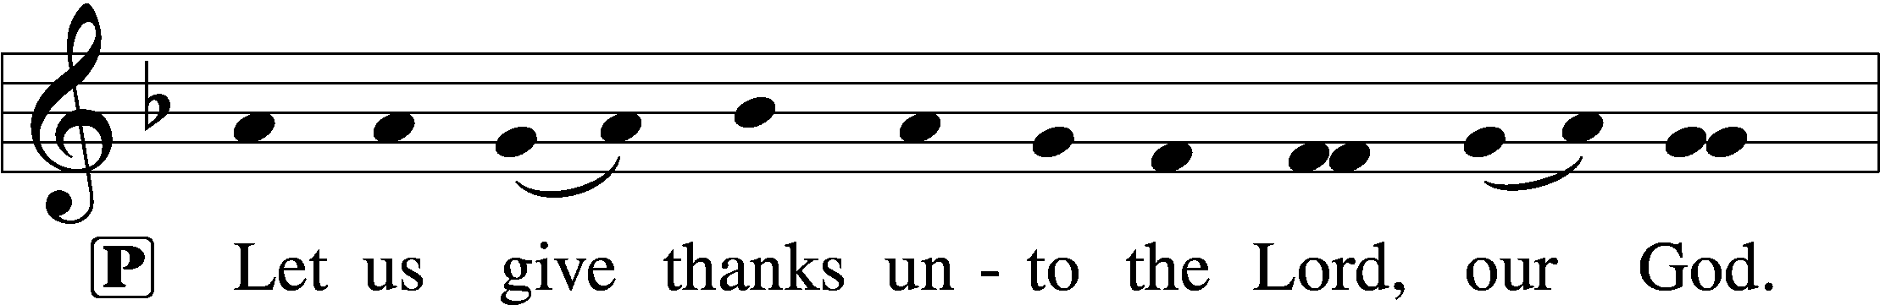

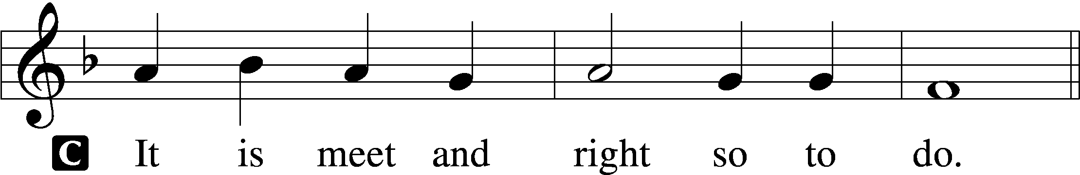

P It is truly meet, right, and salutary that we should at all times and in all places give thanks to You, holy Lord, almighty Father, everlasting God, through Jesus Christ, our Lord, who ascended above the heavens and, sitting at Your right hand, poured out on this day the promised Holy Spirit on His chosen disciples. For all this the whole earth rejoices with exceeding joy. Therefore with angels and archangels and with all the company of heaven we laud and magnify Your glorious name, evermore praising You and saying:

Sanctus LSB 195

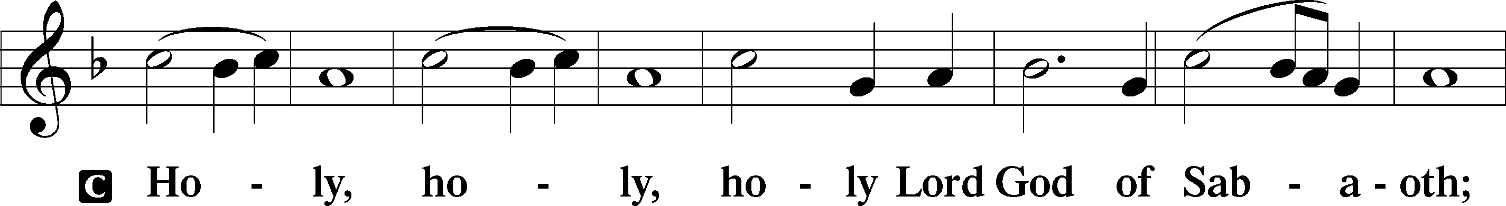

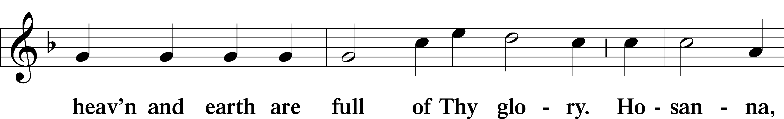

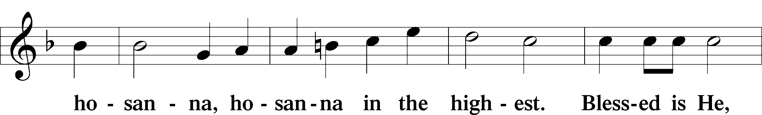

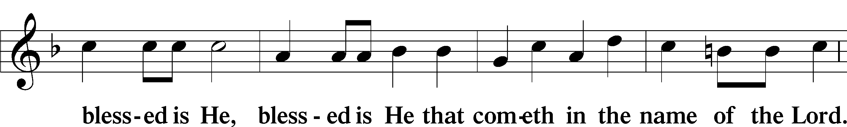

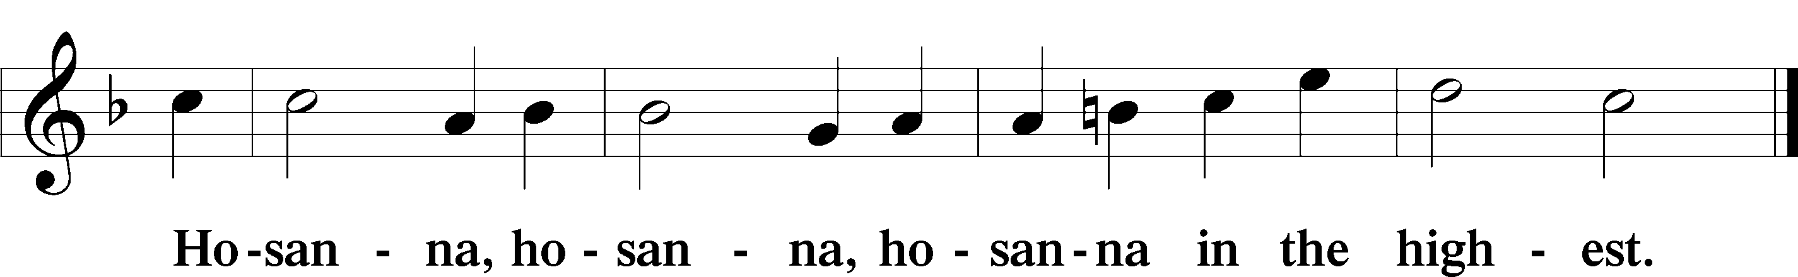

Lord's Prayer  *LSB 162*

P Lord, remember us in Your kingdom and teach us to pray:

C **Our Father who art in heaven,  
 hallowed be Thy name,  
 Thy kingdom come,  
 Thy will be done on earth as it is in heaven;  
 give us this day our daily bread;  
 and forgive us our trespasses as we forgive those who trespass against us;  
 and lead us not into temptation,  
 but deliver us from evil.**

The Words of Our Lord LSB 197

P Our Lord Jesus Christ, on the night when He was betrayed, took bread, and when He had given thanks, He broke it and gave it to the disciples and said: “Take, eat; this is My T body, which is given for you. This do in remembrance of Me.”

In the same way also He took the cup after supper, and when He had given thanks, He gave it to them, saying: “Drink of it, all of you; this cup is the new testament in My T blood, which is shed for you for the forgiveness of sins. This do, as often as you drink it, in remembrance of Me.”

Pax Domini LSB 197

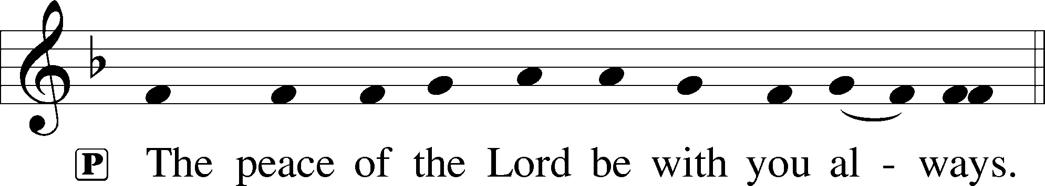

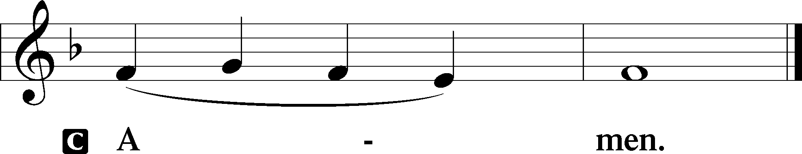

Agnus Dei LSB 198

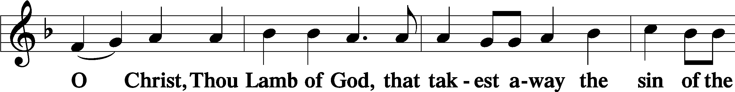

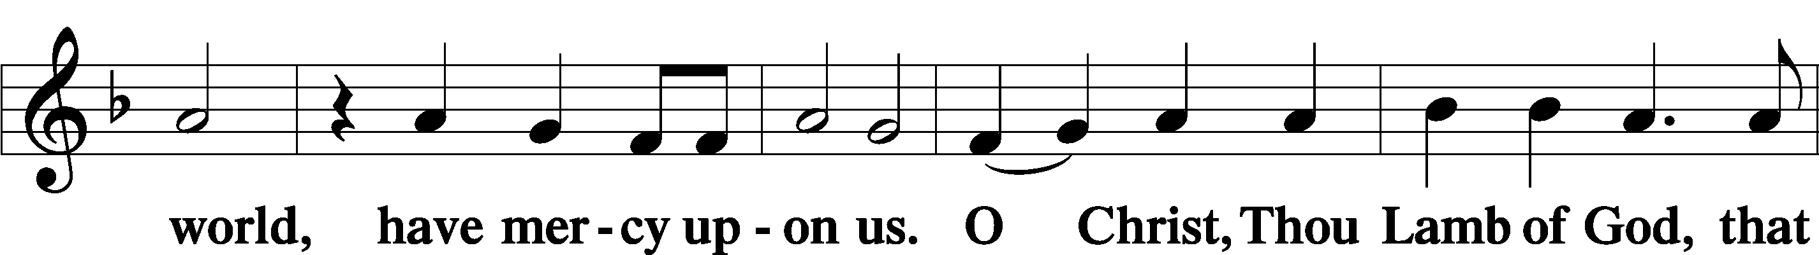

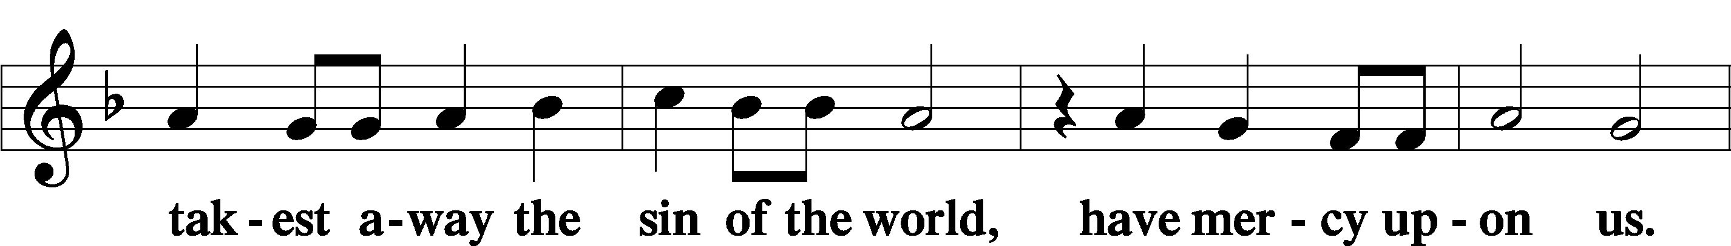

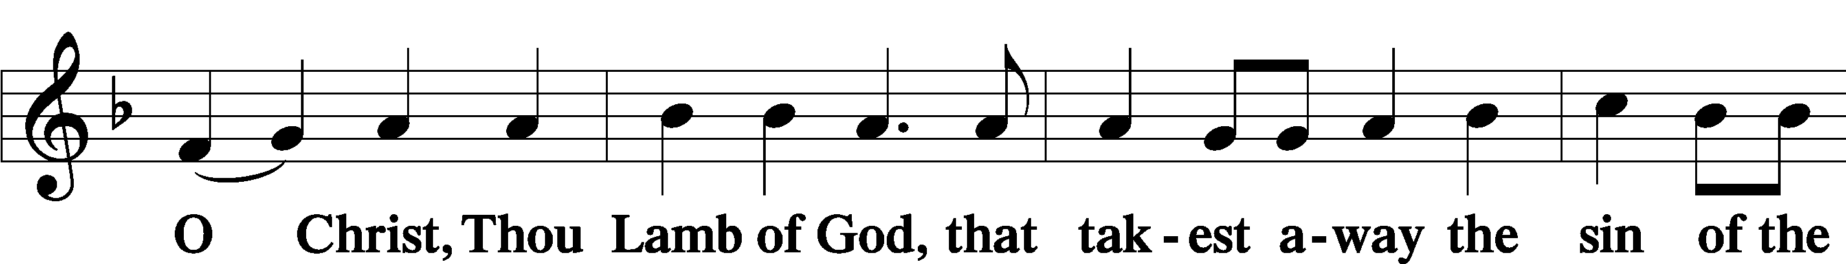

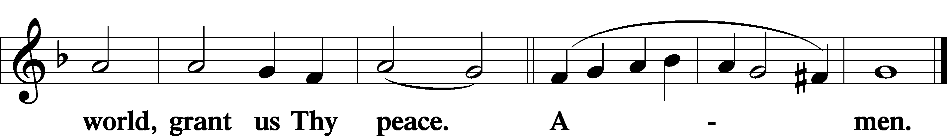

Sit

Distribution

The pastor and those who assist him receive the body and blood of Christ first and then distribute them to those who come to receive, saying:

In dismissing the communicants, the following is said:

P The body and blood of our Lord Jesus Christ strengthen and preserve you in body and soul to life everlasting. Depart T in peace.

C **Amen.**

628 Your Table I Approach

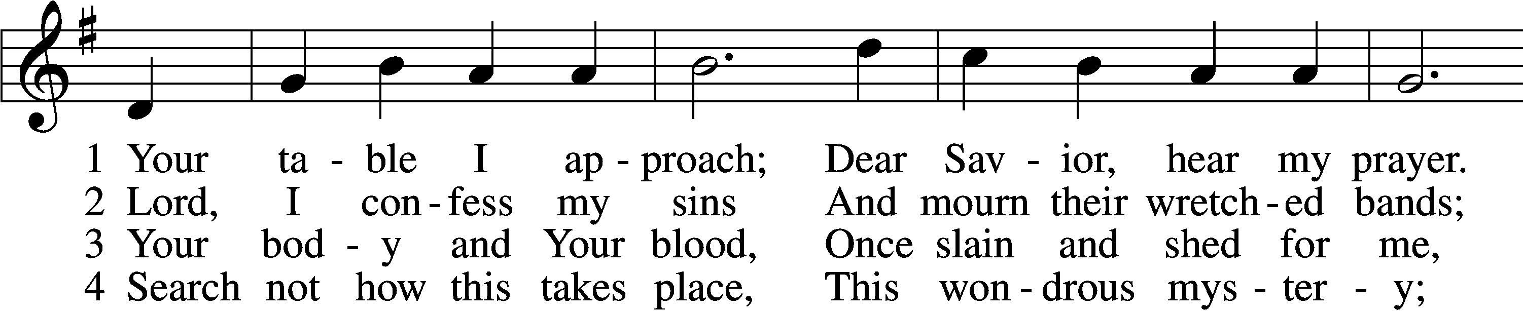

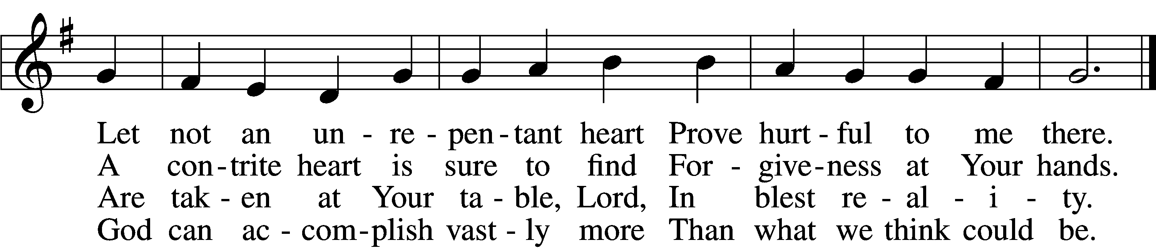

5 O grant, most blessèd Lord,  
 That earth and hell combined  
May not about this sacrament  
 Raise doubt within my mind.

6 Oh, may I never fail  
 To thank You day and night  
For Your true body and true blood,  
 O God, my peace and light.

Text: Gerhard Wolter Molanus, 1633–1722; tr. Matthias Loy, 1828–1915, alt.  
Tune: Trente quatre Pseaumes de David, 1551, Geneva, ed. Louis Bourgeois  
Text and tune: Public domain

559 Oh, How Great Is Your Compassion

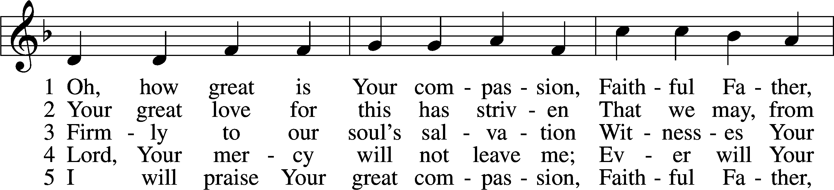

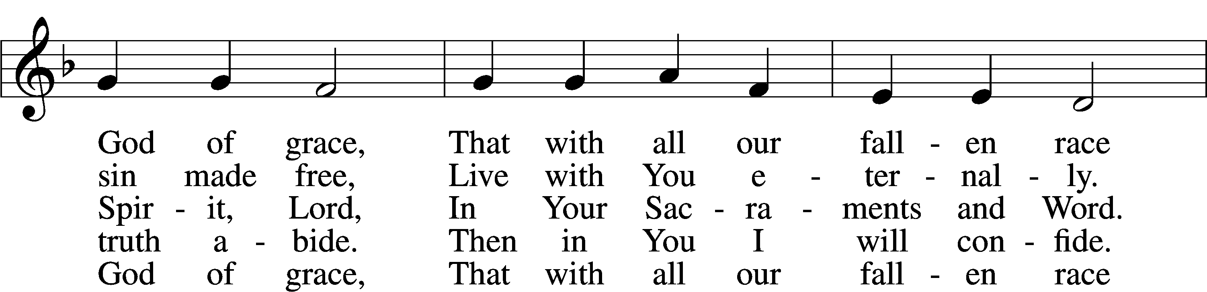

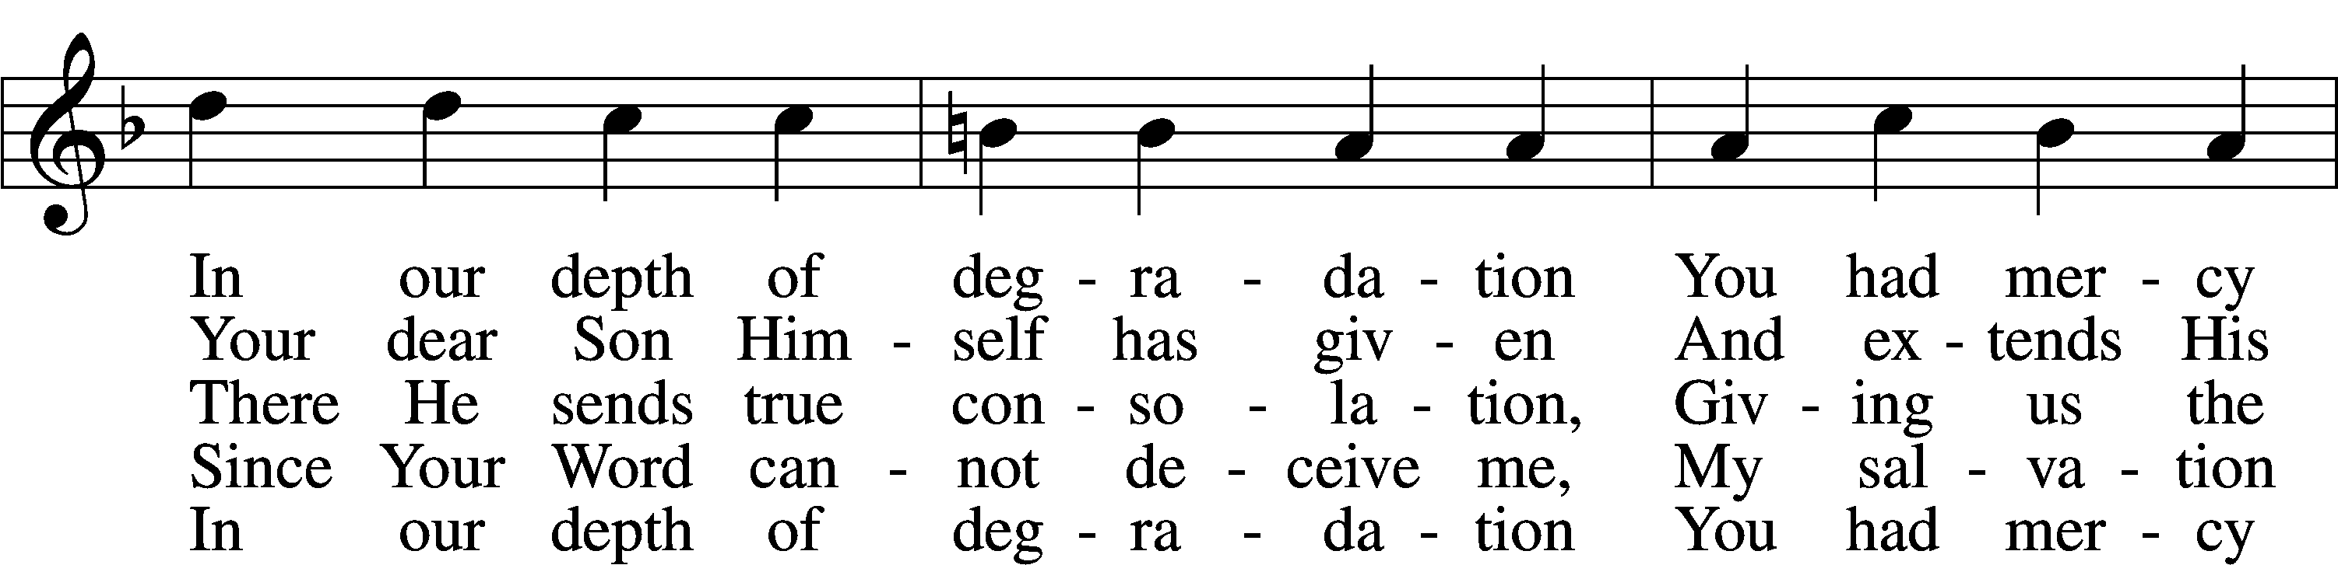

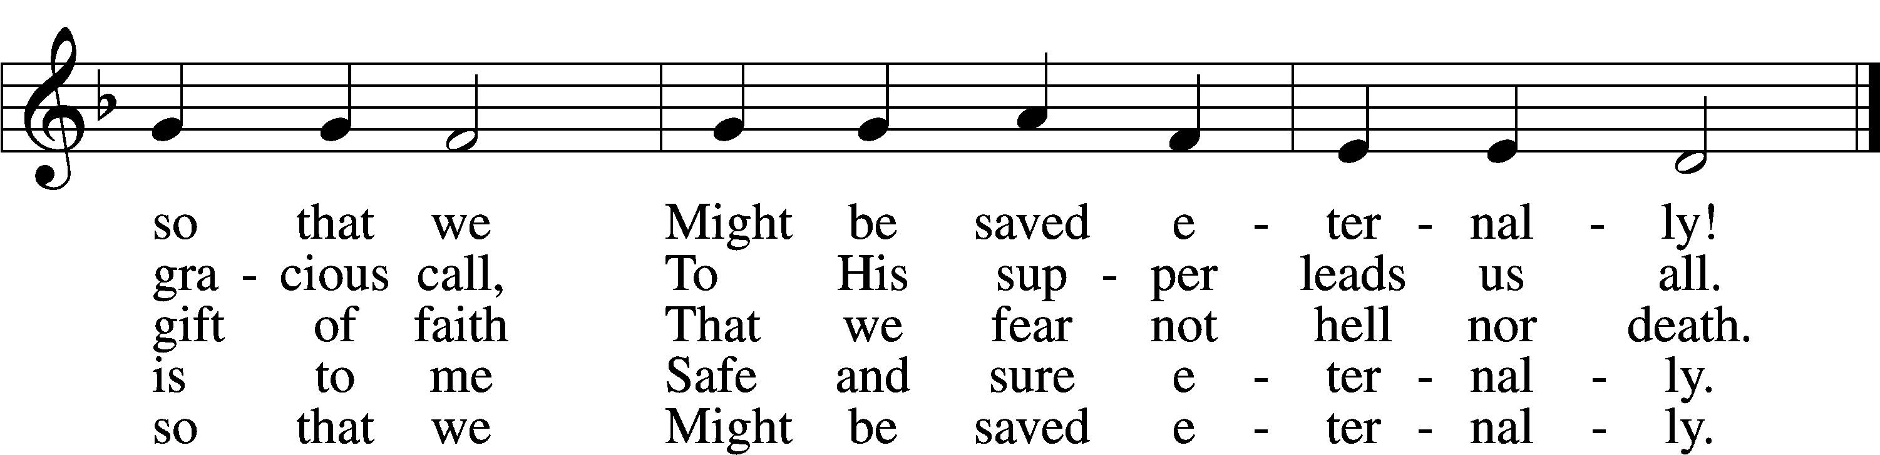

Text: Johann Olearius, 1611–84; tr. August Crull, 1845–1923, alt.  
Tune: Schäffer-Belustigung . . . Hirthen-Lieder, 1653, Altdorf  
Text and tune: Public domain

Stand

Nunc Dimittis LSB 199

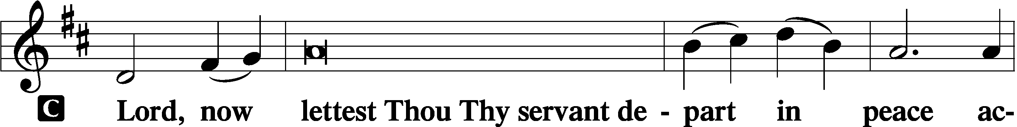

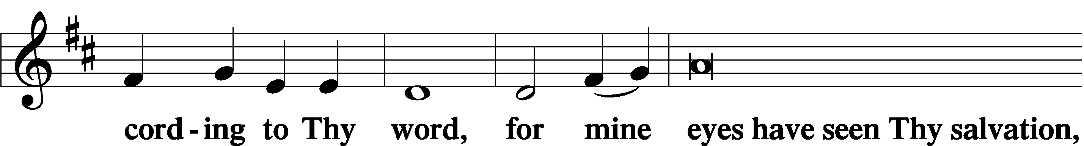

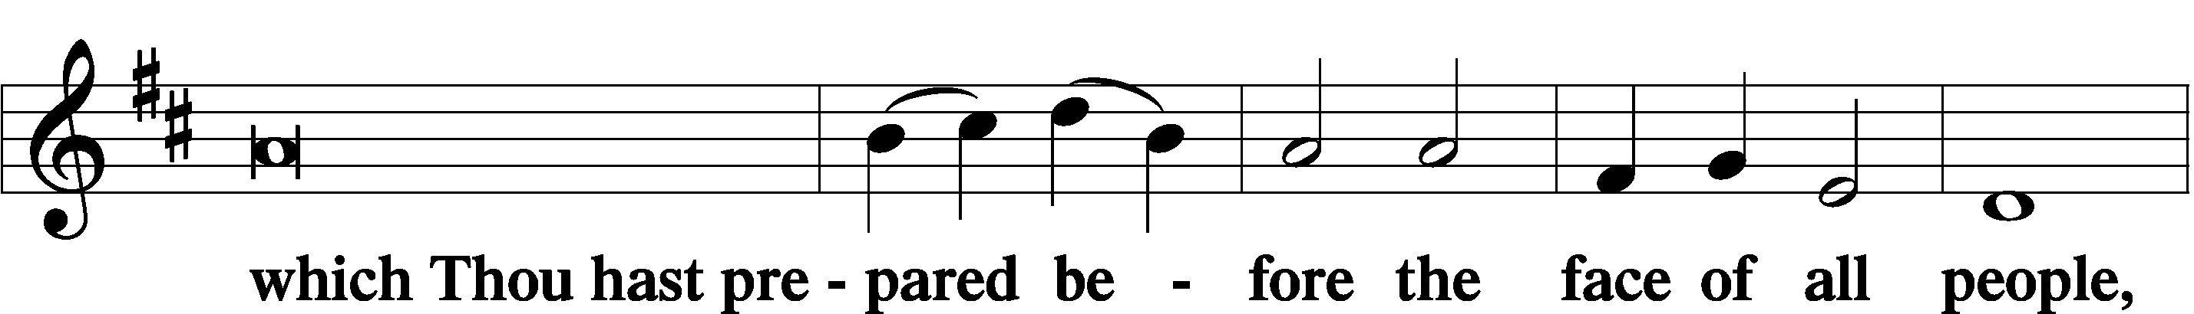

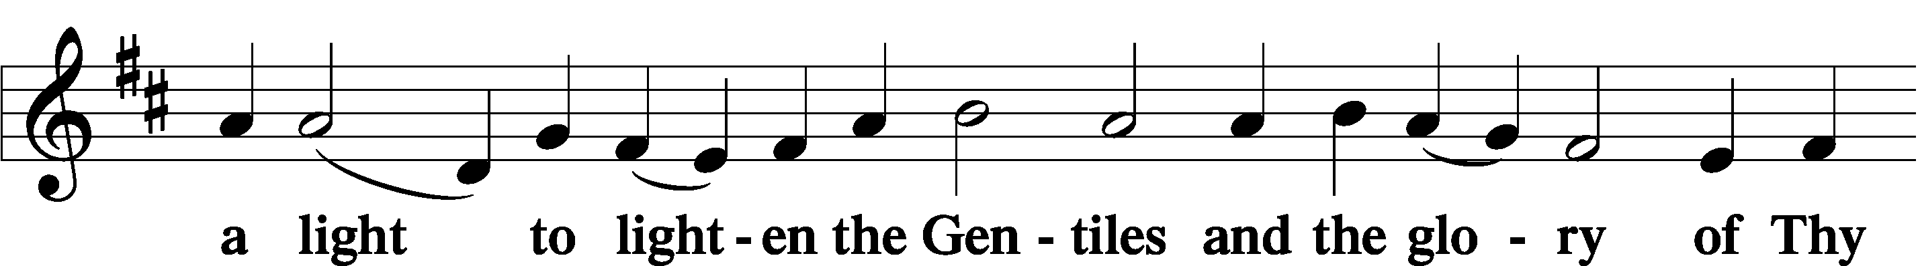

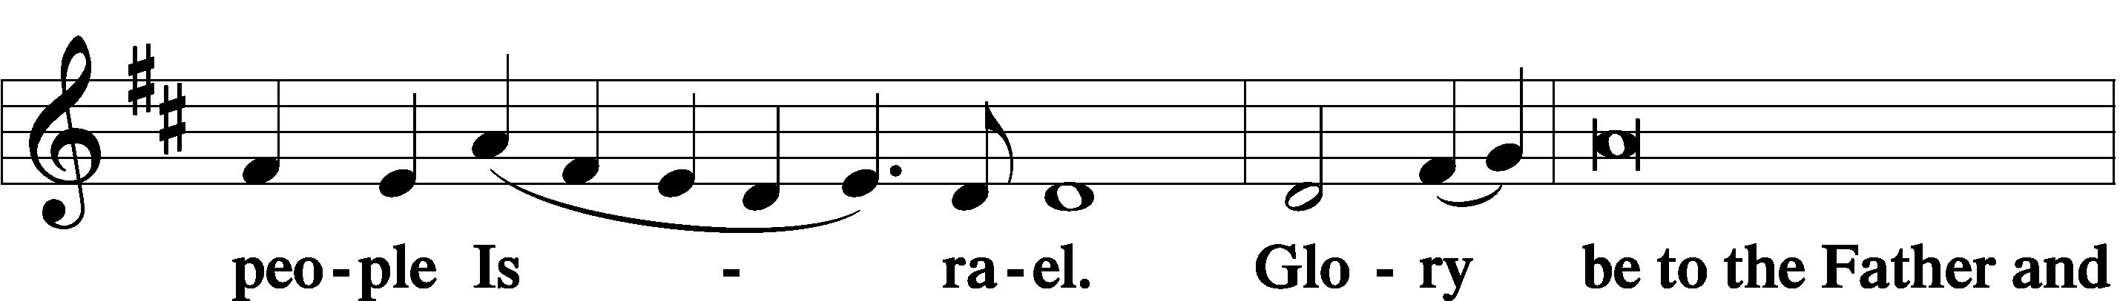

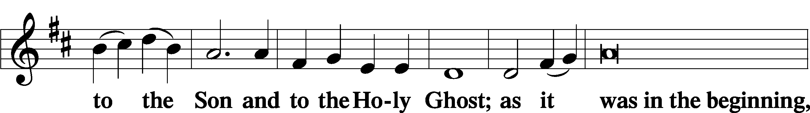

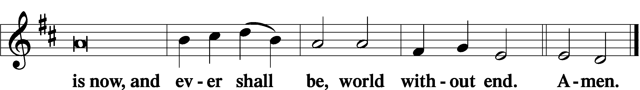

Thanksgiving LSB 200

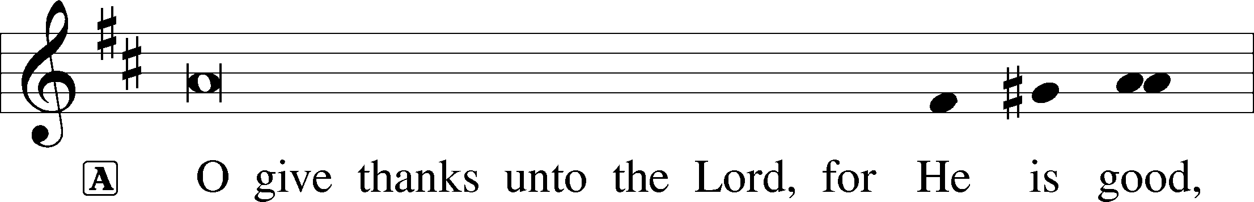

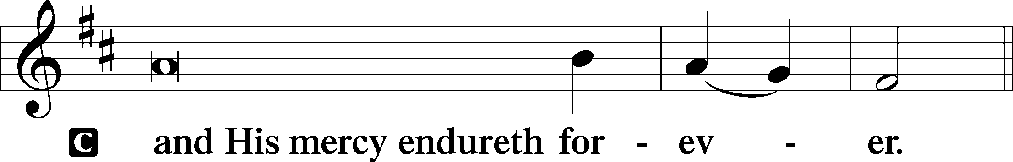

P Let us pray.

We give thanks to You, almighty God, that You have refreshed us through this salutary gift, and we implore You that of Your mercy You would strengthen us through the same in faith toward You and in fervent love toward one another; through Jesus Christ, Your Son, our Lord, who lives and reigns with You and the Holy Spirit, one God, now and forever.

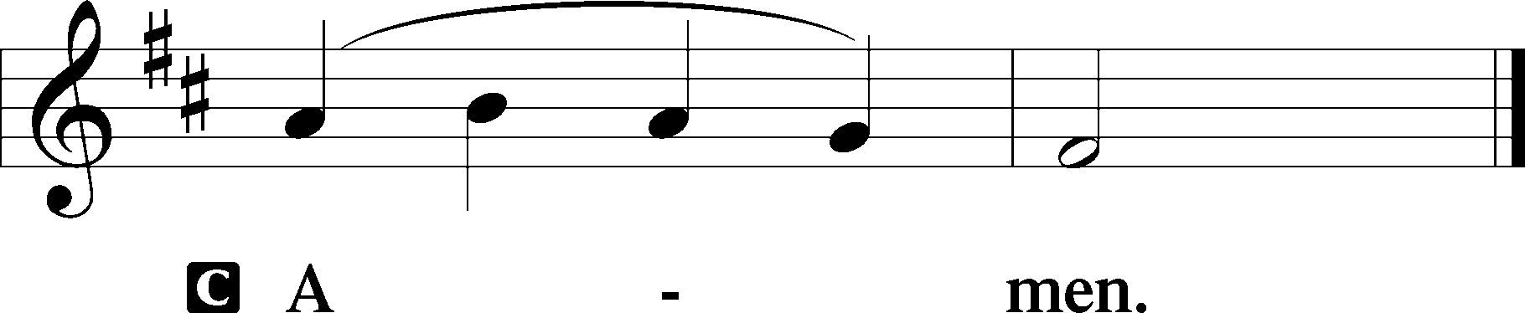

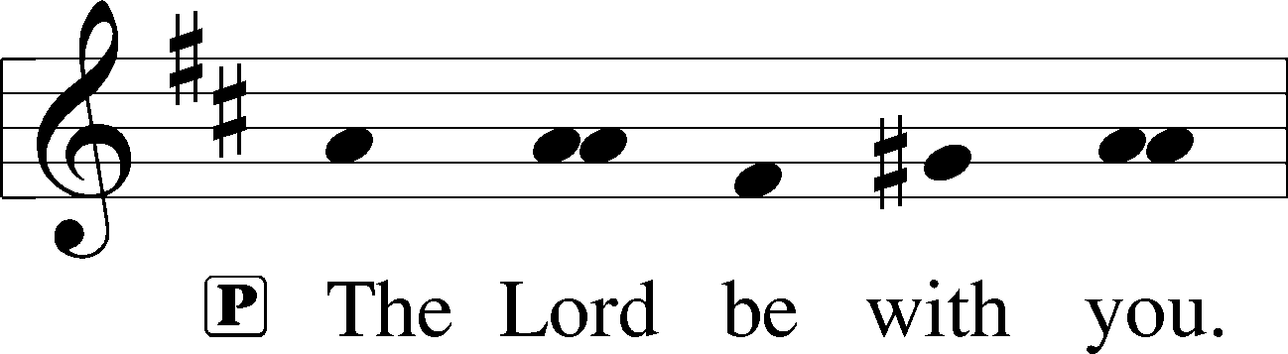

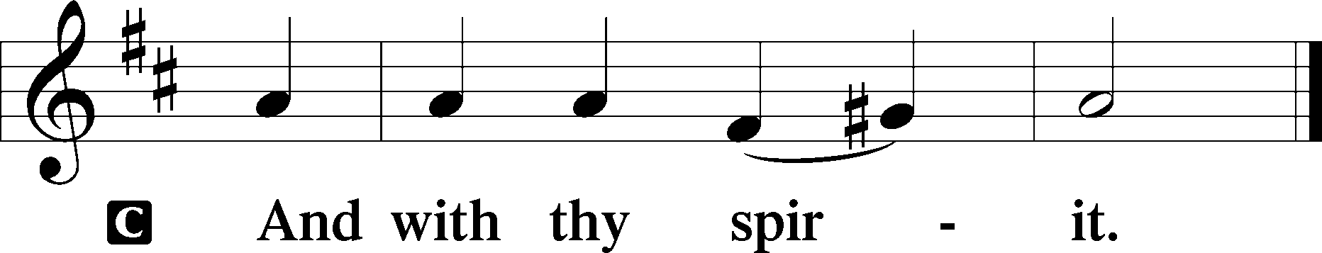

Benedicamus LSB 202

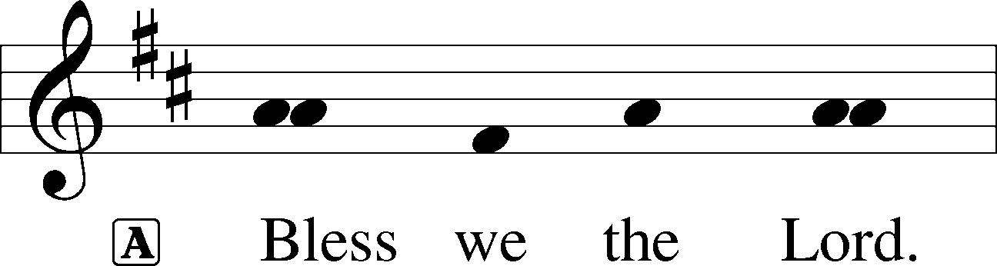

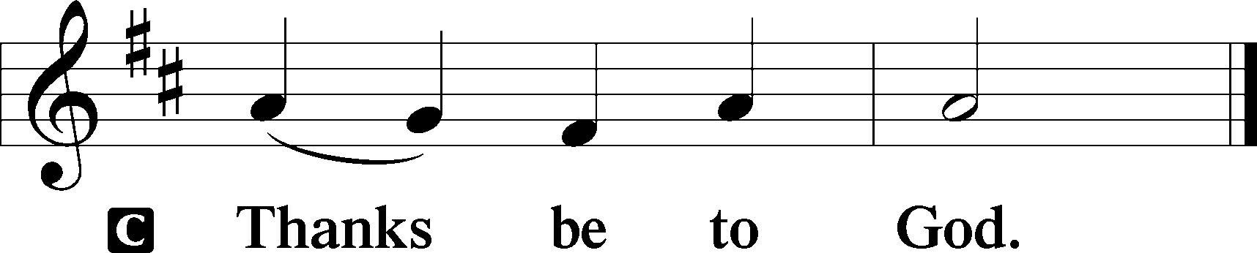

Benediction LSB 202

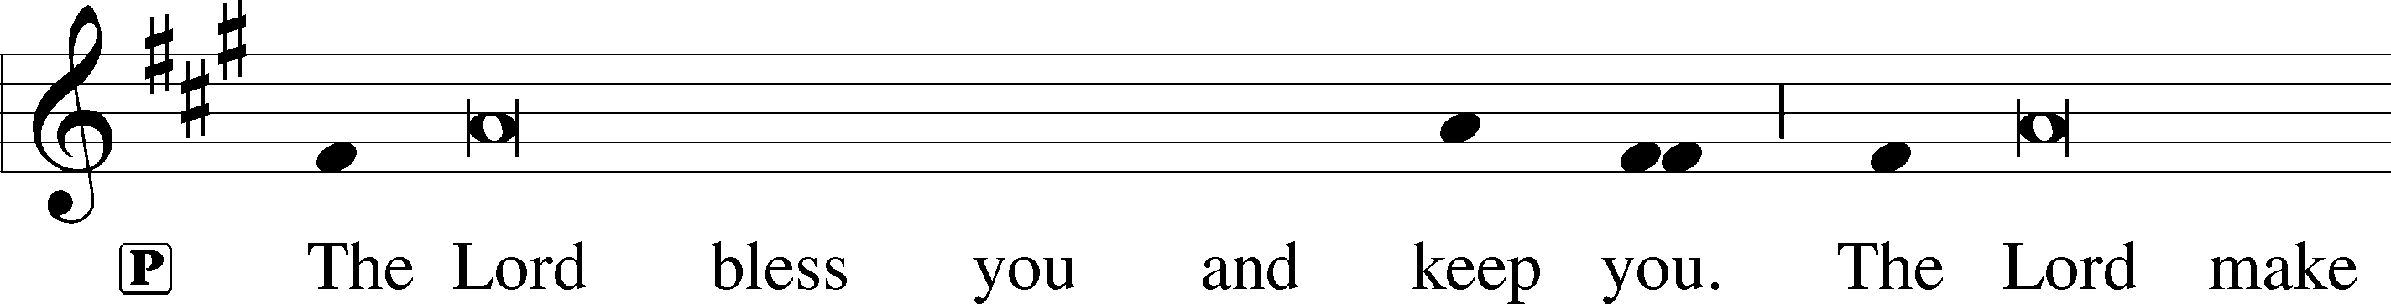

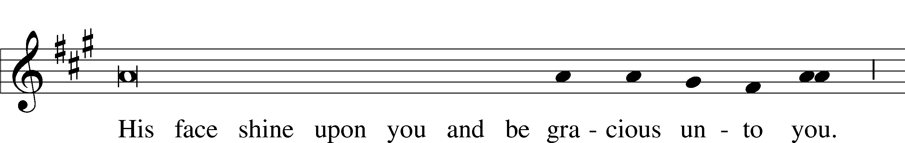

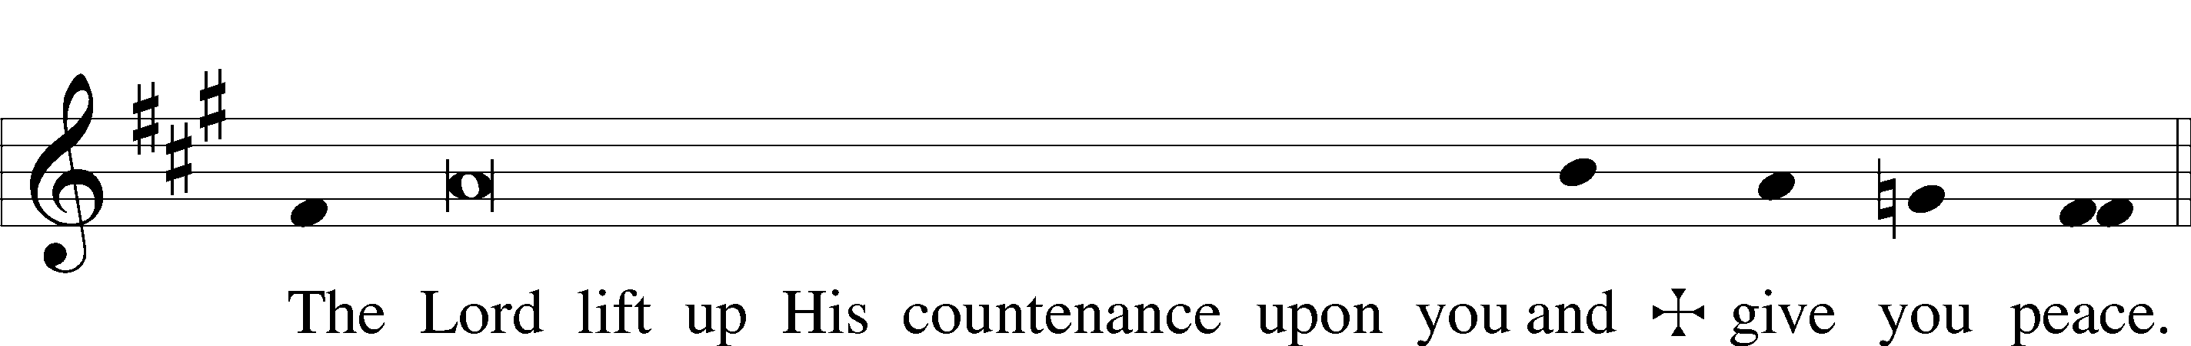

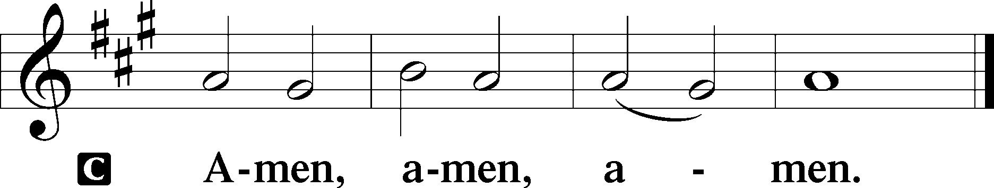

491 Up through Endless Ranks of Angels

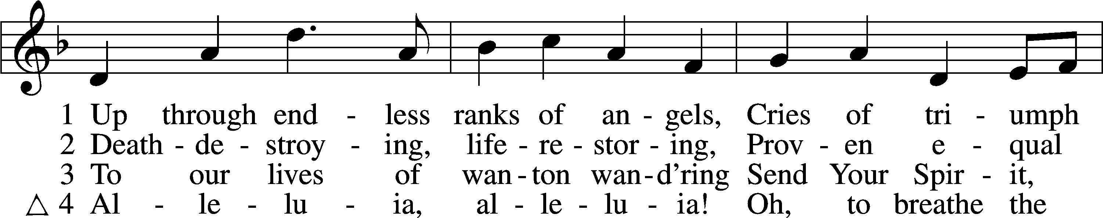

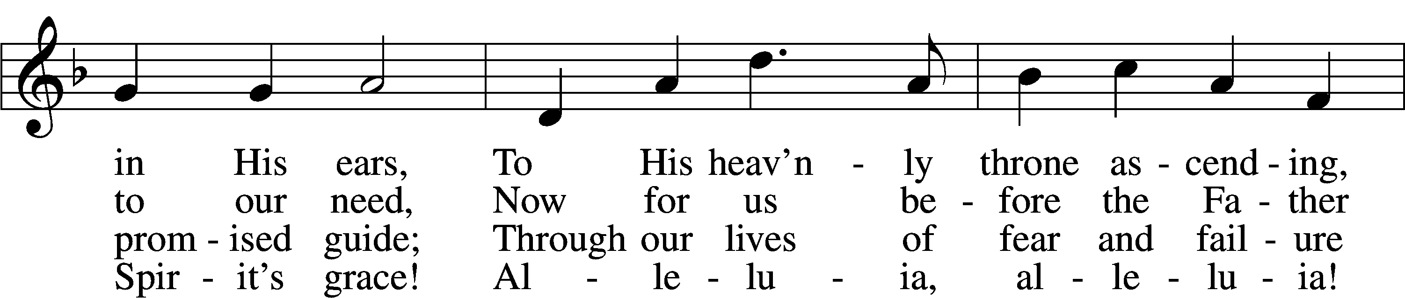

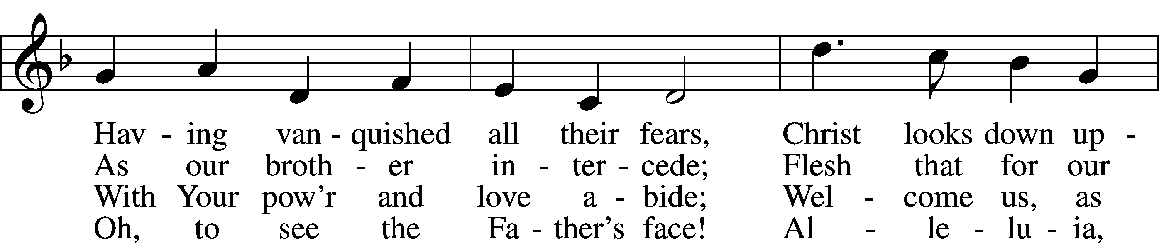

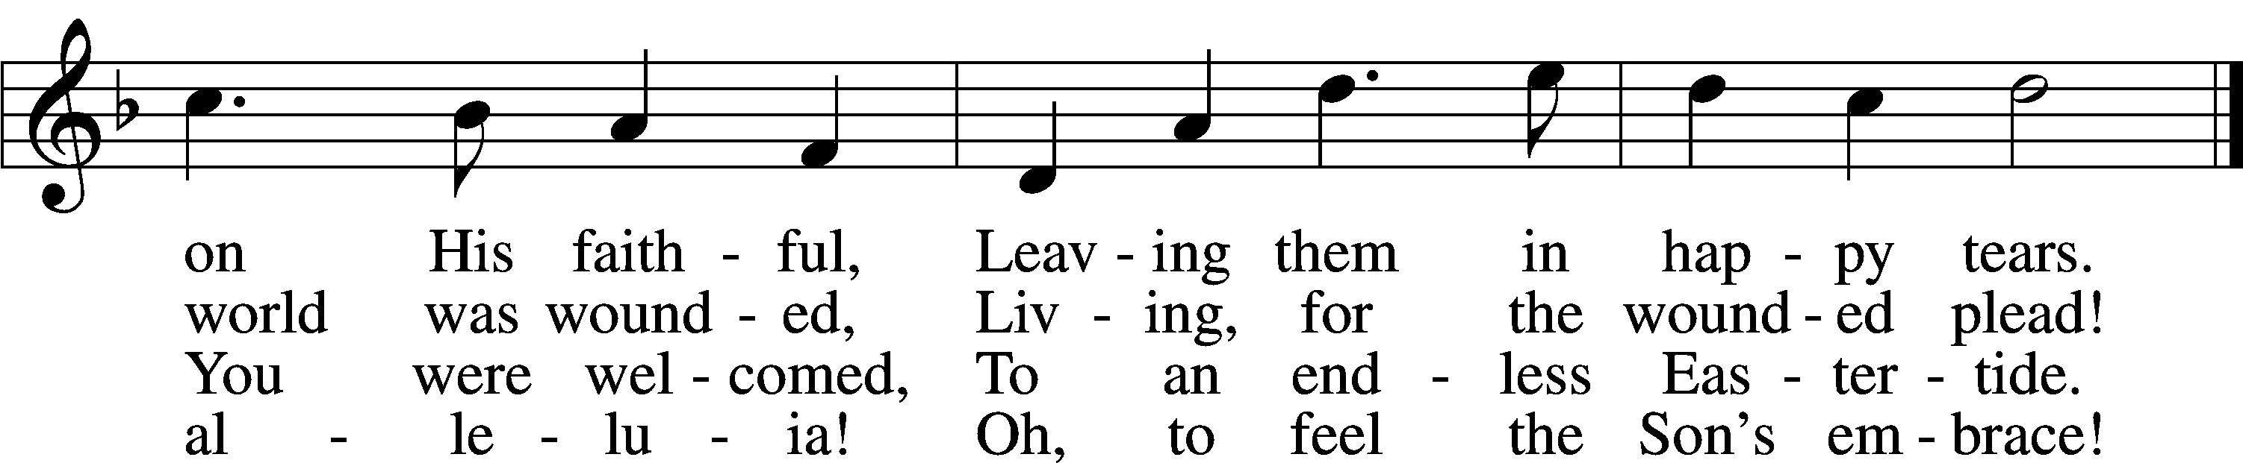

Text: Jaroslav J. Vajda, 1919–2008  
Tune: Henry V. Gerike, 1948  
Text: © 1974 Augsburg Publishing House. Used by permission: LSB Hymn License no. 110005212  
Tune: © 1973 Henry V. Gerike. Used by permission: LSB Hymn License no. 110005212

**\*\*\* Martin Luther Treaties on Good Works \*\*\***

6. We may see this in an everyday example. When a husband and wife really love one another, have pleasure in each other, and thoroughly believe in their love, who teaches them how they are to behave one to another, what they are to do or not to do, say or not to say, what they are to think? Confidence alone teaches them all this, and even more than is necessary. For such a man there is no distinction in works. He does the great and the important as gladly as the small and the unimportant, and vice versa. Moreover, he does them all in a glad, peaceful, and confident heart, and is an absolutely willing companion to the woman. But where there is any doubt, he searches within himself for the best thing to do; then a distinction of works arises by which he imagines he may win favor. And yet he goes about it with a heavy heart and great disinclination. He is like a prisoner, more than half in despair, and often makes a fool of himself.

Thus, a Christian man who lives in this confidence toward God knows all things, can do all things, ventures everything that needs to be done, and does everything gladly and willingly, not that he may gather merits and good works, but because it is a pleasure for him to please God in doing these things. He simply serves God with no thought of reward, content that his service pleases God. On the other hand, he who is not at one with God, or is in a state of doubt, worries and starts looking about for ways and means to do enough and to influence God with his many good works. He runs off to St. James, to Rome, to Jerusalem, hither and thither; he prays St. Bridget’s prayer, this prayer and that prayer; he fasts on this day and that day; he makes confession here and makes confession there; he questions this man and that man, and yet finds no peace. He does all this with great effort and with a doubting and unwilling heart, so that the Scriptures rightly call such works in Hebrew *aven amal*, that is, labor and sorrow. And even then, they are not good works and are in vain. Many people have gone quite crazy with them, and their anxiety has brought them into all kinds of misery. Of these it is written in Wisdom [of Solomon] 5[:6], “We have wearied ourselves in the wrong way and have followed a hard and bitter road; but God’s way we have not acknowledged, and the sun of righteousness has not risen upon us.”

continued next week.

**\*\*\*The Day of Pentecost \*\*\***

***The Holy Spirit Gives Peace***

*Following the flood, Noah’s descendants failed to spread out and fill the earth as God had spoken. Rather, they exalted themselves; with “one language and the same words” (Gen. 11:1) they spoke proudly and arrogantly. The Lord humbled them by confusing “the language of all the earth,” dividing and dispersing the people (Gen. 11:9). That dispersal was reversed on Pentecost Day (the fiftieth day of Easter), when God caused the one Gospel of the Lord Jesus Christ to be preached in a multitude of languages. “At this sound the multitude came together” (Acts 2:6), for the preaching of Christ is the primary work of the Holy Spirit, whereby He gathers people from all nations into one Church. The Holy Spirit teaches and brings to our remembrance the words of Jesus, which are the words of the Father who sent Him. These words bestow forgiveness and peace to those who keep and hold on to them in love for Jesus. “Peace I leave with you; my peace I give to you. Not as the world gives do I give to you. Let not your hearts be troubled, neither let them be afraid.” (John 14:27).*

**\*\*\*“Life Quotes” from Lutherans *for Life\*\*\****

*“Jesus became incarnate as embryo, fetus and teenager, infant and adult. In this way He consecrates humankind of all ages, appearances, and abilities. The Good Lord comes close in skin and bone, the same as ours. He remains near with muscle and blood like we have. He humbly bears these sicknesses and gently carries these sorrows of ours. Jesus has crucifix-ed God on you, ever the servant and once-for-all sacrifice.*Pastor Michael Salemink, Lutherans For Life – A Life Quote from Lutherans For Life • lutheransforlife.org

**\*\*\*For Daily Devotions\*\*\***

**May 28:** Num. 21:10-35; Luke 21:20-38; **29**: Num. 22:1-20; Luke 22:1-23

**30:** Num. 22:21-23:3; Luke 22:24-46; **31:** Num. 23:4-28; Luke 22:47-71

**June 1:** Num. 24:1-25; Luke 23:1-25; **2:** Num. 27:12-23; Luke 23:26-56

**3:** Num. 32:1-6. 16-27; Luke 20:24:1-27

