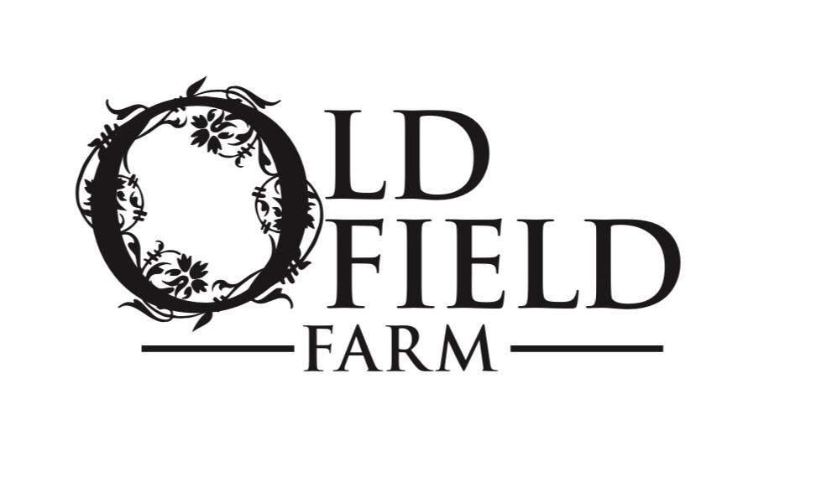

**Old Field Farm Summer Camp Dates and Prices**

Contact us at: Located at:

[oldfieldfarm@gmail.com](mailto:oldfieldfarm@gmail.com) 349 Sarah Wells Trail

Cell: (914) 474-7722 Goshen, NY 10924

Barn: (845) 294-6339

Camp is from 9:00 am – 3:00 pm daily starting July11th

Please select the week(s) you would like to attend.

Check below.

Space is to 10 participants.

Ages 6-14

Camp will be offered the following weeks:

July 11-15th______

August 8-12th_____

Fees: Each week of camp is $575

You can reserve your spot by May 1, 2022 with a $50 non-refundable fee for a certain amount off (will discuss later)

Families registering more than one child will receive 10 percent off the second camper.

Multi Week Discount is available.

INFORMATION Camper’s Legal Name_______________________________________ Parent/Guardian Name(s)________________________________ Camper Birth Date__________( YYYY/MM/DD) Child’s Horse Experience: _______N/A_____ Pony Ride______ Trail Ride _____ Lessons

Parent’s First Name______________ Last Name____________

Cell Number________________________________________

Work Number_________________________________

------------------------------------------------------------------------------------------------------------------------------------------

Substitute Pick Up If you are not able to pick up your child a note must be given ahead of time to the office naming your replacement

Emergency contact (Please list 2 people)

First: Name ______________Last Name_____________ Relationship_____________________________________

Cell Number______________________________________

Second: Name___________________________________ Relationship____________________________________

Cell Number_____________________________________

MEDICAL INFORMATION Does your child have any allergies_____YES______NO

If yes please list Does your child take any medication_________YES_______NO

If yes list Does your child have any chronic illness______YES_______NO

If yes list Has the child been treated recently for medical problems?_____YES____NO

If yes please identify_____________________________________________

**OUR DAILY SCHEDULE INCLUDES**

https://www.sevenmeadowsfarm.net/img/sumpro/image002.png Daily riding lesson-grouped by ability  
https://www.sevenmeadowsfarm.net/img/sumpro/image002.png Grooming  
https://www.sevenmeadowsfarm.net/img/sumpro/image002.png Horse Care  
https://www.sevenmeadowsfarm.net/img/sumpro/image002.png Nutrition  
https://www.sevenmeadowsfarm.net/img/sumpro/image002.png Afternoon Spa Time  
https://www.sevenmeadowsfarm.net/img/sumpro/image002.png Basic First Aid  
https://www.sevenmeadowsfarm.net/img/sumpro/image002.png Horse Science  
https://www.sevenmeadowsfarm.net/img/sumpro/image002.png Parts of Horse, Parts of the Saddle

https://www.sevenmeadowsfarm.net/img/sumpro/image002.png Arts and Crafts  
https://www.sevenmeadowsfarm.net/img/sumpro/image002.png Horseback Games