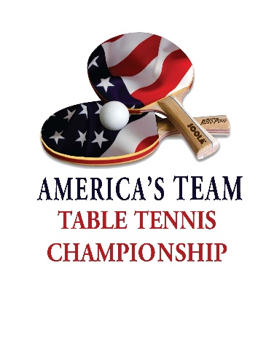 FAQS
America’s Team Championship
May 28-29, 2022
Rockford, IL (1 Hour West of Chicago)
Important Notes: Entry Deadline is May 15. The ratings and team seedings may change from what is currently showing on OmniPong. The USATT ratings from May 20th will be used for the tournament. If a player has no rating, an estimated rating will be used.
Competition format and tentative schedule
Day One: Saturday, May 28, 9 AM. One preliminary round for division placement followed by division play beginning at 11:30 AM. Teams will be provided with the complete schedule for the remainder of the tournament after the preliminary round is completed. NOTE that the teams in the top half of Division One AND bottom half of the last Division do not compete in the preliminary round. We will notify those teams. Some teams may have bye rounds for the division rounds on either day.
Day Two: Sunday, May 29, 9 AM to 7 PM. Division play & finals rounds; Expect to play in 8+ rounds of competition for both days.
Division 1 will consist of 6 to 9 teams with finals tentatively scheduled at 2 pm on Sunday. The competition for the semis and finals for Division One’s top four teams will be the best of five singles matches. This is only for the top four teams in Division One on Sunday. The competition for teams in 5th place or lower in Division One on Sunday will be 5 out of 9 matches.
Division 2 through 6 consists of 8 to 10 teams with the 1st round as the placement round. Round robin for subsequent rounds. All competition is the best 5 out of 9 singles matches.
Swaythling Cup format with the best 5 out of 9 singles matches. Each team has 3 to 5 members with 3 playing in each round (A, B, & C and X, Y, & Z). Each team member plays up to 3 singles matches per round. Matches are 3 out of 5 games to 11 points
- You must start the next match if the table is available – even if one team has 4 wins and may win the round. Matches count in order. As soon as one team has 5 wins that are in the order on the match slip the round is over, and all other matches do not count either for the tournament or for USATT rating points – the players just stop playing.

- The schedule will be determined after player registration is closed and the draws are made. Divisional rounds will begin at 11:30 am on Saturday and are scheduled approximately 2 hours apart for both Saturday and Sunday. There are no scheduled breaks for meals. Please plan accordingly. You may bring in outside food and drink.
- It is critical that the match slips are completely filled out with the correct spelling on first and last names (no nicknames, please). Scores must be legible, and winners’ names circled. Correct information assists with determining tie-breaking in the final placement for each division and accurate results processing that updates players’ USATT ratings.

Tournament Equipment
Joola 3000SC Pro, Joola 3000SC, and Joola 2000-S tables
Joola Prime 40+ ABS white balls
46 large courts on wood floor
2 large courts with red GerFlor rubber flooring

Tournament Information
The tournament hotel is the Radisson Rockford with a $99 per night discount. The deadline for this price is May 15. Call 779.513.8228 and mention America’s Team Table Tennis Championship.
The venue is open for practice on Friday, May 27, from 5 pm to 9 pm.
Teams will receive team signs for photos and for clipping to the barrier where they are playing.
Free bottled water courtesy of Joola Global Championship provided for all competing athletes. Free parking and free admission for entrants and spectators.
Tournament shirts available for sale.
Tournament balls provided at player check-in.
All players must individually check in once for the tournament.
There is a large tournament banner next to the control desk for photos.
Engelbert Solis with Edgeball Table Tennis will have an equipment booth. To preorder equipment, email Engelbert at edgeballtabletennis@yahoo.com.
There is free pizza for all on Saturday evening. There is a concession stand open during the tournament. As stated above, there are no scheduled breaks for meals.
Live streaming on tables one and two. Link to be provided before the event begins.
Custom made medals for top three teams in each division.
Prize money for all teams in Division One – YES, we have more than 48 registered teams!
Division winners get $100 off 2023 America’s Team Championship team entry (50%+ of the team members must be the same.)
Three upcoming Joola tournaments will have entry forms available:
- Sept 1-4, 2022; Joola Global Championships; Kissimmee, FL
- Sept 23-25, 2022; Badger Open; Franklin, WI (between Chicago and Milwaukee)
- Oct 29-30, 2022; Edgeball Chicago International Open; Libertyville, IL
www.EveryoneLovesTableTennis.com

