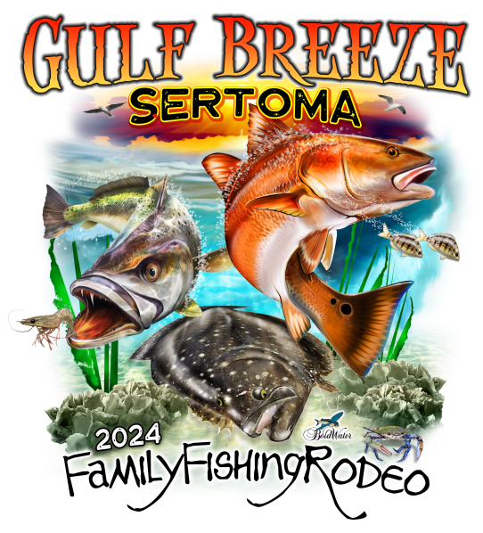

Free tickets are available

Rodeo tickets are available from our Sponsors listed below and from Gulf Breeze Bait and Tackle and Half Hitch Tackle in Navarre

Note: there are Adult and Junior (under age 14) tickets. Each ticket has a code number that allows all anglers to use sponsor tickets - FREE registration at fishingchaos.com. Each Angler must individually register at fishingchaos.com PRIOR to the rodeo.

Rodeo site will be open 12-5 pm with scales open from 2-5 pm.

Pete Della Ratta will be running the kids’ fishing clinic on Saturday only at 1 pm, 2 pm, and 3 pm!

We invite you to participate in our raffle for the Big Green Egg and Yeti Cooler and be sure to check out our silent auction items.

Sertoma promotes our rodeo at familyfishingrodeo.com where you will find info about the tournament.

Rodeo rules and registration and LIVE results can be found at fishingchaos.com.

Again, thank you for supporting Gulf Breeze Sertoma!

