The Woodie Classic by Racketman

**History of Lawn Tennis & Value Proposition**

**– Researched and Assembled by Bob Dienstbach**

**History of Lawn Tennis**

Lawn Tennis was invented in 1874 by Major Walter Clopton Wingfield and played with wood rackets for the next 110 years.

Bjorn Borg and John McEnroe’s July 5th, 1980 Wimbledon battle (wood Donnay racket vs wood Dunlop Maxply Fort racket is a classic) but by 1981 most junior players had made the switch to the power of big graphite rackets. In 1982 Chris Evert won the U.S. Open with a conventional-sized wood racket but Martina Navratilova switched to the big elliptical head of the Yonex R-7 just three weeks before the 1982 French Open and she won it for the first time. Navratilova became the first player to win a major tournament with a big-head graphite racket and Mats Wilander became the second on the following day which helped coin 1982 as *“The Year of the Switch”.*

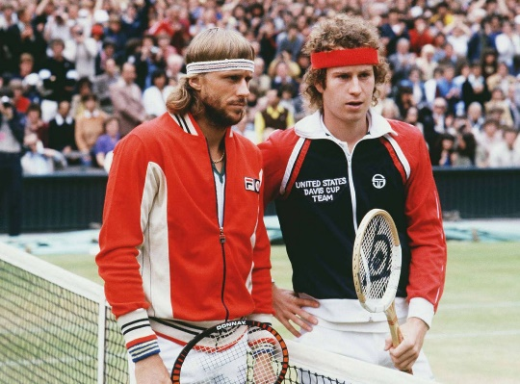 1980 Wimbledon Final – Wood Rackets

By 1983 even McEnroe switched to a midsized graphite Dunlop, but a few die-hards continued to use wood or wood composites. For example, a wood Le Coq Sportif TCO racket was used by Yannick Noah when he won the 1983 French Open. The 1988 Wimbledon was the first tourney where no player used a wooden racket. March 19, 1989 officially marked the end of the wood racket era when at Indian Wells, Miloslav Mecir of Czechoslovakia became the last player in tennis history to win a tournament (over Yannick Noah) with a wooden racquet; a Snauwaert wood composite.

In the 80’s, space age materials engineers looked upon sports as a fresh market for their material innovations. Companies like Wilson, Prince, and Head all began offering tennis racquets made from aluminum, steel, fiberglass, graphite and boron. Once the engineers got graphite right it was game, set and match; Wood just couldn't handle the service speeds generated by graphite 90+ sq inch frames.

Many tennis fans now lament the state of the professional men's game, in which a typical point consists of an ace, or perhaps one or two cannonball shots after the serve. They long for the drama of extended rallies of 1970’s wood racket tennis. Today’s tennis with modern technology polymer frames can be a slugfest, especially with two big servers or competent baseliners on the court at the same time.

Famously, the grass at Wimbledon was changed to one that caused the ball to bounce more slowly because spectators were getting bored that the tournament was dominated by very short points that were not pleasing to watch. For example, there was a match between Edburg and Becker at Wimbledon and their average point duration was 3 seconds or lower. Another example, John Isner and Riley Opelka (2 of the tallest players on the tour), have 1,032 and 1,014 aces respectively. They both played 48 matches each, which means that they averaged 22 and 21 aces per match. The most aces served by an individual player in a professional tennis match is 113 by John Isner (USA) against Nicolas Mahut (France) at the 2010 Wimbledon Championships.

On the ATP, rally lengths of 0-4 shots occur 70% of the time (on both the male and female circuits). Rally lengths between 5-8 shots occur about 20% of the time and the remaining 9 and up rally lengths occur about 10% of the time.

<https://www.mattspoint.com/blog/rally-lengths-in-tennis-a-contrasting-perspective>

The power that professionals can summon from state-of-the-art rackets was simply too much for the delicate touch game of wood rackets to survive. Many fans feel the ineluctable march of technology has degraded tennis by virtually eliminating the serve and volley, and the drama of extended rallies. Many fans believe tennis was a better and more entertaining sport with wood.

In April of 1991 Bjorn Borg reappeared on the professional tennis circuit after a mysterious nine-year absence. Young, powerful champions battled one another on the red clay of Monte Carlo, blasting 130 mph serves armed with the latest generation of oversized, widebody rackets. And then there was Borg stepping onto the clay with a black wood anachronism, custom-made by Gray's of Cambridge to replicate his old Donnay model. His comeback was short-lived, but his defiance of technology gives him a loveable Don Quixote mystic.

**Value Proposition of Wood Rackets in 2022**

Traditional wood rackets have a small hitting surface of 67 sq in compared to the preferred 95 sq in midsize rackets of today. And wood rackets weigh 400g or more compared to modern larger rackets that weigh approx. 300g which allow higher head speeds. Coaches today use wood rackets as a training aid which requires laser-eye focus to watch the ball and hit that tiny sweet-spot over and over.

Tournaments using only wooden racquets change up the game by requiring more creativity with less focus on power and spin. Wood lets you feel the ball contact more and awakens your touch. Wood rackets suit aggressive play and taking the ball on the rise which generates power. The key to generating power with a wood racket is getting your weight through the ball. New gut strings make wood rackets more playable so re-stringing your vintage frame with gut is mandatory.

To some, a wood racket tournament may seem to be a novelty. To others, wood rackets conjure up quaint nostalgic memories: "Can you believe we actually played with these things?" Some may dream of wood rackets the way others dream of childhood; as belonging to a better, more innocent world, a paradise lost…but playing with wood rackets is something much more.

Participants of wood racket tourneys the world over report fresh converts to Wood Tennis who yearn for the next Woodie event. Woodie tournaments are burgeoning because of a growing conviction that tennis is a more challenging and more enjoyable sport when played with conventional rackets.

Classy people store at least one wooden racket in their lockers. Although you won’t be playing with old rackets at the highest level, it’s worth giving them a try from time to time. The ability to compare racket parameters from different eras is priceless. You can gain extra knowledge about what was possible and impossible to do in the past.

**Nostalgia - Fun - Competition – Charity**

The 2022 Inaugural “Woodie Classic” A Fund-Raiser for the USTA Foundation’s NJTL Summer Camp Program held at the Dwight Davis Memorial Tennis Center. The National Junior Tennis and Learning (NJTL) network features more than 250 nonprofit youth development organizations that offer free or low-cost tennis and education programming to over 160,000 under-resourced youth each year.

The Woodie Classic is an opportunity to experience the superior feel and pure joy of a vintage Wood Racket while celebrating the 50th anniversary of the Racketman. <https://www.racketman.com/>