Wood Tennis Tournaments
Around the World

https://www.facebook.com/WoodRacquetClassic
The Costa Mesa Wood Racquet Invitational benefits the John Wayne Cancer Foundation.
Founded by Johnny McCray and Clay Peterson
Palisades Tennis Club in Newport Beach, California 949-644-6900
Carrie DeLong – Club Manager
https://woodracquetfoundation.wordpress.com/about/
https://www.youtube.com/watch?v=WikZtePlefs
https://www.latimes.com/socal/daily-pilot/news/tn-dpt-0904-wood-20100903-story.html
https://baumvision.wordpress.com/2010/12/07/were-so-proud/
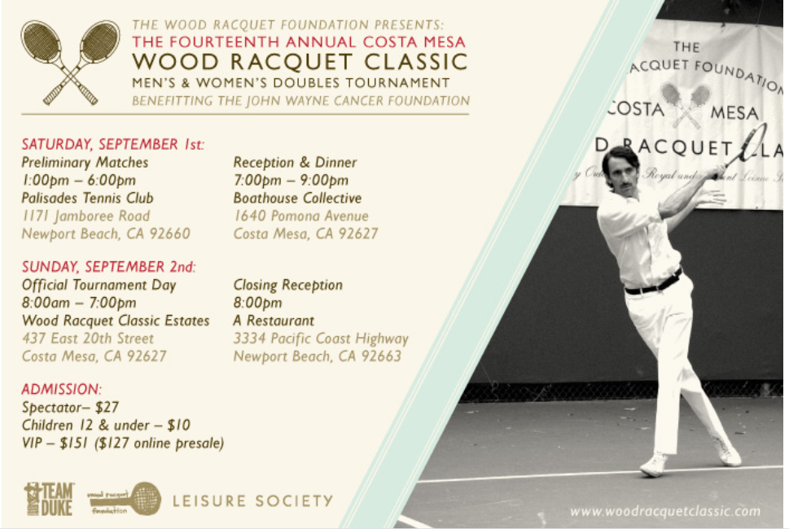

https://qptc.co.uk/news/wooden-racquets-only-brighton-tennis-club-goes-retro/
Queens Park Tennis Club hosted a successful Wooden Racquets tournament
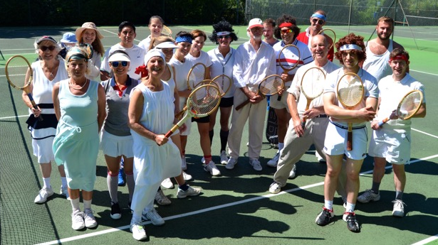
https://www.youtube.com/watch?v=IqN7TAHazhA
Burlington VT
https://www.uswrta.com/
info@uswrta.com (470) 384-9507
https://woodywednesdays.com/
Welcome To Woody Wednesdays, A Wood Racket League Created By The USWRTA
https://cdapress.com/news/2020/dec/02/all-wood-tennis-tourney-champions/
"Old School is Good School Wood Classic" wood tennis tournament at Peak Health and Wellness in Hayden ID
http://tropicaltennistournament.com/
Harbor Island Tennis Center St. Augustine, Florida
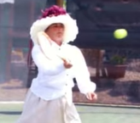
https://www.visitstaugustine.com/event/tropical-tennis-tournament
Harbour Island Tennis – St. Augustine's Gilded Age tournaments
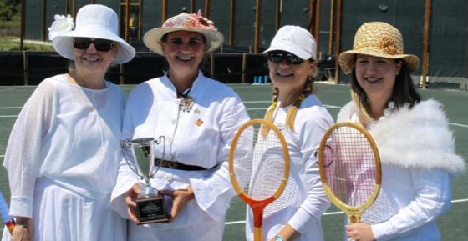
https://trademark.trademarkia.com/the-woody-tennis-championships-74620289.html
This is a brand page for the THE WOODY TENNIS CHAMPIONSHIPS trademark by Swope, Granville
https://www.menofwood.com/
woodytennis@yahoo.com
Grass Courts of Mission Hills Country Club Orange County CA
29th annual
https://business.facebook.com/PanhandleWoodRacquetClassic/?__xts__[0]=68.arc...
The City of Lexington will be hosting a Wimbledon Tennis Tournament/Social
Panhandle Wood Racquet Classic
Scottsbluff NE
https://bonnersferryherald.com/news/2020/oct/22/newhouse-and-beck-win-wooden-racquet-classic/
The Boundary County Tennis Association recently held its final tournament of the season, The Jim Albrecht Memorial Wooden Racquet Classic.
Bonners Ferry, ID
https://www.slobigs.org/event/avila-bay-1st-annual-wood-racquet-tennis-tournament/
Avila Bay Athletic Club & Spa presents: 1st Annual Wood Racquet Tennis Tournament with proceeds benefiting Big Brothers Big Sisters!
https://www.al.com/press-register-sports/2010/04/post_22.html
Mirror Lake Racquet Club - Mobile AL
https://www.championsseriestennis.com/todd-martin-uses-wooden-jack-kramer-pro-staff-to-win-invesco-series-qqq-title-in-newport/
International Tennis Hall of Fame “retro racquet” event on the Invesco Series QQQ, held in conjunction with the ATP’s Hall of Fame Open and the induction ceremonies for the International Tennis Hall of Fame.
Newport RI
https://knowlelawntennis.net/wooden-racket-tournament/
Knowle Lawn Tennis Club Wooden Racket Tournament Bristol England
https://tennislink.usta.com/tournaments/TournamentHome/Tournament.aspx?T=180633
USTA Weiser Wood Racquet One Day Tournament – Eastern PA
https://tennislink.usta.com/Tournaments/TournamentHome/Tournament.aspx?T=207873
USTA SIU Carbondale WOODEN RACQUET CLASSIC
https://clubspark.kiwi/tennisseniorsauckland/TSAActivities/FunTournaments
Tennis Seniors Auckland New Zealand
https://www.ustaflorida.com/wimbledon-whites-and-wooden-racquets-tennis-event-next-weekend-in-ocala/
USTA Florida will host a Wimbledon-style “Ft. King Wimbledon Whites and Wooden Racquets” tennis tournament at the Ft. King Tennis Center in Ocala, Fla.
https://www.echolive.ie/corksport/arid-40287338.html
Douglas Tennis Club was the first in Ireland to test them out when sport returned. Cork County Ireland tennis players ready to embrace the wooden racket revival
https://sju.quadweb.site/events/9-14-2021-west-side-tennis-club-event#!
West Side Tennis Club Event/ 1 Tennis Place Forest Hills, NY
https://www.signmeup.com/site/online-event-registration/113790/SMUCalendar
Oakton Community College Men’s Tennis Team presents the 1st Annual Wooden Racket Tennis Tournament at John’s Park in Glenview, IL.
https://clubspark.lta.org.uk/AldersbrookLawnTennisClub/News/a482a062-07f1-4537-abe7-3e514f6c26a5
Wooden Racquet Tournament Aldersbrook Lawn Tennis Club Wanstead, East London

