
The Woodie Classic by Racketman
Frequently Asked Questions:

Is this a USTA sanctioned event?
No. Because of the abbreviated Match Play format, no points will be awarded for USTA rankings

Do you have to be a USTA member to participate in the tourney or social?
No. Everyone 18 and older who enjoys playing the game and social networking in the tennis community is invited to participate.

Are there any singles brackets?
No. To maximize court time and participation, the Woodie Classic is Doubles only (Men’s, Women’s and Mixed)

Why do we have to play with a wood racket?

There is no doubt that nostalgia is the initial attraction to Wood Tennis. However, the objective is to also bring the past into the present by introducing a younger generation to a category of tennis that requires a higher level of skill and control, and to have lots of fun in the process. The aim is to challenge players. Find out if you have what it takes for a technical serve/volley game, longer points, harder to hit topspin and accuracy.

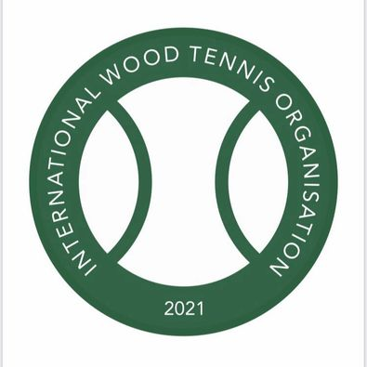 For example: During the IWTO Irish Open in September 2021 players learned (after an initial slight adjustment) that they very quickly 'forgot' that they were playing with wood rackets and took it in stride; secondly, a connection with the sweet spot generates comparable power to a graphite racket, and thirdly, a large portion of entrants were in the 30-50 age bracket, all of whom are now firm converts to Wood Tennis and very much looking forward to the next event.

Does IWTO publish wood rankings?

https://www.facebook.com/International-Wood-Tennis-Organisation-112358487785843
The Woodie Classic is in discussions with the IWTO to possibly award points for our tournament / ie rank the winners with the IWTO.

I don’t own a wood racket. How can I find one?

There are two companies who manufacture new wood tennis rackets.
https://www.facebook.com/grayswoodtennis
https://www.facebook.com/epoktennis
The Grays Masterpiece is €200 + Shipping to USA

Alternatively, Woodie Classic has for sale 200 vintage used wood rackets for sale with all proceeds going to Charity.

