***the Westbrook Group, inc.*** *Aviation Services*

***Des Moines & Creston, Iowa Midwest based with World Wide Experience***

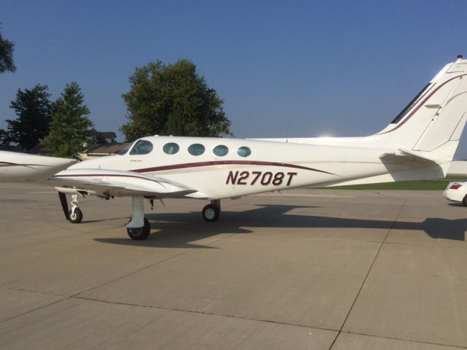

**1980 CESSNA 335**

**REGISTRATION**: N2708T **SERIAL NUMBER**: 335-0033

**EXTERIOR**: Allover White, Maroon & Gray Striping in Contemporary Scheme (9)

**INTERIOR**: Lt. Gray Cabin Seats & Sidewalls; Matching Gray Ultra-Suede Headliner, (8)

Gray Carpet; Executive Writing Table; Gray Upper Instrument Panel

**TOTAL TIME – AIRFRAME**: 3655 Hours

**TOTAL TIME – LT ENGINE**: 953 Hours since Factory Rebuilt

**– RT ENGINE**: 798 Hours since Major Overhaul

**TOTAL TIME – LT PROPELLER**: 339 Hours since Overhaul

**– RT PROPELLER**: 339 Hours since Overhaul

**INSPECTION STATUS**: Next Annual Inspection September 1, 2021

**ENHANCEMENTS:** **Redesigned Instrument Panel**

* **Garmin G500 Dual Screen Electronic Flight Display w/FlightCharts, SafeTaxi**
* **S-Tec 55X Autopilot w/Rate of Climb Pre-Select, Electric Trim & Yaw Damp**
* Vortex Generators w/Increased Useful Load
* Tanis Engine Heaters
* Air Conditioning

**AVIONICS**

* Garmin 530W w/Traffic Alert, Weather, METARs & TAFs
* Garmin 430W w/METARs & TAFs
* Garmin GMA-340 Audio Panel w/6 Place intercom
* Garmin GTX-345 Transponder (ADS-B Out & In)
* RDR-160 Radar
* Garmin GDL 69 Satellite Datalink
* Sirius Satellite (Music & Weather)

**ACCESSORIES**:

* **J.P. Instruments EDM-960** **Twin**

**Engine Electronic Engine Monitoring & Data Display**

* Known Icing
* Long Range Fuel (203 Gallons)
* LH Executive Writing Table
* Upper & Lower Rotating Beacons
* LH & RH Landing Lights
* Pilot & Co-Pilot Articulating Seats
* RH Flight Instruments
* Digital Clock
* Polished Spinners
* Propeller Syncrophaser
* **Super Soundproofing**
* Wemac Ventilation System

**For more Information or to Request a viewing please Contact:**

**Dick Westbrook Ph: 515-262-1124 Email: dick@westbrookaircraft.com**

**REMARKS:**  **Excellent Maintenance**, Excellent Appearance, Corporate Flown, All Logbooks.

We do not make any implied warranties, and specifications are subject to verification upon inspection. Aircraft may be sold, not available or

removed from the market without notice.