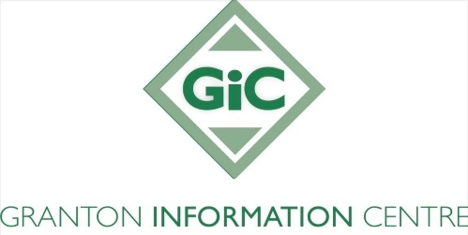

**Granton Information Centre (GIC) Mission Statement and Values**

**Our Mission Statement**

Granton Information Centre (GIC) aims to support residents of Edinburgh (primarily targeting our local community of North Edinburgh) by working towards the eradication of poverty. We provide free, accessible, impartial, and comprehensive advice and representation services, with a focus on benefits, debt, and housing issues.

**Our Values**

* Integrity: Acting honestly and ethically in all dealings with clients, partners, and the community
* Confidentiality: Respecting the privacy of individuals seeking advice, ensuring their information is protected and handled with care
* Impartiality: Providing unbiased guidance that is not influenced by external interests; always remaining neutral and focused on the best interests of our clients
* Respect: Treating individuals with dignity, understanding, and empathy whilst recognising their unique circumstances
* Accessibility: Ensuring GIC’s services are available to those who would benefit from our assistance
* Empowerment: Aiming to empower individuals to make informed decisions and take control of their situations by providing the knowledge, resources, and support they need
* Transparency: Communicating clearly and openly about services, processes, and limitations, so that individuals understand what to expect
* Accountability: Being responsible for the services provided and ensuring that the GIC remains committed to its mission of supporting our clients
* Collaboration: Working together with other organisations, communities, and stakeholders to achieve the best possible outcomes for those seeking advice
* Social Justice: Promoting fairness, equality, and access to support for marginalised or disadvantaged groups, ensuring that everyone has the opportunity to receive high quality advice and guidance.