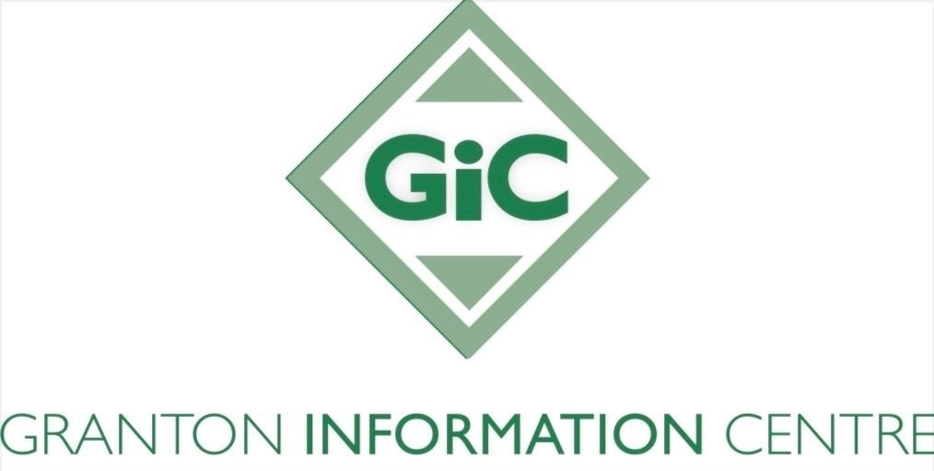

**Granton Information Centre (GIC) Client Service Agreement**

GIC aims to assist our clients with benefit claims, issues and appeals. We also address debt and other financial pressures by providing money advice, negotiating with creditors and representation when necessary. GIC also provides help and advice with housing issues for homeowners, housing association tenants and tenants in the private rented sector, particularly those threatened with repossession actions for mortgage and rent arrears and those experiencing other debt issues that may put their home at risk. Our clients are at the heart of everything we do. By adopting an empathetic and client-centred approach to our work and providing services within a wide range of accessible venues and GP surgeries, we aim to meet the individual needs of our clients.

**What you can expect from GIC:**

• A free, impartial and confidential service

• To be treated with respect and without judgement or prejudice

• We will only discuss your circumstances with relevant parties; we never pass on client data to anyone outside GIC without your permission, unless we are required to do so for legal reasons

• We will obtain written consent from you before undertaking any work on your behalf by asking you to sign a GIC Authorisation document. This document gives GIC your consent to act on your behalf, record and retain personal and financial details and access financial information from 3rd parties when necessary. We will also give you the option to opt into an audit process were the work we undertake for you can be reviewed by an outside body. This is for Quality Assurance purposes only

• We will handle all information and data relating to your case in accordance with the General Data Protection Regulations 2018, and in accordance with GIC’s own data protection and privacy policies (accessible on our website).

**In return, we expect that you:**

• Attend all appointments, or notify us if you need to cancel or reschedule

• Provide accurate information about your circumstances as requested by the adviser e.g. written evidence of your income, debts etc.

• Keep us notified of changes in your circumstances e.g. change of address, birth of a child, additional income etc.

• To not be under the influence, or to consume illegal drugs or alcohol on our premises

• Maintain contact with GIC and ensure we can reach you to enable us to progress your case and act on your behalf

• Always treat our staff with respect and dignity; we have zero tolerance for aggressive or abusive behaviour that could cause our staff to feel afraid, threatened or abused. This includes threatening emails, telephone calls, meetings, and comments on social media or elsewhere.

**GIC reserves the right to withdraw our services if:**

• You wish to pursue a course of action against our advice, or to which we do not wish to become involved

• You disclose any criminal activity in relation to your affairs (e.g. fraud), unless you have made full disclosure to the wronged party. Under these circumstances we will advise you to seek legal advice

• After multiple attempts we are unable to reach you to discuss your case

• You do not maintain any of the expectations detailed in this agreement.