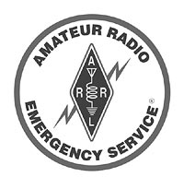
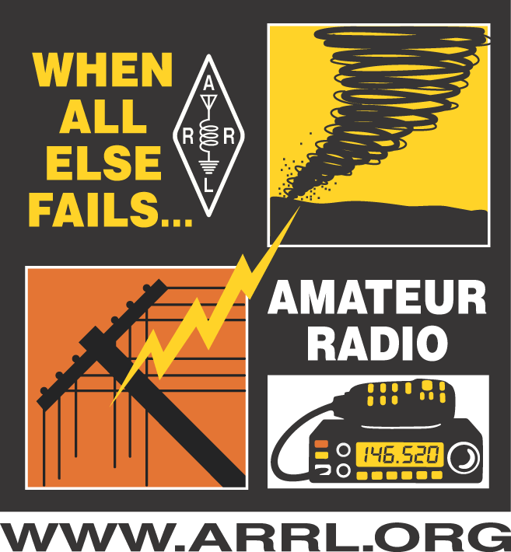
Cecil County ARES Net Script

(Weekly Routine Non-Emergency Training Net)

Sundays at 2000L on the N3RCN 145.470 Repeater
Revised 3/23/2022 kb3ljb
<PREAMBLE>
Calling the Cecil County Amateur Radio Emergency Service (A.R.E.S.) Net. This is George, Kilo Bravo Three Lima Juliet Bravo, net control operator for the (date) net.
<BREAK>
This net meets every Sunday evening at 8:00 pm local time on the N3RCN 145.470 repeater for the purpose of planning, practicing, and discussing the activities of the Cecil County A.R.E.S. Should that frequency become unusable, we will switch to the N3RCN 448.575 (- PL 107.2) repeater and continue the net.

If you have emergency or priority traffic, please call KB3LJB now.
<BREAK>
If you have emergency traffic during this net, please say the pro-word BREAK during the pause after the courtesy beep. We will then stop the net to handle your emergency traffic. If you need the frequency and do NOT have emergency traffic, simply say your call sign after the beep, and you will be directed to go ahead as soon as possible.
<BREAK>
This is a directed net. This net is open to anyone interested in A.R.E.S. and supporting emergency communications in Cecil County. A.R.E.S. membership is not required to check in.
<BREAK>
Do we have a station on frequency wishing to serve as alternate net control? If so, please call now.
<CHECK INS>
To check-in, say the words “This is”, unkey, and listen for a double from another station, then continue by giving your call sign, phonetically, your name, and your county of residence. Please also mention any announcements or other traffic you have for the net.

First, do we have any mobile, portable, emergency power, or short-time stations that wish to check in? If so, please call KB3LJB now. (Acknowledge and record each check-in and repeat the request for check-ins as needed. Release any stations that check in and request an "early out". Now is the time to take comments from the mobile stations.)

We will now take check-ins from A.R.E.S. members, any and all A.R.E.S. members. Please include the county of your A.R.E.S. membership. Call now.

We will now take general check-ins. All stations are now welcome to check in to the net, regardless of A.R.E.S. membership. Call now.
<DISCUSSION / QUESTIONS>
The discussion and question portion of this net allows participating stations to discuss public service and emergency communications activities, as well as addressing any questions about A.R.E.S.

(Call stations in order of check in but proceed to mobile, portable, or short-time stations first. If a station presents a discussion item, open the floor for discussion. If there is a question that you know the direct answer to, answer the question, otherwise, turn the net over to the EC for an answer. If the EC isn’t on freq, allow stations with an answer to answer the question by first calling you.)

<ADDITIONAL CHECK-INS>
Before I close the net, I will pause to recognize any additional check-ins. Any station wishing to check into the net, please call KB3LJB now.
<CLOSE>
I will now close the net. The Cecil County A.R.E.S. group would like to thank all of you for checking in and thank N3RCN for the use of the repeater this evening. The next scheduled net will be (date) at 8:00pm. I will now return the repeater to normal use. This is KB3LJB, closing the net at (time). 73 and good night.

(Verify check-ins and total time for the net with alternate NCS). This evening we had (X) check-ins and (X) minutes for the net.

(Net control stations, please feel free to improvise or change this script as needed, based on specific situations. I believe it has all of the components of a good net, but alterations may be a good thing. Giving your call sign at least once phonetically is probably a good idea.)

Substitute your name and call where I have mine in bold.

