PUBLIC AUCTION

LOCATED @ 233 WEST 9TH STREET, HERMANN, MO.
In Hermann, turn West onto W. 6th St. from Hwy 19/Market St., Go 2 blocks & turn South (L) on Washington St., go 3 blocks & turn East (towards City Park) on W. 9th St.

SATURDAY – AUGUST 29TH 2020 – STARTING @ 9:30AM
Antiques-Collectibles-Furniture-Glassware-Household-Kitchen-Misc-Outdoor-Sport-Shop-Tools-Toys
FURNITURE  4- shelf glass front bookcase  Desk / office chair / 3 hard-back chairs  Couch /2 padded glider style rockers / 2 side tables  Samsung flat screen TV / old baby crib  End table W/ mag rack & lamp combination  Floor lamp / table lamps / vintage lamp  3-shelf knickknack unit / mag. rack / file cab.  Ashtray stand / sm wall curio box / gun rack  Dining room table & 3 leaves & 6 chairs  China cabinet / Corner china cabinet  cedar chest / lg unfinished chest  4-pc. Bedroom set- bed frame & mattress  chest drawers / dresser & mirror / bedside table  twin bed frame  Lg metal wardrobe / 2 sm chest drawers  Framed artwork / air filter / old box fan  vintage oil lamp / oil lamps / oil candles  HOUSEHOLD  Singer Quantum 148 W/ cabinet  Simplicity Easy Lock serger  9 Quilts / 7 Quilt tops / 7 afghans / doilies  7 unfinish Quilt tops W patterns & cut pcs.  Vintage quilts / crochet X-mas tree shirt  Quilting supplies / cutting boards / scissors  Sewing boxes / sewing baskets / notions  Pillows / blankets / window sheers & curtains  Tablecloths / Qn. & Full sz sheets / couch covers  Vintage books / pic. frames / bells  Trinket boxes / knickknacks / suncatchers  Thomas Kinkade collector items / sm lockbox  Cowhide purse & wallet / old radio / clocks  GE vinyl record player / Skylark manual typewriter  Vacuums – Hoover / Rainbow | KITCHEN  Whirlpool 18 cu, ft. refrig / whirlpool elec. stove  Old coffee grinder / 30 cup coffee maker / tea kettle  Hot elec. tray / vac. foodsaver / toaster / honey pot  Waffle maker / G.F. lean Mean Machine / trivets  Pressure cooker / Pyrex pots / Teflon pots & pans  Corning ware / old enamel pot W lid / cookbooks  2 ice cream makers – 1 elec., 1 crank / crockpot  Hickory knife set / cookie jars / cookie cutters  Set of 5 & set of 2 Pyrex mix bowls / veg-o-matic  Assort vintage bowls & plates / coffee cup sets  Assorted sets of Dinnerware / salt & pepper collect  tea service set- pot, sugar, creamer, salt & pepper  GLASSWARE  serving bowls / platters / covered dishes  Red candy dish / nesting chick / shot glasses  depression creamer / glass basket  vintage Patke’s ½ gal. milk bottles / canning jars  1 gal A&W jugs & other gal. jars, jugs  rose print vintage juice jug / rose print pitcher  sets of drinking glasses / vintage glasses  SUNDRIES  grocery cart / sweeper broom  Irons – BD, Oreck / hairdryer / hair trimmer set  Body massager kit / vibrate & heat neck massager  ANTIQUES / VINTAGE MISC & TOYS  8-gal stone jar / 1 gal sausage stuffer / Pepsi box  Vintage apple peeler / sad iron / Saxophone Browning camera / porcelain dolls  Tabletop metal hockey game / Lincoln Logs  Bouncing horse / Carrom tabletop game board  Boxcar Willie - Train whistle W book and cap  trucks & cars / Tonka truck & Jeep  Jungle express wagon | SHOP / TOOLS  Craftsman worktable W drawers / toolboxes  12v air compressor / shop vac / shop light  Dehumidifier / sm heater / old license plates  Floor jack / car ramps / jack stands  Oil cans / old motor tins & cans / old oil spout  Sm lot of stove pipe / braces & bits / hammers  5in vice / 4in angle grinder / 6 ½ in Skilsaw  Lg Skilsaw / BD wizard / Master Craft sander  Punches / pry bar / socket set / pipe clamps  Old pulley / Red metal stool / 2w dolly  OUTDOORS / SPORTS  hatchets / axes / draw knife / log chains  Elec chainsaw / tree trimmer / pole hole digger  Buck & hand saws / crosscut saw / garden tools  Garden hoses / hose reels / wheelbarrow  Old reel type push mower / Troy Bilt 21” self-prop  Alum. ext. ladder / 6ft. step ladder / old doors  6 ft & 16 ft wooden ladders / cistern pump  Barrel pump / Turner R.F. scanner  Marksman BB 1020 air pistol  old camp lantern / Lead pot  Binocular – outdoor life, Tasco / traps  lg lot fishing lures / new reels / bushel baskets  Coolers / thermos / lunchbox / horseshoes  2 porch gliders / lawn chairs / sled  **NOTE**  many unpacked boxes, plenty of shade trees,  food stand will be available

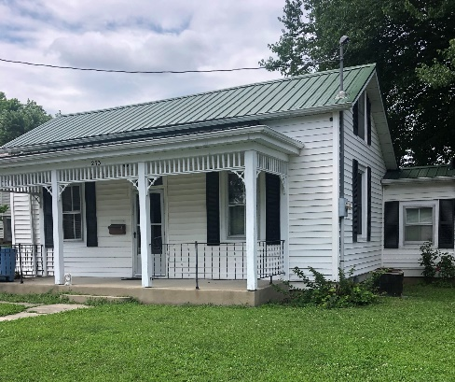
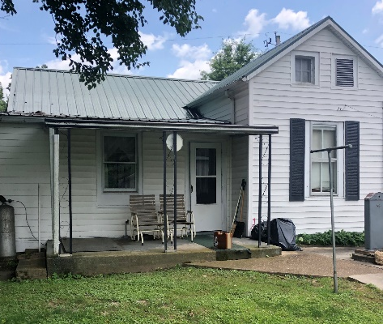
REAL ESTATE @ 233 West 9th St
1 Bedroom / Large Kitchen W eating area
Living Room / Dining Room or 2nd bedroom
Metal Roof / Approx. 985 sq. Ft / On 60 X 120 City Lot
Electric Furnace & Central Air / 200-amp Breaker Box
Sm Wall LP Gas Heater in Kitchen Area
Small Shed & 1 Car Garage W/ workshop in Back
Call 573-252-4767 to set up viewing appointment

Terms - House to be sold AS IS @ Noon day of Auction / 10% down / 50-50 at closing / Owner reserves right to reject final bid

ESTATE & REAL ESTATE OF DELBERT AND OPAL DOTHAGE
AUCTIONEERS NOTE  Any announcements made day of sale takes precedence over printed material. Items sell as is, where is. Nothing to be removed until settled for.  Cash or Check with proper I.D. required. Will now do Credit with 4% upcharge.  Food stand on premises. Owners, Auctioneers & Auction Personnel not responsible for lost & stolen items or accidents. | LEO BADER @ 573-253-4833 HM 573-252-4767  DONALD BADER @ 573-220-1296  E-MAIL baderauction@ktis.net  LIKE US ON http//www.facebook.comBaderAuctionService.OLD.1968  VISIT OUR WEBSITE—www.baderauction.com for all photos & sale bills

BADER AUCTION SERVICE L.L.C.
LEO BADER, ED POWERS, & DONALD BADER – LICENSED AUCTIONEERS
In Service For 50+ Years

