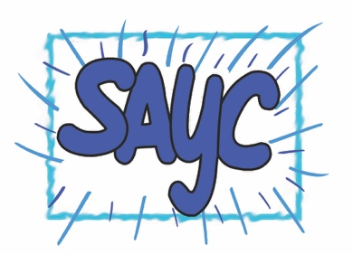
Stanley Area Youth Consortium Bursary Application Form 2021

Please read the accompanying criteria document before completing this application form.

Organisation name
Address
Main contact name |  | Job/volunteer title
Telephone mobile
Telephone home/office
Email address
About your Organisation

What type of organisation are you? | Click on box for drop down menu
Registered Charitable number
Registered Company number (if applicable)
Website
Number of volunteers
Your most recent annual income
Your most recent annual expenditure
Please describe your organisation and what you do. (250 words max)

Purpose of Funding

Where will this activity take place?
What age range of children/young people will you support? | Click on box for drop down menu.
How many children and/or young people will benefit?
Will you charge for your activity? If Yes, how much per session?
What do you want to use this funding for? When will it take place? Explain how this is additional to what you normally do. (300 words)
What difference will this activity make to young people’s physical and/or mental health wellbeing? How will you know what impact you have made? (250 words)

Sum requested (up to £500)
Please itemise what you will spend the money on.

Safeguarding

DBS checks

Please confirm that DBS checks have been conducted on staff and volunteers

Yes No

Please confirm that you have suitable safeguarding policies in place, covering children and vulnerable people, and any other relevant safeguarding issues. This should include reasonable steps you are taking to support staff, volunteers, and the public in relation to COVID-19. We expect these are reviewed and updated regularly by your organisation. We may request to see these policies at any time.

Yes No

Bank Account Details

Please give the bank details for the account you wish to receive the grant if awarded. Please note this must be an official account of the organisation applying. Your bank account must have two unrelated signatories. By signing this application form you are confirming that this is the case.

Account name |  | Sort Code
Bank name |  | Account Number

Declaration

I confirm that the information declared in this application form is accurate and answered faithfully. I understand that inaccurate or false information supplied may result in any grant offered being withdrawn and potentially any grant monies repaid in full.

Signing this application means that you accept all terms and conditions relating to any grant offer and agree to abide by these. This application form should be signed by the person submitting the form and a senior Trustee/Board Member.

Name of person submitting form | Position | Signature (typing in this box will be accepted as an electronic signature). | Date

Name of senior Trustee or Board Member | Position | Signature (typing in this box will be accepted as an electronic signature). | Date

This application should be sent to info@youthconsortium.org together with a signed copy of your latest accounts, a signed copy of your governing document(s) if you are an unregistered organisation plus a scanned copy of a bank statement less than 3 months old from the account that will receive the money if you are successful.

I confirm that I have attached the required documents with my application.

