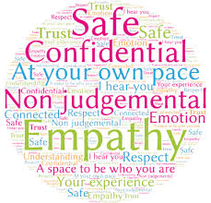

**Counseling Options**

**Colorado Crisis Services:** can access 24/7 services through

[https://coloradocrisisservices.org](https://coloradocrisisservices.org/).

[1-844-493-8255](tel:+1-844-493-8255)

If you are experiencing a mental health crisis, call [Colorado Crisis Services](http://coloradocrisisservices.org/) for 24-Hour assistance: (844) 493-8255 (TALK) or dial 911 for emergency assistance.

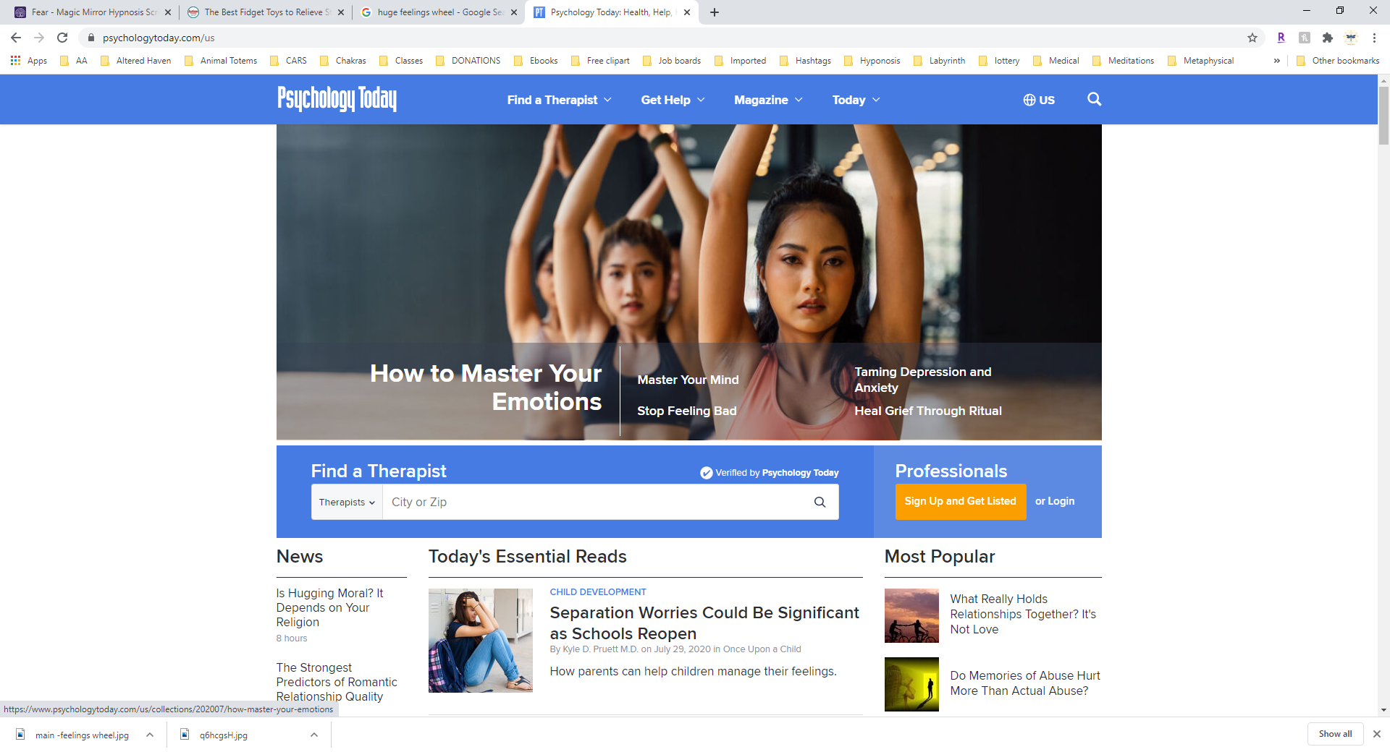

**To find Counseling**

<https://www.psychologytoday.com/us>

[**http://www.communityreachcenter.org/**](http://www.communityreachcenter.org/)

**Warm Line at 303-280-6602 Monday through Friday, 8am to 5pm.**

Community Reach Center provides mental health services and counseling in seven outpatient offices for your convenience. Please click on the office name for hours of operation, information about available services, and a map to that office.

Initial evaluations are provided at the following locations on a first-come, first-served basis:

Locations in Thornton, Westminster, Brighton and Commerce city

Donald C. Ciancio Memorial Building

8989 Huron St.  
Thornton, CO 80260  
Monday-Friday; 8:00am to 3:00pm

Brighton Office

1850 E. Egbert St., Ste. 200  
Brighton, CO 80601  
Wednesday; 8:00am to 10:00am

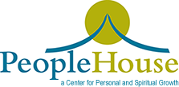 <http://peoplehouse.org/>

303-480-5130

Address : **People House – Main:** 3035 West 25th Avenue Denver , CO 80211

**People House East**: 13693 E. Iliff Ave. Suite 112 Aurora, CO 80014

Welcome to People House

People House is a collaborative community for healing and growth, offering holistic resources for life’s journey— empowering people for 40 years. Our unique community is dedicated to fostering conscious awareness of body, mind and spirit in individuals, couples, and families through counseling, group activities, and training. Come explore the many possibilities People House has to offer: therapy, workshops, sliding fee scale counseling or rent space at People House for your own practice.

The purpose of People House is to create a space and atmosphere where everyone is accepted for who and what they are at this moment, and to enhance the possibilities of who and what they might become should they choose to expand their spiritual awareness. We believe to do so involves everyone living their experience of life with conscious awareness, and responsibly making their own decisions with a willingness to accept the consequences of their words, thoughts and deeds.

At People House, we believe in a few, simple guidelines, which help us increase our experience of Love. These are suggestions, not requirements. We encourage investigation and consideration of all beliefs