WEATHERFORD - SWIM MEET
Saturday, June 6th
CHERRY PARK POOL

302 W. LEE AVE, 76086
817-598-4382 (pool phone)

- Warm-ups will begin at 7:00 AM. Meet will begin promptly at 8:30 AM. Please be on time.
7:00-7:20AM : Weatherford All Lanes
7:25-7:45 AM: Walsh
7:50- 8:10AM: RPA

**8:15 Coaches meeting at the P.A. Tent**
***As of now there is a high chance of rain on Saturday. We will continue to monitor throughout the week. When you email your entries, if you would please send me your phone number I will contact you in the event of any changes.***

- We will move the meet along as quickly as possible. Encourage your swimmers to listen for their event and heat over the PA system. We will not hold events for swimmers.
- All entries must be emailed in HY-TEK form to Matt Williams by Wednesday June 5 at 5:00 pm. Corrections due Thursday June 4th by 5pm. Please send your team roster & Entries in HY-TEK file to: Lynwood85@hotmail.com AND Matt.Williams.8587@gmail.com
- The Weatherford pool is a 25 yard pool.
- This meet will be pre-seeded after all entries are received. We will combine as many events as possible and those combined events will be indicated on the heat sheets.
- We will be using hand held stopwatches for timers. Please coordinate a parent or two on your side that would be willing to help time, if needed. We will make the announcement over the PA for timers if necessary.
- A concession stand will be available on-site, venmo and cash accepted.
- Parents and spectators: Standing room only inside the pool area. Tents, coolers, blankets, etc. will not be allowed inside the pool fence, however, shade is limited outside of the fence and tents are encouraged. There will not be bleacher seating. It is suggested to bring lawn chairs for seating outside of the pool area. All swimmers will report to their events through the North side gate of the pool (see picture below).
- Ribbons and meet results will be available to coaches after the meet. Ribbons will not be mailed, results will be emailed later that weekend.

**We have added a race to our meet. The last race of the day will be a 100-yard doggie paddle relay. Hands must remain under water and heads must remain above water. Swimmers are required to DOGGIE PADDLE! By the way, dogs BARK!! Any age/gender may be on the relay team (4 people total, each swimming one length of the pool. No entries necessary for this event, they will line up behind the blocks! Let’s have a little fun!
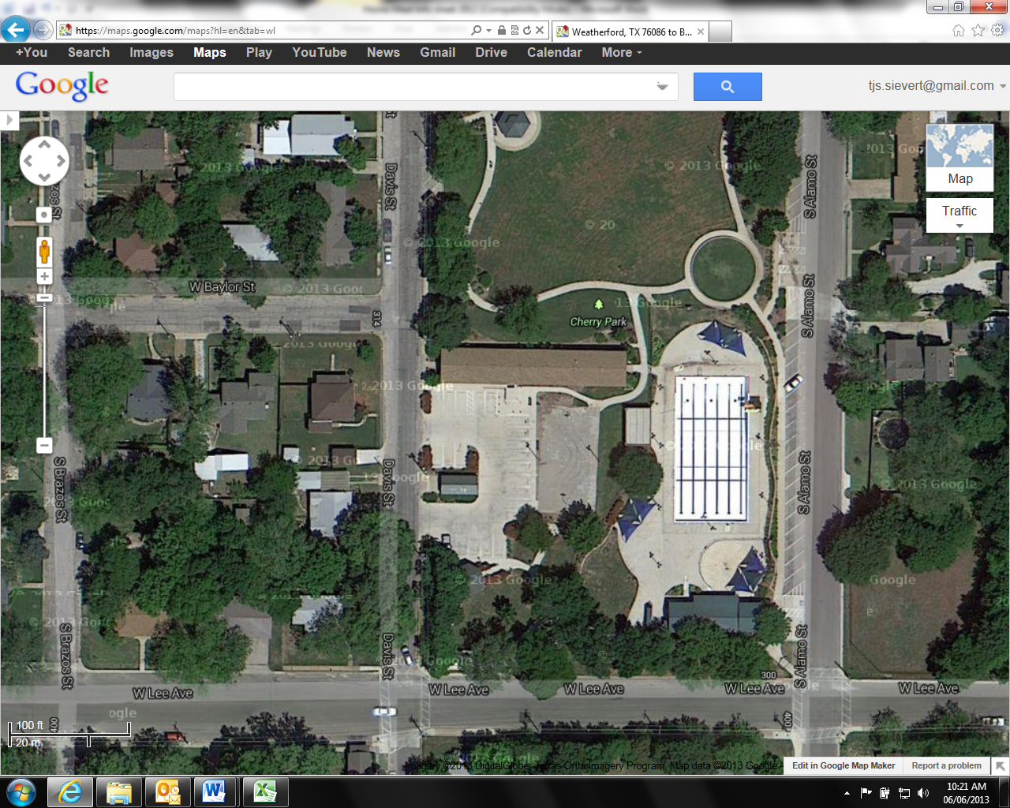
Area available for team set up
Entry gate for heating area

Please also feel free to call Coach Matt or Tif Williams, 817-991-3925 / 817-771-9649 with any questions.

