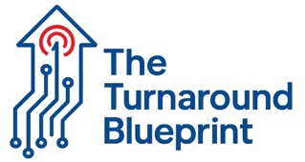

FORM 1.1
INDUSTRY INTELLIGENCE TOOLKIT CHECKLIST

Complete this assessment quarterly
MARKET DATA COLLECTION
- Download latest NIC MAP data for your region
- Join relevant associations (ASHA, Argentum, state association)
- Research top 3 competitors' pricing and occupancy rates
- Track local demographic shifts for adults 75+ annually
- Review state regulatory updates monthly
TECHNOLOGY ASSESSMENT
- Resident/family communication tools available: ☐ Yes ☐ No
- Online portals for updates: ☐ Yes ☐ No
- Smart home features: ☐ Yes ☐ No
- Digital health monitoring: ☐ Yes ☐ No
FINANCIAL HEALTH CHECK
- Calculate labor costs as % of revenue: _____%
- Compare to industry benchmark (40-41%): ☐ Above ☐ At ☐ Below
- Review utility costs per resident per day: $______
Industry benchmark: $6.44/resident/day

